Exp. 6 Finite Word length Effects
6.1 Uniform Quantization and Quantization Error Analysis of a Discrete-Time Sinusoidal Signal Using MATLAB
Objectives:
1. To generate a discrete-time sinusoidal signal in MATLAB.
2. To perform uniform quantization with different quantization levels.
3. To compare the original and quantized signals.
4. To analyse the quantization error and its effect on signal quality.
CODE:
clc;
clear;
close all;
%% Signal
fs = 1000; f = 50;
t = 0:1/fs:0.1;
x = sin(2*pi*f*t);
%% Quantization Levels
L = [8 16 32];
colors = {'r','g','m'};
figure;
for i = 1:length(L)
% Quantization
xq{i} = round((x+1)*(L(i)-1)/2)*(2/(L(i)-1)) - 1;
% Error & MSE
e{i} = x - xq{i};
mse(i) = mean(e{i}.^2);
% Plot Quantized Signals
subplot(4,1,i+1);
stairs(t,xq{i},colors{i},'LineWidth',1.2);
title(['Quantized Signal (' num2str(L(i)) ' Levels)']);
grid on;
end
% Original Signal
subplot(4,1,1);
plot(t,x,'LineWidth',1.5);
title('Original Signal'); grid on;
% Display MSE
fprintf('MSE for 8 Levels = %f\n', mse(1));
fprintf('MSE for 16 Levels = %f\n', mse(2));
fprintf('MSE for 32 Levels = %f\n', mse(3));
%% Error Plots
figure;
for i = 1:3
subplot(3,1,i);
plot(t,e{i});
title(['Error (' num2str(L(i)) ' Levels)']);
grid on;
end
OUTPUT:
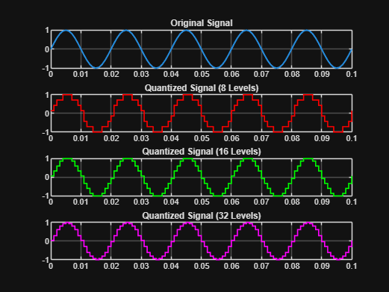
MSE for 8 Levels = 0.010473
MSE for 16 Levels = 0.001763
MSE for 32 Levels = 0.000357
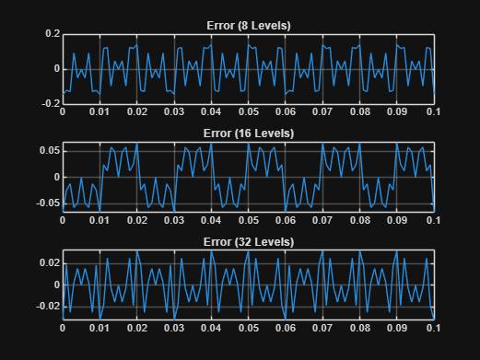

6.2 Analysis of Finite Word Length Effects in Digital Signal Representation Using Truncation Rounding Techniques in MATLAB
Objectives:
1.To represent a digital signal using a finite word length format in MATLAB.
2. To perform truncation and rounding operations on the finite word length representation of the signal.
3. To evaluate and compare the errors resulting from truncation and rounding techniques.
4. To investigate the impact of finite precision arithmetic on the accuracy of digital signal representation.
CODE:
clc; clear; close all
n=0:79;
x=sin(2*pi*n/40);
q=8;
xt=floor(x*q)/q;
xr=round(x*q)/q;
et=x-xt;
er=x-xr;
% Fig 1
figure
plot(n,x,'b',n,xr,'r','LineWidth',1.5)
grid on
title('Original vs Quantized')
legend('Original','Quantized')
% Fig 2
figure
plot(n,x,'b',n,xt,'r',n,xr,'g','LineWidth',1.5)
grid on
title('Truncation vs Rounding')
legend('Original','Truncated','Rounded')
% Fig 3
figure
stem(n,et,'r')
hold on
stem(n,er,'g')
grid on
title('Quantization Error')
legend('Truncation','Rounding')
% Fig 4
figure
bar([mean(et.^2) mean(er.^2)])
set(gca,'XTickLabel',{'Truncation','Rounding'})
grid on
title('MSE Comparison')
ylabel('MSE')
OUTPUT:
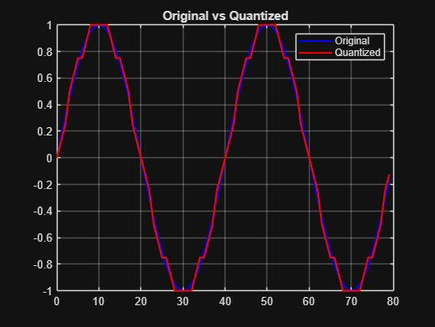
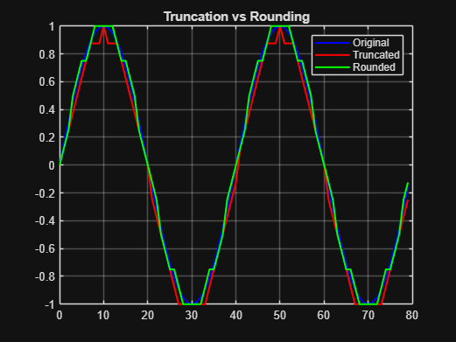
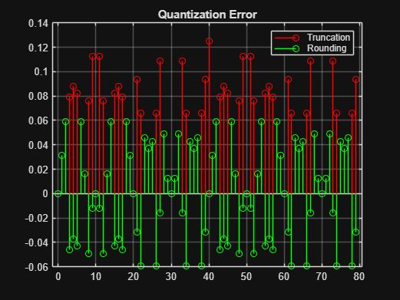
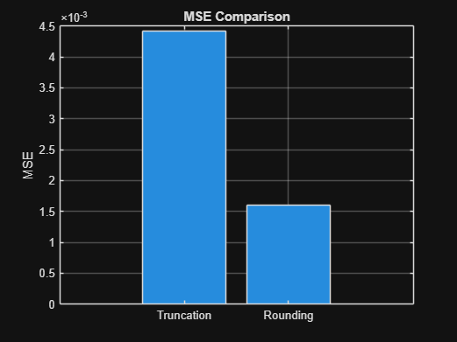
RESULT:
The digital signal was successfully represented using a finite word length format in MATLAB.

