Expt 7 Spectral Estimation
7.1 Power Spectral Density Estimation and Spectral Analysis of Noisy Sinusoidal Signals using Periodogram Method in MATLAB
Objectives:
1. To generate a discrete-time signal consisting of sinusoidal components and noise.
2. To estimate the Power Spectral Density (PSD) of the signal using the Periodogram method.
3. To identify the frequency components present in the signal.
4. To compare the signal power and noise power for assessing the quality of generate signal.
Code:
clc; clear; close all
fs=1000; t=(0:999)/fs;
s=sin(2*pi*100*t)+0.5*sin(2*pi*200*t);
n=0.3*randn(size(t));
x=s+n;
figure, plot(x), grid on
title('Signal with Noise')
figure, periodogram(x,[],[],fs)
title('PSD using Periodogram')
figure
X=abs(fft(x));
f=(0:length(X)-1)*fs/length(X);
plot(f(1:500),X(1:500)), grid on
title('Magnitude Spectrum')
figure
bar([mean(s.^2) var(n)])
set(gca,'XTickLabel',{'Signal','Noise'})
title('Power Comparison')
grid on
OUTPUT:
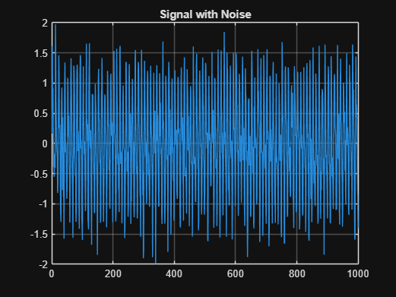
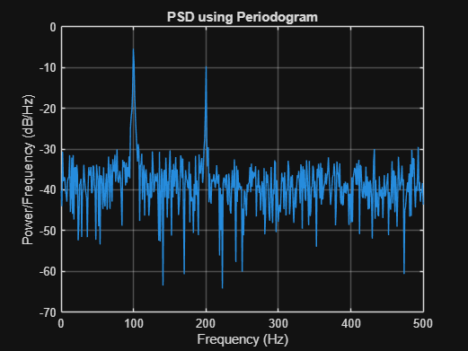
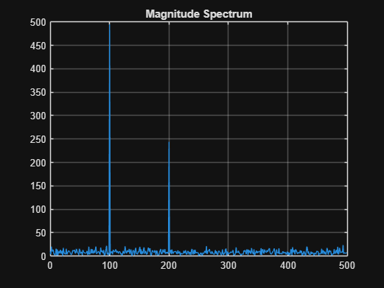
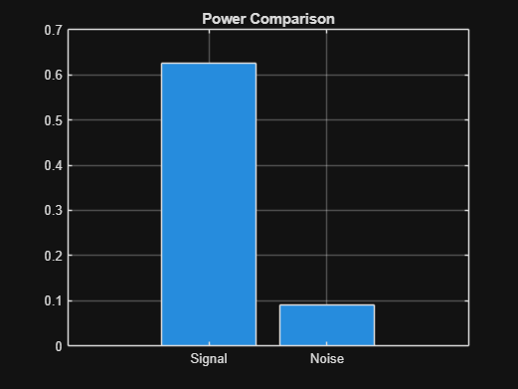
7.2 Analysis of Windowing Effects on Spectral Estimation Using Rectangular, Hamming, Hanning Windows in MATLAB
Objectives:
1. To estimate the spectrum of a signal using different window functions such as Rectangular, Hamming, and Hanning windows.
2. To analyse the effect of window selection on spectral leakage.
3. To compare the main-lobe width and side-lobe levels of different windows.
4. To evaluate the accuracy of frequency component detection.
CODE:
clc; clear; close all;
% Signal
fs = 1000; N = 256; t = (0:N-1)/fs;
x = sin(2*pi*100*t) + 0.8*sin(2*pi*110*t);
NFFT = 2048; f = (0:NFFT/2-1)*(fs/NFFT);
% Windows
w = {rectwin(N), hamming(N), hann(N)};
names = {'Rectangular','Hamming','Hanning'};
% Processing
for i = 1:3
xw = x(:).*w{i};
X = fft(xw,NFFT);
P{i} = abs(X(1:NFFT/2));
P{i} = P{i}/max(P{i});
end
%% Individual Spectrums
figure;
for i = 1:3
subplot(3,1,i);
plot(f,20*log10(P{i}),'LineWidth',1.5);
title(['Spectrum using ' names{i} ' Window']);
xlim([0 250]); grid on;
end
%% Comparison
figure;
plot(f,20*log10(P{1}),'k',f,20*log10(P{2}),'r',f,20*log10(P{3}),'b','LineWidth',1.5);
legend(names); title('Window Comparison'); xlim([50 170]); grid on;
%% Window Shapes
figure;
for i = 1:3
subplot(3,1,i); plot(w{i},'LineWidth',1.5);
title([names{i} ' Window']); grid on;
end
%% Peak Detection
for i = 1:3
[pks{i},loc{i}] = findpeaks(P{i},f,'MinPeakHeight',0.3);
fprintf('\n%s Window Frequencies:\n',names{i});
disp(loc{i});
end
%% Peak Marking (Hamming)
figure;
plot(f,20*log10(P{2}),'LineWidth',1.5); hold on;
plot(loc{2},20*log10(pks{2}),'ro','MarkerFaceColor','r');
title('Detected Frequencies (Hamming)'); xlim([50 170]); grid on;
%% Main Peaks
fprintf('\nMain Spectral Peaks:\n');
for i = 1:3
[~,idx] = max(P{i});
fprintf('%s Window Peak = %.2f Hz\n',names{i},f(idx));
end
OUTPUT:
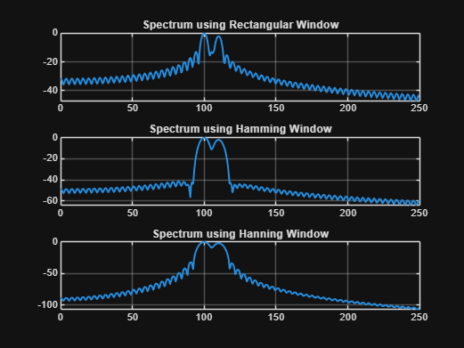
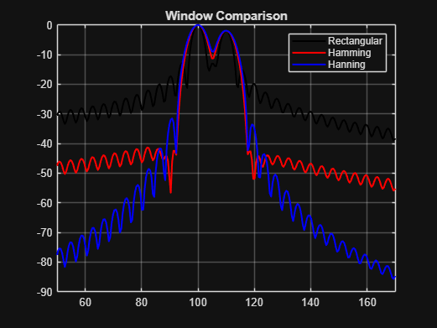
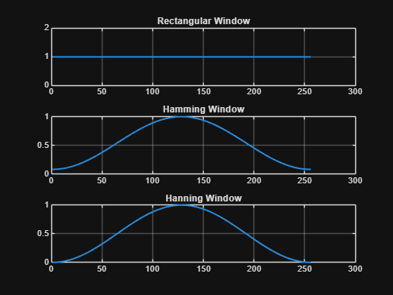
Rectangular Window Frequencies:
100.0977 109.8633
Hamming Window Frequencies:
100.0977 109.8633
Hanning Window Frequencies:
100.0977 109.8633
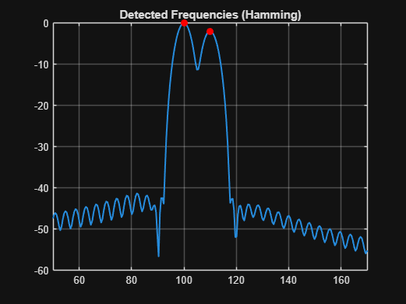
Main Spectral Peaks:
Rectangular Window Peak = 100.10 Hz
Hamming Window Peak = 100.10 Hz
Hanning Window Peak = 100.10 Hz

RESULT:
The spectrum of the given signal was successfully estimated using Rectangular, Hamming, and Hanning window functions in MATLAB.

