Expt 8 Multirate Signal Processing
8.1 Implementation and Analysis of Decimation and Interpolation in Multirate Signal Processing Using MATLAB
Objectives:
1. To generate a discrete-time sinusoidal sequence for multirate signal processing.
2. To perform decimation of a discrete-time sequence by a factor of 2.
3. To perform Interpolation of a discrete-time sequence by a factor of 2.
4. To analyze and compare the original, decimated, and interpolated sequences.
Code:
clc;
clear;
close all;
% Original Sequence
n = 0:40;
x = sin(0.3*pi*n);
% Decimation by 2
y = x(1:2:end);
nd = 0:length(y)-1;
% Interpolation by 2
v = zeros(1,2*length(x));
v(1:2:end) = x;
ni = 0:length(v)-1;
% Figure 1: Original Sequence
figure;
stem(n,x,'filled');
grid on;
title('Original Sequence x[n]');
xlabel('n');
ylabel('Amplitude');
% Figure 2: Decimated Sequence
figure;
stem(nd,y,'filled');
grid on;
title('Decimated Sequence by 2');
xlabel('n');
ylabel('Amplitude');
% Figure 3: Interpolated Sequence
figure;
stem(ni,v,'filled');
grid on;
title('Interpolated Sequence by 2');
xlabel('n');
ylabel('Amplitude');
% Figure 4: Comparison
figure;
stem(n,x,'b'); hold on;
stem(0:2:length(v)-2,v(1:2:end),'r');
legend('Original x[n]','Interpolated Samples');
grid on;
title('Comparison of Sequences');
xlabel('n');
ylabel('Amplitude');
Output:
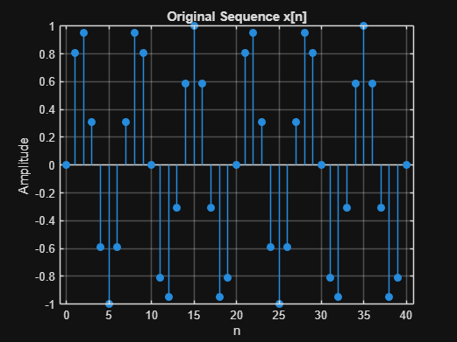
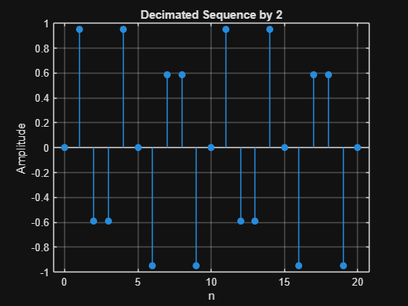
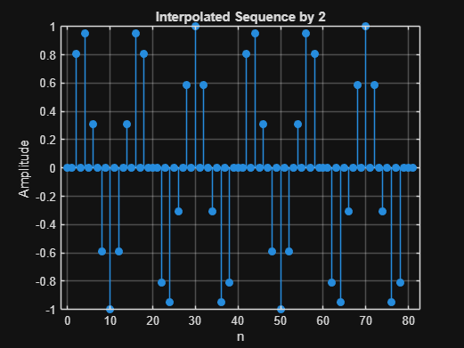
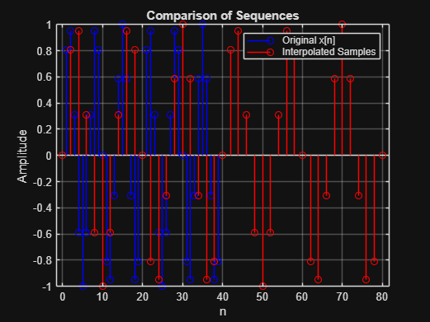

8.2 Polyphase Implementation of Decimation and Interpolation Filters Using MATLAB
Objectives:
1. To perform sampling rate reduction of a discrete-time signal using a polyphase FIR decimation filter with a decimation factor of 2.
2.To perform sampling rate increase of a discrete-time signal using a polyphase FIR interpolation filter with an interpolation factor of 2.
3.To reconstruct the original signal from the decimated signal through interpolation and compare the reconstructed signal with the original input signal.
4.To demonstrate the computational efficiency and effectiveness of polyphase filter structures in multirate digital signal processing applications.
Code:
clc;
clear;
close all;
%% Input Signal
Fs = 1000; % Sampling Frequency
t = 0:1/Fs:1;
% Test Signal
%Time Vector
x = sin(2*pi*50*t) + 0.5*sin(2*pi*120*t);
%% FIR Low-Pass Filter Design
N = 20; % Filter Order
Fc = 0.4;
% Normalized Cutoff Frequency
h = fir1(N,Fc,hamming(N+1));
%% Decimation Factor
M = 2;
% Polyphase Decimation
y_dec = upfirdn(x,h,1,M);
%% Interpolation Factor
L = 2;
% Polyphase Interpolation
y_int = upfirdn(y_dec,h,L,1);
%% Adjust Length for Comparison
if length(y_int) > length(x)
y_int = y_int(1:length(x));
elseif length(y_int) < length(x)
x = x(1:length(y_int));
end
%% Time Axes
t1 = (0:length(x)-1)/Fs;
t2 = (0:length(y_dec)-1)/(Fs/M);
t3 = (0:length(y_int)-1)/Fs;
%% BEST GRAPH OUTPUT
figure('Name','Polyphase Decimation and Interpolation','NumberTitle','off');
% Original Signal
subplot(4,1,1)
plot(t1,x,'b','LineWidth',1.5)
title('Original Input Signal')
xlabel('Time (s)')
ylabel('Amplitude')
grid on
% Decimated Signal
subplot(4,1,2)
stem(t2,y_dec,'r','filled')
title('Decimated Signal (M = 2)')
xlabel('Time (s)')
ylabel('Amplitude')
grid on
% Interpolated Signal
subplot(4,1,3)
plot(t3,y_int,'k','LineWidth',1.5)
title('Interpolated/Reconstructed Signal (L = 2)')
xlabel('Time (s)')
ylabel('Amplitude')
grid on
% Comparison
subplot(4,1,4)
plot(t1,x,'b','LineWidth',1.5)
hold on
plot(t3,y_int,'r--','LineWidth',1.5)
title('Comparison of Original and Reconstructed Signals')
xlabel('Time (s)')
ylabel('Amplitude')
legend('Original Signal','Reconstructed Signal')
grid on
%% Display Information
disp('--------------------------------------');
disp('POLYPHASE DECIMATION & INTERPOLATION');
disp('--------------------------------------');
fprintf('Original Signal Length = %d\n',length(x));
fprintf('Decimated Signal Length = %d\n',length(y_dec));
fprintf('Interpolated Signal Length = %d\n',length(y_int));
%% Separate Figure for Better Visualization
figure;
plot(t1,x,'b','LineWidth',2)
hold on
plot(t3,y_int,'r--','LineWidth',2)
title('Original vs Reconstructed Signal')
xlabel('Time (s)')
ylabel('Amplitude')
legend('Original Signal','Reconstructed Signal')
grid on
Output:
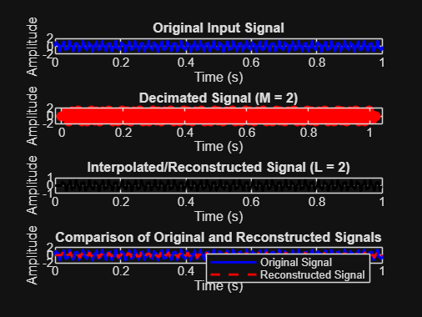
POLYPHASE DECIMATION & INTERPOLATION
Original Signal Length = 1001
Decimated Signal Length = 511
Interpolated Signal Length = 1001
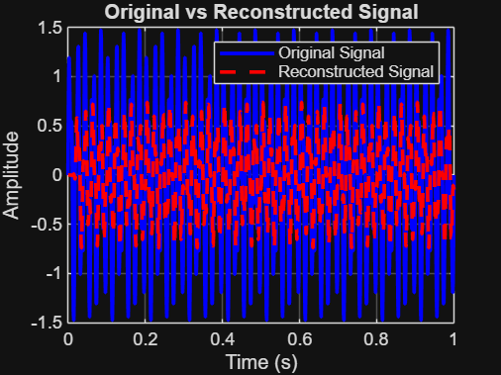
Result:
1. The input signal was successfully decimated by a factor of 2 using a polyphase FIR decimation filter.
2.The input signal was successfully interpolated by a factor of 2 using a polyphase FIR interpolation filter.
3. The original signal was reconstructed from the decimated signal and closely matched the input signal.
4.The polyphase filter structure reduced computational complexity and efficiently performed multirate signal processing operations.

