**BIOMETRIC SENSING SYSTEM**

**Introduction**

Biometric sensing systems have revolutionized the field of computer graphics by providing a novel and efficient way to capture, analyze, and interpret human physiological and behavioral characteristics. These systems leverage advanced technologies to measure unique biological traits such as fingerprints, facial features, iris patterns, and even voice signatures. In the context of computer graphics, biometric sensing enhances user interaction, security, and personalization by enabling devices and applications to recognize and respond to individuals in real time.

The word biometrics is derived from the Greek words bio and metric. Where bio means life and metric means to measure. Biometrics are used to identify his or her physical and behavioural characteristics of a person. This method of identification is chosen over traditional methods, including PIN numbers and passwords for its exactness and case sensitiveness. Based on the designing, this system can be used as an identification system or authentication system. These systems are divided into various types which include vein pattern, fingerprints, hand geometry, DNA, voice pattern, iris pattern, signature dynamics and face detection. This article discusses what is a biometric sensor, different types of biometric sensors and its working.

The integration of biometric sensing in computer graphics facilitates the creation of more intuitive and immersive experiences. From security systems that rely on facial recognition to virtual reality applications that track eye movements, the potential applications are vast and continually expanding. This report delves into the fundamental aspects of biometric sensing systems, exploring their required fields, practical implementations using simple Python code, various applications and usage scenarios, as well as the pros and cons of employing biometric sensing technology. We will conclude with a summary of the key points and future prospects in this dynamic field.

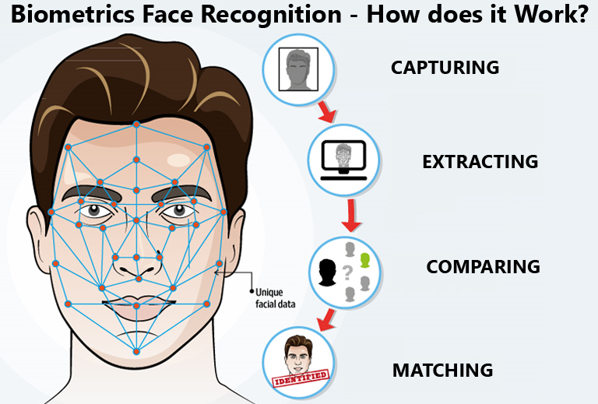

Types of Biometric Sensor

Biometric sensors or [access control systems](https://www.elprocus.com/understanding-about-types-of-access-control-systems/) are classified into two types such as Physiological Biometrics and Behavioral Biometrics. The physiological biometrics mainly include face recognition, fingerprint, hand geometry, Iris recognition, and DNA. Whereas behavioral biometrics include keystroke, signature and voice recognition. For a better understanding of this concept, some of them are discussed below.

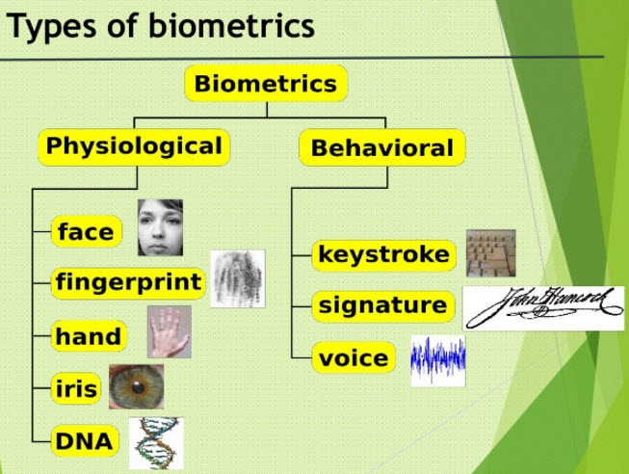

*Types of Biometric Sensing*

#### **Face Recognition :**

A face recognition system is one type of biometric computer application that can identify or verify a person from a digital image by comparing and analyzing patterns. These biometric systems are [used in security systems](https://www.elprocus.com/electronic-security-system/). Present facial recognition systems work with face prints and these systems can recognize 80 nodal points on a human face. Nodal points are nothing but endpoints used to measure variables on a person’s face, which includes the length and width of the nose, cheekbone shape, and eye socket depth.

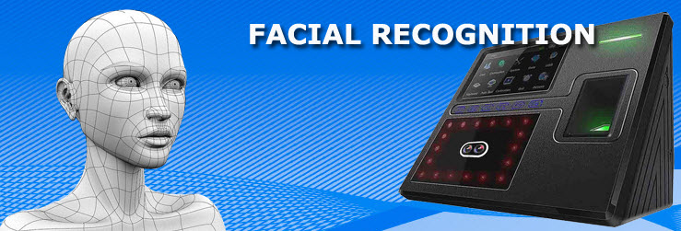

*Face Recognition*

Face recognition systems work by capturing data for the nodal points on a digital image of a person’s face and resulting data can be stored as a face print. When the conditions are favourable, these systems use face prints to identify accurately. Currently, these systems focus on smartphone applications which include personal marketing, social networking, and image tagging purposes. Social sites like FB uses software for face recognition to tag the users in photographs. This software also increases marketing personalization. For instance, billboards have been designed with integrated software that recognizes the ethnicity, gender and estimated age of onlookers to deliver targeted marketing.

## **Techniques for face recognition:**

[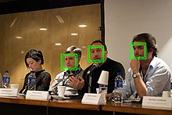](https://en.wikipedia.org/wiki/File:Face_detection.jpg)

Automatic face detection with [OpenCV](https://en.wikipedia.org/wiki/OpenCV)

While humans can recognize faces without much effort, facial recognition is a challenging [pattern recognition](https://en.wikipedia.org/wiki/Pattern_recognition) problem in [computing](https://en.wikipedia.org/wiki/Computing). Facial recognition systems attempt to identify a human face, which is three-dimensional and changes in appearance with lighting and facial expression, based on its two-dimensional image. To accomplish this computational task, facial recognition systems perform four steps. First [face detection](https://en.wikipedia.org/wiki/Face_detection) is used to segment the face from the image background. In the second step the segmented face image is aligned to account for face [pose](https://en.wikipedia.org/wiki/Pose), image size and photographic properties, such as [illumination](https://en.wikipedia.org/wiki/Illumination_(image)) and [grayscale](https://en.wikipedia.org/wiki/Grayscale). The purpose of the alignment process is to enable the accurate localization of facial features in the third step, the facial feature extraction. Features such as eyes, nose and mouth are pinpointed and measured in the image to represent the face. The so established [feature vector](https://en.wikipedia.org/wiki/Feature_vector) of the face is then, in the fourth step, matched against a database of faces.

### Human identification at a distance (HID):

To enable human identification at a distance (HID) low-resolution images of faces are enhanced using [face hallucination](https://en.wikipedia.org/wiki/Face_hallucination). In [CCTV](https://en.wikipedia.org/wiki/CCTV) imagery faces are often very small. But because facial recognition algorithms that identify and plot facial features require high resolution images, resolution enhancement techniques have been developed to enable facial recognition systems to work with imagery that has been captured in environments with a high [signal-to-noise ratio](https://en.wikipedia.org/wiki/Signal-to-noise_ratio). Face hallucination algorithms that are applied to images prior to those images being submitted to the facial recognition system use example-based machine learning with pixel substitution or [nearest neighbour distribution](https://en.wikipedia.org/wiki/Nearest_neighbour_distribution) indexes that may also incorporate demographic and age related facial characteristics. Use of face hallucination techniques improves the performance of high resolution facial recognition algorithms and may be used to overcome the inherent limitations of super-resolution algorithms. Face hallucination techniques are also used to pre-treat imagery where faces are disguised. Here the disguise, such as sunglasses, is removed and the face hallucination algorithm is applied to the image. Such face hallucination algorithms need to be trained on similar face images with and without disguise. To fill in the area uncovered by removing the disguise, face hallucination algorithms need to correctly map the entire state of the face, which may be not possible due to the momentary facial expression captured in the low resolution image.

### 3-dimensional recognition:

[Three-dimensional face recognition](https://en.wikipedia.org/wiki/Three-dimensional_face_recognition) technique uses 3D sensors to capture information about the shape of a face. This information is then used to identify distinctive features on the surface of a face, such as the contour of the eye sockets, nose, and chin.[[45]](https://en.wikipedia.org/wiki/Facial_recognition_system#cite_note-Williams2-45) One advantage of 3D face recognition is that it is not affected by changes in lighting like other techniques. It can also identify a face from a range of viewing angles, including a profile view.[[45]](https://en.wikipedia.org/wiki/Facial_recognition_system#cite_note-Williams2-45)[[37]](https://en.wikipedia.org/wiki/Facial_recognition_system#cite_note-Bonsor2-37) Three-dimensional data points from a face vastly improve the precision of face recognition. 3D-dimensional face recognition research is enabled by the development of sophisticated sensors that project structured light onto the face.[[46]](https://en.wikipedia.org/wiki/Facial_recognition_system#cite_note-Crawford2-46) 3D matching technique are sensitive to expressions, therefore researchers at [Technion](https://en.wikipedia.org/wiki/Technion) applied tools from [metric geometry](https://en.wikipedia.org/wiki/Metric_geometry) to treat expressions as [isometries](https://en.wikipedia.org/wiki/Isometries).[[47]](https://en.wikipedia.org/wiki/Facial_recognition_system#cite_note-Kimmel2-47) A new method of capturing 3D images of faces uses three tracking cameras that point at different angles; one camera will be pointing at the front of the subject, second one to the side, and third one at an angle. All these cameras will work together so it can track a subject's face in real-time and be able to face detect and recognize.

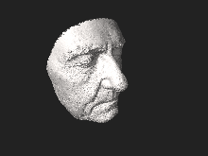

*3D model of a human face*

**Required Fields :**

1. **Biometric Traits**: Characteristics such as fingerprints, facial features, iris patterns, voice, and even gait.
2. **Sensing Devices**: Hardware like fingerprint scanners, cameras, microphones, and other sensors.
3. **Data Acquisition**: Methods for capturing biometric data, including image processing and signal processing techniques.
4. **Feature Extraction**: Techniques for identifying unique patterns and features from raw biometric data.
5. **Pattern Recognition**: Algorithms for matching extracted features against stored templates to verify identity.
6. **Security Protocols**: Measures to protect biometric data from unauthorized access and misuse.
7. **Integration with Systems**: Methods for embedding biometric sensing into computer graphics applications.

## **Application:**

### 🡪Social media

Founded in 2013, [Looksery](https://en.wikipedia.org/wiki/Looksery) went on to raise money for its face modification app on Kickstarter. After successful crowdfunding, [Looksery](https://en.wikipedia.org/wiki/Looksery) launched in October 2014. The application allows video chat with others through a special filter for faces that modifies the look of users. [Image augmenting](https://en.wikipedia.org/wiki/Augmented_reality) applications already on the market, such as [Facetune](https://en.wikipedia.org/wiki/Facetune) and Perfect365, were limited to static images, whereas Looksery allowed augmented reality to live videos. In late 2015 [SnapChat](https://en.wikipedia.org/wiki/Snap_Inc.) purchased Looksery, which would then become its landmark lenses function. Snapchat filter applications use face detection technology and on the basis of the facial features identified in an image a 3D mesh mask is layered over the face. A variety of technologies attempt to fool facial recognition software by the use of [anti-facial recognition masks](https://en.wikipedia.org/wiki/Anti-facial_recognition_mask).

[DeepFace](https://en.wikipedia.org/wiki/DeepFace) is a [deep learning](https://en.wikipedia.org/wiki/Deep_learning) facial recognition system created by a research group at [Facebook](https://en.wikipedia.org/wiki/Facebook,_Inc.). It identifies human faces in digital images. It employs a nine-layer [neural net](https://en.wikipedia.org/wiki/Neural_net) with over 120 million connection weights, and was [trained](https://en.wikipedia.org/wiki/Machine_learning) on four million images uploaded by Facebook users. The system is said to be 97% accurate, compared to 85% for the FBI's [Next Generation Identification](https://en.wikipedia.org/wiki/Next_Generation_Identification) system.

[TikTok](https://en.wikipedia.org/wiki/TikTok)'s algorithm has been regarded as especially effective, but many were left to wonder at the exact programming that caused the app to be so effective in guessing the user's desired content. In June 2020, TikTok released a statement regarding the "For You" page, and how they recommended videos to users, which did not include facial recognition. In February 2021, however, TikTok agreed to a $92 million settlement to a US lawsuit which alleged that the app had used facial recognition in both user videos and its algorithm to identify age, gender and ethnicity.

**🡪ID verification**

The emerging use of facial recognition is in the use of [ID verification services](https://en.wikipedia.org/wiki/ID_verification_service). Many companies and others are working in the market now to provide these services to banks, ICOs, and other e-businesses. Face recognition has been leveraged as a form of biometric [authentication](https://en.wikipedia.org/wiki/Authentication) for various computing platforms and devices; [Android 4.0 "Ice Cream Sandwich"](https://en.wikipedia.org/wiki/Android_Ice_Cream_Sandwich) added facial recognition using a [smartphone](https://en.wikipedia.org/wiki/Smartphone)'s front camera as a means of [unlocking](https://en.wikipedia.org/wiki/Lock_screen) devices, while [Microsoft](https://en.wikipedia.org/wiki/Microsoft) introduced face recognition login to its [Xbox 360](https://en.wikipedia.org/wiki/Xbox_360) video game console through its [Kinect](https://en.wikipedia.org/wiki/Kinect) accessory, as well as [Windows 10](https://en.wikipedia.org/wiki/Windows_10) via its "Windows Hello" platform (which requires an infrared-illuminated camera). In 2017, Apple's [iPhone X](https://en.wikipedia.org/wiki/IPhone_X) smartphone introduced facial recognition to the product line with its "[Face ID](https://en.wikipedia.org/wiki/Face_ID)" platform, which uses an infrared illumination system.

**🡪Face ID**

[Apple](https://en.wikipedia.org/wiki/Apple_Inc.) introduced [Face ID](https://en.wikipedia.org/wiki/Face_ID) on the flagship iPhone X as a biometric authentication successor to the [Touch ID](https://en.wikipedia.org/wiki/Touch_ID), a [fingerprint](https://en.wikipedia.org/wiki/Fingerprint) based system. Face ID has a facial recognition sensor that consists of two parts: a "Romeo" module that projects more than 30,000 infrared dots onto the user's face, and a "Juliet" module that reads the pattern. The pattern is sent to a local "Secure Enclave" in the device's [central processing unit](https://en.wikipedia.org/wiki/Central_processing_unit) (CPU) to confirm a match with the phone owner's face.

The facial pattern is not accessible by Apple. The system will not work with eyes closed, in an effort to prevent unauthorized access. The technology learns from changes in a user's appearance, and therefore works with hats, scarves, glasses, and many sunglasses, beard and makeup. It also works in the dark. This is done by using a "Flood Illuminator", which is a dedicated [infrared](https://en.wikipedia.org/wiki/Infrared) flash that throws out invisible infrared light onto the user's face to properly read the 30,000 facial points.

**🡪Healthcare**

Facial recognition algorithms can [help in diagnosing](https://en.wikipedia.org/wiki/Computer-aided_diagnosis) some diseases using specific features on the nose, cheeks and other part of the [human face](https://en.wikipedia.org/wiki/Face). Relying on developed data sets, machine learning has been used to identify genetic abnormalities just based on facial dimensions. FRT has also been used to verify patients before surgery procedures.

In March, 2022 according to a publication by Forbes, FDNA, an AI development company claimed that in the space of 10 years, they have worked with geneticists to develop a database of about 5,000 diseases and 1500 of them can be detected with facial recognition algorithms.

**Deployment of FRT for availing government services:**

**\*\*India\*\***

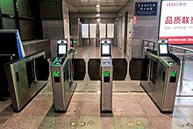

*Boarding gates with facial recognition technology at Chatrapati Shivaji Airport*

In an interview, the National Health Authority chief Dr. R.S. Sharma said that facial recognition technology would be used in conjunction with [Aadhaar](https://en.wikipedia.org/wiki/Aadhaar) to authenticate the identity of people seeking vaccines. Ten human rights and digital rights organizations and more than 150 individuals signed a statement by the [Internet Freedom Foundation](https://en.wikipedia.org/wiki/Internet_Freedom_Foundation) that raised alarm against the deployment of facial recognition technology in the central government's vaccination drive process. Implementation of an error-prone system without adequate legislation containing mandatory safeguards, would deprive citizens of essential services and linking this untested technology to the vaccination roll-out in India will only exclude persons from the vaccine delivery system.

In July, 2021, a press release by the Government of Meghalaya stated that facial recognition technology (FRT) would be used to verify the identity of pensioners to issue a Digital Life Certificate using "Pensioner's Life Certification Verification" mobile application. The notice, according to the press release, purports to offer pensioners "a secure, easy and hassle-free interface for verifying their liveness to the Pension Disbursing Authorities from the comfort of their homes using smart phones". Mr. Jade Jeremiah Lyngdoh, a law student, sent a legal notice to the relevant authorities highlighting that "The application has been rolled out without any anchoring legislation which governs the processing of personal data and thus, lacks lawfulness and the Government is not empowered to process data."

**\*\*European Union**\*\*

Police forces in at least 21 countries of the European Union use, or plan to use, facial recognition systems, either for administrative or criminal purposes.

**\*\*Greece**\*\*

Greek police passed a contract with Intracom-Telecom for the provision of at least 1,000 devices equipped with live facial recognition system. The delivery is expected before the summer 2021. The total value of the contract is over 4 million euros, paid for in large part by the Internal Security Fund of the [European Commission](https://en.wikipedia.org/wiki/European_Commission).

**\*\*Italy**\*\*

Italian police acquired a face recognition system in 2017, Sistema Automatico Riconoscimento Immagini (SARI). In November 2020, the Interior ministry announced plans to use it in real-time to identify people suspected of seeking asylum.

**\*\*The Netherland\*\***

The [Netherlands](https://en.wikipedia.org/wiki/Netherlands) has deployed facial recognition and artificial intelligence technology since 2016.[[145]](https://en.wikipedia.org/wiki/Facial_recognition_system#cite_note-145) The database of the Dutch police currently contains over 2.2 million pictures of 1.3 million Dutch citizens. This accounts for about 8% of the population. In The Netherlands, face recognition is not used by the police on municipal CCTV.

**\*\*South Africa**\*\*

In South Africa, in 2016, the city of Johannesburg announced it was rolling out smart CCTV cameras complete with automatic number plate recognition and facial recognition.

**Deployment in security services**

[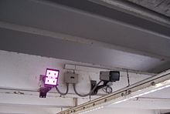](https://en.wikipedia.org/wiki/File:Surveillance_equipment_5413.jpg)

*Swiss European*[*surveillance*](https://en.wikipedia.org/wiki/Surveillance)*: face recognition and vehicle make, model, color and*[*license plate reader*](https://en.wikipedia.org/wiki/License_plate_recognition)

**🡪Commonwealth**

The [Australian Border Force](https://en.wikipedia.org/wiki/Australian_Border_Force) and [New Zealand Customs Service](https://en.wikipedia.org/wiki/New_Zealand_Customs_Service) have set up an automated border processing system called [SmartGate](https://en.wikipedia.org/wiki/SmartGate" \o "SmartGate) that uses face recognition, which compares the face of the traveller with the data in the [e-passport](https://en.wikipedia.org/wiki/Biometric_passport) microchip. All Canadian international airports use facial recognition as part of the Primary Inspection Kiosk program that compares a traveler face to their photo stored on the [ePassport](https://en.wikipedia.org/wiki/EPassport). This program first came to [Vancouver International Airport](https://en.wikipedia.org/wiki/Vancouver_International_Airport) in early 2017 and was rolled up to all remaining international airports in 2018–2019.

Police forces in the United Kingdom have been trialing live facial recognition technology at public events since 2015. In May 2017, a man was arrested using an automatic facial recognition (AFR) system mounted on a van operated by the South Wales Police. [Ars Technica](https://en.wikipedia.org/wiki/Ars_Technica) reported that "this appears to be the first time [AFR] has led to an arrest". However, a 2018 report by [Big Brother Watch](https://en.wikipedia.org/wiki/Big_Brother_Watch) found that these systems were up to 98% inaccurate. The report also revealed that two UK police forces, [South Wales Police](https://en.wikipedia.org/wiki/South_Wales_Police) and the [Metropolitan Police](https://en.wikipedia.org/wiki/Metropolitan_Police), were using live facial recognition at public events and in public spaces. In September 2019, South Wales Police use of facial recognition was ruled lawful. Live facial recognition has been trialled since 2016 in the streets of London and will be used on a regular basis from [Metropolitan Police](https://en.wikipedia.org/wiki/Metropolitan_Police) from beginning of 2020. In August 2020 the [Court of Appeal](https://en.wikipedia.org/wiki/Court_of_Appeal_(England_and_Wales)) ruled that the way the facial recognition system had been used by the South Wales Police in 2017 and 2018 violated human rights.

**Advantages and disadvantages :**

**🡪Compared to other biometric systems**

In 2006, the performance of the latest face recognition algorithms was evaluated in the [Face Recognition Grand Challenge (FRGC)](https://en.wikipedia.org/wiki/Face_Recognition_Grand_Challenge_(FRGC)). High-resolution face images, 3-D face scans, and iris images were used in the tests. The results indicated that the new algorithms are 10 times more accurate than the face recognition algorithms of 2002 and 100 times more accurate than those of 1995. Some of the algorithms were able to outperform human participants in recognizing faces and could uniquely identify identical twins.

One key advantage of a facial recognition system that it is able to perform mass identification as it does not require the cooperation of the test subject to work. Properly designed systems installed in airports, multiplexes, and other public places can identify individuals among the crowd, without passers-by even being aware of the system. However, as compared to other biometric techniques, face recognition may not be most reliable and efficient. Quality measures are very important in facial recognition systems as large degrees of variations are possible in face images. Factors such as illumination, expression, pose and noise during face capture can affect the performance of facial recognition systems. Among all biometric systems, facial recognition has the highest false acceptance and rejection rates, thus questions have been raised on the effectiveness of or bias of face recognition software in cases of railway and airport security, law enforcement and housing and employment decisions.

**🡪Weaknesses**

Ralph Gross, a researcher at the [Carnegie Mellon Robotics Institute](https://en.wikipedia.org/wiki/Carnegie_Mellon_Robotics_Institute) in 2008, describes one obstacle related to the viewing angle of the face: "Face recognition has been getting pretty good at full frontal faces and 20 degrees off, but as soon as you go towards profile, there've been problems." Besides the pose variations, low-resolution face images are also very hard to recognize. This is one of the main obstacles of face recognition in surveillance systems. It has also been suggested that camera settings can favour sharper imagery of white skin than of other skin tones.

Face recognition is less effective if [facial expressions](https://en.wikipedia.org/wiki/Facial_expression) vary. A big smile can render the system less effective. For instance: Canada, in 2009, allowed only neutral facial expressions in passport photos.

There is also inconstancy in the datasets used by researchers. Researchers may use anywhere from several subjects to scores of subjects and a few hundred images to thousands of images. Data sets may be diverse and inclusive or mainly contain images of white males. It is important for researchers to make available the datasets they used to each other, or have at least a standard or representative dataset.

Although high degrees of accuracy have been claimed for some facial recognition systems, these outcomes are not universal. The consistently worst accuracy rate is for those who are 18 to 30 years old, Black and female.

Facial recognition systems have been criticized for upholding and judging based on assumptions about people of colour  and also on a [binary gender](https://en.wikipedia.org/wiki/Gender_binary) assumption. When classifying the faces of [cisgender](https://en.wikipedia.org/wiki/Cisgender) individuals into male or female, these systems are often fairly accurate, however were typically confused or unable to determine the [gender identity](https://en.wikipedia.org/wiki/Gender_identity) of [transgender](https://en.wikipedia.org/wiki/Transgender) and [non-binary](https://en.wikipedia.org/wiki/Non-binary_gender) people. [Gender norms](https://en.wikipedia.org/wiki/Gender_role) are being upheld by these systems, so much so that even when shown a photo of a cisgender male with long hair, algorithms were split between following the gender norm of males having short hair, and the [masculine](https://en.wikipedia.org/wiki/Masculinity) facial features and became confused. This accidental misgendering of people can be very harmful for those who do not identify with their [sex assigned at birth](https://en.wikipedia.org/wiki/Sex_assignment), by disregarding and invalidating their gender identity. This is also harmful for people who do not ascribe to traditional gender norms, because it invalidates their [gender expression](https://en.wikipedia.org/wiki/Gender_expression), regardless of their [gender identity](https://en.wikipedia.org/wiki/Gender_identity).

**🡪Ineffectiveness**

Critics of the technology complain that the [London Borough of Newham](https://en.wikipedia.org/wiki/London_Borough_of_Newham) scheme has, as of 2004, never recognized a single criminal, despite several criminals in the system's database living in the Borough and the system has been running for several years. "Not once, as far as the police know, has Newham's automatic face recognition system spotted a live target." This information seems to conflict with claims that the system was credited with a 34% reduction in crime (hence why it was rolled out to Birmingham also).

An experiment in 2002 by the local police department in [Tampa](https://en.wikipedia.org/wiki/Tampa,_Florida), Florida, had similarly disappointing results. A system at Boston's [Logan Airport](https://en.wikipedia.org/wiki/Logan_International_Airport) was shut down in 2003 after failing to make any matches during a two-year test period.

In 2014, Facebook stated that in a standardized two-option facial recognition test, its online system scored 97.25% accuracy, compared to the human benchmark of 97.5%.

Systems are often advertised as having accuracy near 100%; this is misleading as the outcomes are not universal. The studies often use samples that are smaller and less diverse than would be necessary for large scale applications. Because facial recognition is not completely accurate, it creates a list of potential matches. A human operator must then look through these potential matches and studies show the operators pick the correct match out of the list only about half the time. This causes the issue of targeting the wrong suspect.

**Simple Python Code for Biometric Sensing :**

Here’s an example of a simple Python code snippet for facial recognition using the OpenCV library:

import cv2  
  
def capture_image():  
 # Initialize the webcam  
 video_capture = cv2.VideoCapture(0)  
   
 print("Capturing image. Look at the camera.")  
 ret, frame = video_capture.read()  
   
 # Release the webcam  
 video_capture.release()  
 cv2.destroyAllWindows()  
   
 return frame  
  
def detect_faces(image):  
 # Convert the image to grayscale  
 gray_image = cv2.cvtColor(image, cv2.COLOR_BGR2GRAY)  
   
 # Load the pre-trained face detector from OpenCV  
 face_cascade = cv2.CascadeClassifier(cv2.data.haarcascades + 'haarcascade_frontalface_default.xml')  
   
 # Detect faces in the image  
 face_locations = face_cascade.detectMultiScale(gray_image, scaleFactor=1.1, minNeighbors=5, minSize=(30, 30))  
   
 return face_locations  
  
def display_detected_faces(image, face_locations):  
 # Loop over each face found in the image  
 for (x, y, w, h) in face_locations:  
 # Draw a box around the face  
 cv2.rectangle(image, (x, y), (x + w, y + h), (0, 255, 0), 2)  
   
 # Display the resulting image  
 cv2.imshow('Face Detection', image)  
 cv2.waitKey(0)  
 cv2.destroyAllWindows()  
  
def main():  
 # Capture an image from the webcam  
 image = capture_image()  
   
 # Detect faces in the image  
 face_locations = detect_faces(image)  
   
 if len(face_locations) > 0:  
 print(f"Found {len(face_locations)} face(s) in the image.")  
 # Display the image with detected faces  
 display_detected_faces(image, face_locations)  
 else:  
 print("No faces found in the image.")  
  
if __name__ == "__main__":  
 main()

**Alternatively for code reduction**

import cv2  
  
def capture_image():  
 # Initialize the webcam  
 video_capture = cv2.VideoCapture(0)  
   
 print("Capturing image. Look at the camera.")  
 ret, frame = video_capture.read()  
   
 # Release the webcam  
 video_capture.release()  
 cv2.destroyAllWindows()  
   
 return frame  
  
def detect_faces(image):  
 # Convert the image to grayscale  
 gray_image = cv2.cvtColor(image, cv2.COLOR_BGR2GRAY)  
   
 # Load the pre-trained face detector from OpenCV  
 face_cascade = cv2.CascadeClassifier(cv2.data.haarcascades + 'haarcascade_frontalface_default.xml')  
   
 # Detect faces in the image  
 face_locations = face_cascade.detectMultiScale(gray_image, scaleFactor=1.1, minNeighbors=5, minSize=(30, 30))  
   
 return face_locations  
  
def display_detected_faces(image, face_locations):  
 # Loop over each face found in the image  
 for (x, y, w, h) in face_locations:  
 # Draw a box around the face  
 cv2.rectangle(image, (x, y), (x + w, y + h), (0, 255, 0), 2)  
   
 # Display the resulting image  
 cv2.imshow('Face Detection', image)  
 cv2.waitKey(0)  
 cv2.destroyAllWindows()  
  
def main():  
 # Capture an image from the webcam  
 image = capture_image()  
   
 # Detect faces in the image  
 face_locations = detect_faces(image)  
   
 if len(face_locations) > 0:  
 print(f"Found {len(face_locations)} face(s) in the image.")  
 # Display the image with detected faces  
 display_detected_faces(image, face_locations)  
 else:  
 print("No faces found in the image.")  
  
if __name__ == "__main__":  
 main()

**Applications and Usage :**

1. **Security Systems**: Facial recognition and fingerprint scanning for access control.
2. **Healthcare**: Monitoring patient vital signs through wearable sensors.
3. **Virtual Reality**: Tracking eye movements and facial expressions to enhance immersion.
4. **Gaming**: Personalizing gameplay experiences based on biometric data.
5. **Automotive**: Driver recognition and monitoring for safety and personalization.
6. **Marketing**: Analyzing consumer emotions and responses to advertisements.

**Pros and Cons of Biometric Sensing :**

**Pros:**

* Enhanced security through unique identifiers.
* Improved user experience with personalized interactions.
* Increased efficiency in identification and verification processes.
* Greater convenience by eliminating the need for passwords or keys.

**Cons:**

* Privacy concerns regarding the collection and storage of biometric data.
* Potential for false positives or negatives in recognition systems.
* High initial cost for implementation and maintenance.
* Vulnerability to spoofing and hacking if not properly secured.

**Conclusion:**

Biometric sensing systems represent a significant advancement in the field of computer graphics, offering a range of benefits from enhanced security to improved user experiences. As technology continues to evolve, the applications and effectiveness of biometric systems are expected to expand, making them an integral part of various industries. However, it is essential to address the associated challenges, particularly concerning privacy and security, to fully harness the potential of biometric sensing technologies. By understanding and mitigating these issues, we can pave the way for more secure, efficient, and personalized computing environments.

**References:**

* 1. [**^**](https://en.wikipedia.org/wiki/Facial_recognition_system#cite_ref-1) [*"Face Recognition based Smart Attendance System Using IoT"*](https://www.irjet.net/archives/V9/i3/IRJET-V9I333.pdf)*(PDF). International Research Journal of Engineering and Technology.****9****(3): 5. March 2022.*
  2. SITNFlash (October 24, 2020). [*"Racial Discrimination in Face Recognition Technology"*](https://sitn.hms.harvard.edu/flash/2020/racial-discrimination-in-face-recognition-technology/). Science in the News*. Retrieved July 1, 2023*.
  3. [*"Facial Recognition Technology: Federal Law Enforcement Agencies Should Have Better Awareness of Systems Used By Employees"*](https://www.gao.gov/products/gao-21-105309). www.gao.gov*. Retrieved September 5, 2021*.
  4. Security, Help Net (August 27, 2020). [*"Facing gender bias in facial recognition technology"*](https://www.helpnetsecurity.com/2020/08/27/facial-recognition-bias/). Help Net Security*. Retrieved July 1, 2023*.
  5. [**^**](https://en.wikipedia.org/wiki/Facial_recognition_system#cite_ref-8) Team, Lumen Database (May 5, 2021). [*"Sexism in Facial Recognition Technology"*](https://medium.com/berkman-klein-center/sexism-in-facial-recognition-technology-d5e547a6e7bc). Berkman Klein Center Collection*. Retrieved July 1, 2023*.
  6. [Understanding bias in facial recognition technologies](https://arxiv.org/ftp/arxiv/papers/2010/2010.07023.pdf)
  7. [**^**](https://en.wikipedia.org/wiki/Facial_recognition_system#cite_ref-10) Wiggers, Kyle (March 5, 2022). [*"Study warns deepfakes can fool facial recognition"*](https://venturebeat.com/2021/03/05/study-warns-deepfakes-can-fool-facial-recognition). VentureBeat*. Retrieved June 4, 2022*.