**React HandsOn**

**Exercise 1 myfirstreact app**

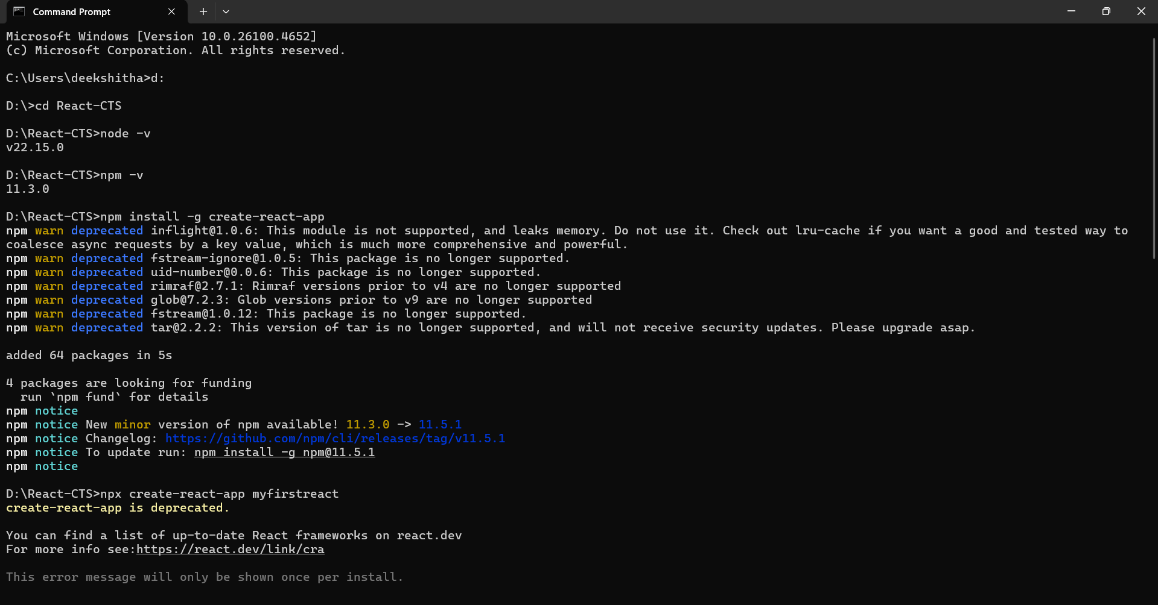

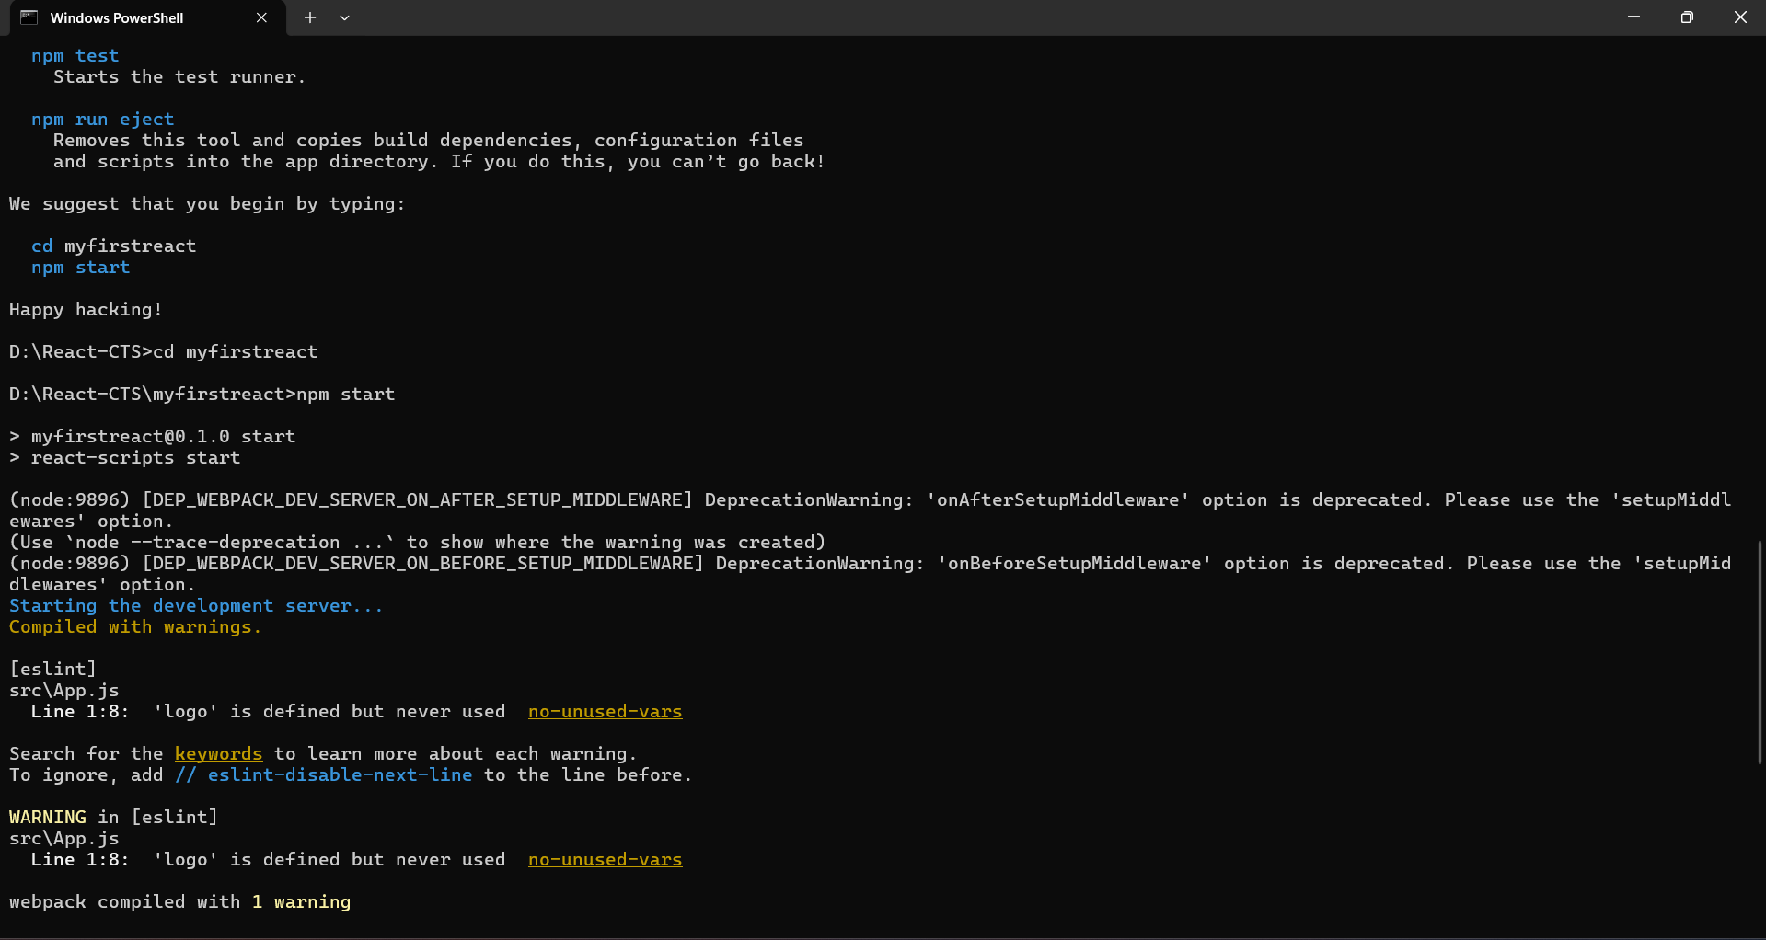

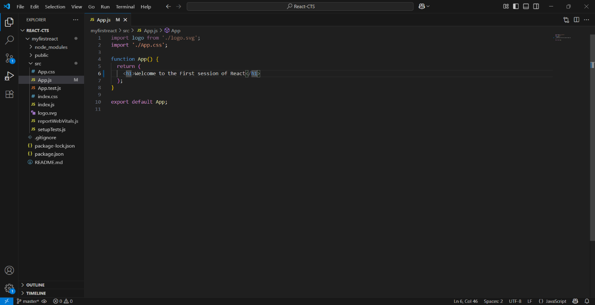

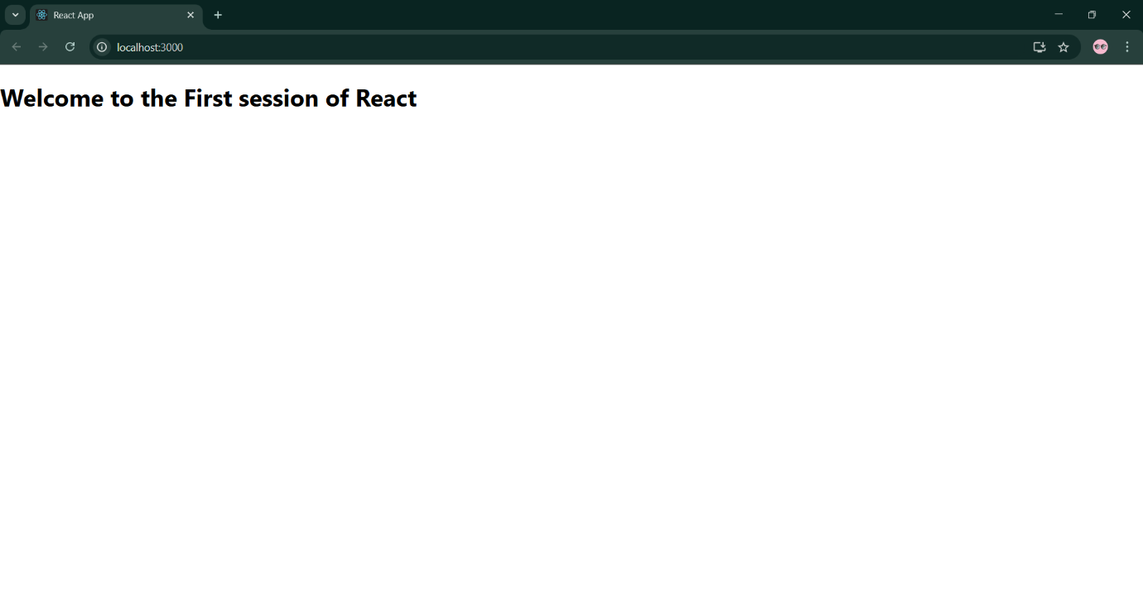

**Exercise 2 StudentApp**

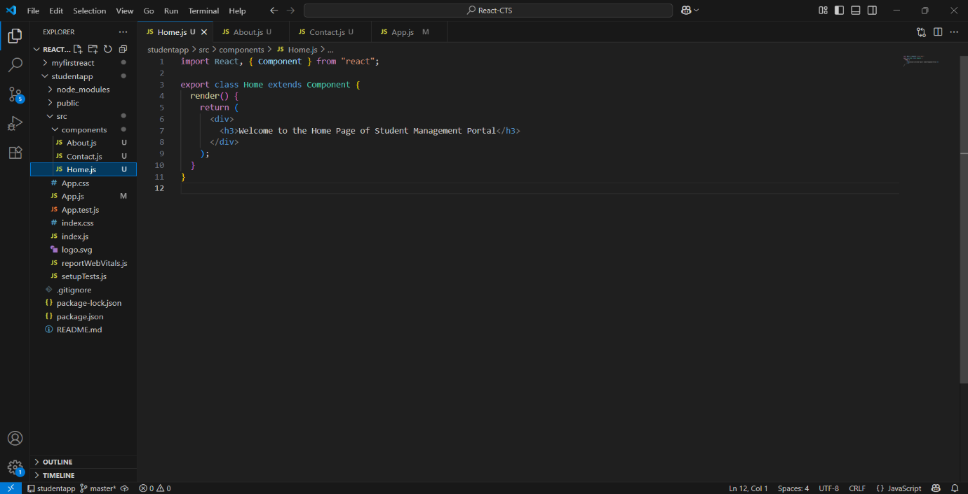

**About.js**

import React, { Component } from "react";

export class About extends Component {

  render() {

    return (

      <div>

        <h3>Welcome to the About Page of Student Management Portal</h3>

      </div>

    );

  }

}

**Contact.js**

import React, { Component } from "react";

export class Contact extends Component {

  render() {

    return (

      <div>

        <h3>Welcome to the Contact Page of Student Management Portal</h3>

      </div>

    );

  }

}

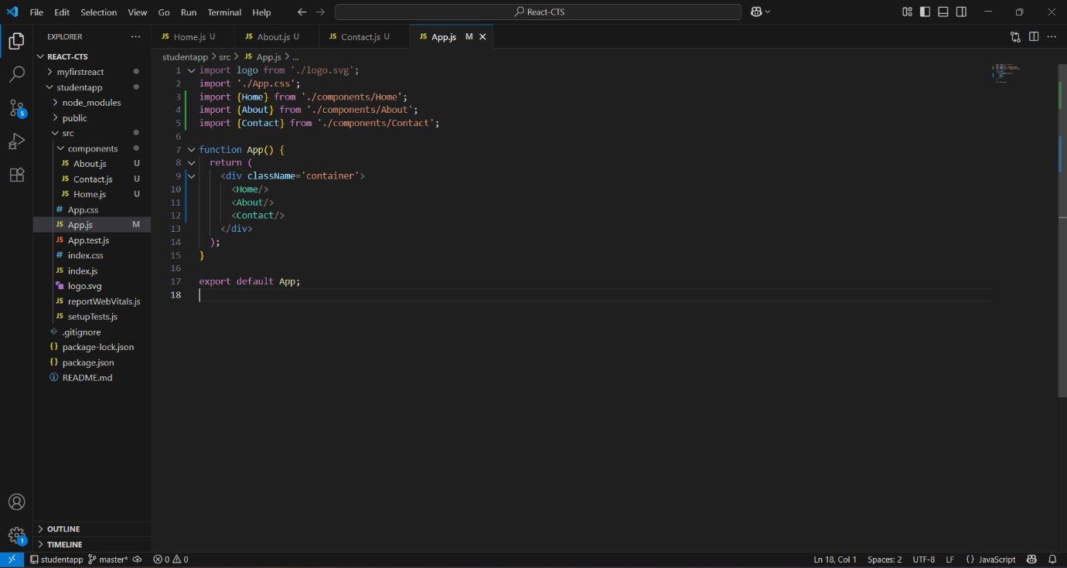

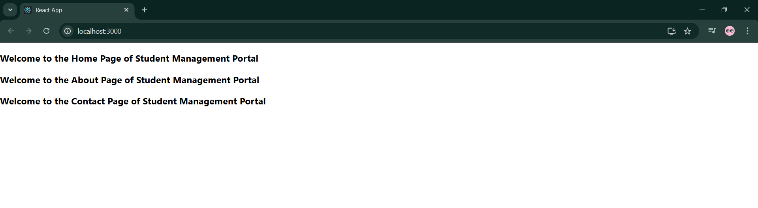

**Exercise 3 scorecalculatorapp**

**CalculateScore.js**

import './Stylesheets/mystyle.css';

const percentToDecimal = (decimal) => {

return (decimal.toFixed(2) + '%');

};

const calcScore = (total, goal) => {

return percentToDecimal(total / goal);

};

export const CalculateScore = ({ Name, School, total, goal }) => (

<div className="formatstyle">

<h1>

<font color="Brown">Student Details:</font>

</h1>

<div className="Name">

<b><span>Name: </span></b>

<span>{Name}</span>

</div>

<div className="School">

<b><span>School: </span></b>

<span>{School}</span>

</div>

<div className="Total">

<b><span>Total: </span></b>

<span>{total}</span>

<span> Marks</span>

</div>

<div className="Score">

<b>Score: </b>

<span>{calcScore(total, goal)}</span>

</div>

</div>

);

**mystyle.css**

.Name {

font-weight: 300;

color: blue;

}

.School {

color: crimson;

}

.Total {

color: darkmagenta;

}

.formatstyle {

text-align: center;

font-size: large;

}

.Score {

color: forestgreen;

}

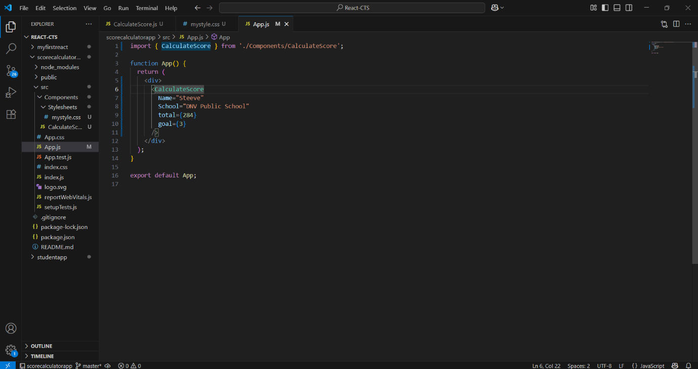

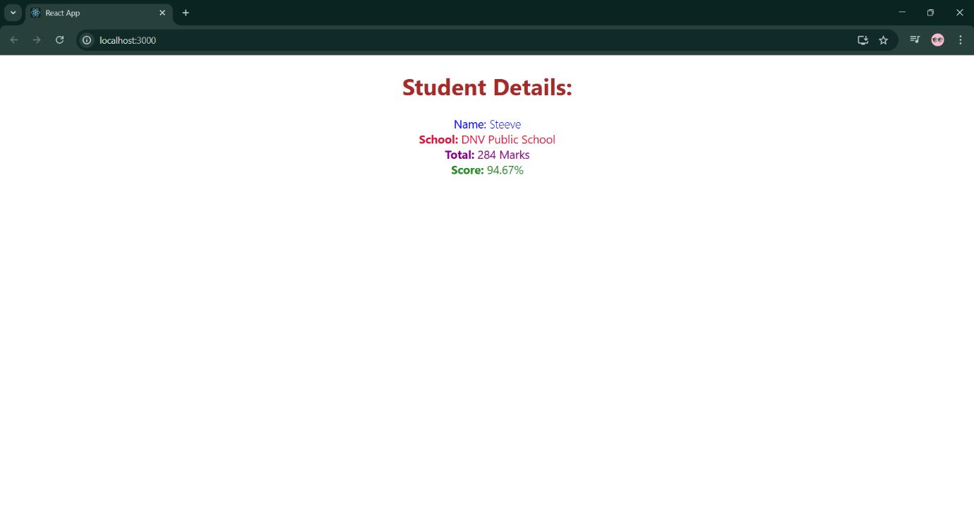

**Exercise 4 blogapp**

**Post.js**

class Post {

constructor(id, title, body) {

this.id = id;

this.title = title;

this.body = body;

}

}

export default Post;

**Posts.js**

import React from "react";

import Post from "./Post";

class Posts extends React.Component {

constructor(props) {

super(props);

this.state = {

posts: [],

error: null

};

}

loadPosts() {

fetch("https://jsonplaceholder.typicode.com/posts")

.then((response) => {

if (!response.ok) {

throw new Error("Network response was not ok");

}

return response.json();

})

.then((data) => {

const postList = data.map(

(item) => new Post(item.id, item.title, item.body)

);

this.setState({ posts: postList });

})

.catch((error) => {

this.setState({ error: error.message });

});

}

componentDidMount() {

this.loadPosts();

}

componentDidCatch(error, info) {

alert("An error occurred: " + error);

}

render() {

const { posts, error } = this.state;

if (error) {

return <p style={{ color: "red" }}>Error: {error}</p>;

}

return (

<div>

<h1>Posts</h1>

{posts.map((post) => (

<div key={post.id}>

<h3>{post.title}</h3>

<p>{post.body}</p>

</div>

))}

</div>

);

}

}

export default Posts;

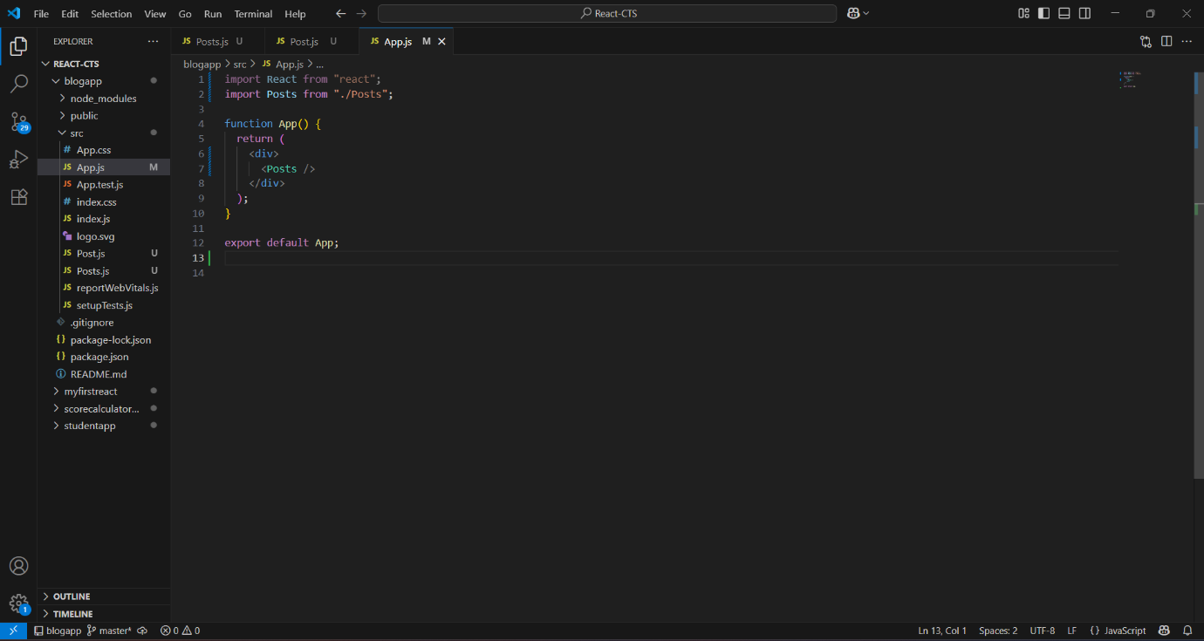

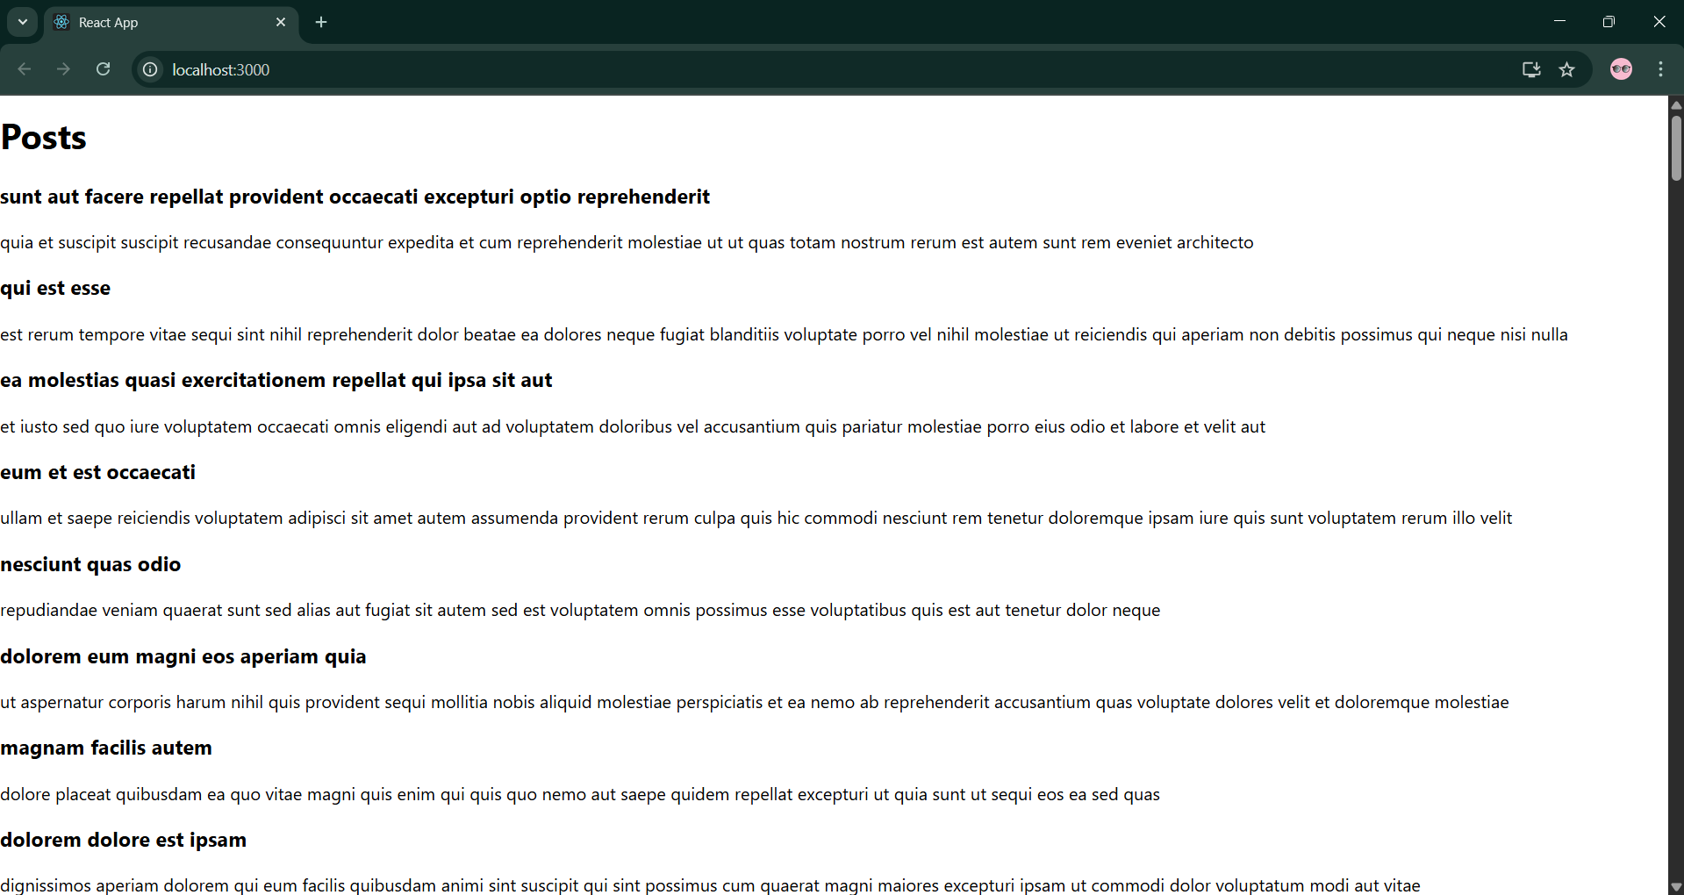

**Exercise 5 Cohorts Details**

**Cohort.js:**

import React from 'react';

import CohortDetails from './CohortDetails';

const Cohort = () => {

  const cohorts = [

{

id: 'INTADMDF10',

title: '.NET FSD',

startDate: '22-Feb-2022',

status: 'Scheduled',

coach: 'Aathma',

trainer: 'Jojo Jose'

},

{

id: 'ADM21JF014',

title: 'Java FSD',

startDate: '10-Sep-2021',

status: 'Ongoing',

coach: 'Apoorv',

trainer: 'Elisa Smith'

},

{

id: 'CDBJF21025',

title: 'Java FSD',

startDate: '24-Dec-2021',

status: 'Ongoing',

coach: 'Aathma',

trainer: 'John Doe'

}

  ];

  return (

    <div>

      <h2>Cohort Dashboard</h2>

      {cohorts.map((cohort, index) => (

        <CohortDetails key={index} cohort={cohort} />

      ))}

    </div>

  );

};

export default Cohort;

**Cohortdetails.js:**

import React from 'react';

import styles from './CohortDetails.module.css';

const CohortDetails = ({ cohort }) => {

const { id, title, startDate, status, coach, trainer } = cohort;

const titleStyle = {

color: status.toLowerCase() === 'ongoing' ? 'green' : 'blue'

};

return (

<div className={styles.box}>

<h3 style={titleStyle}>{id} - {title}</h3>

<dl>

<dt>Started On:</dt>

<dd>{startDate}</dd>

<dt>Current Status:</dt>

<dd>{status}</dd>

<dt>Coach:</dt>

<dd>{coach}</dd>

<dt>Trainer:</dt>

<dd>{trainer}</dd>

</dl>

</div>

);

};

export default CohortDetails;

**CohortDetails.module.css:**

.box {

  width: 300px;

  display: inline-block;

  margin: 10px;

  padding: 10px 20px;

  border: 1px solid black;

  border-radius: 10px;

}

dt

{

  font-weight: 500;

}

**App.js:**

import logo from './logo.svg';

import './App.css';

import { CohortsData} from './Cohort'

import CohortDetails from './CohortDetails';

function App() {

  return (

  <div>

    <h1>Cohorts Details</h1>

    {CohortsData.map(cohort => <CohortDetails cohort={cohort}/>)}

  </div>

  );

}

export default App;

**Output**

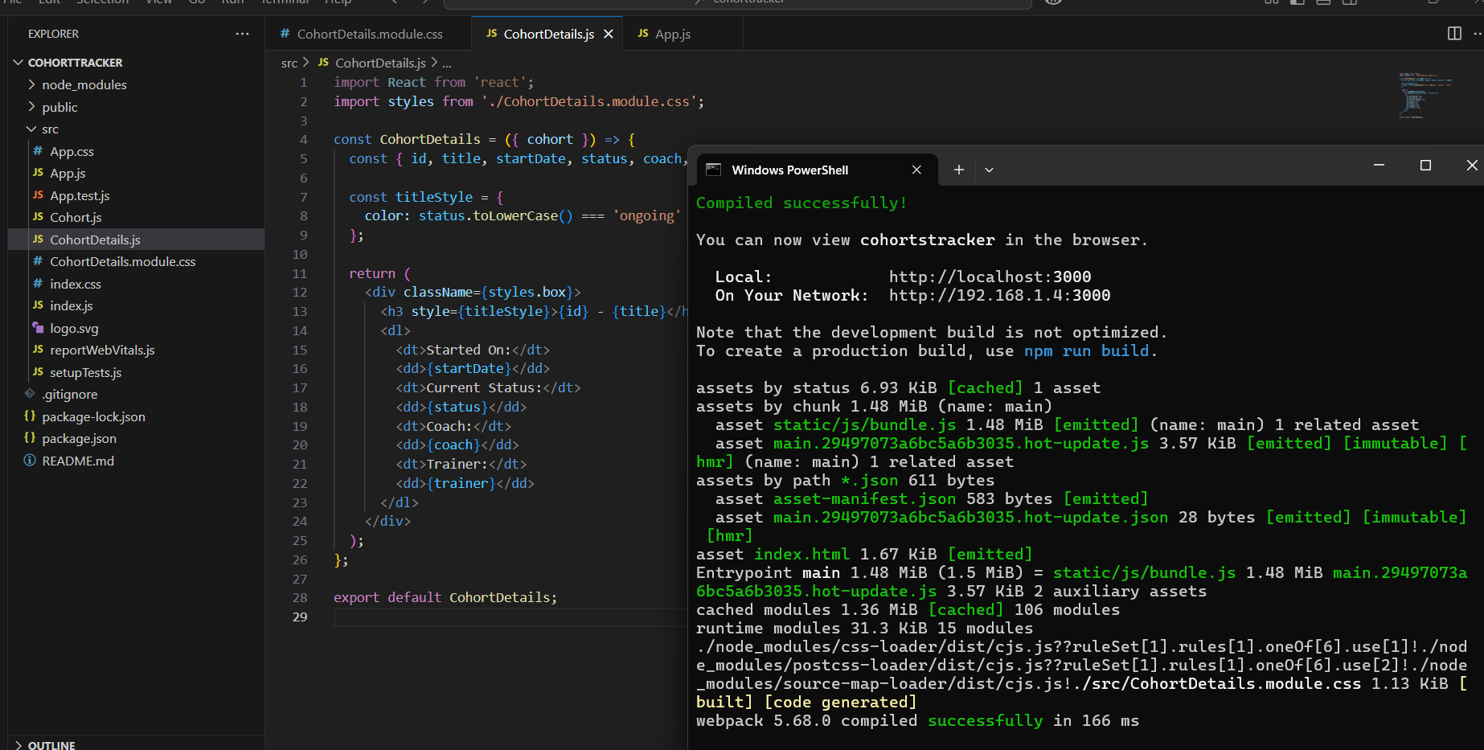

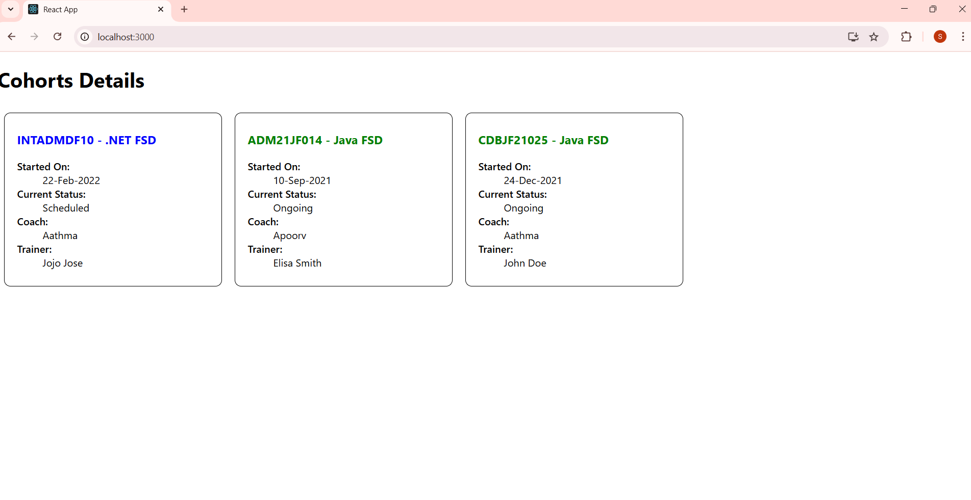

**Exercise 6 TrainersApp**

**Trainer.js**

class Trainer {

constructor(trainerId, name, email, phone, technology, skills) {

this.trainerId = trainerId;

this.name = name;

this.email = email;

this.phone = phone;

this.technology = technology;

this.skills = skills;

}

}

export default Trainer;

**TrainersMock.js**

import Trainer from "./Trainer";

const trainersMock = [

new Trainer(

't-syed',

'Syed Khaleelullah',

'khaleelullah@cognizant.com',

'97676516962',

'.NET',

['C#', 'SQL Server', 'React', '.NET Core']

),

new Trainer(

't-jojo',

'Jojo Jose',

'jojo@cognizant.com',

'9897199231',

'Java',

['Java', 'JSP', 'Angular', 'Spring']

),

new Trainer(

't-elisa',

'Elisa Jones',

'elisa@cognizant.com',

'9871121235',

'Python',

['Python', 'Django', 'Angular']

),

];

export default trainersMock;

**TrainerList.js**

import React from "react";

import { Link } from "react-router-dom";

function TrainerList({ trainers }) {

return (

<div>

<h3>Trainers List</h3>

<ul>

{trainers.map((trainer) => (

<li key={trainer.trainerId}>

<Link to={`/trainers/${trainer.trainerId}`}>{trainer.name}</Link>

</li>

))}

</ul>

</div>

);

}

export default TrainerList;

**TrainerDetails.js**

import React from "react";

import { useParams } from "react-router-dom";

import trainersMock from "./TrainersMock";

function TrainerDetails() {

const { id } = useParams();

const trainer = trainersMock.find((t) => t.trainerId === id);

if (!trainer) return <p>Trainer not found</p>;

return (

<div>

<h3>Trainers Details</h3>

<p>{trainer.name} ({trainer.technology})</p>

<p>{trainer.email}</p>

<p>{trainer.phone}</p>

<ul>

{trainer.skills.map((skill, index) => (

<li key={index}>{skill}</li>

))}

</ul>

</div>

);

}

export default TrainerDetails;

**Home.js**

import React from "react";

function Home() {

return <h2>Welcome to My Academy trainers page</h2>;

}

export default Home;

**App.js**

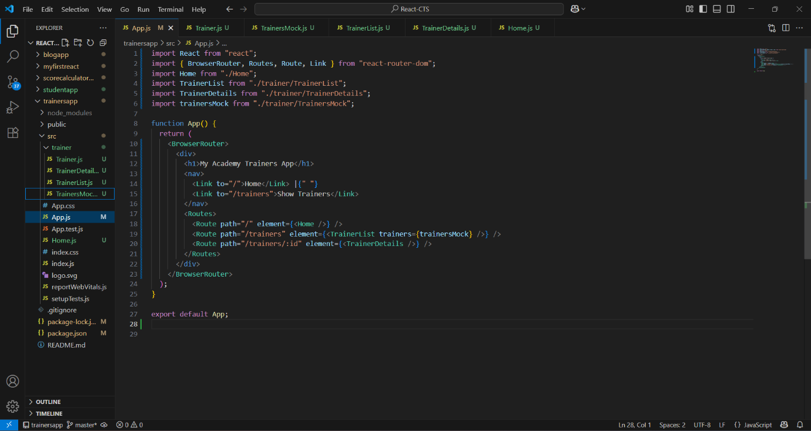

**Output**

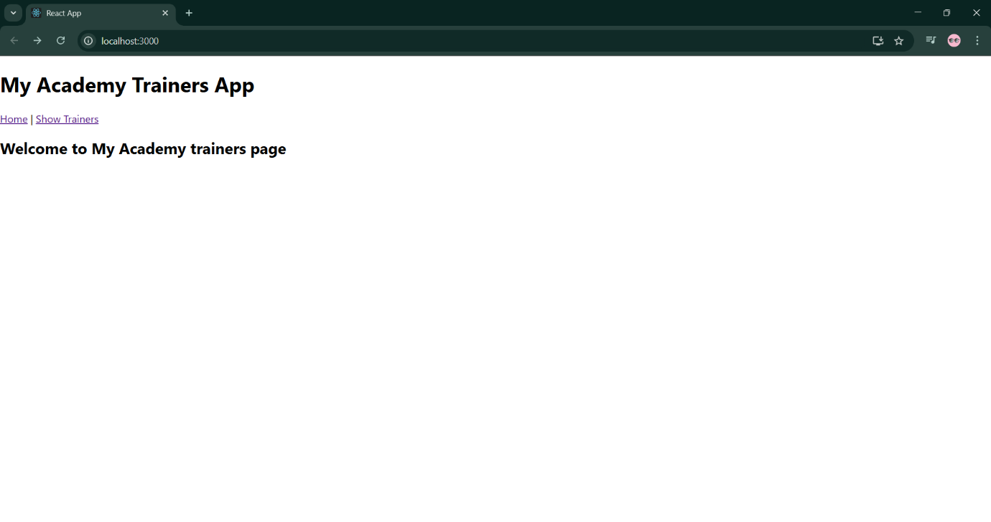

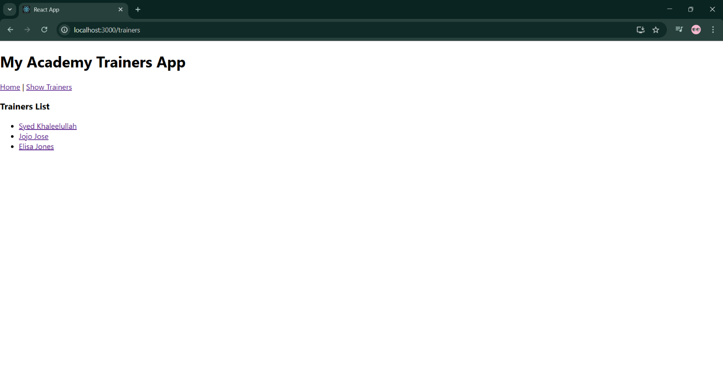

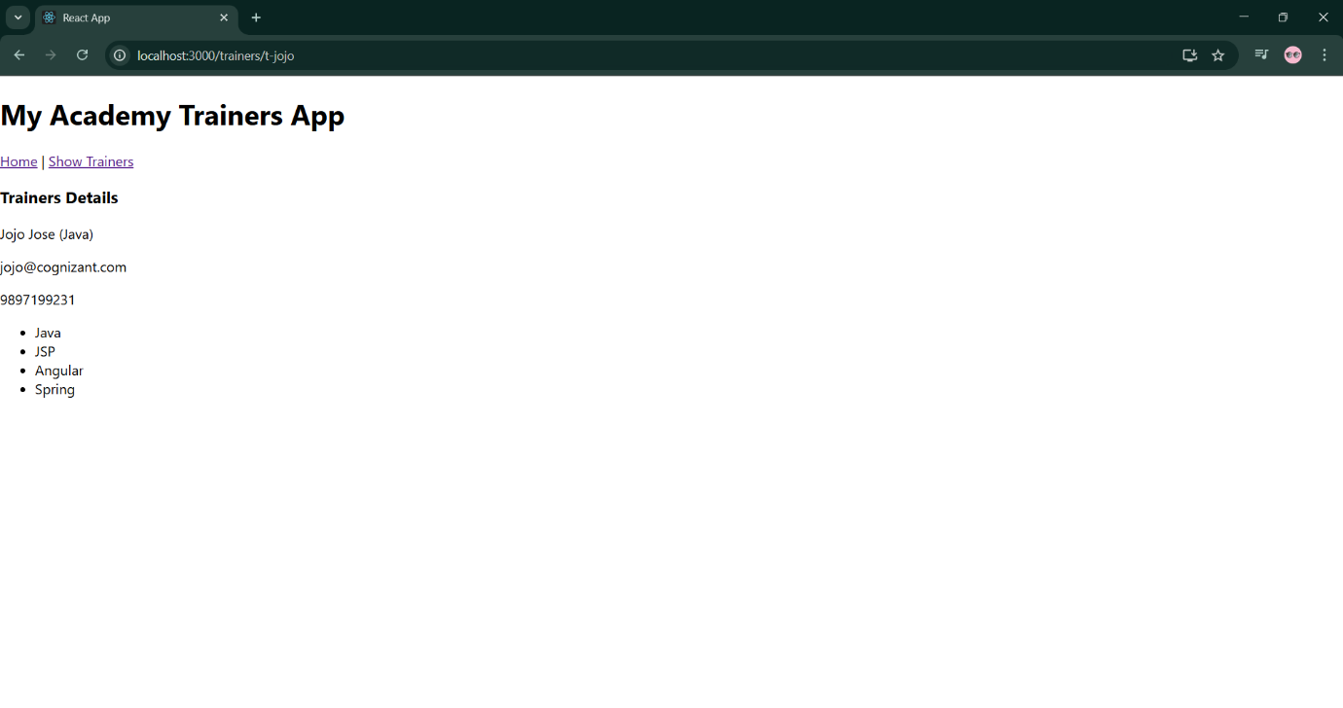

**Exercise 7 shoppingapp**

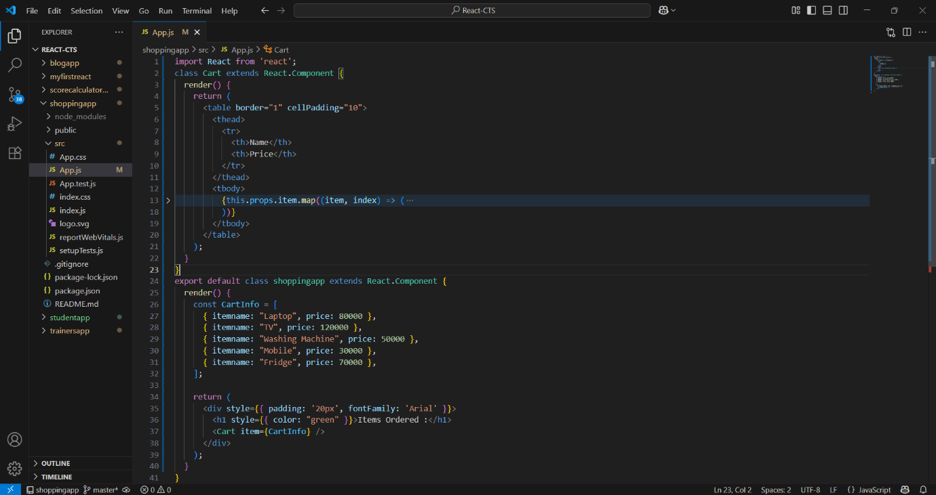

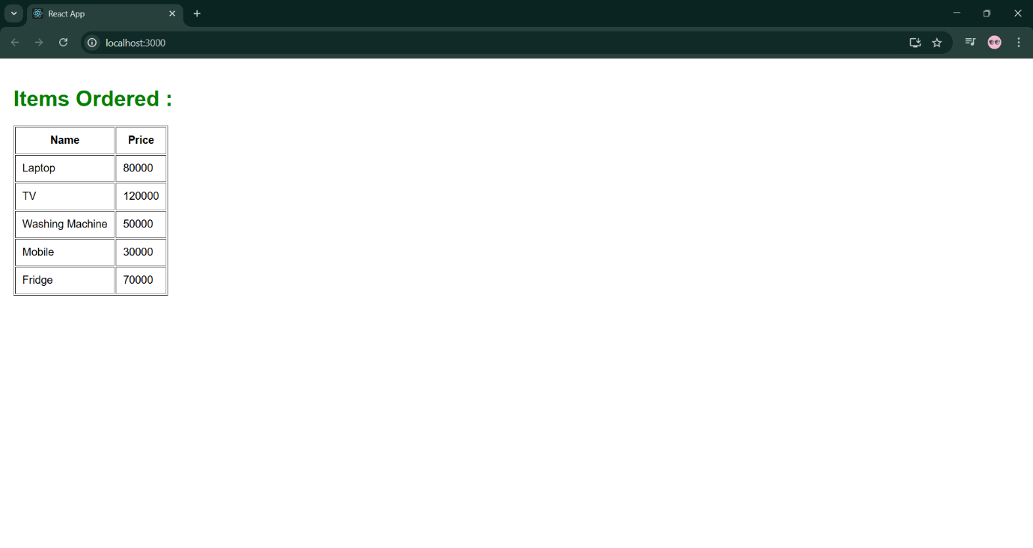

**Exercise 8 counterapp**

**App.js**

import React from 'react';

import './App.css';

class CountPeople extends React.Component {

  constructor() {

    super();

    this.state = {

      entrycount: 0,

      exitcount: 0

    };

  }

  updateEntry = () => {

    this.setState((prevState) => ({

      entrycount: prevState.entrycount + 1

    }));

  };

  updateExit = () => {

    this.setState((prevState) => ({

      exitcount: prevState.exitcount + 1

    }));

  };

  render() {

    return (

      <div style={{ padding: '30px', textAlign: 'center' }}>

        <h1>People Counter</h1>

        <button onClick={this.updateEntry} style={{ marginRight: '20px', padding: '10px' }}>

          Login ➜

        </button>

        <button onClick={this.updateExit} style={{ padding: '10px' }}>

          Exit ➜

        </button>

        <div style={{ marginTop: '30px', fontSize: '20px' }}>

          <p>People Entered: {this.state.entrycount}</p>

          <p>People Left: {this.state.exitcount}</p>

        </div>

      </div>

    );

  }

}

function App() {

  return (

    <div className="App">

      <CountPeople />

    </div>

  );

}

export default App;

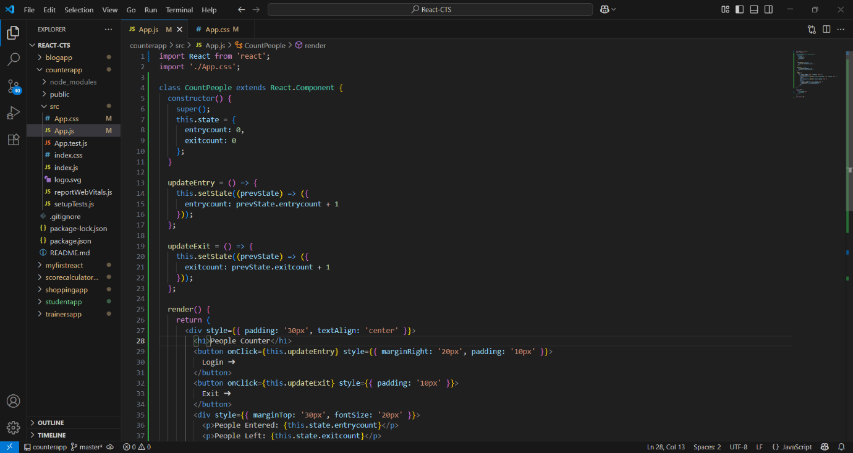

**Output**

