**Week 7 React HandsOn**

**Exercise 9 cricketapp**

**ListofPlayers.js**

import React from 'react';

const ListofPlayers = () => {

const players =

{ name: "Sachin", score: 91 },

{ name: "Dhoni", score: 66 },

{ name: "Yuvraj", score: 68 },

{ name: "Virat", score: 89 },

{ name: "Rohit", score: 58 },

{ name: "Raina", score: 74 },

{ name: "Smith", score: 90 },

{ name: "Stokes", score: 55 },

{ name: "Babar", score: 88 },

{ name: "Warner", score: 45 },

{ name: "Maxwell", score: 72 },

];

const below70 = players.filter(p => p.score < 70);

return (

<div>

<h2>All Players (Indian + International)</h2>

<ul>

{players.map((player, index) => (

<li key={index}>{player.name} - {player.score}</li>

))}

</ul>

<h2>Players Scoring Below 70</h2>

<ul>

{below70.map((player, index) => (

<li key={index}>{player.name} - {player.score}</li>

))}

</ul>

</div>

);

};

export default ListofPlayers;

**IndianPlayers.js**

import React from 'react';

const IndianPlayers = () => {

const oddPlayers = [

{ label: "First", name: "Sachin1" },

{ label: "Third", name: "Virat3" },

{ label: "Fifth", name: "Yuvraj5" },

];

const evenPlayers = [

{ label: "Second", name: "Dhoni2" },

{ label: "Fourth", name: "Rohit4" },

{ label: "Sixth", name: "Raina6" },

];

const mergedPlayers = [

"First Player",

"Second Player",

"Third Player",

"Fourth Player",

"Fifth Player",

"Sixth Player",

];

return (

<div>

<h2>Odd Players</h2>

<ul>

{oddPlayers.map((player, index) => (

<li key={index}>{player.label} : {player.name}</li>

))}

</ul>

<h2>Even Players</h2>

<ul>

{evenPlayers.map((player, index) => (

<li key={index}>{player.label} : {player.name}</li>

))}

</ul>

<h2>List of Indian Players Merged:</h2>

<ul>

{mergedPlayers.map((player, index) => (

<li key={index}>Mr. {player}</li>

))}

</ul>

</div>

);

};

export default IndianPlayers;

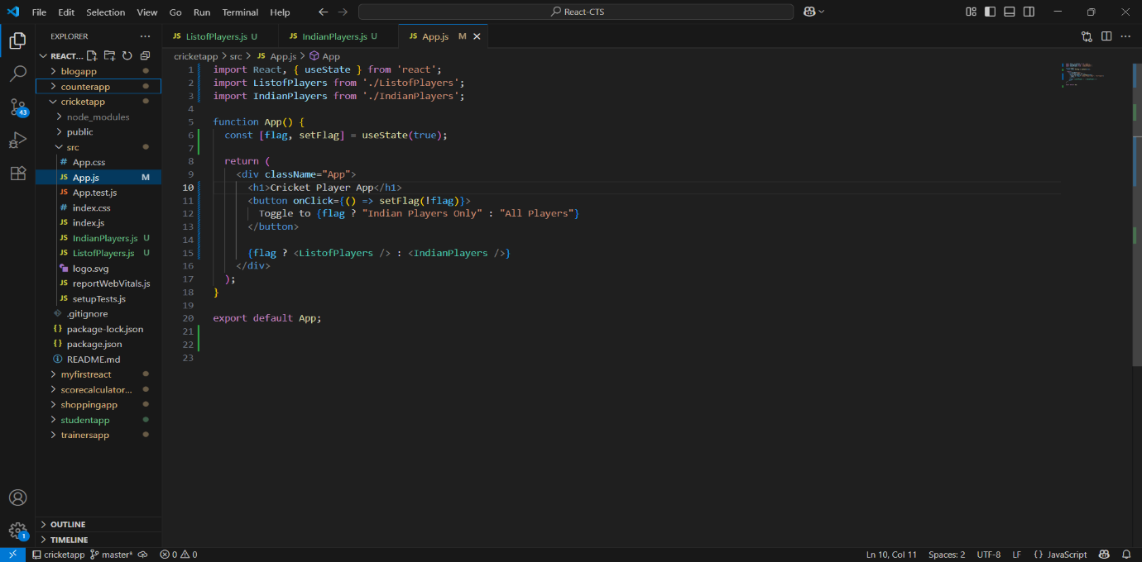

**Output**

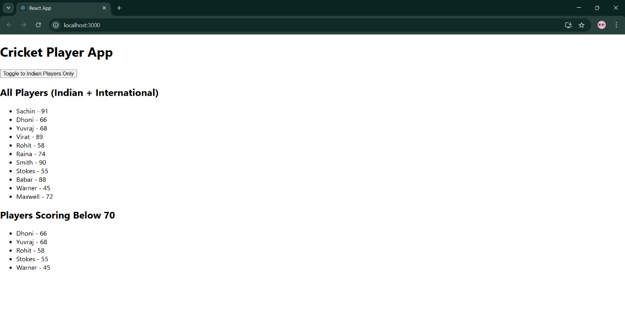

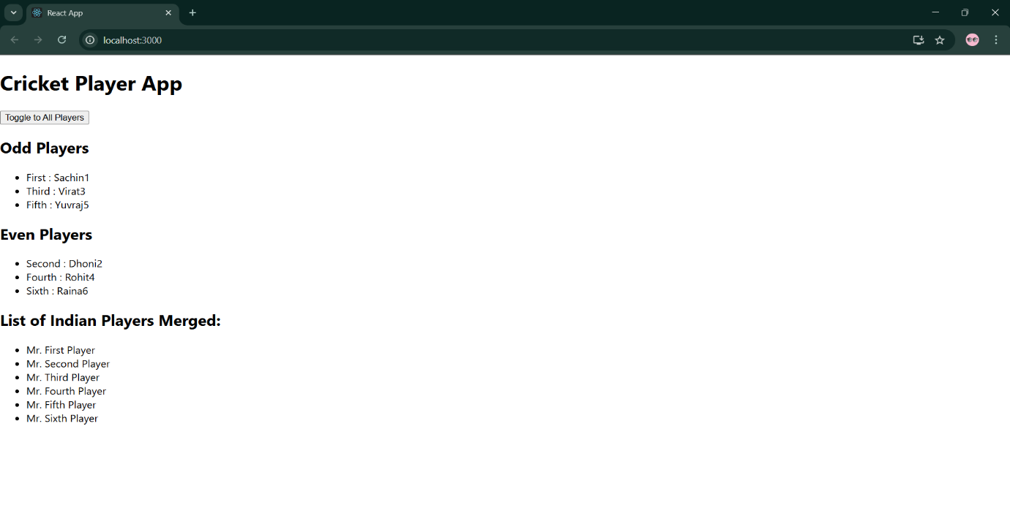

**Exercise 10 officespacerentalapp**

**App.js**

import React from 'react';

function App() {

  const offices = [

    {

      name: "Skyline Tower",

      rent: 55000,

      address: "Bangalore",

      image: "off3.jpg"

    },

    {

      name: "Ocean View",

      rent: 65000,

      address: "Chennai",

      image: "imageoff2.jpg"

    },

    {

      name: "Green Square",

      rent: 47000,

      address: "Hyderabad",

      image: "image1.jpg"

    }

  ];

  const heading = <h1 style={{ textAlign: 'center' }}>🏢 Office Space Rental App</h1>;

  return (

    <div>

      {heading}

      <div style={{ display: 'flex', flexWrap: 'wrap', justifyContent: 'center' }}>

        {offices.map((office, index) => (

          <div key={index} style={{

            border: '1px solid #ccc',

            borderRadius: '10px',

            padding: '20px',

            margin: '15px',

            width: '300px',

            boxShadow: '2px 2px 12px rgba(0,0,0,0.1)'

          }}>

            <img src={office.image} alt={office.name} style={{ width: '100%', height: '200px', borderRadius: '10px' }} />

            <h2>{office.name}</h2>

            <p>

              <b>Rent: </b>

              <span style={{ color: office.rent < 60000 ? 'red' : 'green' }}>

                ₹{office.rent}

              </span>

            </p>

            <p><b>Address:</b> {office.address}</p>

          </div>

        ))}

      </div>

    </div>

  );

}

export default App;

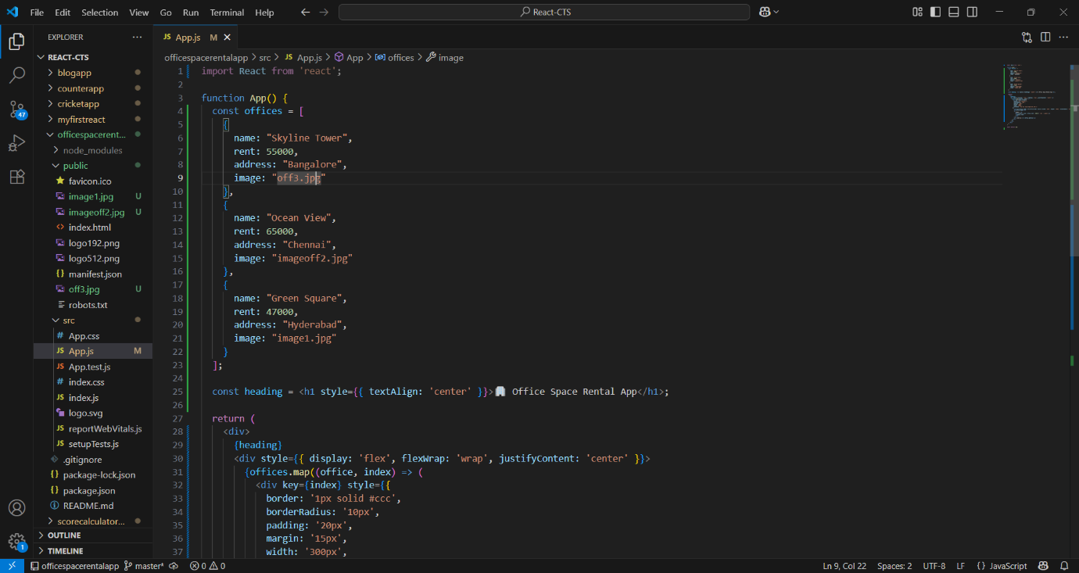

**Output**

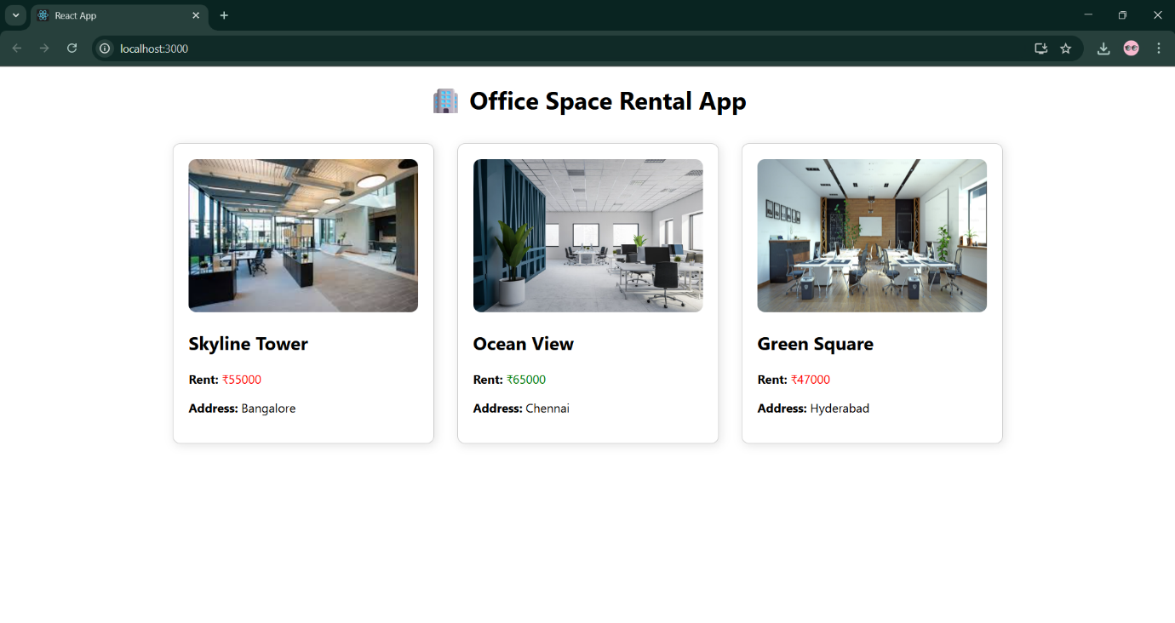**Exercise 11 eventexamplesapp**

**App.js**

import React, { Component } from 'react';

import CurrencyConvertor from './CurrencyConvertor';

class App extends Component {

  constructor(props) {

    super(props);

    this.state = {

      count: 0

    };

  }

  increment = () => {

    this.setState(prevState => ({ count: prevState.count + 1 }));

    alert("Hello! Member");

  };

  decrement = () => {

    this.setState(prevState => ({ count: prevState.count - 1 }));

  };

  sayWelcome = (msg) => {

    alert(msg);

  };

  handleSyntheticEvent = () => {

    alert("I was clicked");

  };

  render() {

    return (

      <div style={{ padding: '30px', textAlign: 'center' }}>

        <h1>React Event Examples App</h1>

        <h2>Counter: {this.state.count}</h2>

        <button onClick={this.increment}>Increment</button>{" "}

        <button onClick={this.decrement}>Decrement</button>

        <hr />

        <button onClick={() => this.sayWelcome("Welcome")}>Say Welcome</button>

        <hr />

        <button onClick={this.handleSyntheticEvent}>OnPress</button>

        <hr />

        <CurrencyConvertor />

      </div>

    );

  }

}

export default App;

**CurrencyConverter.js**

class CurrencyConvertor extends Component {

  constructor(props) {

    super(props);

    this.state = {

      rupees: '',

      euros: ''

    };

  }

  handleChange = (e) => {

    this.setState({ rupees: e.target.value });

  };

  handleSubmit = (e) => {

    e.preventDefault();

    const euro = this.state.rupees / 90; // Assume 1 Euro = ₹90

    this.setState({ euros: euro.toFixed(2) });

  };

  render() {

    return (

      <div>

        <h2>Currency Convertor</h2>

        <form onSubmit={this.handleSubmit}>

          <input

            type="number"

            placeholder="Enter amount in ₹"

            value={this.state.rupees}

            onChange={this.handleChange}

          />

          <button type="submit">Convert</button>

        </form>

        <p>Amount in Euro: € {this.state.euros}</p>

      </div>

    );

  }

}

export default CurrencyConvertor;

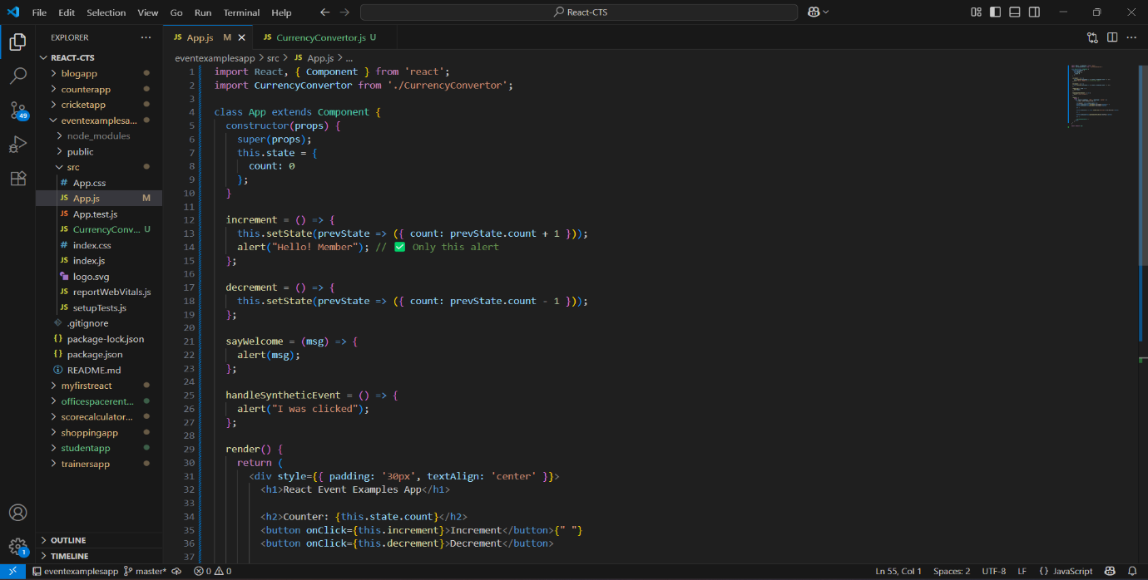

**Output**

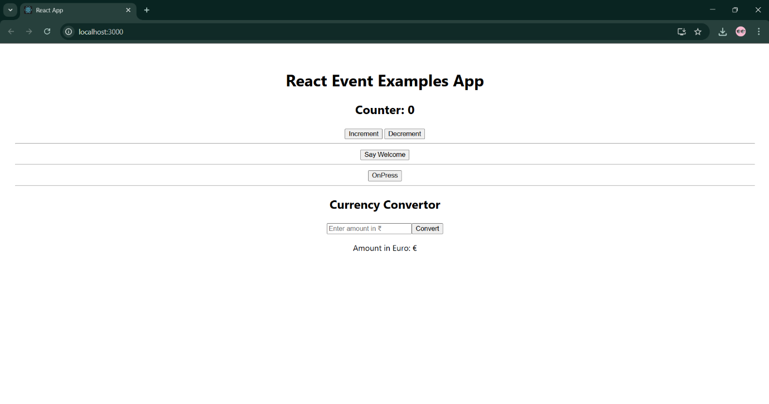

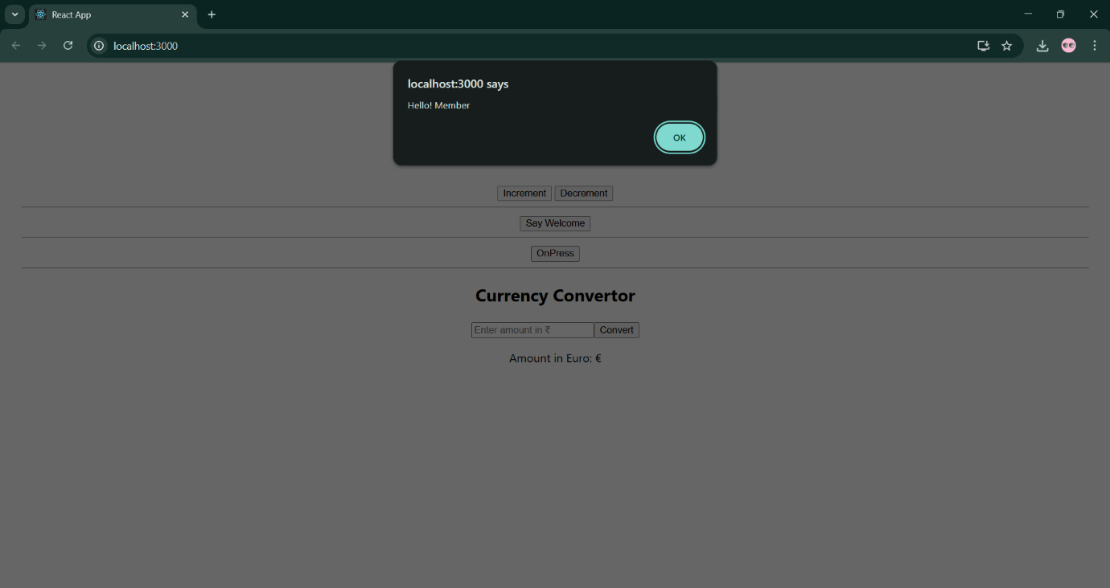

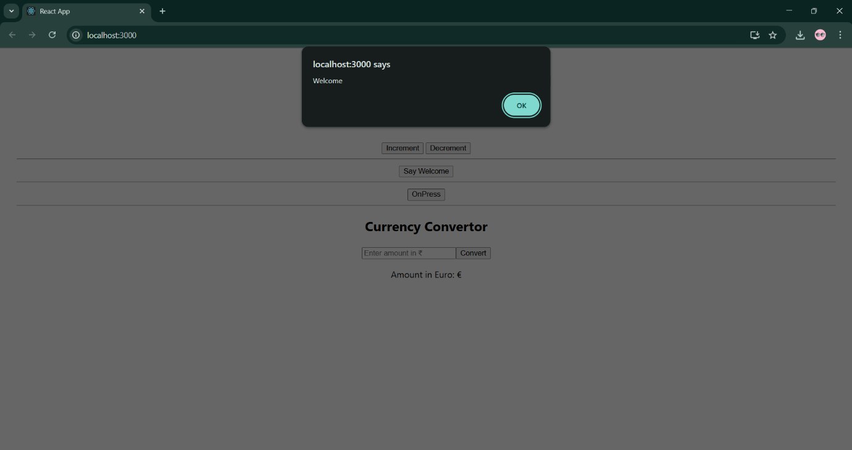

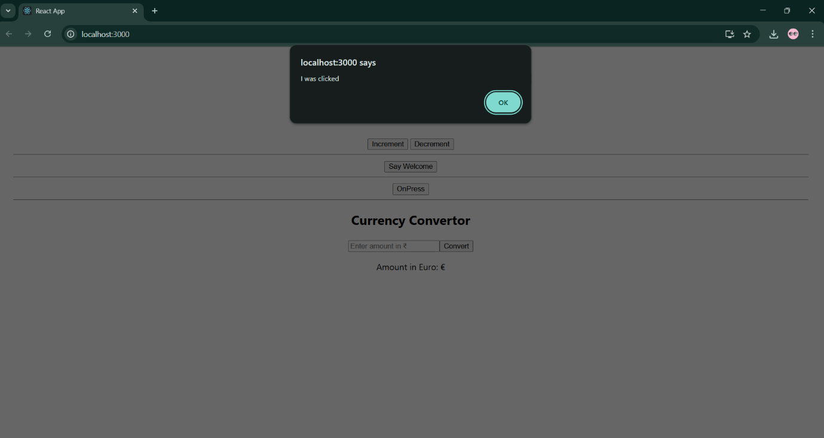

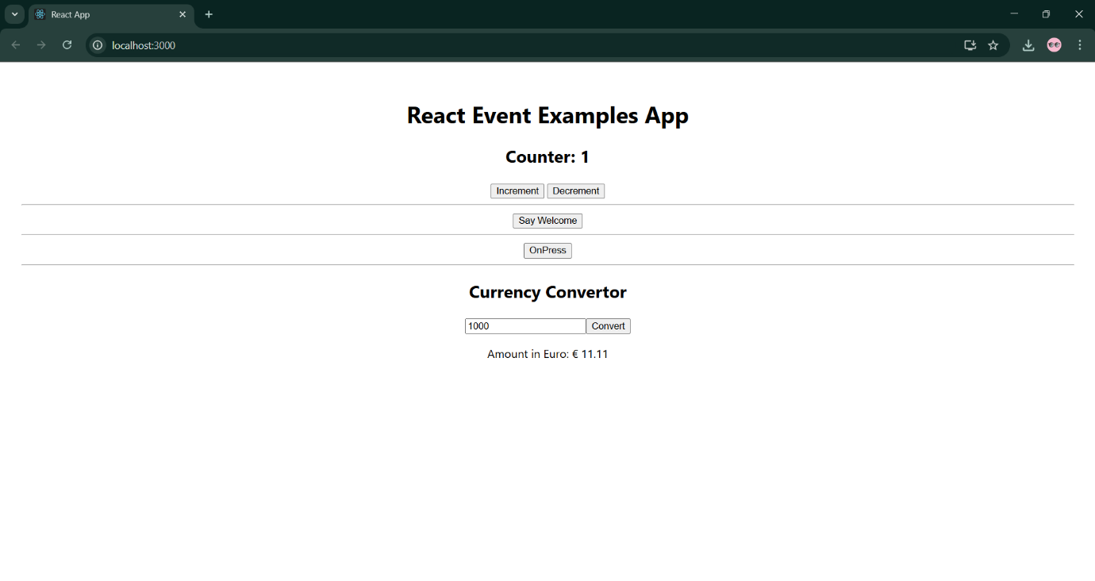

**Exercise 12 ticketbookingapp**

**App.js**

import React, { Component } from 'react';

class App extends Component {

constructor(props) {

super(props);

this.state = {

isLoggedIn: false

};

}

handleLogin = () => {

this.setState({ isLoggedIn: true });

};

handleLogout = () => {

this.setState({ isLoggedIn: false });

};

render() {

let pageContent;

const flightDetails = (

<div>

<h2>Flight Details</h2>

<ul style={{ listStyleType: "none", padding: 0 }}>

<li>Flight No: AI203</li>

<li>From: Chennai</li>

<li>To: Delhi</li>

<li>Time: 10:30 AM</li>

</ul>

</div>

);

if (this.state.isLoggedIn) {

pageContent = (

<div>

<h1>Welcome, User! </h1>

{flightDetails}

<button style={{ backgroundColor: 'green', color: 'white' }}>

Book Ticket

</button>

<br /><br />

<button onClick={this.handleLogout}>Logout</button>

</div>

);

} else {

pageContent = (

<div>

<h1>Welcome, Guest! </h1>

{flightDetails}

<p>Please login to book your ticket.</p>

<button onClick={this.handleLogin}>Login</button>

</div>

);

}

return (

<div style={{ padding: '30px', fontFamily: 'Arial', textAlign: 'center' }}>

<h1>Ticket Booking App</h1>

{pageContent} {}

</div>

);

}

}

export default App;

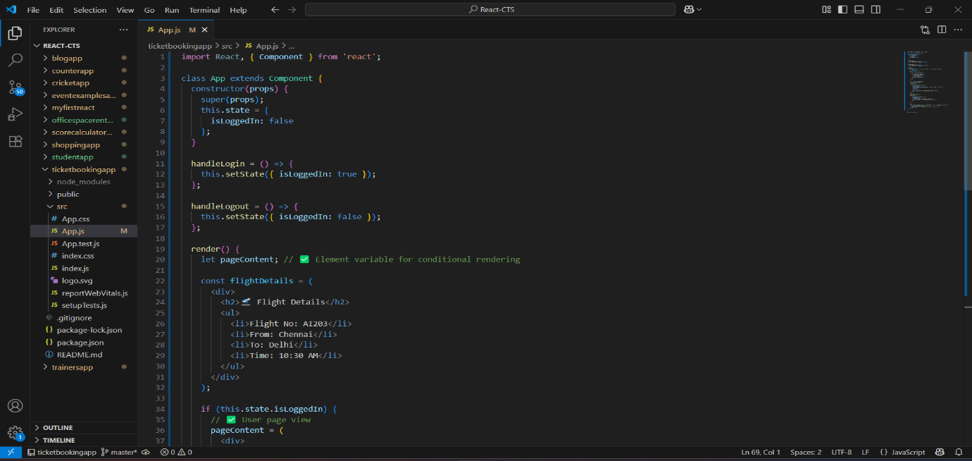

**Output:**

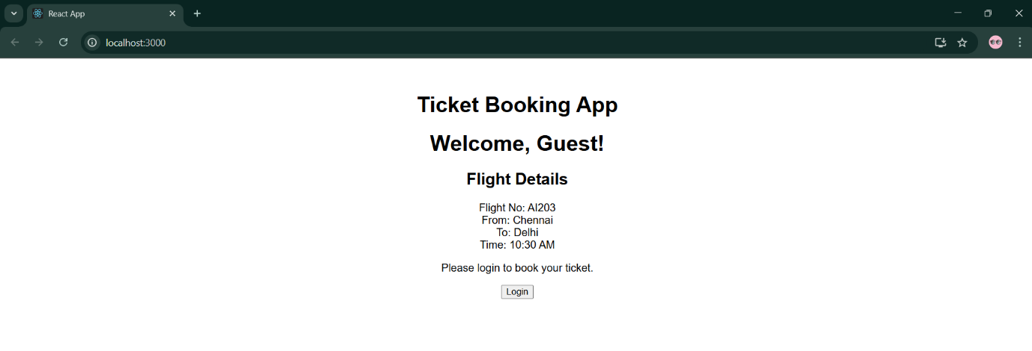

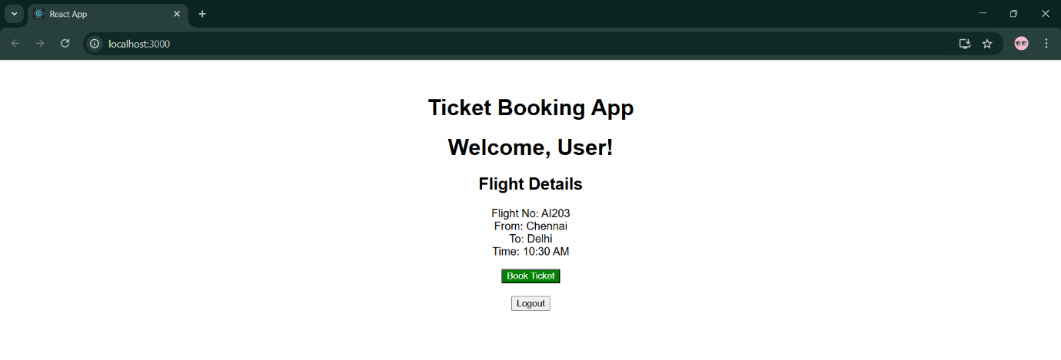

**Exercise 13 bloggerapp**

**BookDetails.js**

import React from 'react';

function BookDetails() {

return (

<div>

<h2>Book Details</h2>

<ul>

<li>Name: React Essentials</li>

<li>Author: John Doe</li>

<li>Price: ₹499</li>

</ul>

</div>

);

}

export default BookDetails;

**BlogDetails.js**

import React from 'react';

function BlogDetails() {

return (

<div>

<h2>Blog Details</h2>

<ul>

<li>Title: Learning React</li>

<li>Author: Jane Smith</li>

<li>Published: Aug 2025</li>

</ul>

</div>

);

}

export default BlogDetails;

**CourseDetails.js**

import React from 'react';

function CourseDetails() {

return (

<div>

<h2>Course Details</h2>

<ul>

<li>Course Name: React Mastery</li>

<li>Instructor: Alex Kumar</li>

<li>Duration: 6 weeks</li>

</ul>

</div>

);

}

export default CourseDetails;

**App.js**

import React, { useState } from 'react';

import BookDetails from './BookDetails';

import BlogDetails from './BlogDetails';

import CourseDetails from './CourseDetails';

function App() {

const [selected, setSelected] = useState('');

// 1. if-else conditional

let content = null;

if (selected === 'book') {

content = <BookDetails />;

} else if (selected === 'blog') {

content = <BlogDetails />;

} else if (selected === 'course') {

content = <CourseDetails />;

}

return (

<div style={{ padding: '30px', textAlign: 'center' }}>

<h1>Blogger App</h1>

<div style={{ marginBottom: '20px' }}>

<button onClick={() => setSelected('book')}>Show Book</button>{" "}

<button onClick={() => setSelected('blog')}>Show Blog</button>{" "}

<button onClick={() => setSelected('course')}>Show Course</button>{" "}

<button onClick={() => setSelected('')}>Clear</button>

</div>

{/* 2. Rendering using element variable */}

{content}

{/* 3. Ternary conditional rendering */}

{selected === '' ? <p>Please select an option above.</p> : null}

{/* 4. Short-circuit rendering */}

{selected === 'book' && <p>You selected Book </p>}

</div>

);

}

export default App;

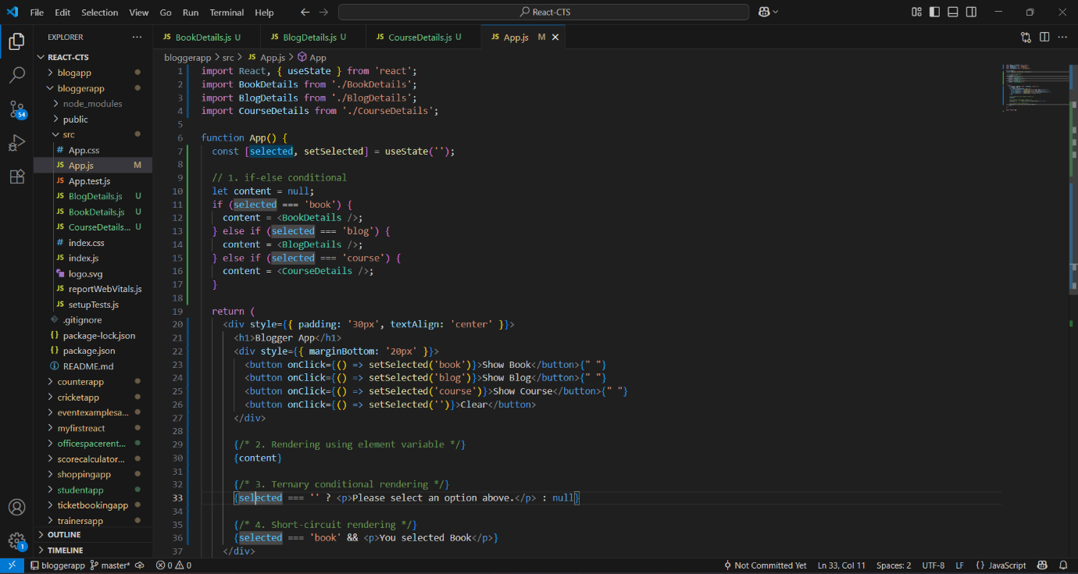

**Output:**

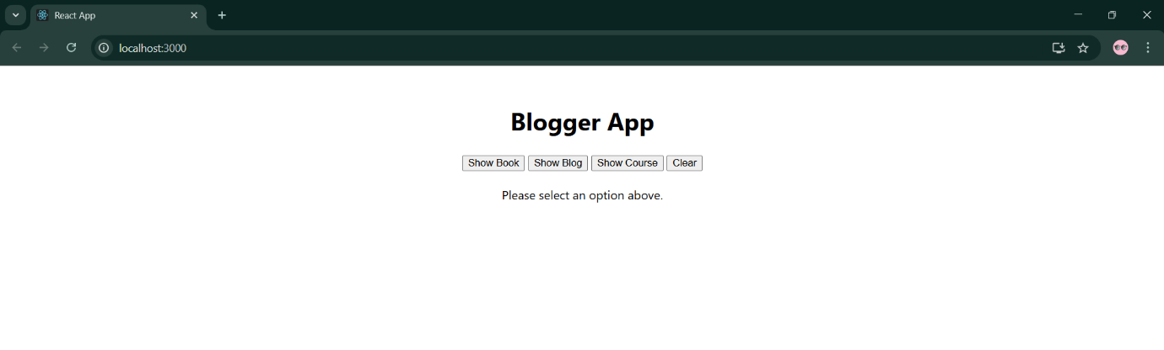

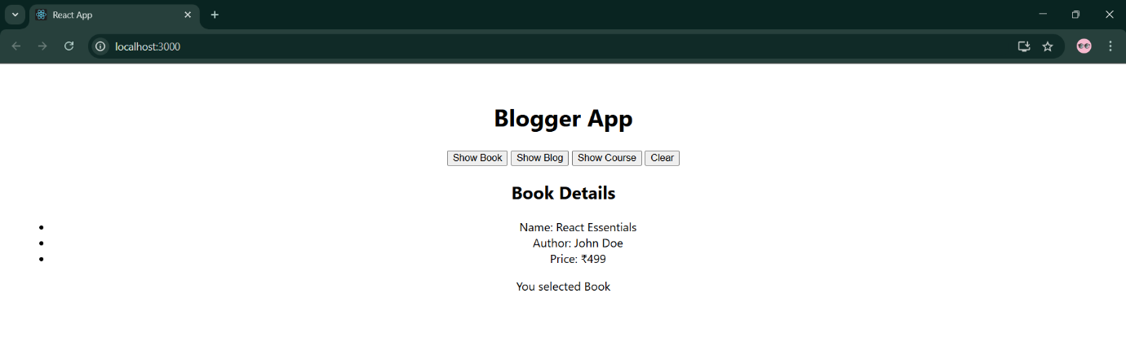

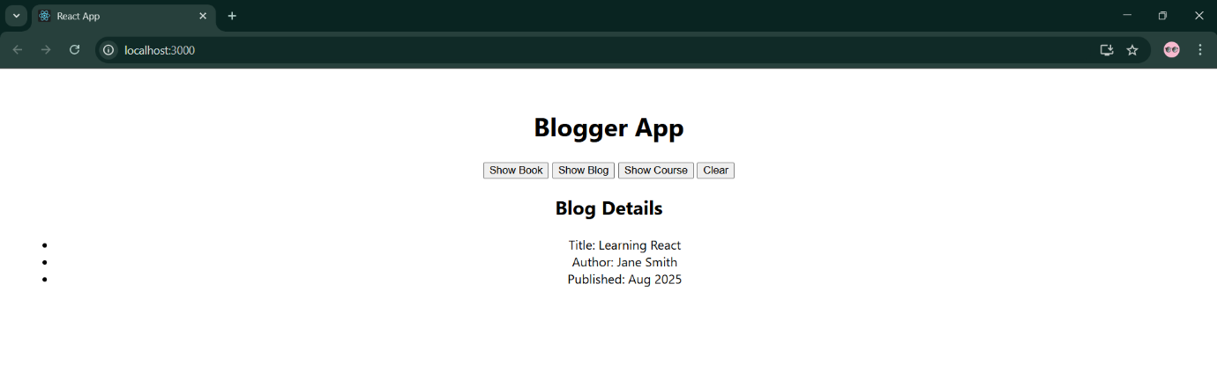

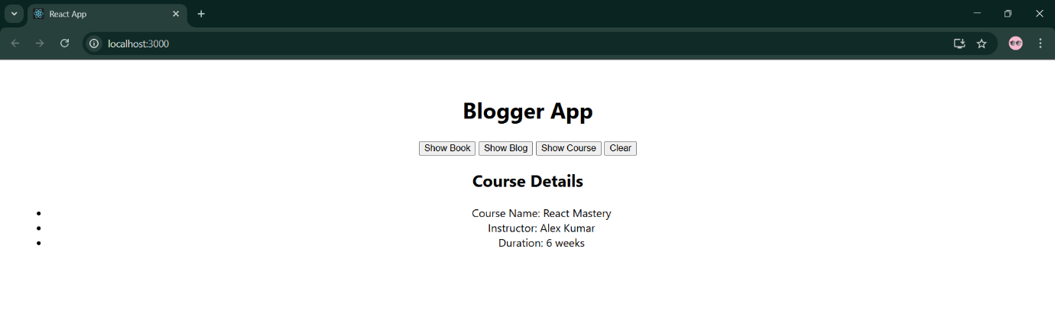

**Exercise 14 employeesapp**

**ThemeContext.js**

import React from 'react';

const ThemeContext = React.createContext('light'); // default theme

export default ThemeContext;

**EmployeesList.js**

import React from 'react';

import EmployeeCard from './EmployeeCard';

function EmployeesList() {

const employees = [

{ id: 1, name: 'Deekshitha', role: 'Frontend Dev' },

{ id: 2, name: 'Kiran', role: 'Backend Dev' },

{ id: 3, name: 'Lakshmi', role: 'QA Engineer' },

];

return (

<div>

<h2>Employees</h2>

{employees.map(emp => (

<EmployeeCard key={emp.id} employee={emp} />

))}

</div>

);

}

export default EmployeesList;

**EmployeeCard.js**

import React, { useContext } from 'react';

import ThemeContext from './ThemeContext';

function EmployeeCard({ employee }) {

const theme = useContext(ThemeContext);

const buttonClass =

theme === 'light'

? { backgroundColor: 'white', color: 'black' }

: { backgroundColor: 'black', color: 'white' };

return (

<div

style={{

border: '1px solid gray',

margin: '10px',

padding: '10px',

borderRadius: '8px',

}}

>

<h3>{employee.name}</h3>

<p>Role: {employee.role}</p>

<button style={buttonClass}>View</button>

</div>

);

}

export default EmployeeCard;

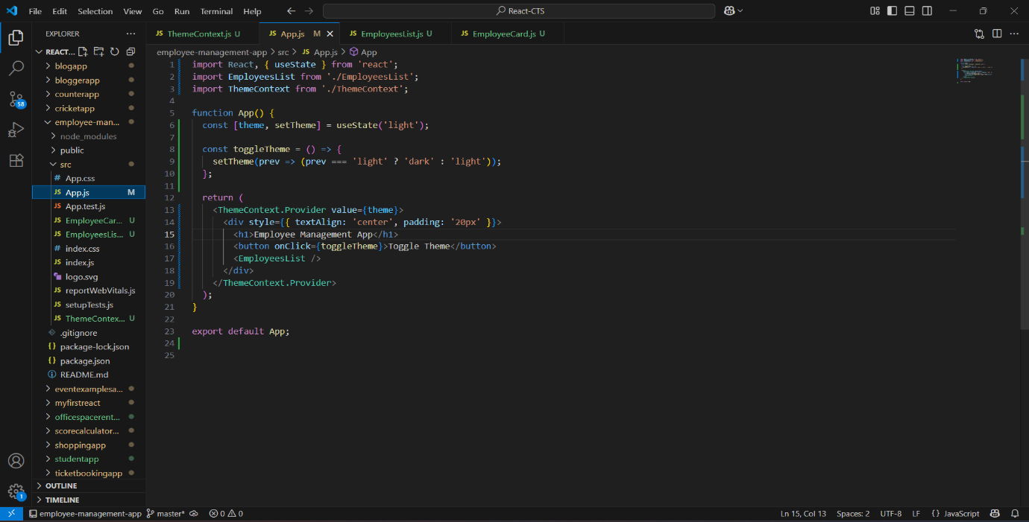

**Output:**

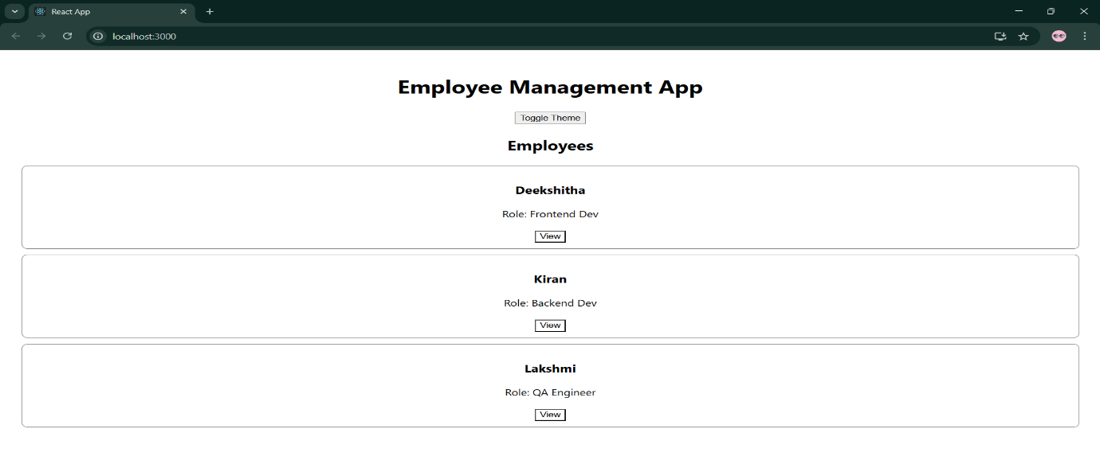

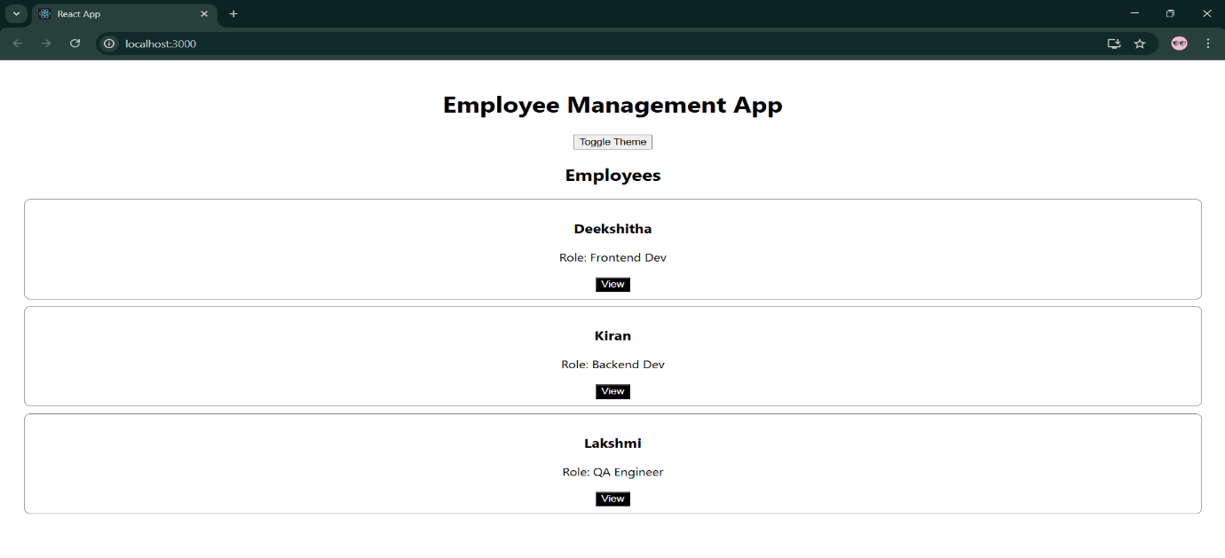

**Exercise 15 ticketraisingapp**

**ComplaintRegister.js**

import React, { useState } from 'react';

function ComplaintRegister() {

const [employeeName, setEmployeeName] = useState('');

const [complaint, setComplaint] = useState('');

const handleSubmit = (e) => {

e.preventDefault();

const referenceNo = Math.floor(100000 + Math.random() * 900000);

alert(

`Complaint Registered Successfully!\nReference No: ${referenceNo}\nName: ${employeeName}\nComplaint: ${complaint}`

);

// Reset the form

setEmployeeName('');

setComplaint('');

};

return (

<div style={{ textAlign: 'center', marginTop: '50px' }}>

<h1>Complaint Register</h1>

<form onSubmit={handleSubmit} style={{ width: '400px', margin: '0 auto' }}>

<div>

<label>Employee Name:</label><br />

<input

type="text"

value={employeeName}

onChange={(e) => setEmployeeName(e.target.value)}

required

style={{ width: '100%', padding: '8px', marginTop: '5px' }}

/>

</div>

<br />

<div>

<label>Complaint:</label><br />

<textarea

value={complaint}

onChange={(e) => setComplaint(e.target.value)}

required

rows="5"

style={{ width: '100%', padding: '8px', marginTop: '5px' }}

></textarea>

</div>

<br />

<button type="submit" style={{ padding: '10px 20px' }}>

Submit Complaint

</button>

</form>

</div>

);

}

export default ComplaintRegister;

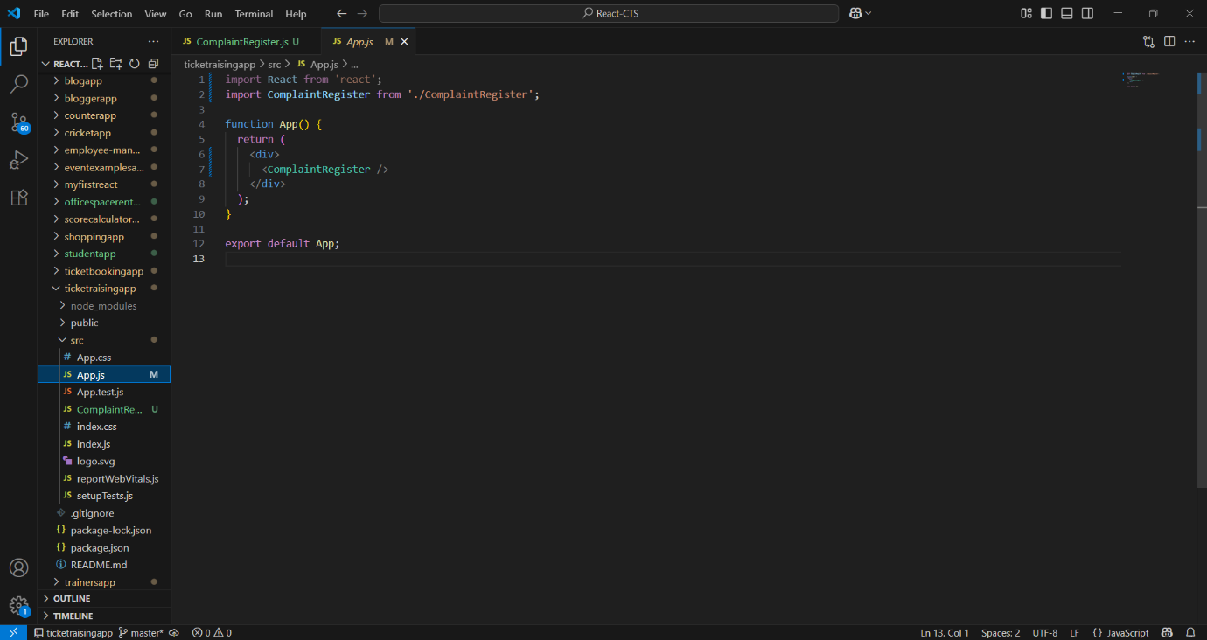

**Output:**

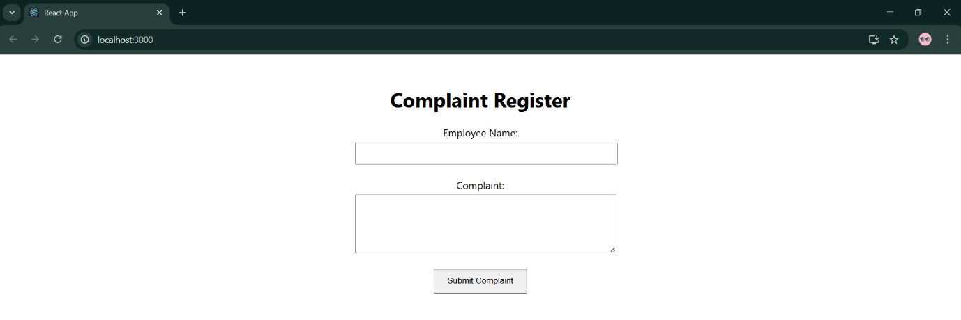

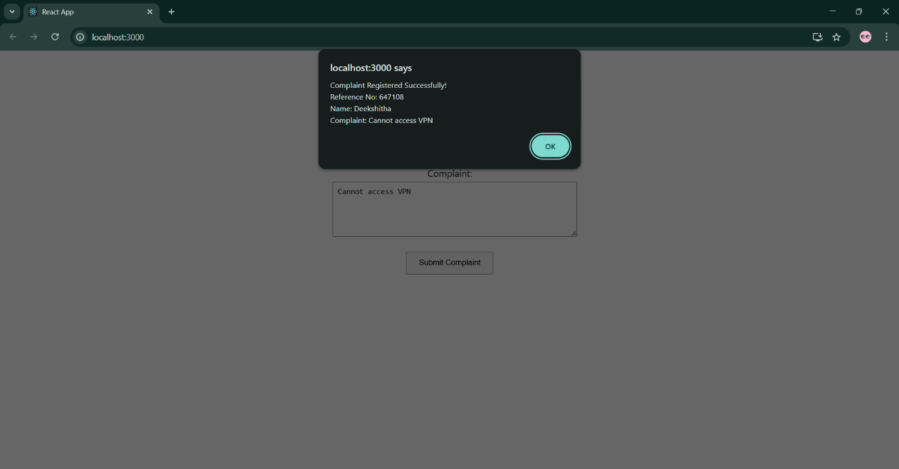

**Exercise 16 mailregisterapp**

**Register.js**

import React, { useState } from 'react';

function Register() {

const [form, setForm] = useState({

name: '',

email: '',

password: ''

});

const [errors, setErrors] = useState({});

const validate = () => {

const newErrors = {};

if (form.name.length < 5) {

newErrors.name = "Name must be at least 5 characters.";

}

if (!form.email.includes('@') || !form.email.includes('.')) {

newErrors.email = "Email must contain '@' and '.'.";

}

if (form.password.length < 8) {

newErrors.password = "Password must be at least 8 characters.";

}

setErrors(newErrors);

return Object.keys(newErrors).length === 0;

};

const handleChange = (e) => {

const { name, value } = e.target;

setForm(prev => ({ ...prev, [name]: value }));

};

const handleSubmit = (e) => {

e.preventDefault();

if (validate()) {

alert("Registration Successful!\n" + JSON.stringify(form, null, 2));

setForm({ name: '', email: '', password: '' });

setErrors({});

}

};

return (

<div style={{ width: '400px', margin: '50px auto', textAlign: 'left' }}>

<h2 style={{ textAlign: 'center' }}> Mail Register</h2>

<form onSubmit={handleSubmit}>

<div>

<label>Name:</label><br />

<input

type="text"

name="name"

value={form.name}

onChange={handleChange}

required

style={{ width: '100%', padding: '8px' }}

/>

{errors.name && <p style={{ color: 'red' }}>{errors.name}</p>}

</div>

<div>

<label>Email:</label><br />

<input

type="email"

name="email"

value={form.email}

onChange={handleChange}

required

style={{ width: '100%', padding: '8px' }}

/>

{errors.email && <p style={{ color: 'red' }}>{errors.email}</p>}

</div>

<div>

<label>Password:</label><br />

<input

type="password"

name="password"

value={form.password}

onChange={handleChange}

required

style={{ width: '100%', padding: '8px' }}

/>

{errors.password && <p style={{ color: 'red' }}>{errors.password}</p>}

</div>

<br />

<button type="submit" style={{ width: '100%', padding: '10px' }}>

Register

</button>

</form>

</div>

);

}

export default Register;

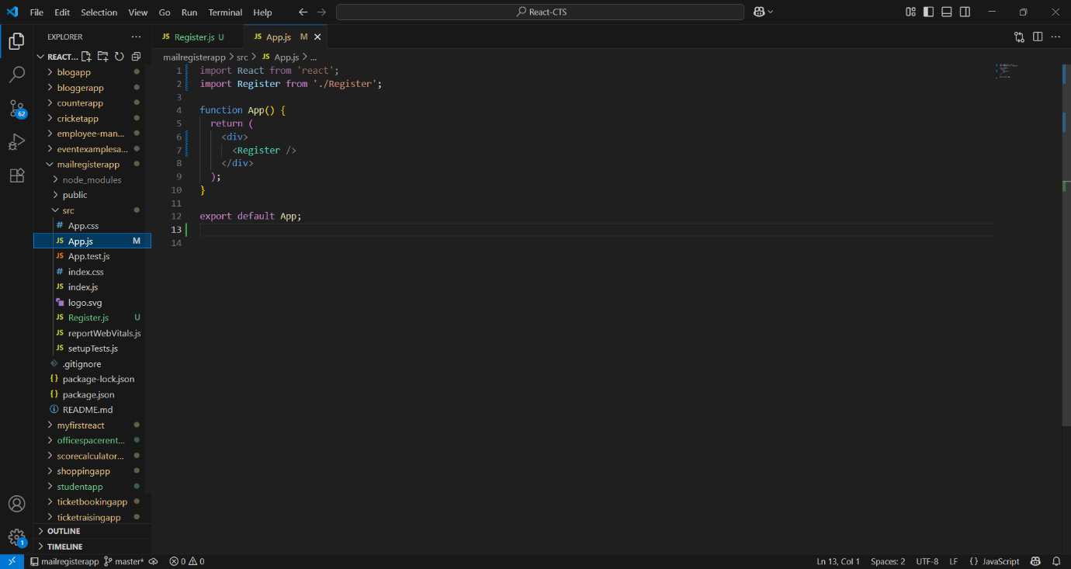

**Output:**

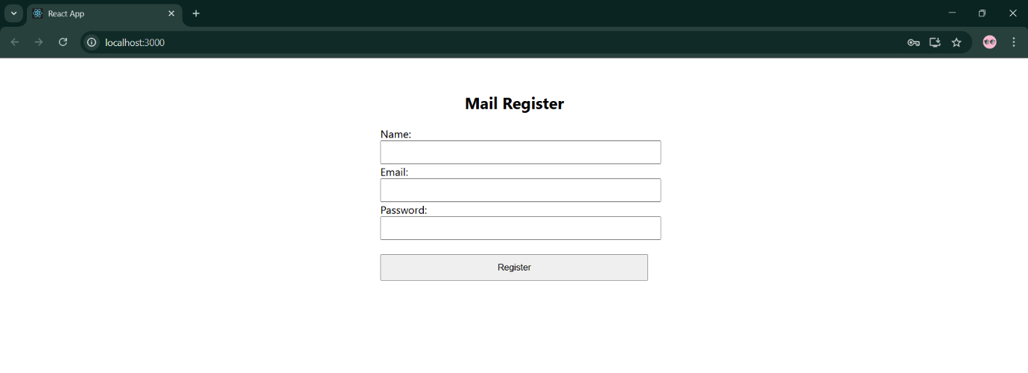

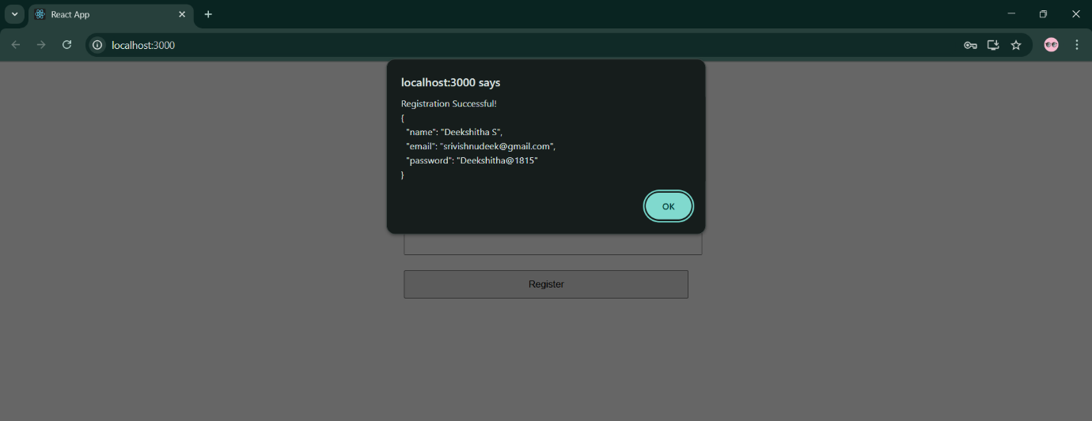

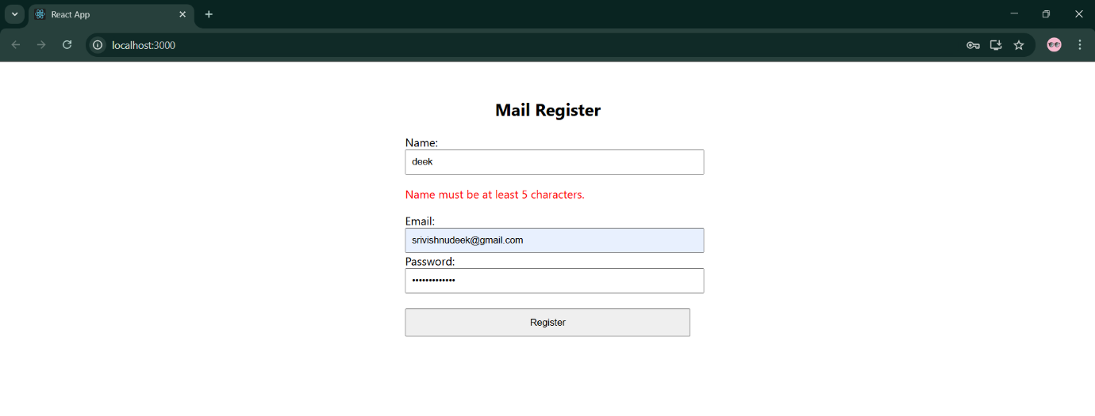

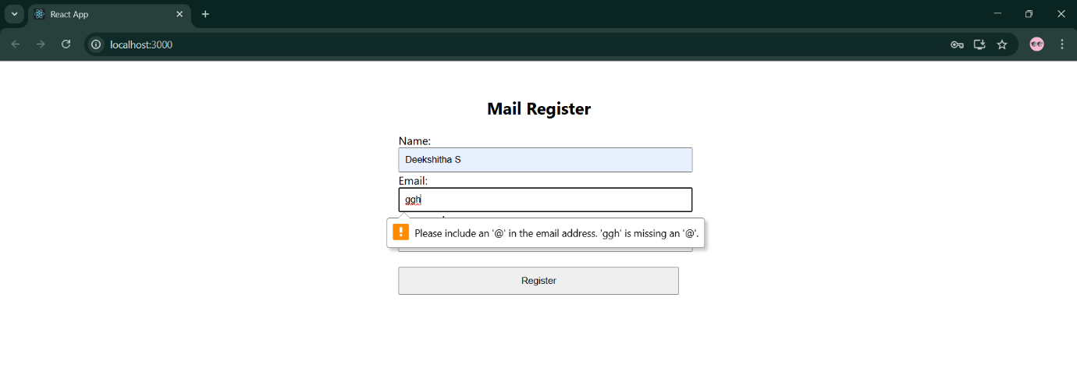

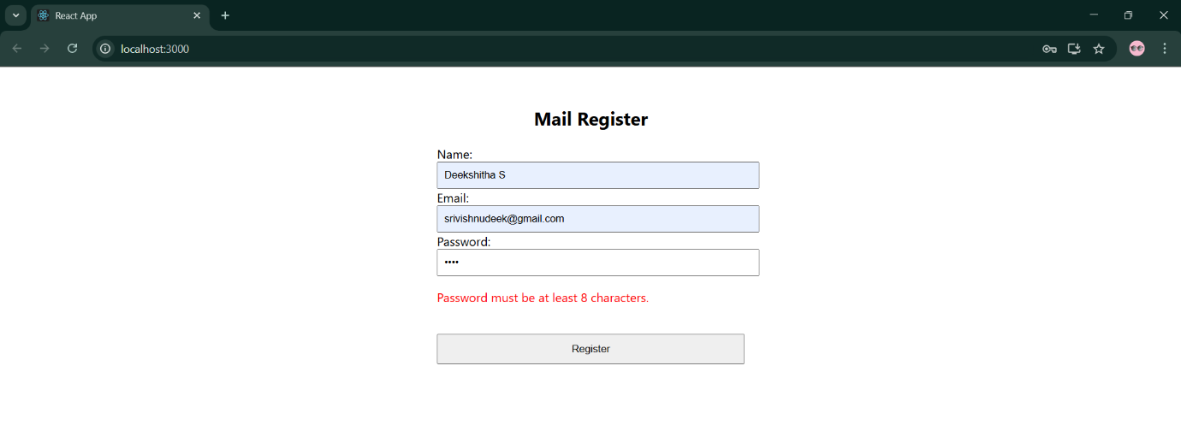

**Exercise 17 fetchuserapp**

**Getuser.js**

import React, { Component } from 'react';

class Getuser extends Component {

constructor(props) {

super(props);

this.state = {

user: null

};

}

async componentDidMount() {

try {

const response = await fetch('https://api.randomuser.me/');

const data = await response.json();

const user = data.results[0];

this.setState({ user });

} catch (error) {

console.error("Error fetching user:", error);

}

}

render() {

const { user } = this.state;

return (

<div style={{ textAlign: 'center', marginTop: '50px' }}>

<h1> Random User Info</h1>

{user ? (

<div>

<h2>

{user.name.title}. {user.name.first}

</h2>

<img

src={user.picture.large}

alt="User"

style={{ borderRadius: '50%', width: '150px', height: '150px' }}

/>

</div>

) : (

<p>Loading user data...</p>

)}

</div>

);

}

}

export default Getuser;

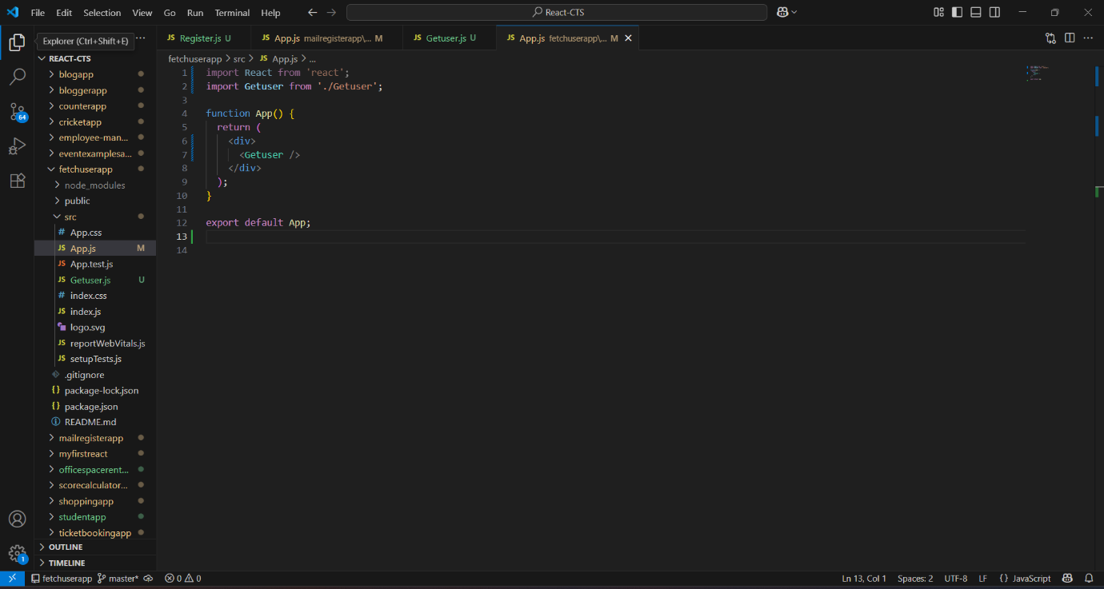

**Output:**

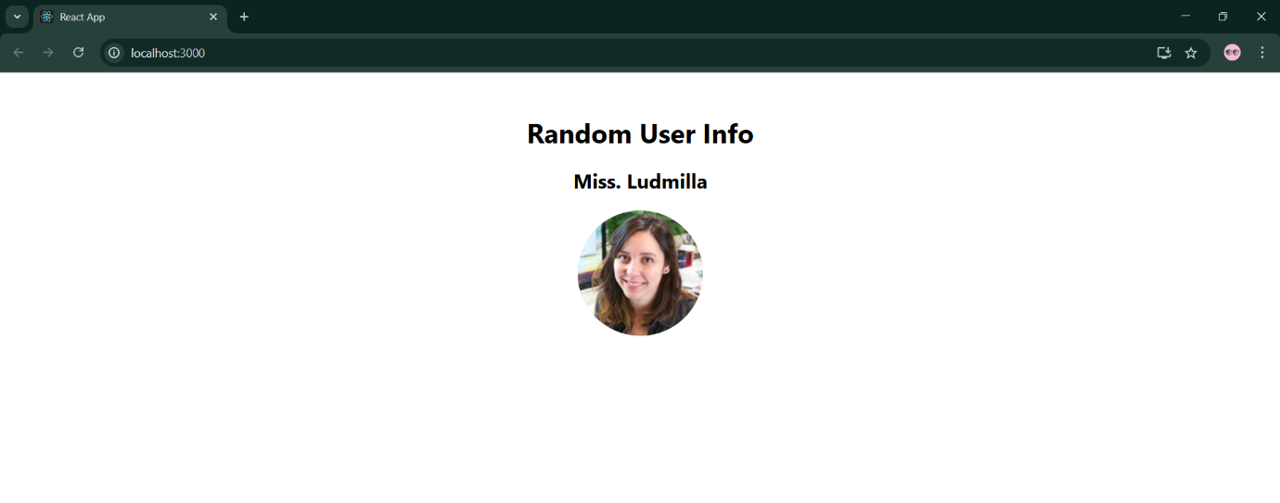

**Exercise 18 cohort-dashboard**

**Cohort.js**

export const CohortData = [

  {

    code: 'CTS2025-FSD',

    description: 'Full Stack Developer Program',

    duration: '12 weeks',

    status: 'Ongoing'

  }

];

**CohortDetails.js**

import React from 'react';

function CohortDetails({ cohort }) {

  return (

    <div>

      <h3>{cohort.code}</h3>

      <p>{cohort.description}</p>

      <p>{cohort.duration}</p>

      <p>Status: {cohort.status}</p>

    </div>

  );

}

export default CohortDetails;

**CohortDetails.test.js**

import React from 'react';

import { render, screen } from '@testing-library/react';

import CohortDetails from './CohortDetails';

import { CohortData } from './Cohort';

describe('CohortDetails Component', () => {

  test('renders cohort details correctly', () => {

    render(<CohortDetails cohort={CohortData[0]} />);

    expect(screen.getByRole('heading', { level: 3 })).toHaveTextContent(CohortData[0].code);

    expect(screen.getByText(CohortData[0].description)).toBeInTheDocument();

    expect(screen.getByText(CohortData[0].duration)).toBeInTheDocument();

    expect(screen.getByText(`Status: ${CohortData[0].status}`)).toBeInTheDocument();

  });

});

**setupTests.js**

import '@testing-library/jest-dom';

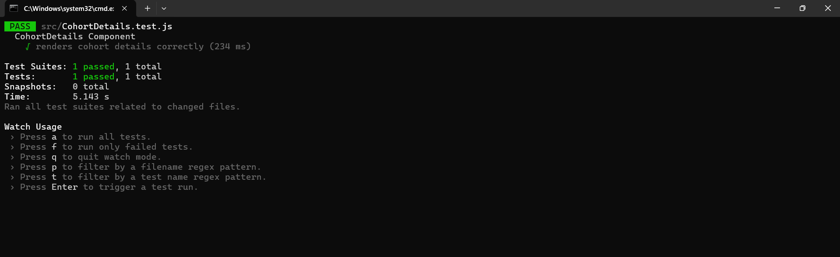

**Exercise 19 gitclientapp**

**GitClient.js**

import axios from 'axios';

class GitClient {

  async getRepositories(user) {

    const response = await axios.get(`https://api.github.com/users/${user}/repos`);

    return response.data.map(repo => repo.name);

  }

}

export default GitClient;

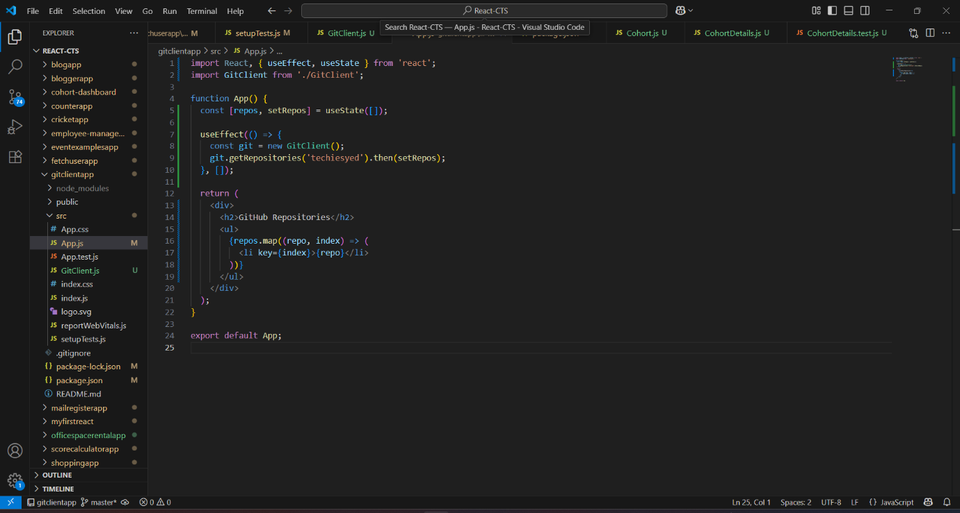

**Output:**

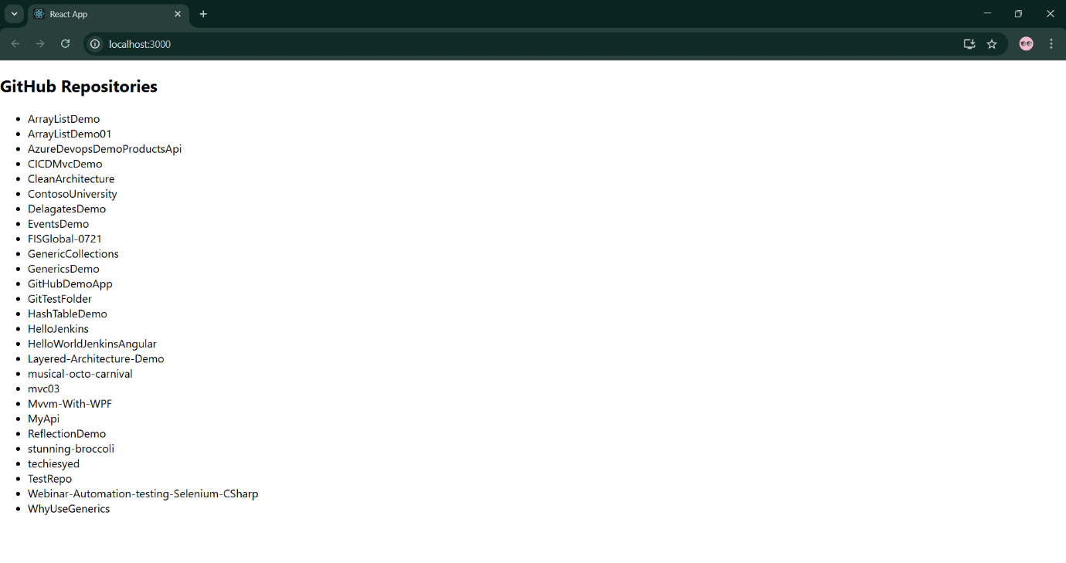

**GitClient.test.js**

const axios = require('axios');

const GitClient = require('./GitClient').default;

jest.mock('axios');

describe('Git Client Tests', () => {

  test('should return repository names for techiesyed', async () => {

    const mockData = {

      data: [

        { name: 'repo1' },

        { name: 'repo2' }

      ]

    };

    axios.get.mockResolvedValue(mockData);

    const git = new GitClient();

    const repos = await git.getRepositories('techiesyed');

    expect(repos).toEqual(['repo1', 'repo2']);

    expect(axios.get).toHaveBeenCalledWith('https://api.github.com/users/techiesyed/repos');

  });

});

**Test output:**

