**Week 8 Git HandsOn**

**Exercise 1**

**Step 1: Setup your machine with Git Configuration**

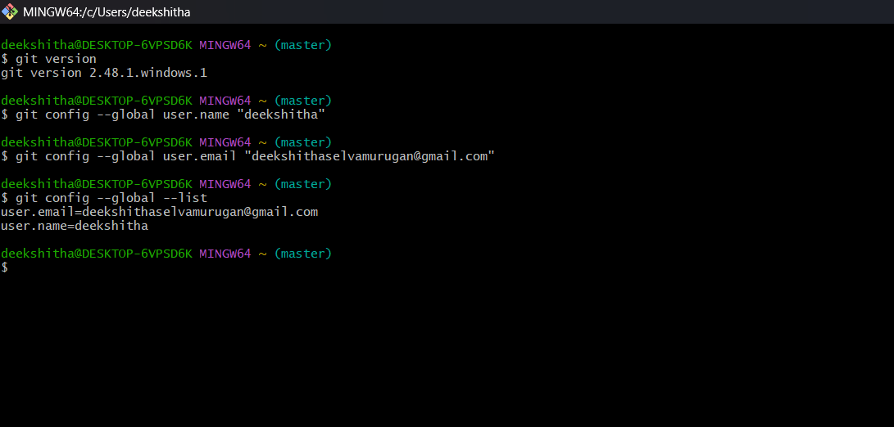

**Step 2: Integrate notepad++.exe to Git and make it a default editor**

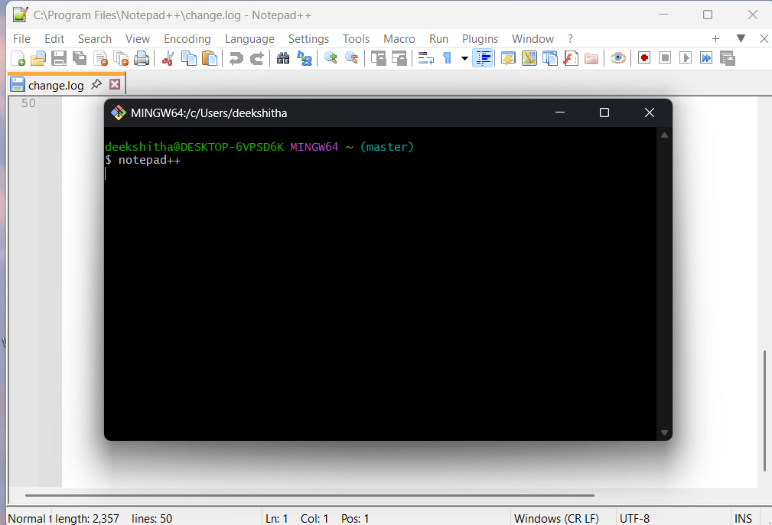

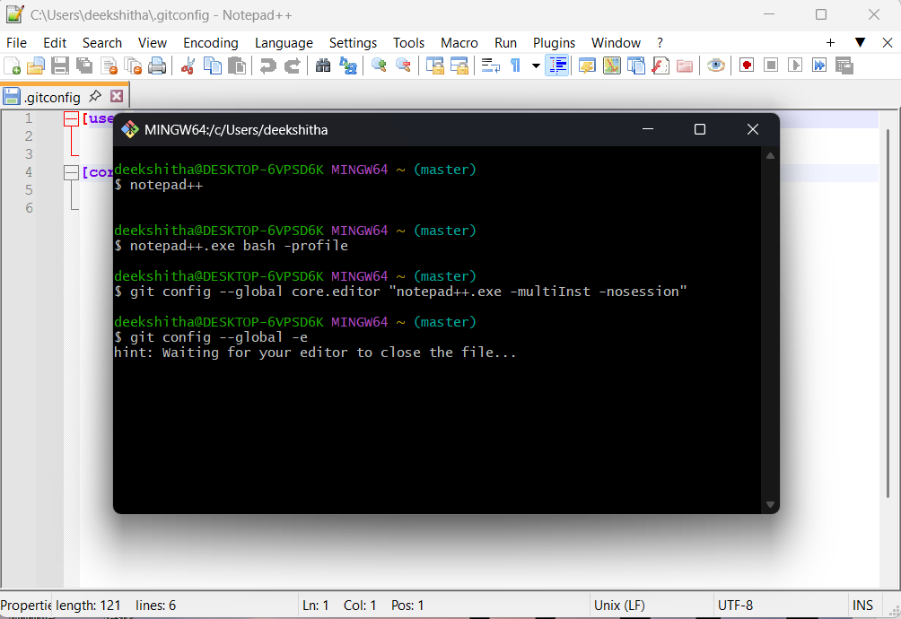

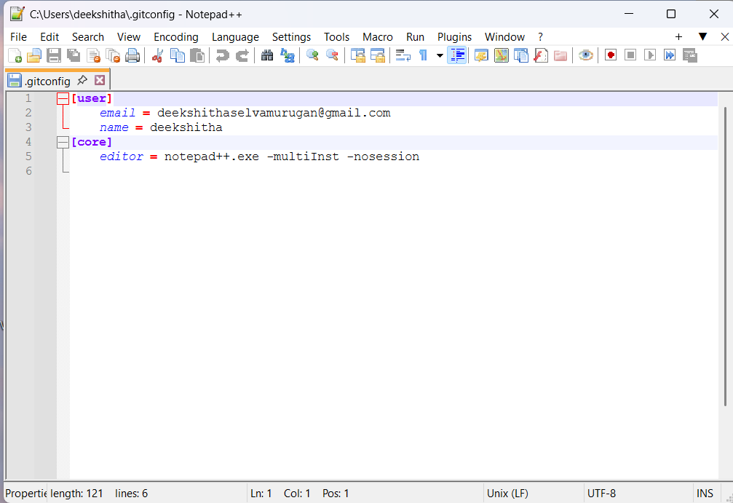

**Step 3: Add a file to source code repository**

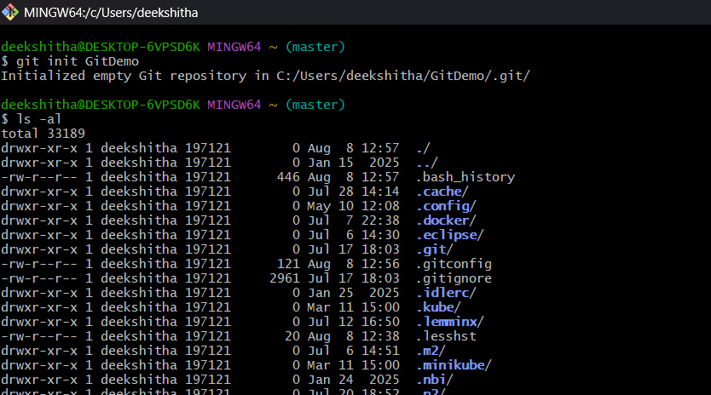

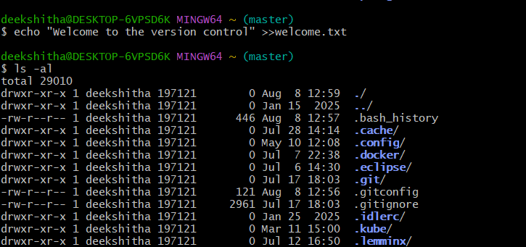

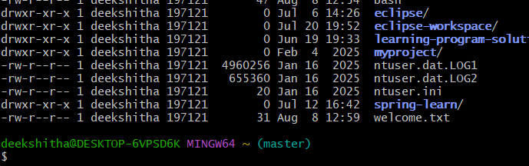

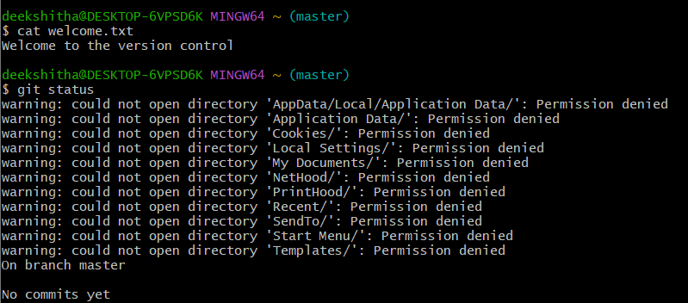

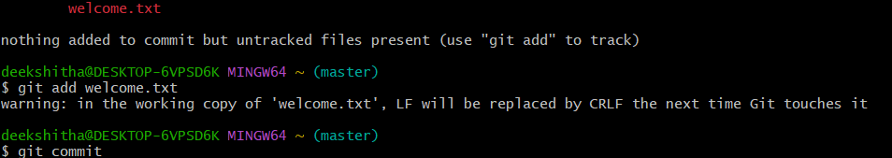

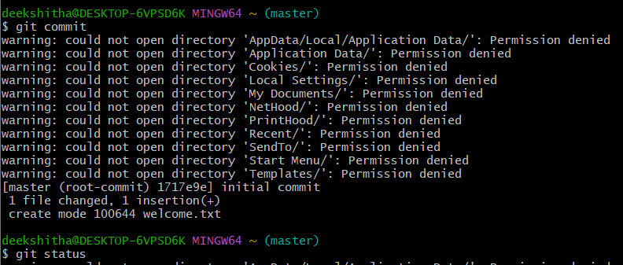

**Exercise 2**

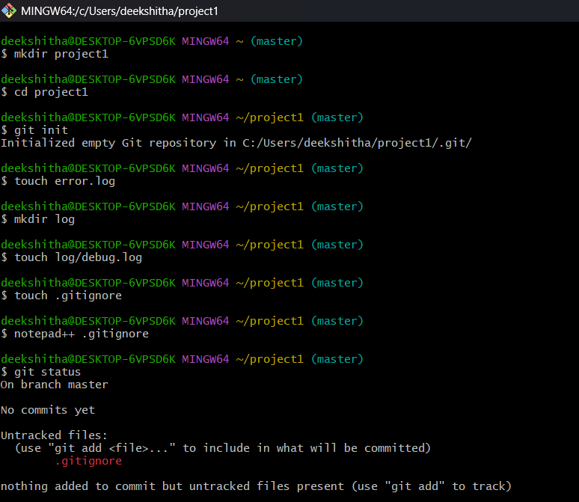

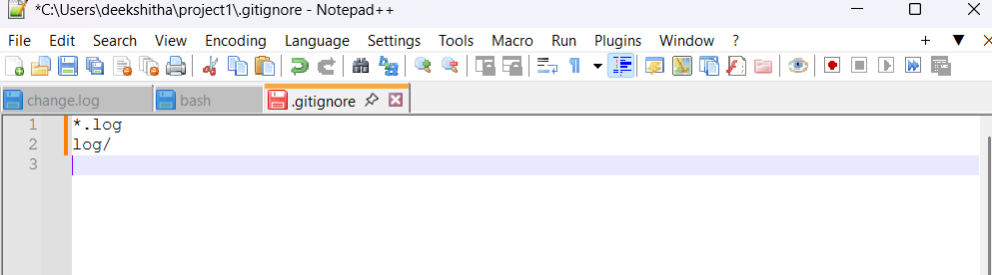

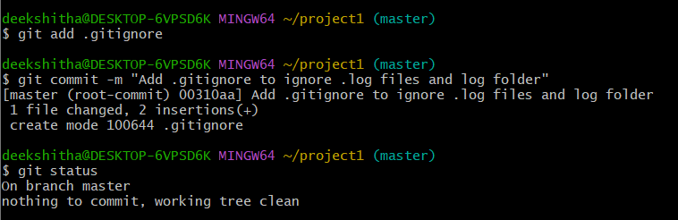

**Exercise 3**

**Branching**

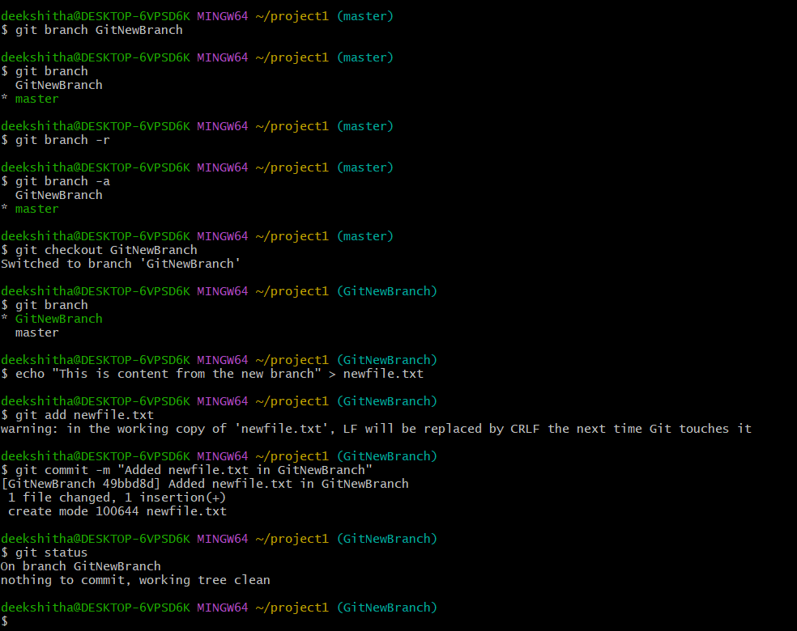

**Merging**

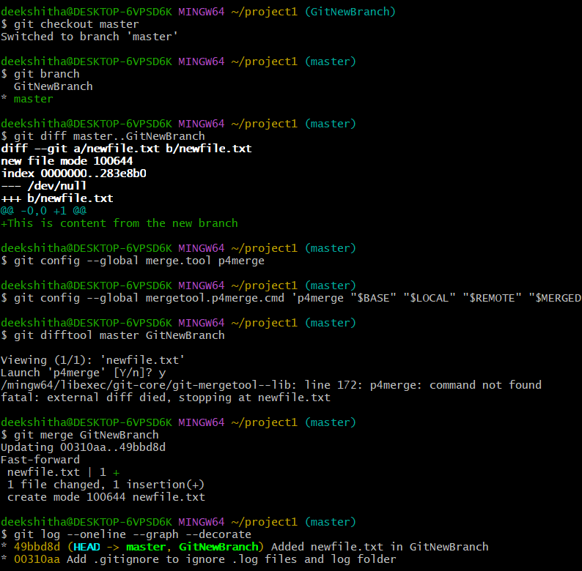

**Delete the branch and check status**

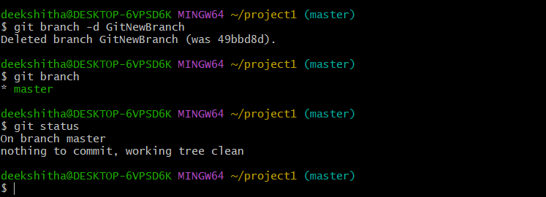

**Exercise 4**

1. Verify if master is in clean state.

2. Create a branch “GitWork”. Add a file “hello.xml”.

3. Update the content of “hello.xml” and observe the status

4. Commit the changes to reflect in the branch

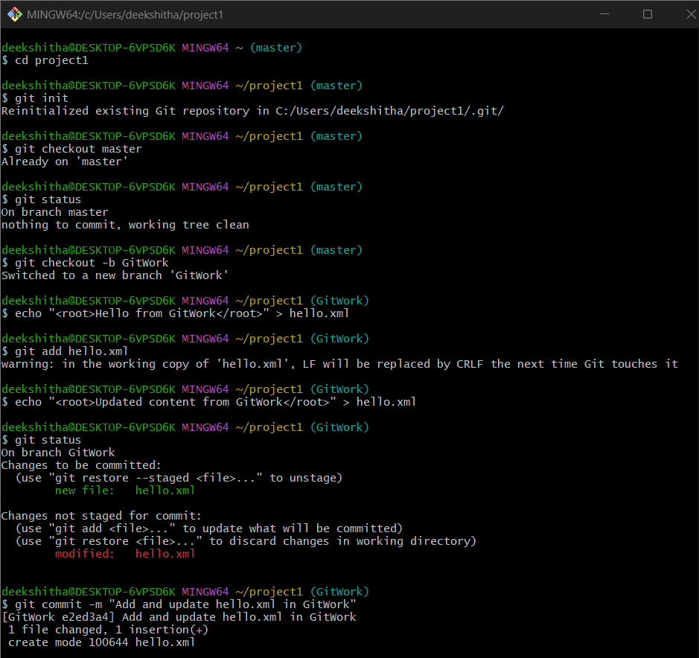

5. Switch to master.

6. Add a file “hello.xml” to the master and add some different content than previous.

7. Commit the changes to the master

8. Observe the log by executing “git log –oneline –graph –decorate –all”

9. Check the differences with Git diff tool

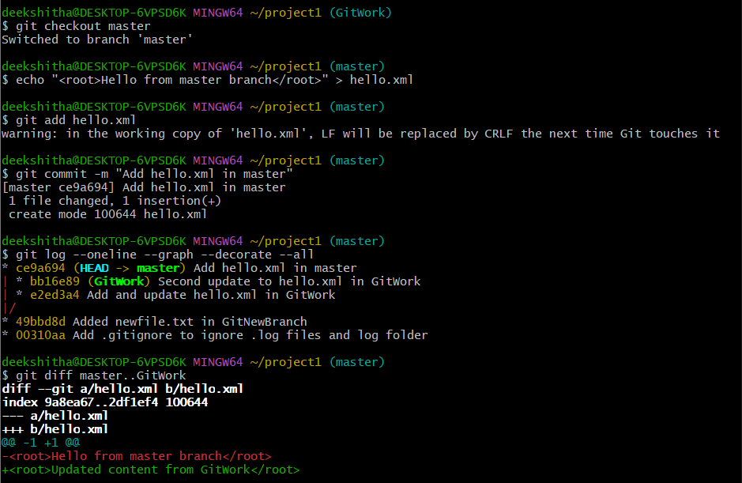

10. For better visualization, use P4Merge tool to list out all the differences between master and branch

11. Merge the bran to the master

12. Observe the git mark up.

13. Use 3-way merge tool to resolve the conflict

14. Commit the changes to the master, once done with conflict

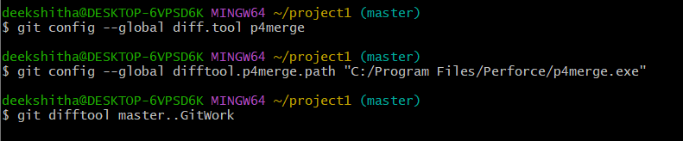

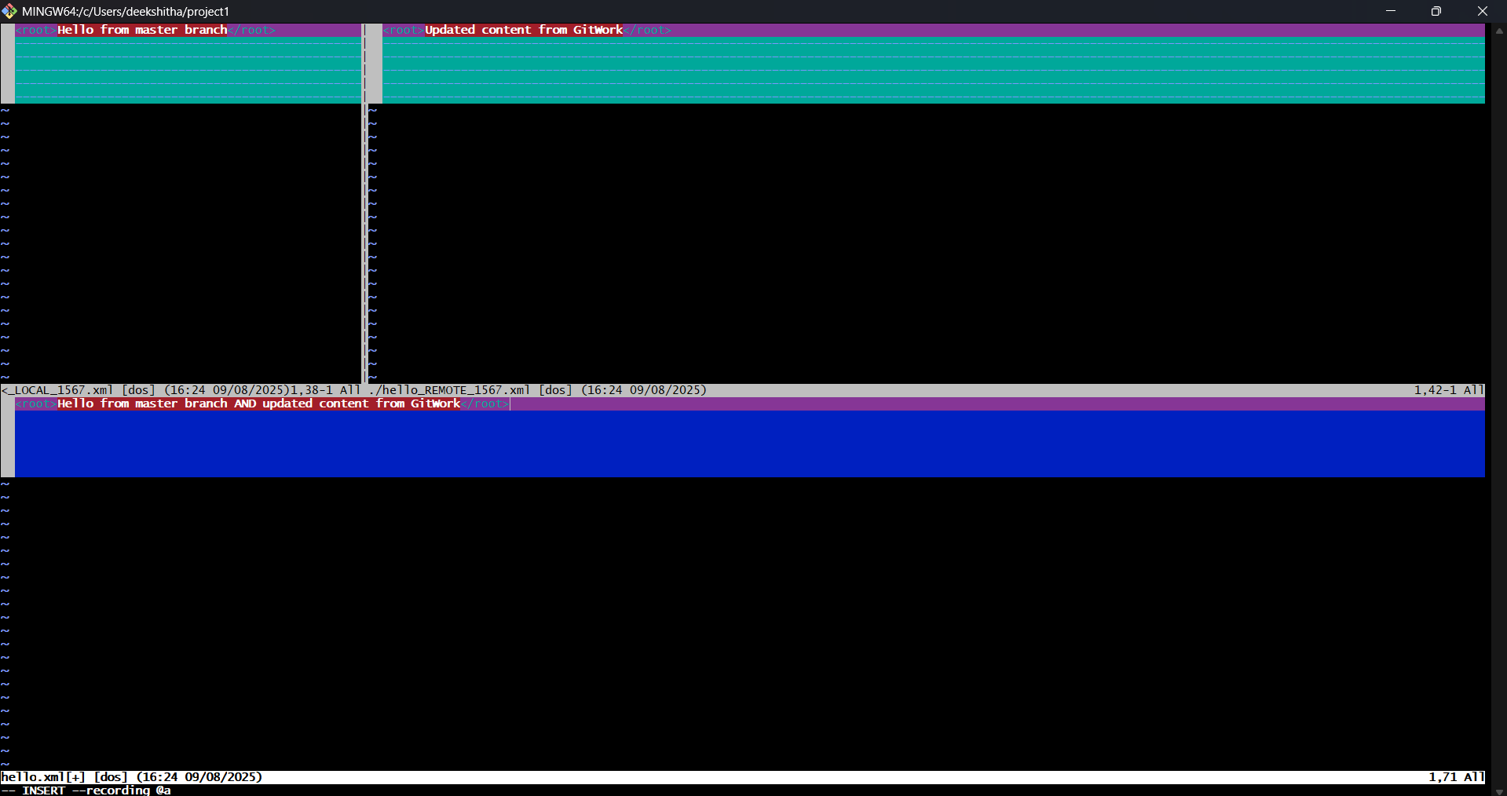

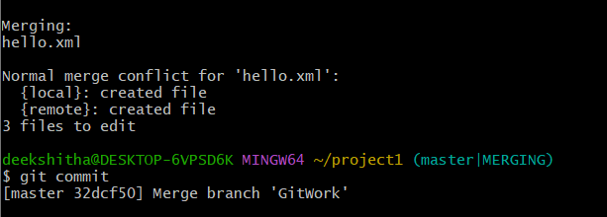

15. Observe the git status and add backup file to the .gitignore file.

16. Commit the changes to the .gitignore

17. List out all the available branches

18. Delete the branch, which merge to master.

19. Observe the log by executing “git log –oneline –graph –decorate”

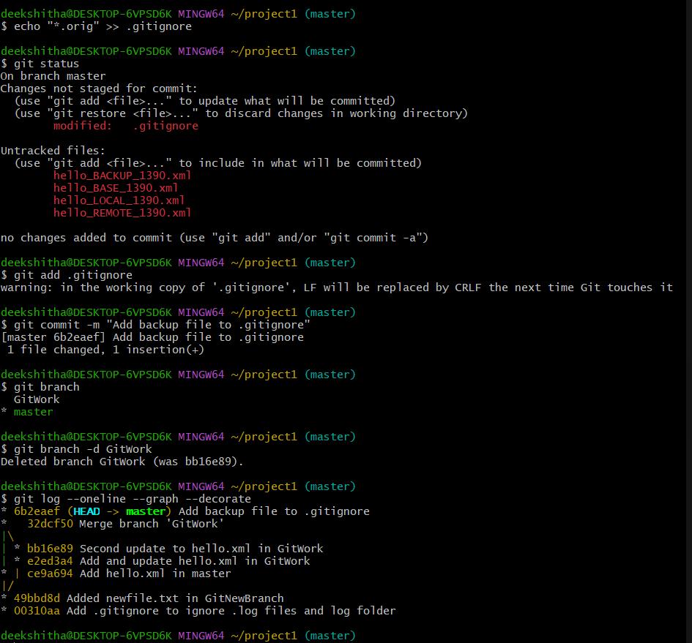

**Exercise 5**

1. Verify if master is in clean state.

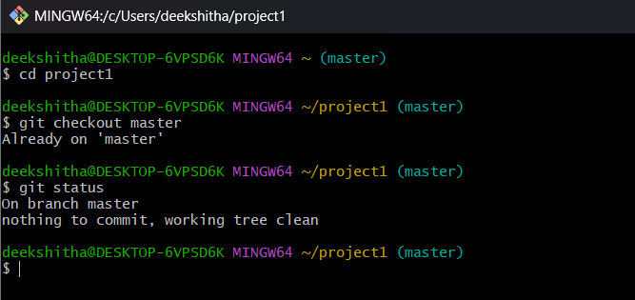

1. List out all the available branches.

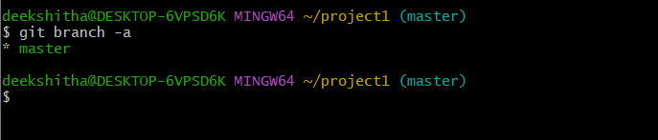

1. Pull the remote git repository to the master

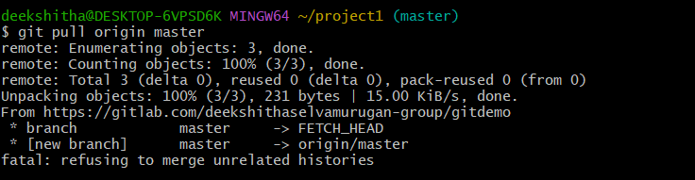

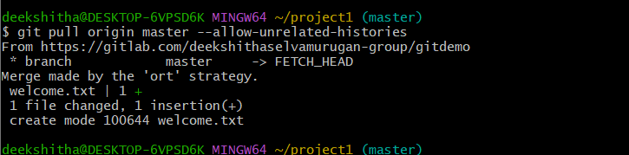

1. Push the changes, which are pending from “Git-T03-HOL_002” to the remote repository.

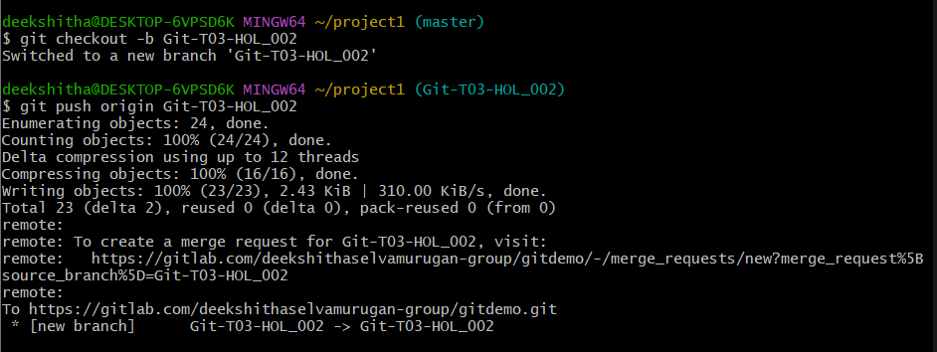

1. Observe if the changes are reflected in the remote repository.

