MATRIX OPERATION SYSTEM

Cornerstone project work submitted to Aditya University in partial fulfilment of the
requirements for the award of the Degree of

B.Tech. degree
in
Computer Science & Engineering (2026-2027)

SUBMITTED BY

K VINOOTNA | 25B11AI618
I CHAITRIKA SRI | 25B11AI715
V DEEKSHITHA | 25B11AIC54
M MADHU SHALINI | 25B11AI758

UNDER THE GUIDANCE OF
T VIJAYA LAKSHMI (M.Tech)
ASSISTANT PROFESSOR
Department of
AIML

Department of Computer Science & Engineering
Aditya University, Aditya Nagar, ADB Road,
Surampalem, Kakinada, District, Andhra Pradesh, India - 533437
DECLARATION

I hereby declare that the Cornerstone project work entitled “MATRIX OPERATION SYSTEM” is being submitted by me for the award of the B. Tech Degree in Computer Science and Engineering, Aditya University, Aditya Nagar, ADB Road, Surampalem is a record of original work carried out by us. We further declare that this project work has not been submitted, either in full or in part, for the award of any degree or diploma in this or any other institution. We also confirm that this work has been carried out with academic honesty and complies with the Institutional Academic Integrity and AI Usage Policy.

Submitted By

K VINOOTNA 25B11AI618

I CHAITRIKA SRI 25B11AI715

V DEEKSHITHA 25B11AIC54

M MADHU SHALINI 25B11AI758

Place : Surampalem Date : 15-10-2026

DEPARTMENT OF COMPUTER SCIENCE & ENGINEERING
ADITYA UNIVERSITY, ADITYA NAGAR,
SURAMPALEM.

This is to certify that the cornerstone project entitled “MATRIX OPERATION SYSTEM” is being submitted by K VINOOTNA (25B11AI618),I CHAIRTIKA SRI(25B11AI715), V DEEKSHITHA (25B11AIC54), M MADHU SHALINI (25B11AI758) in partial fulfilment for the award of B. Tech Degree from Aditya University, is a record of original work done by them under my supervision. The contents of this project, in full or in parts, have not been submitted to any other Institute or University for the award of any degree or diploma.

Project Guide
T Vijaya Lakshmi (MTech)
Assistant Professor
Department of AIML
Aditya University

ACKNOWLEDGEMENT
It is with immense pleasure that we express our sincere gratitude to our Cornerstone Project Guide, T VIJAYA LAKSHMI, ASSISTANT PROFESSOR, who has guided us throughout the project. Her valuable support, encouragement, and guidance have greatly contributed to the successful completion of this work.

We would like to thank our Deputy Heads of the Department, DR R SUNEETHA, ASSISTANT PROFESSSOR, DR B MANIKYALA RAO, ASSISTANT PROFESSOR
Department of AIML, for their support and valuable suggestions.

Our deepest thanks to our Head of the Department, DR K NAGA BHARGAVI,
ASSOCIATE PROFESSOR, for her inspiration and for providing all the necessary facilities and resources required for this project.

We also extend our sincere thanks to DR. M.V. RAJESH, ASSOCIATE DEAN, SCHOOL OF COMPUTING, for his encouragement and support during our project.

We would like to express our sincere gratitude to DR. G. SURESH, REGISTRAR; DR. A.
RAMESH, PRO VICE-CHANCELLOR (ENGINEERING & SCIENCES); DR. S. RAMA SREE, PRO VICE-CHANCELLOR (ACADEMICS); DR. M.B. SRINIVAS, VICE-CHANCELLOR; AND DR. M. SREENIVASA REDDY, DEPUTY PRO CHANCELLOR AND MANAGEMENT, ADITYA UNIVERSITY, for providing excellent infrastructure and state-of-the-art laboratories.

Finally, we would like to thank the FACULTY MEMBERS, LAB TECHNICIANS, NONTEACHING STAFF, AND OUR FRIENDS who have directly or indirectly supported us in completing this Cornerstone project successfully.

ABSTRACT

The Matrix Operation System is a C++-based application developed to perform mathematical operations on matrices efficiently and accurately. The system supports basic matrix operations such as addition, subtraction, multiplication, and transpose.
The main purpose of the system is to simplify matrix calculations, reduce manual effort, and minimize calculation errors. It provides a simple and user-friendly interface through which users can enter matrix elements and select the required operation.
The system also checks matrix dimensions to ensure that the selected operation can be performed correctly. Object-Oriented Programming concepts are used to organize the matrix operations into reusable and manageable functions.
The Matrix Operation System can be useful for students, teachers, engineers, programmers, researchers, and data analysts for academic, mathematical, and computational purposes. Overall, the system provides an efficient and organized approach to performing matrix calculations using C++.

ABBREVATIONS

Abbreviation | Full Form
C++ | C Plus Plus
OPP | Object-Oriented Programming
UI | User Interface
CPU | Central Processing Unit
IDE | Integrated Development Environment
RAM | Random Access Memory
I/O | Input / Output
DSA | Data Structures And Algorithms

LIST OF FIGURES

Figure No. | Title | Page No.
Figure 2.3.1 | Matrix Input Screen | 25
Figure 2.3.2 | Matrix Addition Output | 26
Figure 2.3.3 | Matrix Subtraction Output | 27
Figure 2.3.4 | Matrix Multiplication Output | 28
Figure 2.3.5 | Matrix Transpose Output | 29

LIST OF TABLES

Table no. | Title | Page No.
Table 1.1 | Matrix Operations And Requirements | 12
Table 2.1 | OPP Concepts Used | 15

TABLE OF CONTENTS

CONTENTS | PAGE NO
Title Page | I
Certificate | II
Declaration | III
Acknowledgement | IV
Abstract | V
Abbreviations | VI
List of Figures | VII
List of Tables | VIII
CHAPTER -1 Project Planning
1.1. Problem statement
1.2. Project Objective
1.3. Planned Modules
1.4. System Architecture (Algorithm & Flowchart)
CHAPTER -1 Project Implementation
2.1. OOP Concepts Used for implementation
2.2. Code
2.3. Output Screens
CHAPTER-3 Conclusion & Future Scope
3.1. Conclusion
3.2. Future Scope

CHAPTER – 1

PROJECT PLANNING

1.1 PROBLEM STATEMENT

Performing matrix operations manually can be time-consuming and may result in calculation errors, especially when working with large matrices. Managing different matrix operations manually also makes the calculations difficult to verify and organize.

The Matrix Operation System is developed to provide a simple and efficient solution for performing matrix calculations. The system allows users to enter matrix elements and select the required operation through a menu-driven interface. It performs operations such as matrix addition, subtraction, multiplication, and transpose accurately.

The system also checks the dimensions of matrices before performing operations, helping to ensure that the selected operation is valid. Thus, the system reduces manual effort, saves time, and provides clear and accurate results.

1.2 PROJECT OBJECTIVE

The main objectives of the Matrix Operation System are:
- To develop a matrix calculation system using C++.
- To perform matrix operations accurately and efficiently.
- To reduce manual calculation time and errors.
- To apply Object-Oriented Programming concepts in a practical application.
- To provide a simple and user-friendly menu-driven interface.
- To organize matrix operations using classes and member functions.
- To display clear and accurate results for different matrix operations.

1.3 PLANNED MODULES
The Matrix Operation System consists of the following modules:

1.3.1 Input Module
This module accepts the matrix dimensions and elements entered by the user.

1.3.2 Validation Module
This module checks the matrix dimensions and validates the input before performing the selected operation.

1.3.3 Addition Module
This module performs addition of two matrices having the same order.

1.3.4 Subtraction Module
This module performs subtraction of two matrices having the same order.

1.3.5 Multiplication Module
This module performs matrix multiplication using the rows and columns of the matrices.

1.3.6 Transpose Module
This module converts the rows of a matrix into columns and the columns into rows.

1.3.7 Result Module
This module displays the result of the selected matrix operation in a clear format.

1.3.8 Reset / Exit Module
This module allows the user to clear the inputs or exit the system.

Table 1.1 – Matrix Operations And Requirements

Operation | Required Condition | Output
Addition | Both matrices must have same dimensions | Sum Matrix
Subtraction | Both matrices must have same dimensions | Difference Matrix
Multiplication | Columns of first matrix = rows of second matrix | Product Matrix
Transpose | Any valid matrix | Transposed Matrix

1.4 SYSTEM ARCHITECTURE – ALGORITHM & FLOWCHART

1.4.1 SYSTEM ARCHITECTURE

The Matrix Operation System follows a simple process. First, the user enters the matrix dimensions and elements. The system validates the input and checks whether the selected operation can be performed. The user then selects an operation such as addition, subtraction, multiplication, or transpose. The system performs the selected operation and displays the result.

System Flow:
User Input → Input Validation → Operation Selection → Matrix Processing → Result
Display → Reset / Exit
The architecture provides an organized way to handle different matrix operations and makes the system easy to use.

1.4.2 ALGORITHM

Step 1: Start the Matrix Operation System.
Step 2: Accept the matrix dimensions and elements from the user.
Step 3: Validate the entered matrix dimensions and input.
Step 4: Display the available matrix operations.
Step 5: Allow the user to select the required operation.
Step 6: Perform the selected operation:
- Addition
- Subtraction
- Multiplication
- Transpose
Step 7: Display the calculated result.
Step 8: Allow the user to perform another operation, reset the input, or exit the system.
Step 9: Stop the program.

CHAPTER – 2

PROJECT IMPLEMENTATION

2.1 OOP CONCEPTS USED FOR IMPLEMENTATION

The Matrix Operation System is implemented using C++ and applies Object-Oriented Programming concepts to organize the matrix operations. The use of OOP makes the program structured, reusable, and easier to manage.

2.1.1 Class
A class is used to organize the data and functions required for performing matrix operations. It provides a structured way to manage the matrix-related operations within the system.

2.1.2 Objects
Objects are used to access the data and functions defined inside the class. They help in performing the required matrix operations.

2.1.3 Encapsulation
Encapsulation combines data and the functions that operate on that data into a single unit.
In this project, matrix-related data and operations are organized together.

2.1.4 Member Functions
Member functions are used to perform different matrix operations. Separate functions can be used for addition, subtraction, multiplication, and transpose operations.

2.1.5 Reusability
The use of classes and member functions makes the operations reusable and helps avoid unnecessary repetition of code.

Table 2.1 – OPP Concepts Used

OPP Consept | Application in the Project
Class | Organizes matrix data and operations
Object | Used to access class data and functions
Encapsulation | Combines matrix data and related functions
Member Functions | Performs addition, subtraction, multiplication and transpose
Reusability | Allows operations to be organized and reused

2.2 CODE

The Matrix Operation System is implemented using C++. The program accepts matrix values from the user and provides a menu to select the required operation. Based on the user's selection, the corresponding matrix operation is performed and the result is displayed.
The main operations implemented in the system are:
- Matrix Addition
- Matrix Subtraction
- Matrix Multiplication
- Matrix Transpose
- Input Validation
- Result Display
- Reset / Exit
Note: The complete source code of the project should be included in this section as provided in the actual project implementation.
#include <iostream>
using namespace std;

class Matrix
{
private:
int mat[10][10];
int rows, cols;

public:

void input()
{
cout << "Enter number of rows: ";
cin >> rows;

cout << "Enter number of columns: ";
cin >> cols;

cout << "Enter matrix elements:\n";

for (int i = 0; i < rows; i++)
{
for (int j = 0; j < cols; j++)
{
cin >> mat[i][j];
}
}
}

void display()
{
for (int i = 0; i < rows; i++)
{
for (int j = 0; j < cols; j++)
{
cout << mat[i][j] << " ";
}
cout << endl;
}
}

bool sameSize(Matrix m)
{
return (rows == m.rows && cols == m.cols);
}

Matrix add(Matrix m)
{
Matrix result;

result.rows = rows;
result.cols = cols;

for (int i = 0; i < rows; i++)
{
for (int j = 0; j < cols; j++)
{
result.mat[i][j] = mat[i][j] + m.mat[i][j];
}
}

return result;
}

Matrix subtract(Matrix m)
{
Matrix result;

result.rows = rows;
result.cols = cols;

for (int i = 0; i < rows; i++)
{
for (int j = 0; j < cols; j++)
{
result.mat[i][j] = mat[i][j] - m.mat[i][j];
}
}

return result;
}

Matrix multiply(Matrix m)
{
Matrix result;

result.rows = rows;
result.cols = m.cols;

for (int i = 0; i < rows; i++)
{
for (int j = 0; j < m.cols; j++)
{
result.mat[i][j] = 0;

for (int k = 0; k < cols; k++)
{
result.mat[i][j] +=
mat[i][k] * m.mat[k][j];
}
}
}

return result;
}

Matrix transpose()
{
Matrix result;

result.rows = cols;
result.cols = rows;

for (int i = 0; i < rows; i++)
{
for (int j = 0; j < cols; j++)
{
result.mat[j][i] = mat[i][j];
}
}

return result;
}

int getRows()
{
return rows;
}

int getCols()
{
return cols;
}

};

int main()
{
Matrix A, B, result;
int choice;

do
{
cout << "\n====================================\n";
cout << " MATRIX OPERATION SYSTEM\n";
cout << "====================================\n";

cout << "1. Matrix Addition\n";
cout << "2. Matrix Subtraction\n";
cout << "3. Matrix Multiplication\n";
cout << "4. Matrix Transpose\n";
cout << "5. Reset\n";
cout << "6. Exit\n";

cout << "Enter your choice: ";
cin >> choice;

if (choice == 1)
{
cout << "\nEnter Matrix A:\n";
A.input();

cout << "\nEnter Matrix B:\n";
B.input();

if (A.sameSize(B))
{
result = A.add(B);

cout << "\nResult of Matrix Addition:\n";
result.display();
}
else
{
cout << "\nError: Addition requires matrices "
<< "of the same size.\n";
}
}

else if (choice == 2)
{
cout << "\nEnter Matrix A:\n";
A.input();

cout << "\nEnter Matrix B:\n";
B.input();

if (A.sameSize(B))
{
result = A.subtract(B);

cout << "\nResult of Matrix Subtraction:\n";
result.display();
}
else
{
cout << "\nError: Subtraction requires matrices "
<< "of the same size.\n";
}
}

else if (choice == 3)
{
cout << "\nEnter Matrix A:\n";
A.input();

cout << "\nEnter Matrix B:\n";
B.input();

if (A.getCols() == B.getRows())
{
result = A.multiply(B);

cout << "\nResult of Matrix Multiplication:\n";
result.display();
}
else
{
cout << "\nError: Number of columns of Matrix A "
<< "must be equal to the number of rows "
<< "of Matrix B.\n";
}
}

else if (choice == 4)
{
cout << "\nEnter Matrix:\n";
A.input();

result = A.transpose();

cout << "\nTranspose of Matrix:\n";
result.display();
}

else if (choice == 5)
{
cout << "\nSystem has been reset.\n";
}

else if (choice == 6)
{
cout << "\nExiting Matrix Operation System...\n";
}

else
{
cout << "\nInvalid choice. Please try again.\n";
}

} while (choice != 6);

return 0;

}

2.3 OUTPUT SCREENS

The Matrix Operation System displays the required results after the user selects an operation. The output screens demonstrate the working of the system and the results produced for different matrix operations.

2.3.1 Matrix Input Screen
This screen shows the user entering the dimensions and elements of the matrices.
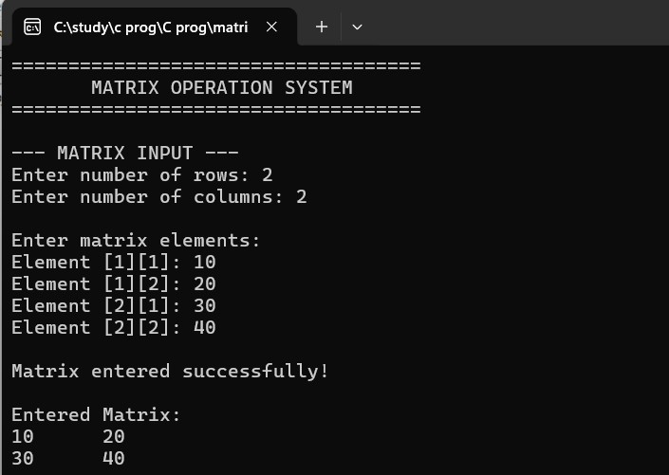

2.3.2 Matrix Addition Output
This screen shows the result obtained after performing addition of two matrices having the same order
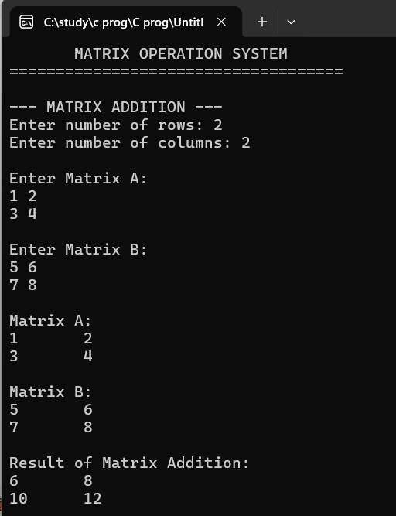

2.3.3 Matrix Subtraction Output

This screen shows the result obtained after performing subtraction of two matrices having the same order.

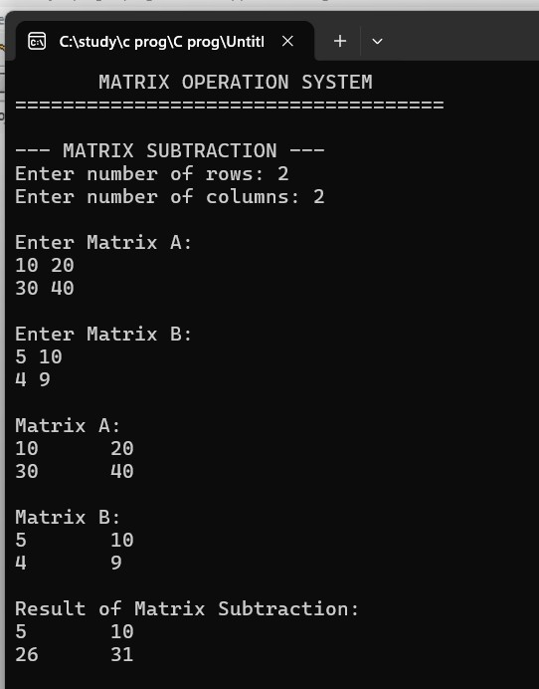

2.3.4 Matrix Multiplication Output

This screen shows the result obtained after multiplying two compatible matrices.

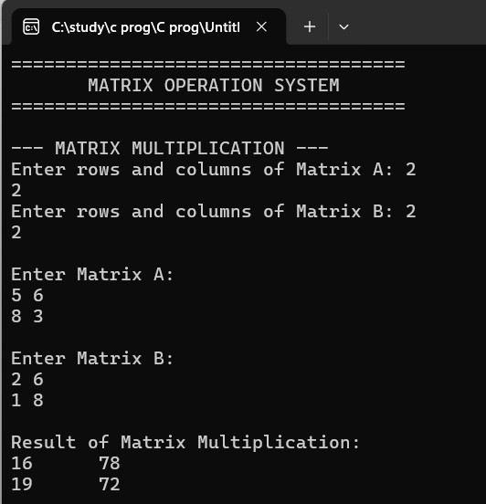

2.3.5 Matrix Transpose Output

This screen shows the transpose of the selected matrix, where rows are converted into columns and columns into rows.

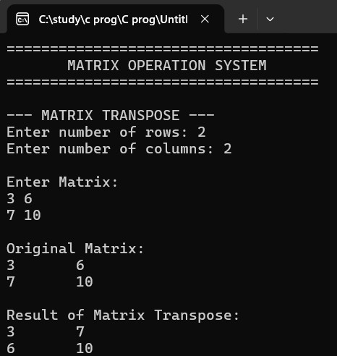

2.3.6 Exit / Reset Screen

This screen shows the option to reset the inputs or exit the Matrix Operation System.

CHAPTER – 3

CONCLUSION & FUTURE SCOPE

3.1 CONCLUSION

The Matrix Operation System successfully provides a simple and efficient way to perform common mathematical operations on matrices using C++. The system performs operations such as matrix addition, subtraction, multiplication, and transpose.

The project reduces the time and effort required for manual matrix calculations and helps minimize calculation errors. It also provides a simple menu-driven interface through which users can select the required operation and view the result clearly.

The project demonstrates the practical application of Object-Oriented Programming concepts such as classes and member functions in solving mathematical problems. Overall, the Matrix Operation System provides an organized and user-friendly approach to performing matrix calculations.

3.2 FUTURE SCOPE

The Matrix Operation System can be enhanced in the future by adding more advanced matrix operations and additional features. Possible improvements include:
- Addition of determinant calculation.
- Addition of inverse of a matrix.
- Support for larger matrices.
- Addition of rank calculation.
- Support for eigenvalues and eigenvectors.
- Improved user interface for easier interaction.
- Addition of an option to save and retrieve matrix results.
- Addition of more validation features for handling incorrect inputs.
- Development of a graphical user interface for better usability.

These enhancements can make the system more powerful and useful for advanced mathematical, engineering, and academic applications.

