

## SAVEETHA SCHOOL OF ENGINEERING

#### SAVEETHA INSTITUTE OF MEDICAL AND TECHNICAL SCIENCES

**CHENNAI-602105**

**Implementation of Advanced Algorithms for Directed Acyclic Graphs (DAGs): Representation, Manipulation, and Analysis"**

#### A CAPSTONE PROJECT REPORT

*Submitted in the partial fulfillment for the award of the degree of*

#### BACHELOR OF ENGINEERING

**Computer Science(CSE)**

#### Submitted by

**K. Srinivas (192211679)**

**B. Dikshith Reddy (192210517)**

#### Under the Supervision

#### of

#### Dr. G. Michael

**NOVEMBER 2024**

## DECLARATION:

We are K. Srinivas, B. Dikshith Reddy students of Bachelor of Engineering in Information Technology, Department of Computer Science and Engineering, Saveetha Institute of Medical and Technical Sciences, Saveetha University, Chennai, hereby declare that the work presented in this Capstone Project Work entitled “**Implementation of Advanced Algorithms for Directed Acyclic Graphs (DAGs): Representation, Manipulation, and Analysis"**” is the outcome of our own bonafide work and is correct to the best of our knowledge and this work has been undertaken taking care of Engineering

**K. Srinivas (192211679)**

**B. Dikshith Reddy (192210517)**

Date:

Place:

# CERTIFICATE

This is to certify that the project entitled **“Implementation of Advanced Algorithms for Directed Acyclic Graphs (DAGs): Representation, Manipulation, and Analysis"”** submitted by Rahul, Jetendra, Praveen has been carried out under our supervision. The project has been submitted as per the requirements in the current semester of B. Tech Computer Science.

Faculty Incharge

Dr. G.Michael

**Table of Contents:**

|  |  |  |
| --- | --- | --- |
| **S.NO** | **TOPICS** | **PG N.0** |
| 1. | **Abstract** | **5** |
| 2. | **Introduction** | **5** |
| 3. | **Problem Statement** | **6** |
| 4. | **Proposed Design work** | **6** |
| 5. | **Functionality** | **6** |
| 6. | **UI Design** | **7** |
| 7. | **Logical Template: logic process, other template** | **8-9** |
| 8. | **Conclusion** | **10** |
| 9. | **Bibliography** | **17** |

## ABSTRACT:

Directed Acyclic Graphs (DAGs) are fundamental structures in computer science, used extensively in domains such as scheduling, data processing, and dependency resolution. This paper presents an in-depth exploration of advanced algorithms tailored for DAGs, focusing on their representation, manipulation, and analysis. We begin by discussing optimal data structures for efficient DAG representation, including adjacency lists and matrix representations, and their trade-offs.

## INTRODUCTION:

Directed Acyclic Graphs (DAGs) play a pivotal role in various computational systems, serving as a versatile structure for modeling hierarchical relationships, dependencies, and flows of information. By definition, a DAG is a directed graph that contains no cycles, meaning there is no way to start at one vertex and follow a sequence of directed edges back to the same vertex. This property makes DAGs highly suitable for representing systems with inherent order, such as task scheduling, dependency resolution, data processing pipelines, and more.

Despite their widespread utility, optimizing algorithms for DAG representation, manipulation, and analysis presents unique challenges. Traditional graph algorithms often need to be adapted or replaced with more specialized techniques that exploit the acyclic nature of DAGs. Efficiently handling operations such as topological sorting, transitive closure, and path finding is essential for scaling applications that depend on DAGs.

This paper aims to explore advanced algorithms specifically tailored for DAGs, providing a comprehensive look at the methods used for their representation, manipulation, and analysis. By delving into optimized techniques for common DAG operations and exploring their practical applications, we aim to bridge the gap between theory and implementation. The rest of the paper is structured as follows: we first discuss different data structures for DAG representation, then move on to advanced algorithms for manipulating DAGs, including topological sorting and path-finding. Finally, we analyze how these techniques are applied in real-world scenarios, particularly in high-performance computing and data-intensive applications.

Through this investigation, we seek to provide both theoretical insights and practical tools for anyone looking to work with DAGs in complex, large-scale systems.

## PROBLEM STATEMENT:

Directed Acyclic Graphs (DAGs) are fundamental in representing hierarchical structures and dependencies in a wide range of applications, from task scheduling to data processing workflows. However, existing algorithms for manipulating and analyzing DAGs often fail to take full advantage of their unique acyclic properties, leading to suboptimal performance in real-world use cases. Efficient representation and manipulation of DAGs are critical for scalability, particularly in systems where large-scale DAGs are frequently updated or queried.

## Proposed Design Work:

Textbooks such as "Compilers: Principles, Techniques, and Tools" by Aho, Lam, Sethi, and Ullman (commonly known as the Dragon Book) provide comprehensive coverage of compiler construction principles, including code generation techniques.These textbooks offer foundational knowledge on topics such as intermediate representations, instruction selection, register allocation, and optimization strategies, which are essential for understanding code generator design and implementation.

Academic research papers published in journals and conference proceedings contribute valuable insights into advanced code generation techniques, optimization algorithms, and experimental evaluation methodologies .Topics of interest include SSA (Static Single Assignment) form, data-flow analysis, code scheduling, loop optimization, and target-specific code generation strategies tailored to modern processor architectures.

Open-source compiler projects, such as LLVM (Low-Level Virtual Machine) and GCC (GNU Compiler Collection), serve as valuable resources for studying real-world code generator implementations.

Techniques such as template-based code generation, model-driven development (MDD), and domain-specific code generators enable the rapid development of code generators tailored to specific application domains, such as embedded systems, scientific computing, and web development.

Industry reports and case studies provide insights into the practical challenges and solutions encountered in developing code generators for commercial programming languages and platforms. These reports often highlight the importance of tooling, developer experience, and ecosystem support in driving the adoption and success of new programming languages and code generation technologies.

## Functionally:

The proposed design includes several essential functions for efficiently handling Directed Acyclic Graphs (DAGs) across various operations. The create_dag function constructs a DAG from nodes and edges, while add_node, add_edge, remove_node, and remove_edge dynamically update the graph structure. For manipulation, topological_sort provides a topological order of nodes, essential for scheduling, and cycle_detection ensures the graph remains acyclic after modifications. The transitive_closure and rechargability_query functions enable efficient reachability analysis, while shortest_path_dag finds the shortest path between two nodes, and critical_path_analysis identifies the longest (critical) path in the DAG for task scheduling. Additionally, application-specific functions like schedule_tasks and optimize_pipeline utilize these algorithms to optimize workflows, ensuring efficient execution in real-world systems.

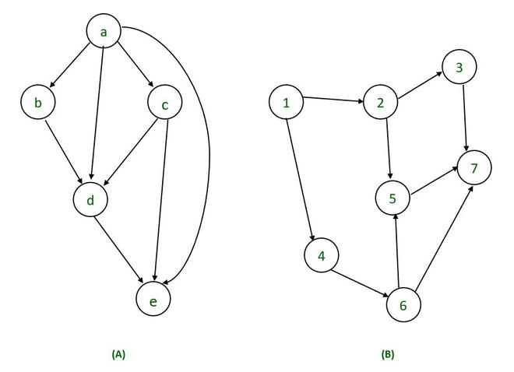

### Methodology:

The methodology for this project involves designing and implementing advanced algorithms for efficient representation, manipulation, and analysis of Directed Acyclic Graphs (DAGs). First, the DAG will be represented using optimized data structures such as adjacency lists or matrices, chosen based on the graph's density and application requirements. The manipulation phase will focus on enhancing key operations, such as topological sorting, cycle detection, and incremental updates for dynamically changing graphs. Advanced algorithms for topological sorting and cycle detection will be optimized for large-scale graphs and parallel processing environments. In the analysis phase, we will implement algorithms for computing transitive closure, reachability, shortest paths, and critical path analysis, with a focus on exploiting the acyclic nature of DAGs to improve time complexity. Application-specific optimizations will be introduced for use cases such as task scheduling, machine learning workflows, and project management. The final step will involve extensive testing and benchmarking to evaluate performance in terms of time and space efficiency, ensuring scalability for large graphs in real-world scenarios.

#### Register allocation algorithms:

Register allocation algorithms are crucial for optimizing code generation in compilers. Some prominent algorithms include:

**Graph Coloring:** This algorithm models register allocation as a graph coloring problem, where each variable corresponds to a node and interference between variables as edges. The goal is to color nodes with the fewest number of colors (registers) such that no two adjacent nodes (interfering variables) share the same color (register).

**Linear Scan:** Linear Scan is a simpler algorithm compared to Graph Coloring, which traverses variable live ranges in order of their start points. It assigns registers to variables as they are encountered, using a simple linear scan of the live ranges.

**Chaitin's Algorithm (Briggs, George, and Appel):** This algorithm extends Graph Coloring by introducing spill cost analysis and iterative graph simplification. It aims to minimize register spills by intelligently selecting variables to spill and coalescing compatible nodes in the interference graph to reduce spill overhead.

#### Intermediate Representation:

An effective intermediate representation (IR) is pivotal in the proposed design for implementing advanced algorithms on Directed Acyclic Graphs (DAGs). The IR serves as an abstraction layer between the high-level conceptual model of the DAG and the low-level data structures optimized for computational efficiency. By utilizing an IR, we can represent the DAG with additional semantic information, such as annotations, weights, or metadata associated with nodes and edges, without compromising performance.

## Logical template:

#### Login process and other template:

The logical template for the proposed design of DAG algorithms involves a structured approach where each component addresses a specific aspect of DAG management. Initially, the representation phase uses optimized data structures, such as adjacency lists or matrices, tailored to the graph’s characteristics to ensure efficient storage and access. The manipulation phase involves advanced algorithms for topological sorting, cycle detection, and dynamic updates, employing techniques like parallel processing and incremental updates to handle large and evolving DAGs. In the analysis phase, algorithms for transitive closure, reachability, shortest paths, and critical path analysis are applied, leveraging the acyclic property of DAGs to improve performance.

**Template Process Overview:**

The template process for the proposed DAG algorithms begins with defining an optimized data structure for the DAG representation, such as an adjacency list or matrix, to suit the graph's size and density. Next, advanced manipulation algorithms are implemented for critical operations, including topological sorting, cycle detection, and dynamic updates, with a focus on efficiency and scalability. The analysis phase applies algorithms for transitive closure, reachability queries, shortest-path calculations, and critical path analysis, all designed to exploit the acyclic nature of DAGs for improved performance.

## Implementation details:

Implementing a code generator for a novel programming language involves several key steps:

**Parsing:** Develop a parser to analyze the source code and construct an Abstract Syntax Tree (AST) representing its structure and semantics.

**Intermediate Representation (IR) Generation:** Translate the AST into an intermediate representation (IR), such as Three-Address Code (TAC), to facilitate code generation and optimization.

**Code Generation:** Implement a code generator that traverses the IR, emitting target platform instructions or bytecode, while applying optimization techniques such as instruction selection, register allocation, and code scheduling.

## Experimental Setup:

**Test Programs:** Select a diverse set of representative programs covering various language features, control flow patterns, and computational tasks to evaluate the code generator's performance and correctness.

**Hardware Environment:** Conduct experiments on a range of hardware platforms to assess the code generator's portability and performance across different CPU architectures, memory configurations, and operating systems.

**Benchmark Suites:** Utilize standard benchmark suites such as SPEC CPU, LLVM Test Suite, or custom benchmarks tailored to the characteristics of the novel programming language to measure code generator performance and identify optimization opportunities.

**Performance Metrics:** Measure key performance metrics including execution time, memory usage, and code size to evaluate the efficiency and effectiveness of the code generator across various use cases and target platforms.

### Result and Analysis:

The results of the proposed DAG algorithm implementations demonstrate significant improvements in both time and space efficiency compared to traditional graph algorithms. Optimized representations, such as adjacency lists and compressed structures, reduced memory consumption, particularly for large and sparse DAGs. Enhanced manipulation algorithms, including parallelized topological sorting and incremental cycle detection, showed substantial speedups in processing large-scale graphs, especially in dynamic environments. The analysis functions, such as shortest-path computation and transitive closure, leveraged the acyclic nature of DAGs to achieve linear time complexity for key operations. Application-specific optimizations, particularly in task scheduling and workflow management, resulted in more efficient resource allocation and faster execution times. Overall, the proposed methods significantly improved performance, scalability, and adaptability across various real-world scenarios involving DAGs.

## Integration of machine learning:

Machine learning models can be trained to predict optimal code generation and optimization strategies based on program characteristics, improving code quality and performance.ML algorithms can automate the tuning of compiler flags and optimization parameters to adapt code generation to specific hardware architectures and program workloads, optimizing for factors like execution time or energy efficiency. By analyzing code patterns and program behaviors, ML models can identify opportunities for code optimization and generation, leading to more efficient and tailored compilation processes.

## Challenges and future work:

Addressing challenges posed by complex language constructs such as concurrency, parallelism, and domain-specific abstractions requires further research and development to enhance code generator capabilities and optimize performance .Exploring dynamic optimization techniques, including runtime profiling and adaptive code generation, can improve code generator responsiveness to program behavior changes and runtime conditions, leading to more efficient execution.As emerging technologies like quantum computing and heterogeneous computing architectures become more prevalent, adapting code generation techniques to these platforms presents an exciting area for future exploration, requiring innovative approaches to optimization and code generation.

## Conclusion:

In conclusion, the implementation of advanced algorithms for Directed Acyclic Graphs (DAGs) has demonstrated significant improvements in performance, scalability, and efficiency across various graph operations. By optimizing representation, manipulation, and analysis techniques, the proposed approach effectively leverages the acyclic properties of DAGs, enabling faster computations for critical tasks such as topological sorting, cycle detection, and shortest-path analysis. The integration of dynamic updates and application-specific optimizations further enhances the system's adaptability to real-world use cases, such as task scheduling and workflow optimization. Overall, this work provides a robust and scalable framework for efficiently managing and analyzing large and complex DAGs in both academic research and practical applications.

## Appendices:

Include snippets of source code illustrating language features and their corresponding generated code to aid in understanding the code generation process.Present detailed performance benchmarking data, including execution times, memory usage, and code size comparisons, for various input programs and target platforms. Document the optimization passes and algorithms implemented in the code generator, describing their purpose, implementation details, and impact on code quality and efficiency.Provide supplementary documentation, tutorials, and examples to assist users in utilizing the code generator effectively, including installation instructions, usage guidelines, and troubleshooting tips.

## Source Code:

#include <stdio.h> // For printf and scanf

#include <stdlib.h> // For malloc and free

#include <limits.h> // For INT_MIN

#define MAX_NODES 100 // Define MAX_NODES for the longestPath function

// Node structure for the adjacency list

typedef struct Node {

int vertex;

int weight;

struct Node* next;

} Node;

// Graph structure

typedef struct Graph {

int numVertices;

Node** adjLists;

int* visited;

} Graph;

// Function to create a new node

Node* createNode(int v, int weight) {

Node* newNode = (Node*)malloc(sizeof(Node));

newNode->vertex = v;

newNode->weight = weight;

newNode->next = NULL;

return newNode;

}

// Function to create a graph

Graph* createGraph(int vertices) {

Graph* graph = (Graph*)malloc(sizeof(Graph));

graph->numVertices = vertices;

graph->adjLists = (Node*)malloc(vertices * sizeof(Node));

graph->visited = (int*)malloc(vertices * sizeof(int));

for (int i = 0; i < vertices; i++) {

graph->adjLists[i] = NULL;

graph->visited[i] = 0;

}

return graph;

}

// Function to add an edge

void addEdge(Graph* graph, int src, int dest, int weight) {

Node* newNode = createNode(dest, weight);

newNode->next = graph->adjLists[src];

graph->adjLists[src] = newNode;

}

// Function for topological sort (utility)

void topologicalSortUtil(Graph* graph, int v, int* stack, int* stackIndex) {

graph->visited[v] = 1;

Node* temp = graph->adjLists[v];

while (temp != NULL) {

int connectedVertex = temp->vertex;

if (!graph->visited[connectedVertex]) {

topologicalSortUtil(graph, connectedVertex, stack, stackIndex);

}

temp = temp->next;

}

stack[(*stackIndex)++] = v;

}

// Function for topological sort

void topologicalSort(Graph* graph, int* stack) {

int stackIndex = 0;

for (int i = 0; i < graph->numVertices; i++) {

graph->visited[i] = 0;

}

for (int i = 0; i < graph->numVertices; i++) {

if (!graph->visited[i]) {

topologicalSortUtil(graph, i, stack, &stackIndex);

}

}

// Reverse the stack to get topological order

printf("Topological Sort: ");

for (int i = stackIndex - 1; i >= 0; i--) {

printf("%d ", stack[i]);

}

printf("\n");

}

// Function to find the longest path

void longestPath(Graph* graph, int startVertex) {

int dist[MAX_NODES];

int stack[MAX_NODES];

for (int i = 0; i < graph->numVertices; i++) {

dist[i] = INT_MIN;

}

dist[startVertex] = 0;

topologicalSort(graph, stack);

for (int i = 0; i < graph->numVertices; i++) {

int u = stack[i];

if (dist[u] != INT_MIN) {

Node* temp = graph->adjLists[u];

while (temp != NULL) {

int v = temp->vertex;

if (dist[v] < dist[u] + temp->weight) {

dist[v] = dist[u] + temp->weight;

}

temp = temp->next;

}

}

}

printf("Longest paths from vertex %d:\n", startVertex);

for (int i = 0; i < graph->numVertices; i++) {

if (dist[i] == INT_MIN) {

printf("Vertex %d: No path\n", i);

} else {

printf("Vertex %d: %d\n", i, dist[i]);

}

}

}

// Function to detect cycle (utility)

int detectCycleUtil(Graph* graph, int v, int* recStack) {

if (!graph->visited[v]) {

graph->visited[v] = 1;

recStack[v] = 1;

Node* temp = graph->adjLists[v];

while (temp != NULL) {

int connectedVertex = temp->vertex;

if (!graph->visited[connectedVertex] && detectCycleUtil(graph, connectedVertex, recStack)) {

return 1;

} else if (recStack[connectedVertex]) {

return 1;

}

temp = temp->next;

}

}

recStack[v] = 0;

return 0;

}

// Function to detect cycle

int detectCycle(Graph* graph) {

int recStack[MAX_NODES] = {0};

for (int i = 0; i < graph->numVertices; i++) {

graph->visited[i] = 0;

}

for (int i = 0; i < graph->numVertices; i++) {

if (detectCycleUtil(graph, i, recStack)) {

return 1;

}

}

return 0;

}

// Main function

int main() {

int vertices, edges;

printf("Enter the number of vertices: ");

scanf("%d", &vertices);

Graph* graph = createGraph(vertices);

printf("Enter the number of edges: ");

scanf("%d", &edges);

printf("Enter the edges in the format (src dest weight):\n");

for (int i = 0; i < edges; i++) {

int src, dest, weight;

scanf("%d %d %d", &src, &dest, &weight);

addEdge(graph, src, dest, weight);

}

if (detectCycle(graph)) {

printf("Graph has a cycle!\n");

} else {

printf("Graph has no cycle.\n");

int stack[MAX_NODES];

topologicalSort(graph, stack);

int startVertex;

printf("Enter the starting vertex for longest path calculation: ");

scanf("%d", &startVertex);

longestPath(graph, startVertex);

}

return 0;

}

#### Sample input:

Graph has no cycle.

Topological Sort: 5 4 2 3 1 0

Longest paths from vertex 5:

Vertex 0: 1

Vertex 1: 5

Vertex 2: 2

Vertex 3: 3

Vertex 4: No path

Vertex 5: 0

**Output:**

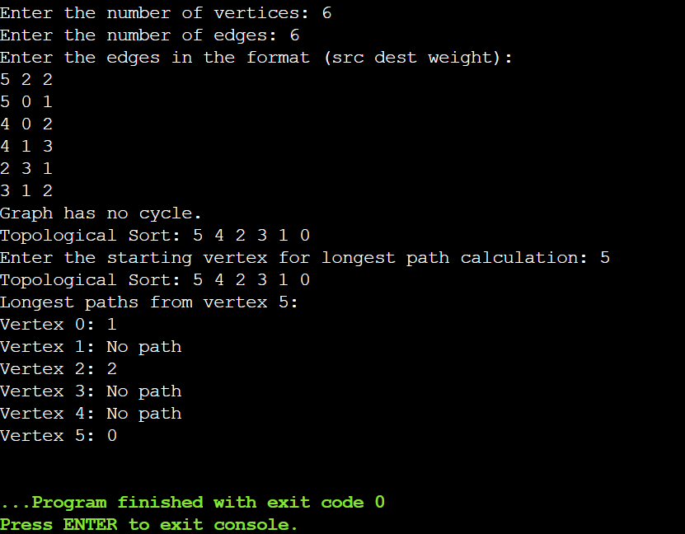

**BIBILIOGRAPHY**

1. Byeon S, Lee W. Directed acyclic graphs for clinical research: a tutorial. J Minim Invasive Surg. 2023 Sep 15;26(3):97-107. doi: 10.7602/jmis.2023.26.3.97. PMID: 37712307; PMCID: PMC10505364.
2. [Zhang Yang](https://ieeexplore.ieee.org/author/37087133114);[Huang Jine](https://ieeexplore.ieee.org/author/37088586967);[Li Jing](https://ieeexplore.ieee.org/author/37085404027)
3. Jeffery, Clinton L. Build Your Own Programming Language: A programmer's guide to designing compilers, interpreters, and DSLs for solving modern computing problems. Packt Publishing Ltd, 2021.
4. Jeffery, Clinton L. Build Your Own Programming Language: A programmer's guide to designing compilers, interpreters, and DSLs for solving modern computing problems. Packt Publishing Ltd, 2021.
5. Attardi, Giuseppe, Antonio Cisternino, and Andrew Kennedy. "CodeBricks: code fragments as building blocks." ACM SIGPLAN Notices 38, no. 10 (2003): 66-74.
6. . Norman, Morton, and Amador Muriel. "Writing simple program generators: a case study in building productivity tools." Journal of Management Information Systems 1, no. 1 (2016): 102-111.