Sets:
A set is a well-defined collection of distinct objects, also known as elements.

• Union: (union ∪):
The union of two sets contains all elements from both sets.
• Intersection: (∩intersection∩):
The intersection of two sets contains only the elements that are common to both sets.
Difference:
The difference between set A and set B (A−B Cap A minus cap B 𝐴−𝐵)
Contains all elements that are in A but not in B.
Compliment:
The complement of a set contains all the elements of the universal set that are not in that set.

Venn diagrams:

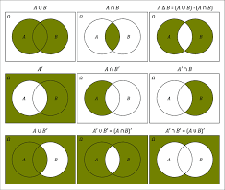

• infinite set: A set with an unlimited number of elements.
• Subset: A set A cap A is a subset of set B cap B

If all elements of A cap A
There are also elements of B cap B
This is written as:
A ⊆ B cap A is a subset of or equal to cap B, 𝐴⊆𝐵

• Universal set: A set containing all possible elements under consideration for a particular problem.

This below pictures is about the topic sets:

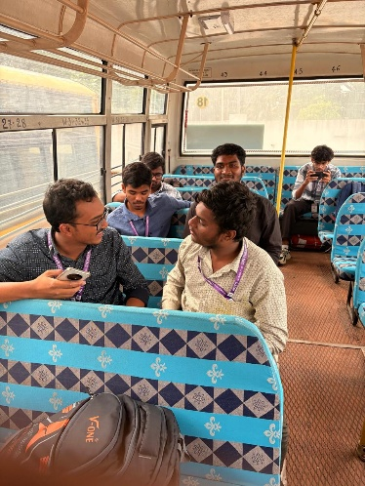 fig_1
- This above diagram tells about a,b,c,d.
- Sitting together. 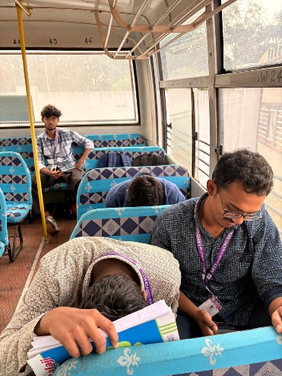 fig_2
- This picture shows 3 members a,b,c sitting together.

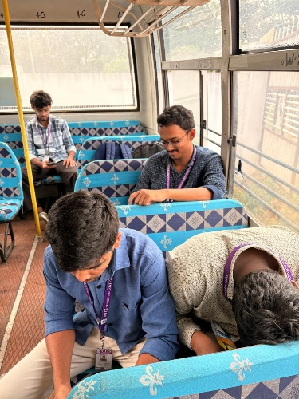 fig_3
This picture shows that the different from fig_2
The placement of two students are different.
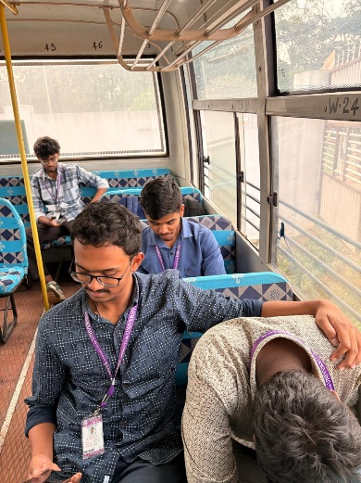 fig_4
This fig is different from fig_3.
This is different because the 1 person is interchanged.

Another observation
