Research on Python (on day to day life)
On Garden Delights (for tea)
Step:-1 We Visited Garden Delights restaurant located at Reddy’s colony.
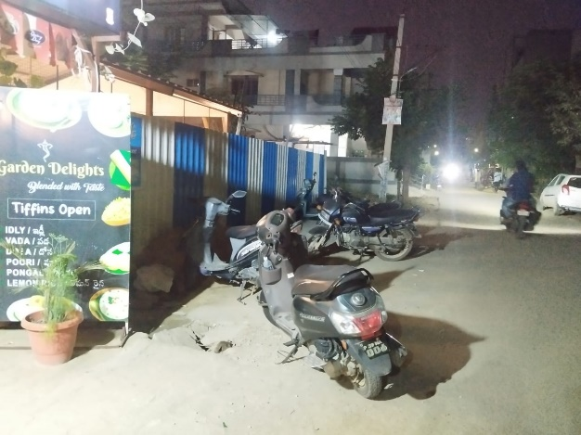
Step 2:- bikes are parked unorderly like set in python

In above we can’t found any duplicate bike. Here we can’t find which bike will un park first .
->above pic can park bicycle , cars ,van ,bus , humans are stand there and all animals are also stand here.
->in above pic we find only homogenous element (bikes).
->In front of that shop we can park multiple type items. Like heterogenous elements.
Finally we conclude that above pic is pointing set data type in Python

Step3:-when we entering into that restaurant at that front we observer one lighting board .
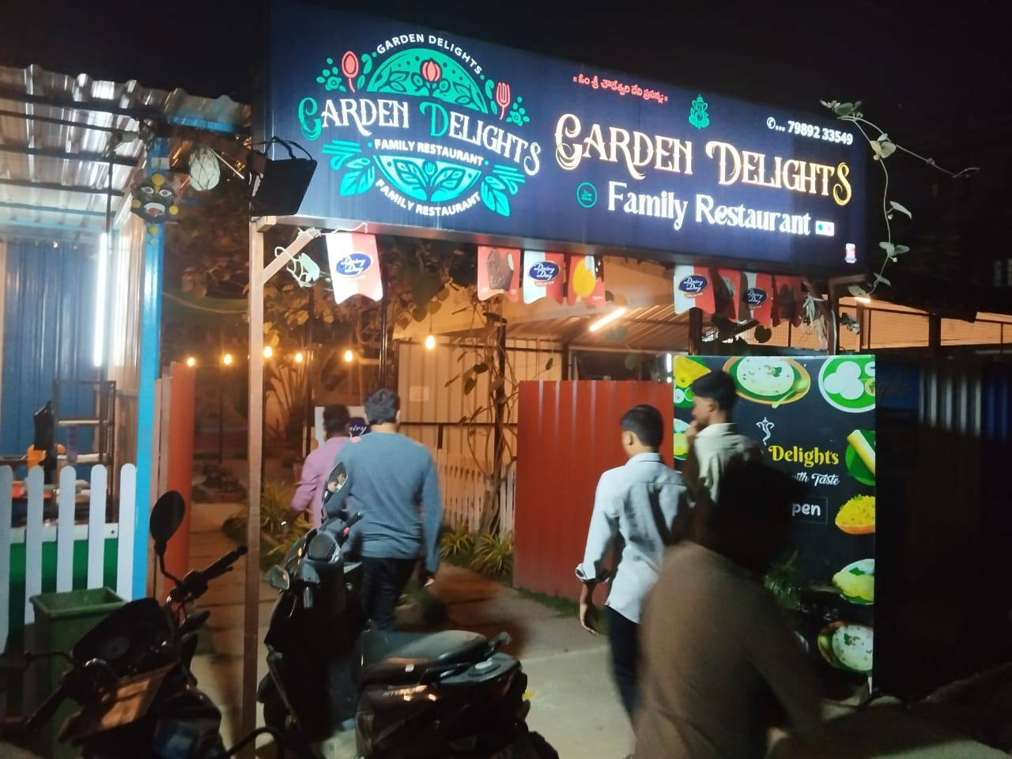

In above pic we observe one lighting board with restaurant name “Garden Delights”.
->In lighting board all word are arranged in sequence in order and also elements are fixed just like a tuple.
->In above pic we find duplicate words “Garden Delights family restaurant e.t.c .
->we find multiple elements i.e. phone number, logo, name, Telugu words e.t.c.
Tuple:- collection of different type of elements which is arranged in order but elements are fix it allows duplicates .

Step 4:- In that restaurant we observe 6 person are sitting in round table they are taking selfie.
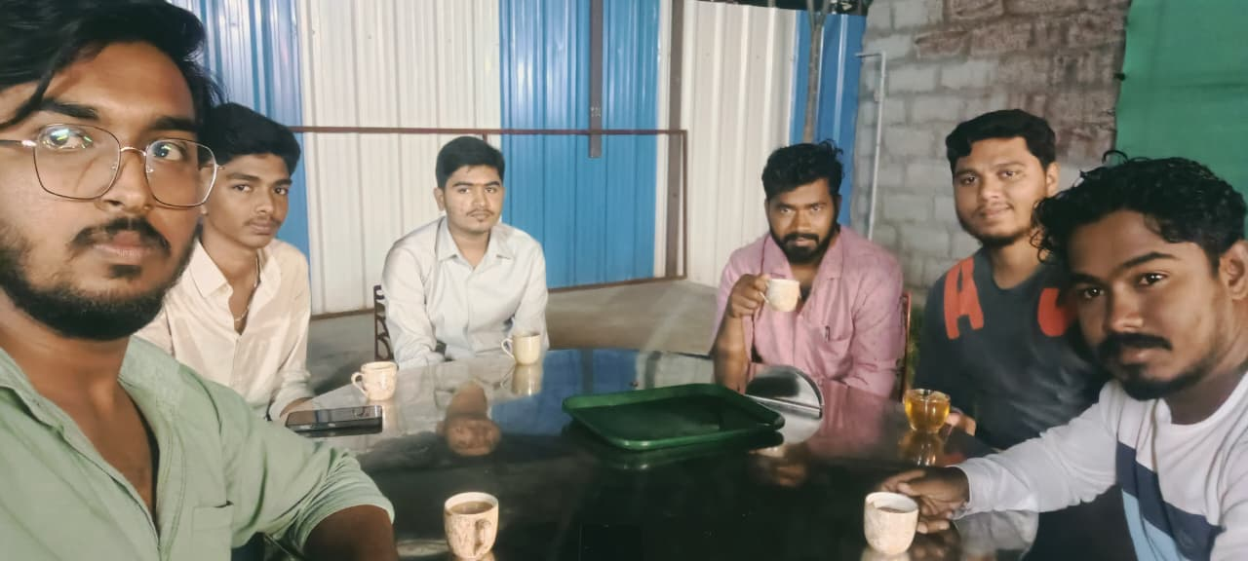
In above pic we observe that each person having a cup of tea.
We have specified two persons whose details are maintained in Python using the dictionary (dict) data type.
Here key is person and values are tea cups.
Person duplication is not passable (key). Cup can be duplicated (values).
Dict:-if you want represented group of elements in the form of key value pairs then we can go for dict data type.

Step 5:-
In this pic we observed different objects like chairs, tables, steel rods, lights.
