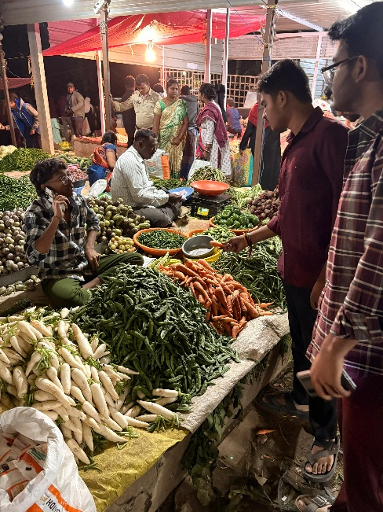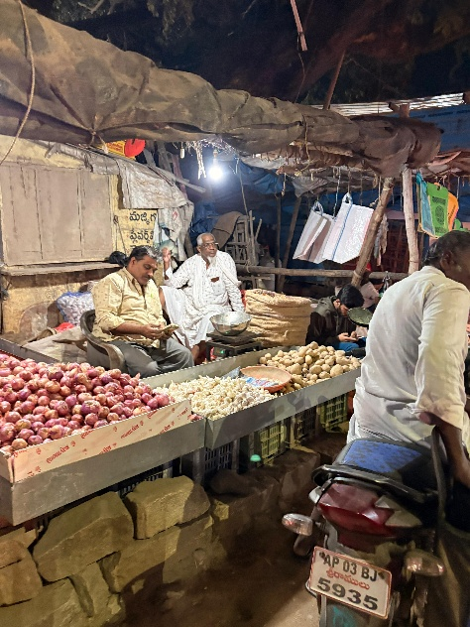
Asking for ½ kg carrot asking for 2½ kg of onions. Shopkeeper said
Shopkeeper said ½ kg=30 that 5kg is 100 and 2 ½ kg is 50
In this picture we observed that so from this picture we can observe that
Different vegetables are there in this picture also we used arithmetic op.
And the prices of them also diff
In this pic shopkeeper said 1kg =60
But we asked for ½ kg then he said ½ kg is
30.
So from this pic we can understand that
<Arithmetic operators>
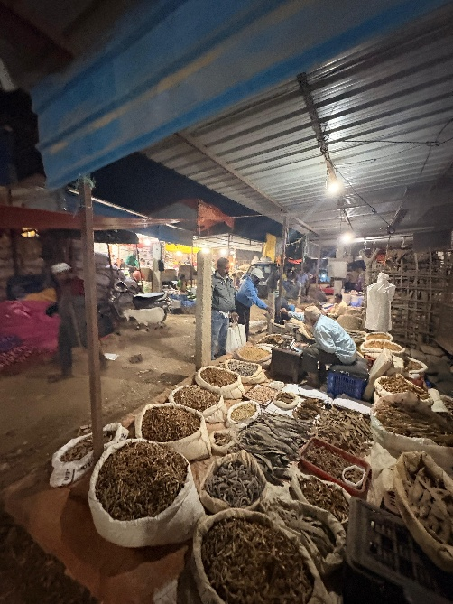 in this pic we can observe the different spices like
Comparision of any two vegetables.
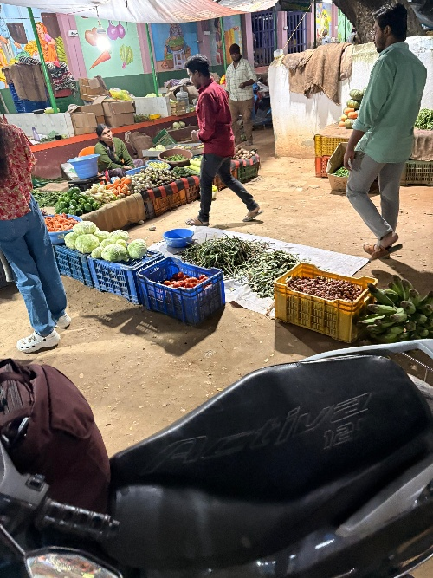 we can take the vegetables as assignment example
Onion is the variable and the price of the onion is called as assignment.

