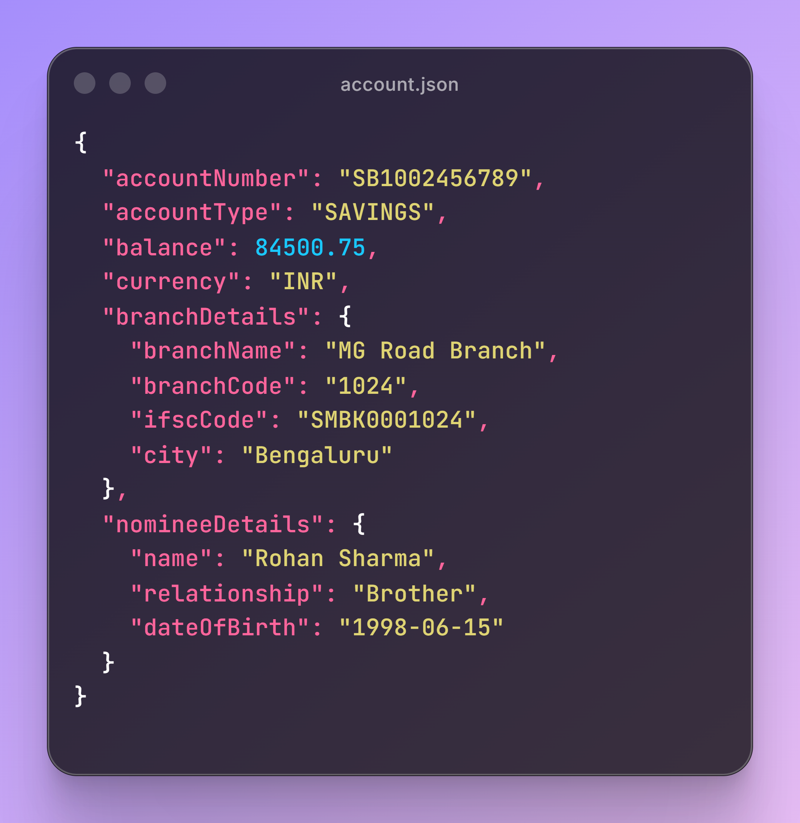
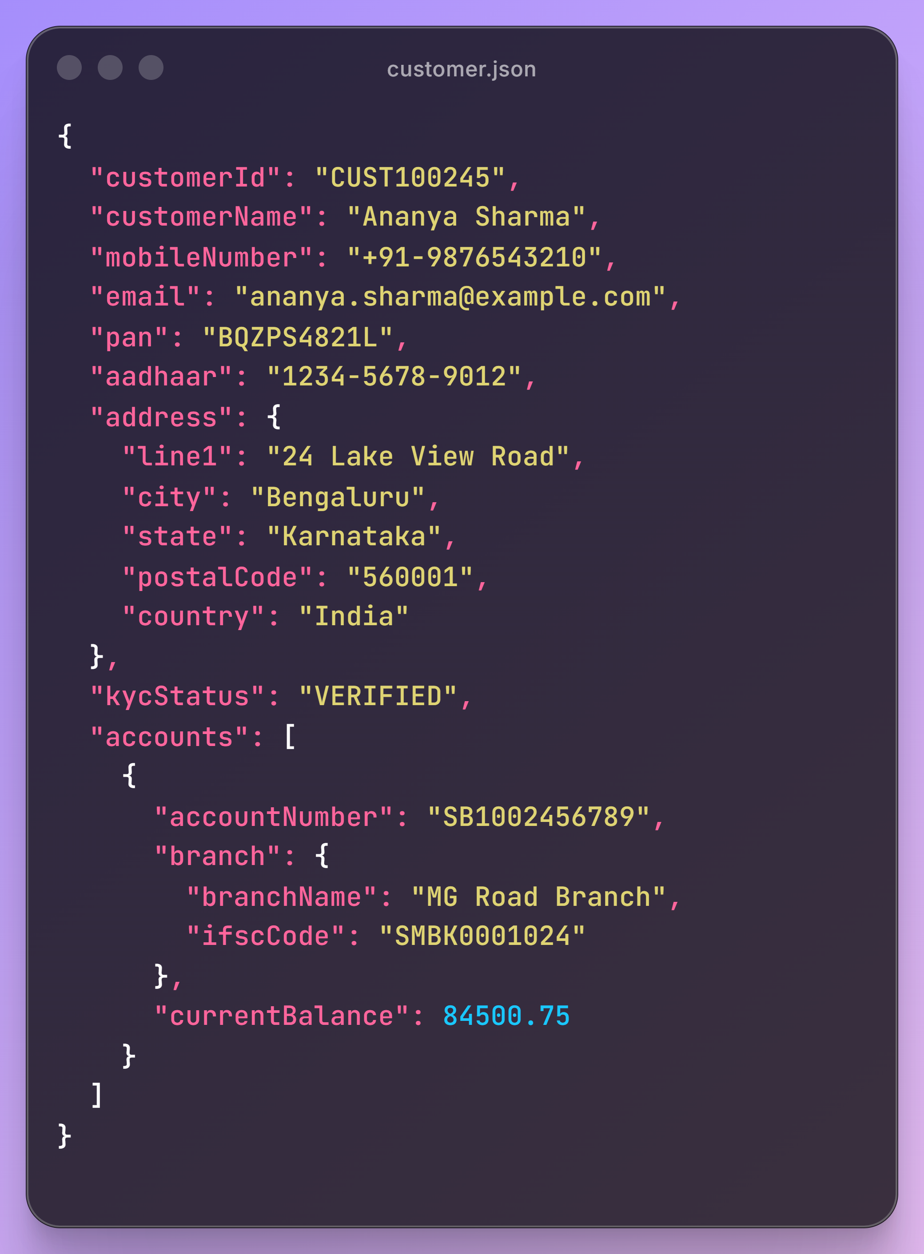

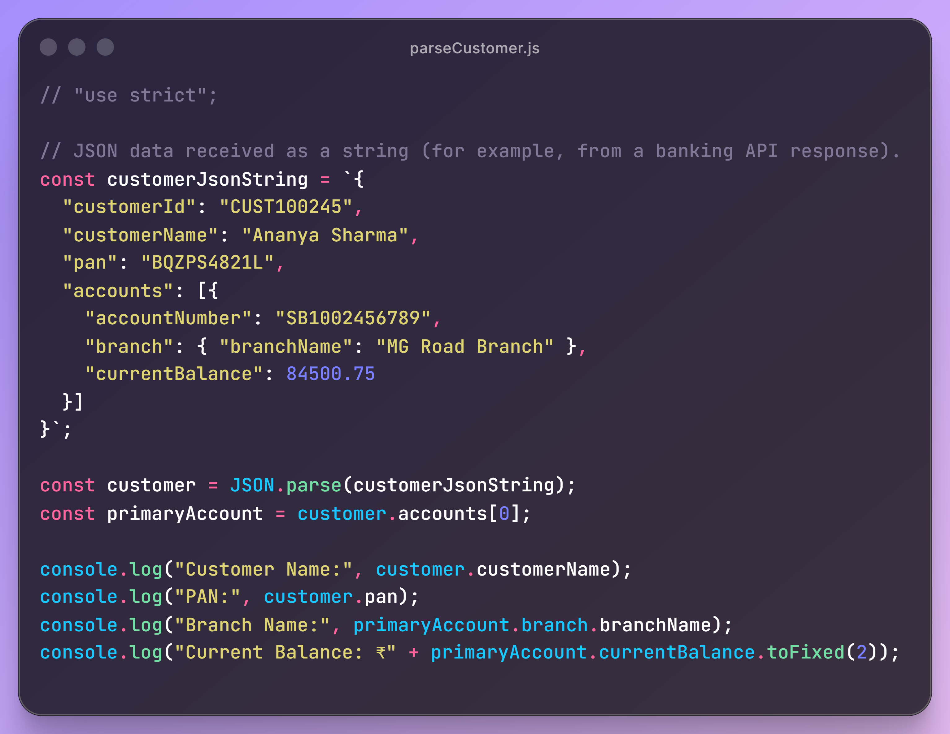
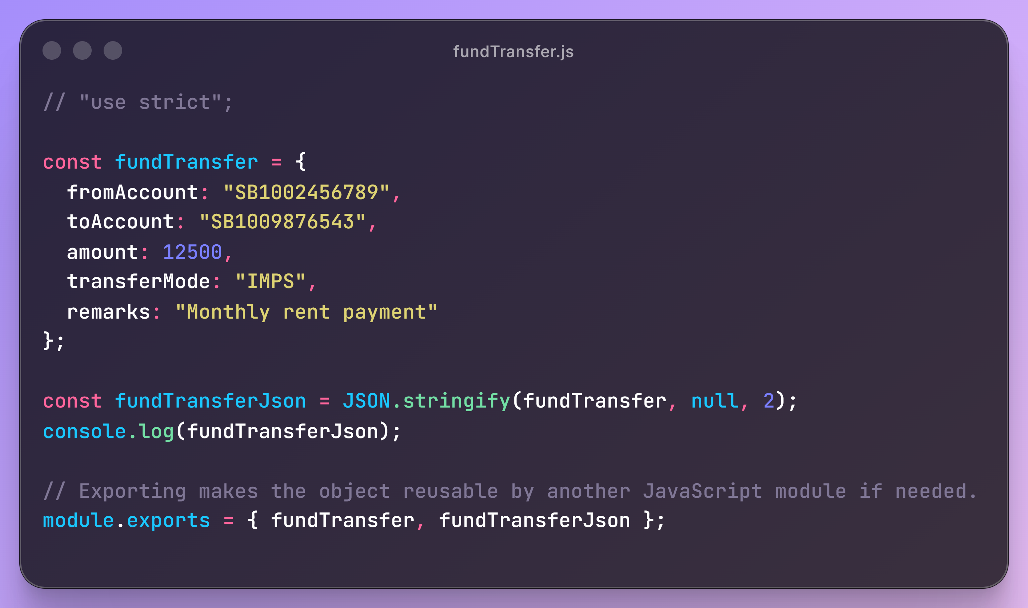

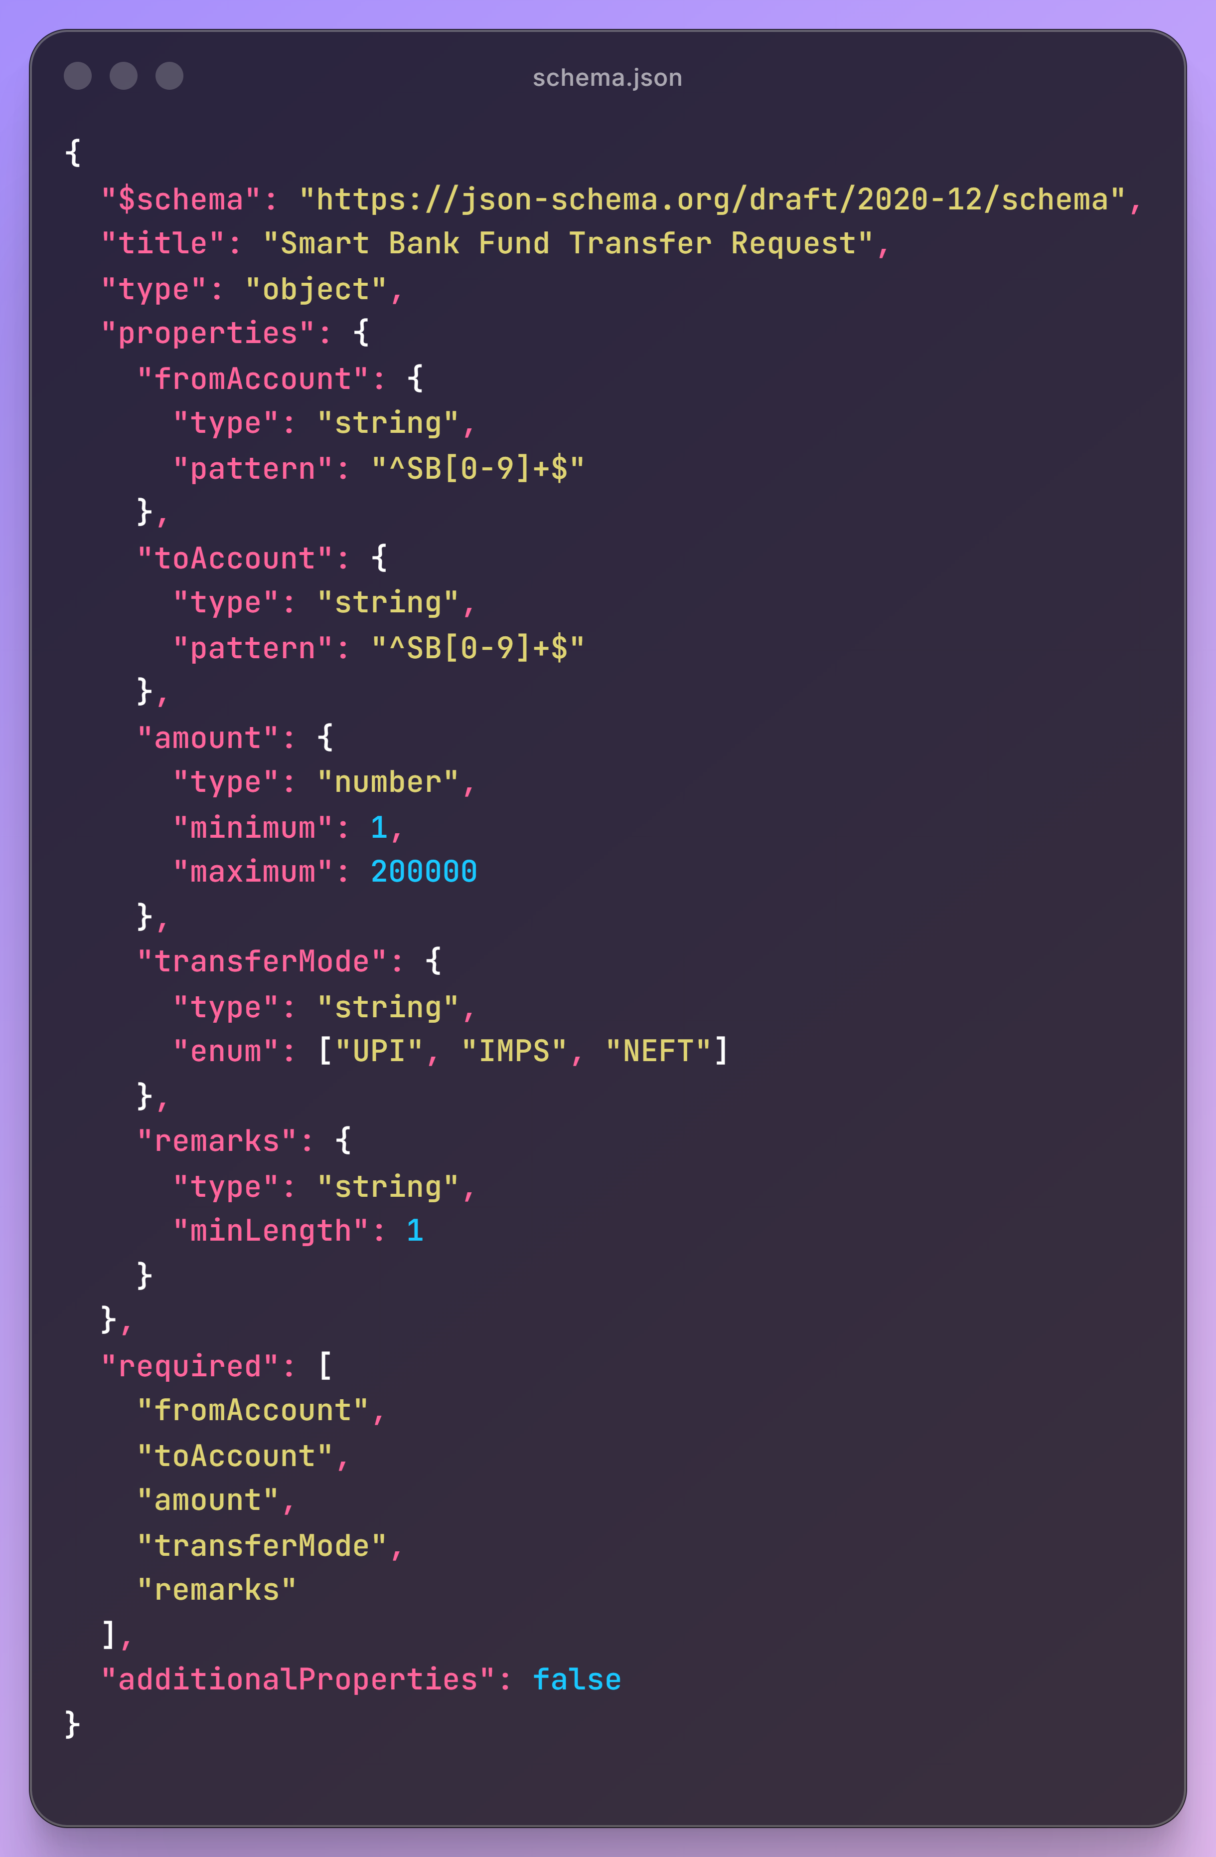

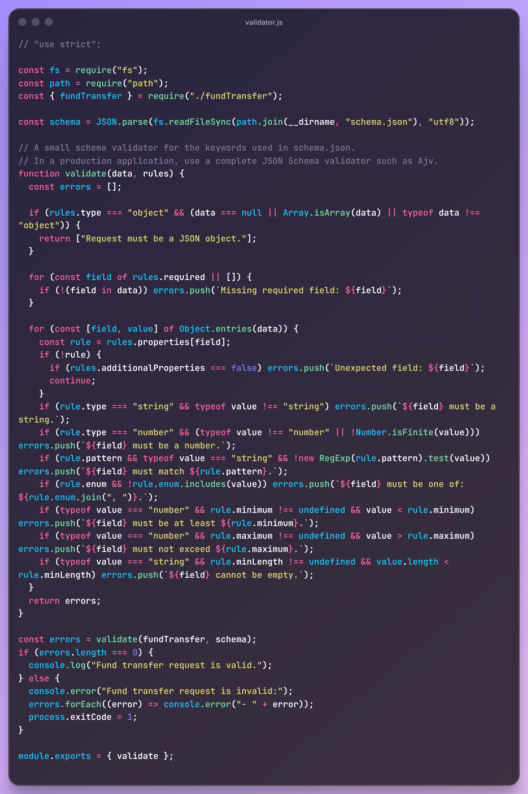
1. What is a data interchange format? Give two situations where it is required.
Answer: A data interchange format is a standard way to represent and transfer data between different systems. It is required when a mobile banking app communicates with a banking API, and when a payment gateway sends transaction details to a merchant system.
2. Why is a common data format useful when two different applications exchange information?
Answer: It ensures both applications understand the data in the same way, reducing conversion effort, errors, and compatibility problems.
3. Name four commonly used data interchange formats.
Answer: JSON, XML, CSV, YAML.
4. What is JSON? What does the term JSON stand for?
Answer: JSON is a lightweight text-based format used to store and exchange structured data. JSON stands for JavaScript Object Notation.
5. List any four benefits of JSON.
Answer: JSON is lightweight, human-readable, easy to parse, language-independent, and supports nested data.
6. Write three differences between JSON and XML.
Answer: JSON uses braces and brackets, while XML uses tags. JSON is less verbose than XML. JSON uses key-value pairs and native arrays, while XML uses elements and attributes.
7. What is a JSON object? Which symbols are used to define an object?
Answer: A JSON object is a collection of key-value pairs. It is defined using curly braces { }.
8. What is a JSON property? Explain the key-value structure.
Answer: A JSON property is an item inside a JSON object. It has a key and a value, for example: "name": "Deekshith". The key identifies the property and the value stores its data.
9. What is a JSON array? How is it different from a JSON object?
Answer: A JSON array is an ordered list of values enclosed in square brackets [ ]. A JSON object stores named key-value pairs, while an array stores values by position.
10. List the valid JSON data types.
Answer: String, number, boolean, null, object, and array.
11. What is a nested JSON object? Give one practical example where nesting is useful.
Answer: A nested JSON object is an object inside another object.
For example, a customer object can contain an address object with city, state, and postal code.

12. What is JSON parsing?
Answer: JSON parsing is the process of converting JSON text into a usable object or data structure in a programming language.
13. What is the purpose of JSON.parse() in JavaScript?
Answer: JSON.parse() converts a JSON string into a JavaScript object or array.
14. What is the purpose of JSON.stringify() in JavaScript?
Answer: JSON.stringify() converts a JavaScript object or array into a JSON string.
15. What is a schema and why is a schema useful for JSON data?
Answer: A schema defines the expected structure and rules for JSON data. It is useful for validating data and ensuring it follows an agreed format.
16. What is JSON Schema validation? Mention any four rules that a schema can enforce.
Answer: JSON Schema validation checks whether JSON data follows the rules in a schema. It can enforce data types, required fields, number ranges, allowed values, patterns, and string lengths.
Rules-Like : “minLength”, “maximum”, “required”, “enum”
17. What is the difference between a required property and an optional property in JSON Schema?
Answer: A required property must be included in the JSON data. An optional property may be omitted, but if included, it must follow its defined rules.
18. What is the purpose of the type, properties, required and items keywords in JSON Schema?
Answer: type defines the data type; properties defines rules for object fields; required lists mandatory fields; and items defines the rules for values inside an array.

