
MVP Testing Guide

Thank you for agreeing to test the Frontera MVP. Our vision is to create the world’s best Product Model Coaching platform.

Product Model Transformations Are Failing Enterprises: Frontera Is Inventing the future of Strategy and Product Model Coaching, through A First-of-Its-Kind Product Coaching Platform which replaces outdated Consultancy-Led “Transformations”.

Frontera Coaching is the future of digital transformation: modular, AI-powered, practitioner-built, and designed to embed product strategy, team development, and outcome-based execution at enterprise scale.

In this testing phase we are asking you to help us test the Product Strategy Development feature, as well as provide feedback on any/ all perceptions on the Product, Mission and experience in the platform.

This is designed for a company product strategy for startup to Enterprise, rather than an individual product team, which will come later.

We will use sessions recording software to analyse the usability of the platform, this only records what happens on the screen.

Section 1: Preparation (Complete Before starting the Testing)
Please read this entire section and complete the steps below. If you are open to a call post testing I would really like to hear some direct feedback on the product concept and user experience.

1.1 Choose a Company
You'll be using Frontera to develop a product strategy for a real (or realistic) company. Choose one of the following:
- Your own company — ideal if you're comfortable sharing strategic information
- A company you know well — a previous employer, a client,, competitor, or a company in your industry
- A start up idea you have
- A fictional company — if you'd prefer, invent a company in an industry you understand (e.g. "a mid-sized fintech lender targeting SMEs")

Whichever you choose, you should be able to speak to the company's products, customers, competitors, and strategic challenges. It will help you assess the quality of the coaching and recommendations.

1.2 Gather Supporting Materials
The platform will ask you to upload documents that describe the company's context and performance. Having these ready will make the session smoother and more realistic.

Useful materials to have (any format — PDF, Word, web links):
- Annual report or financial summary
- Company strategy document or investor presentation
- Product roadmap or product overview
- Market research or competitive analysis
- Customer research, personas, or survey results
- Press releases or recent news articles about the company

Don't have these to hand? That's fine. You have options:
- Use publicly available materials — most companies publish annual reports, investor decks, and press releases on their websites.
- Use the document finder in the Discovery section, where you can ask the ai coach to search using key words or urls
- Generate example documents using an AI tool — open ChatGPT or Claude (claude.ai) and ask it to create realistic example documents. For example:
- "Write a one-page executive summary of annual results for a mid-sized B2B SaaS company in the healthcare sector with £25m revenue"
- "Create a brief competitive landscape overview for a fintech company competing in SME lending in the UK"
- "Write a product strategy summary for a logistics technology company focused on last-mile delivery"

Save each response as a PDF or Word document so you can upload it during the session.

If you want guidance on a longer prompt. Here is one I created for a fictional company to follow the test the platform myself. You don’t need to write this much, but it might help.
“The Lochee Investment Company (LIC) is a start-up at pre-seed stage. They specialise in digital financial planning, aiming to solve the UK Financial advice gap through subscription a based product and platform that helps those who cannot access advice (afford or knowledge), those who do not have enough assets for f2f IFA service, or those who do not value the current advice offering. LIC are creating a greenfield modern advice and planning platform that supports, guides and coaches you through your financial life: financial health, long term goals, planning and pro-active coaching throughout all stages.

LIC uses Open data, from banking, consumer tech, investment, insurance and public data to complement the coaching interaction and through the use of data and insights, helps you plan, grow and be aware of your financial future with confidence and protection. I want you to create a sample pitch pack for the Lochee Investment Company, you should use the branding in the Logo design chat in this folder. Search for content/ back ground on targeted support, uk advice gap and generational wealth transfer using sources such as: Langcat, Next Wealth, FTRC, Ian Mckenna, FT Adviser, Investment Trends, The Times, Citywire, Proffesional Adviser, FCA, FT and wider).
For the USP/ IP in the product market fit, please propose a winning platform which combines personalisation in risk, life stage, desires, occupation etc, with market leading AI coaching interface, behaviour and financial goals planning journeys and cost/ charging which is affordable and aligns with the client outcomes (often a challenge of investment companies, misaligned objectives). Also propose on how this will engage the different personas who do not/ cannot engage with Financial advice. I know I have not given all the answers to create this, I want you to use the sources proposed and wider and create a pitch which will require creativity from you.”

Aim to have 3 documents+ ready. One is the minimum — the more context you provide, the more tailored the coaching experience will be.

1.3 Set Up Your Environment
- Use a laptop or desktop computer with a modern browser (Chrome, Edge, Safari, or Firefox)
- Have your documents saved somewhere accessible on your computer
- Close other tabs and applications to minimise distractions

Section 2: Tasks (Complete During the Session)
Please work through these tasks in order. Take your time with each one and think out loud as you go.
If you have feedback on a section, part of a journey can you take a screenshot and add to this pack with a description of the issue/ or any feedback. (good, bad, confusing?)

Refresh Issues
There is one known issue on page rendering. If the first load of a page renders incorrectly. Please refresh the browser page this should fix it. (as shown below)
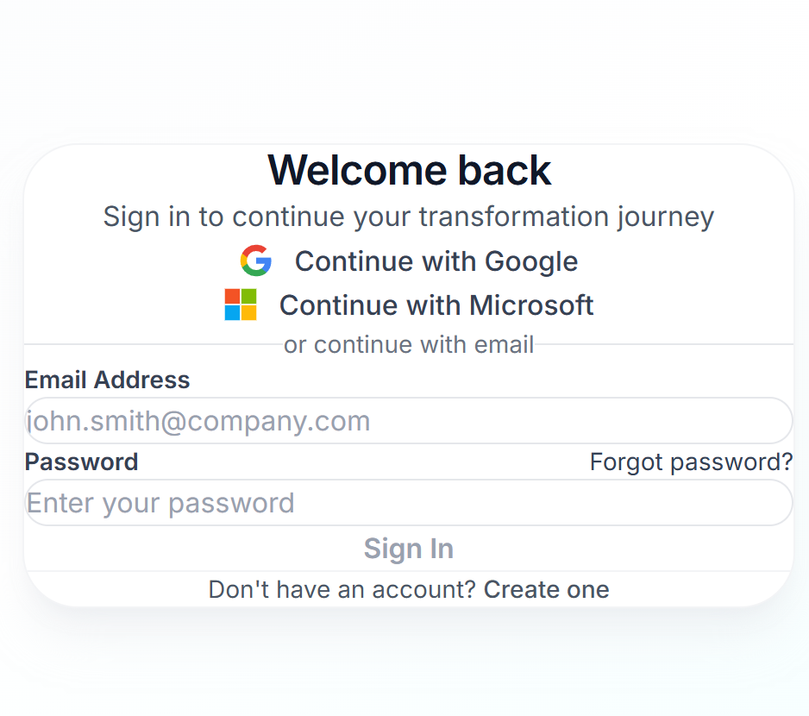 vs 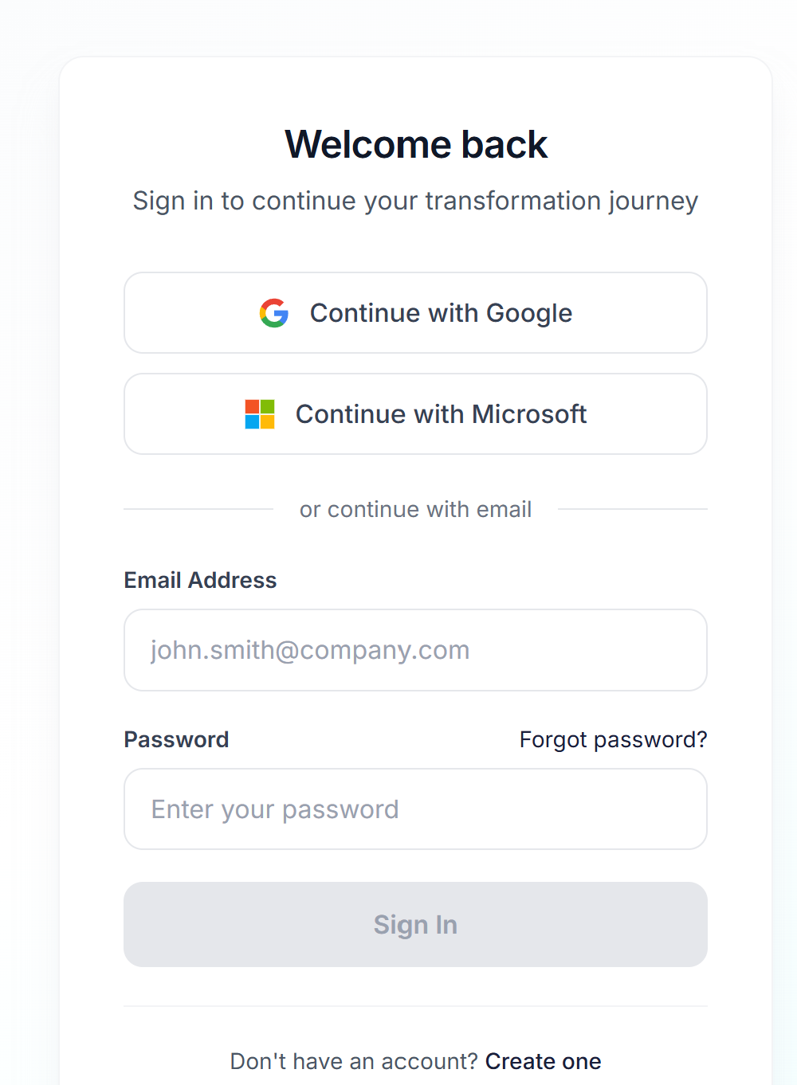

And another example
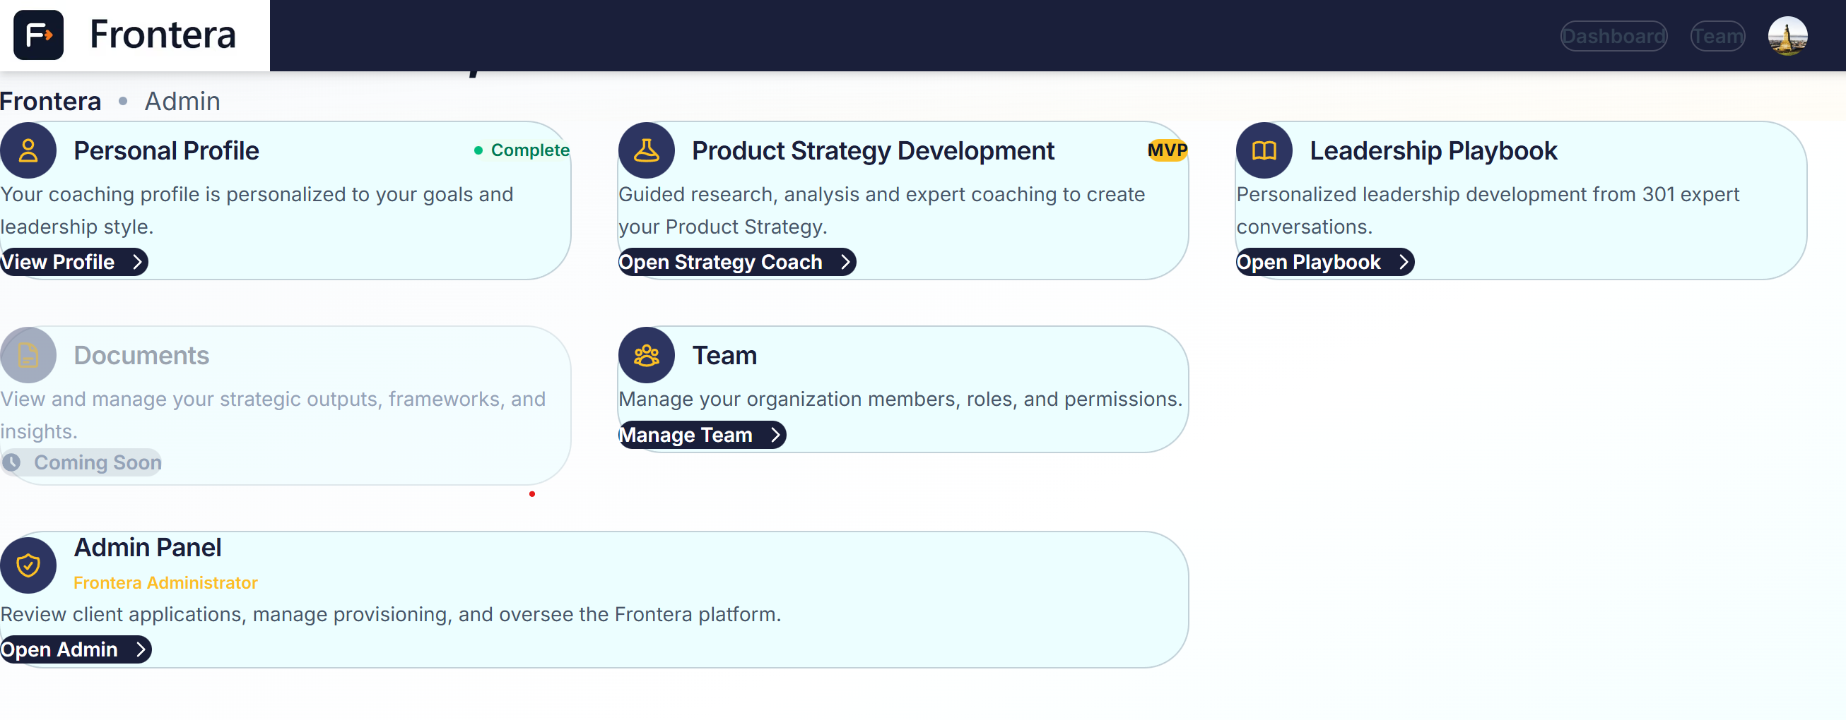

Task 1: Sign Up and Set Up Your Company
Go to the Frontera platform URL (https://frontera-platform.vercel.app/), select “book a demo button” and create a company account.
We will then validate and send you an invite to set up your user profile, linked to your company. (if you can email me direct deek.smith@gmail.com, I will make sure it is set up asap).

Task 2: Explore the Dashboard
Once your company is set up, take a look at the dashboard. Familiarise yourself with what's available. In this specific test we want you to: -
- Complete the Personal Profile section
- Then the Product Strategy Development module
- If you have time please also review the Leadership playbook section, but 1 & 2 are most important if possible

Task 3: Complete your Personal Profile
This helps the platform tailor the coaching profile to your needs and preferences.
- Select Open Profile button under the “Personal Profile” card and complete the instructions.
- Return to the dashboard once completed

Task 4: Start the Product Strategy Coach
Open the Product Strategy Development tool and begin working through it. The coach will guide you through several phases.

For context this session is designed to coach the user through a structured and phased process to develop a Product strategy. It is supposed to be a multi-day and muti-interaction activity with coaching, reflection and iteration. As you are testing please feel free to either enter as much context as you want in the questions/ coaching, or use the AI suggestions for speed if quicker/ easier at any point.

During each phase, try to:
- Read what the coach tells you
- Respond with real information about your company where possible
- Upload the materials you prepared when prompted
- Use any available AI features if you notice them
- Validate/ challenge/ debate the AI prompts with your coach

Task 4: Continue Through the Strategy Process
Keep working through the phases. Go as far as you can, providing thoughtful responses at each stage.

If you get stuck at any point, note what confused you and move on to the next section.

Section 3: Post-Task Interview Questions
Can you complete your answers to this question after complete the tasks above.

Open-Ended (ask first, before any rating scales)
1. Tell me about your experience using the platform today.
2. What stood out to you — positively or negatively?
3. Was there anything you expected to find that wasn't there?
4. Was there a point where you felt unsure what to do next?
5. How would you describe what Frontera does to a colleague?
6. Would you use this for real strategic work? Why or why not?
7. What frustrated you?
8. What did you enjoy/ value in the experience?
9. How would you describe the quality of the coaching and recommendations throughout the process

Section 4: Feedback Questionnaire

About You
Role / Title: _______________________________________________
Industry: _______________________________________________
Company size: □ 1–50 □ 51–200 □ 201–1000 □ 1000+
How often do you do strategic planning? □ Weekly □ Monthly □ Quarterly □ Annually □ Rarely

Task Ease
How easy or difficult was each task? (1 = Very Difficult, 7 = Very Easy)

Task | 1 | 2 | 3 | 4 | 5 | 6 | 7
Signing up and setting up your company
Understanding the dashboard
Starting the Strategy Coach
Working through Discovery phase
Working through Research / Terrain Mapping
Working through Synthesis (if reached)

System Usability Scale (SUS)
Rate each statement from 1 (Strongly Disagree) to 5 (Strongly Agree).

# | Statement | 1 | 2 | 3 | 4 | 5
1 | I think I would like to use this platform regularly
2 | I found the platform unnecessarily complex
3 | I thought the platform was easy to use
4 | I think I would need help from someone to use this platform
5 | I found the various features were well integrated
6 | I thought there was too much inconsistency in the platform
7 | I imagine most people would learn to use this platform quickly
8 | I found the platform very awkward to use
9 | I felt very confident using the platform
10 | I needed to learn a lot before I could get going

AI Coaching Experience
# | Statement | 1 | 2 | 3 | 4 | 5
1 | The AI coach's guidance was relevant to my company
2 | The AI coach helped me think about strategy in a new way
3 | I trusted the AI coach's suggestions
4 | The coaching felt too generic
5 | I would prefer this over a human consultant for initial strategy work

Value and Willingness to Pay
1. What is the most valuable thing Frontera gave you today?
: _______________________________________________

2. What was missing or disappointing?
: _______________________________________________

3. How likely would you be to recommend Frontera to a colleague? (0–10)
0 — 1 — 2 — 3 — 4 — 5 — 6 — 7 — 8 — 9 — 10

4. What would you expect to pay per month for a tool like this?
□ £0 (wouldn't pay) □ Under £50 □ £50–100 □ £100–250 □ £250–500 □ £500+

5. What one thing would make you sign up today?
: _______________________________________________

Open Comments
Is there anything else you'd like to share about your experience?
: _______________________________________________
: _______________________________________________

Section 5: Facilitator Observation Sheet
Fill in through session recording.

Participant ID: _____ Date: ___________

Timestamp | Task / Phase | Observation (hesitation, error, comment, delight)

Completion Summary
Task | Completed? | Notes
Sign up + company setup | □ Yes □ Partial □ No
Dashboard exploration | □ Yes □ Partial □ No
Discovery phase | □ Yes □ Partial □ No
Research / Terrain Mapping | □ Yes □ Partial □ No
Synthesis | □ Yes □ Partial □ No
Strategic Bets | □ Yes □ Partial □ No

Top 3 issues observed:
1. _______________________________________________________________
2. _______________________________________________________________
3. _______________________________________________________________

Participant's overall sentiment: □ Very Positive □ Positive □ Neutral □ Negative □ Very Negative

