AtliQ Hotels
Business Report (April – July 2022)

Overview

AtliQ hotels is a chain business of total 25 hotels across different cities in India.
The goal of this report is to extract insights from the given data about the bookings and we will try to answer why Atliq is losing its market share in hotel business.

- Total Revenue: ₹ 1.71 B
- Total Bookings: 134 K
- Total Hotels: 25

Analysis

Business Trend
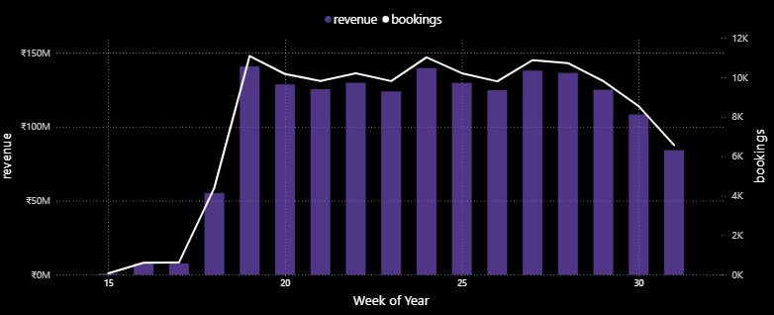

We can observe that the bookings and revenue correlates well. That means an increase in bookings directly implies increase in revenue (as expected).
There is a sudden jump in early weeks and gradual decline in later weeks, so we need to find why is the revenue declining.

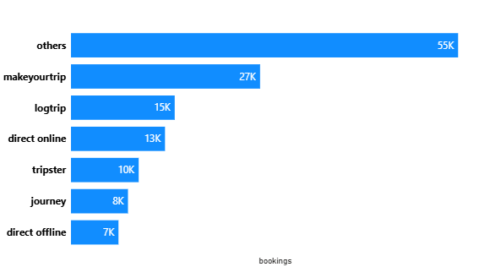
Before that, Let’s also look at the sources of bookings and total hotels in each city:
Booking Platform

Some unknown booking platform ‘others’
is the biggest source of booking
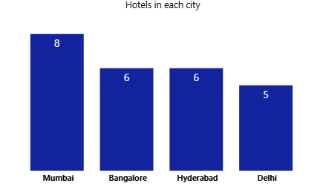
We have total 25 hotels, with
Mumbai being the top in list.

Let’s see the revenue breakdown from each city:
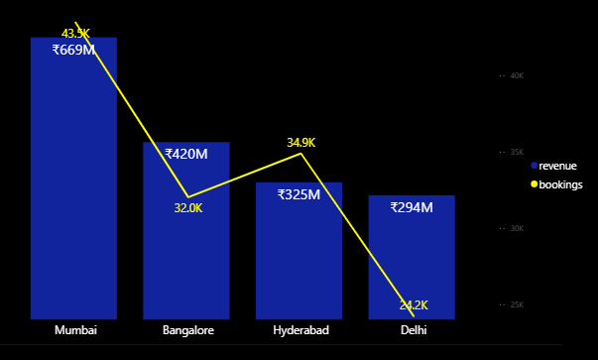

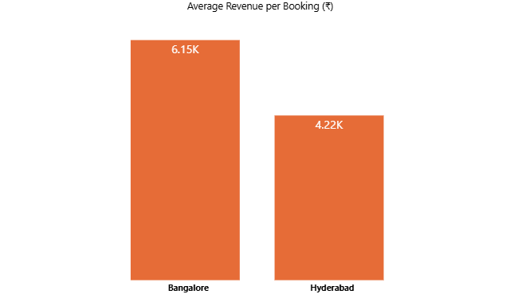
Total hotels in Hyderabad and Bangalore are same, but the revenue from later is almost 30% more than Hyderabad, even with lesser bookings. This is the case because the hotel rooms are generally more costly in Bangalore, so their revenue per customer is more compared to that in Hyderabad, which can be verified from below chart:
We have total 4 room types across all hotels, with standard generally being the cheaper one and Presidential the expensive one.
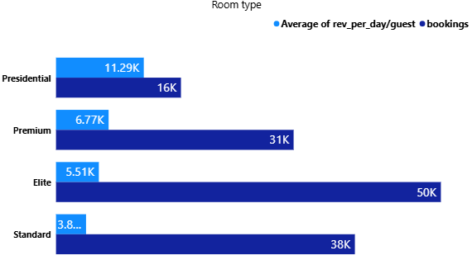

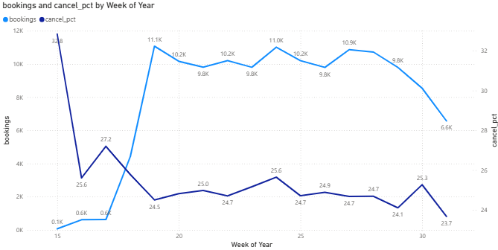
Bookings Trend

The blue line shows the booking trend and the purple one shows the percentage of bookings that were cancelled. We observe that cancellation percentage is gradually declining, which is a good thing because when a booking is cancelled, only 40% of its booking price is marked as revenue realized.
The no of bookings has also declined significantly in later weeks, this is the reason why revenue also shows the same trend.
This trend is almost same in every city.

To answer why the bookings are slowing down requires further investigation into the hotels, to see if there is some problem with food, management or something else that the competitor is doing good at. We could do analysis of reviews of customers if we had the data and that would give us some insights on their sentiment about hotel.
At this point we do not have any other data, so we have tried to focus on booking cancellation and noted interesting trends in each city.

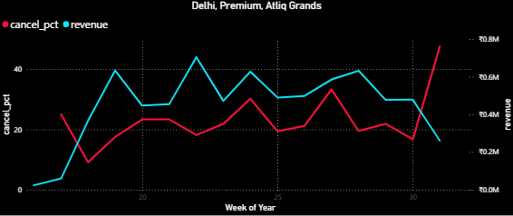
First is Delhi’s Atliq Grands Hotel
In premium room category.
There is a sharp rise in cancellation %
from week 30, and reaching
above 45%.

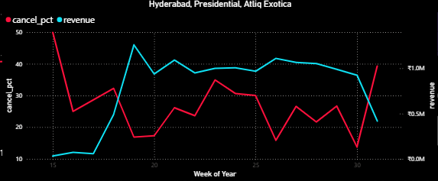
Something same can be seen
In Hyderabad’s Atliq Exotica Hotel
In presidential room category and
Mumbai’s Atliq seasons hotel in
Standard room category.

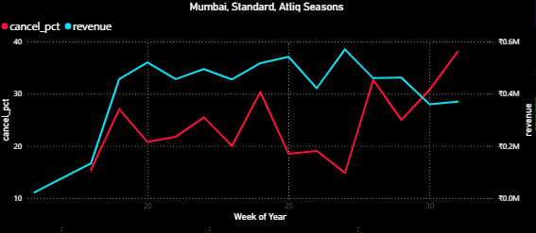

In the elite room category of Bangalore’s Atliq Blu hotel, you can see gradual increase in cancellation % from week 21.
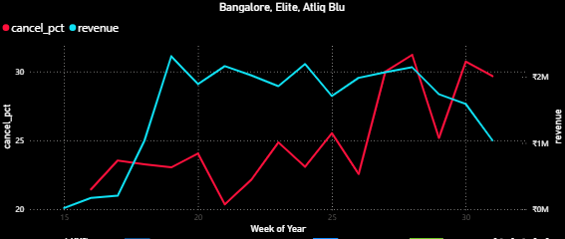

Conclusion

The bookings have declined in recent weeks and this directly impacts the revenue generated.
The overall trend for booking cancellation is also declining. In the last week it was around 23 % which is slightly less than previous weeks, that means few people cancel their bookings, and that’s a good thing.
But for these few hotels shown above we need to investigate further why their cancellation rate is rising and for that we might need some data related to customer feedback/review.
Based on customer review we can find what is wrong with the business, reduce cancellation rate and increase bookings.

