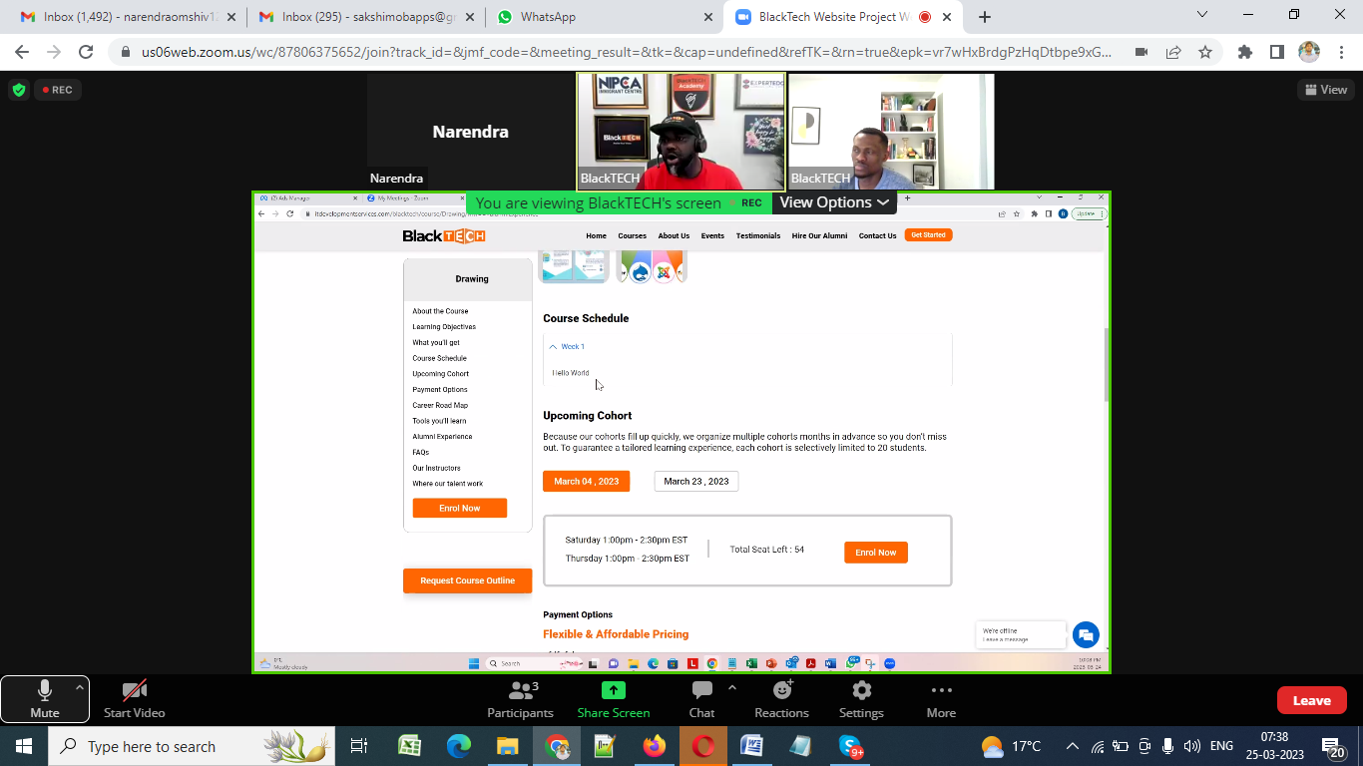

We should be able to huder Course schedule, upcoming cohort should be able to edit. (Already Done)

You can hide/show Course schedule of a particular course from Admin Panel (Course Section) as shown below snapshot

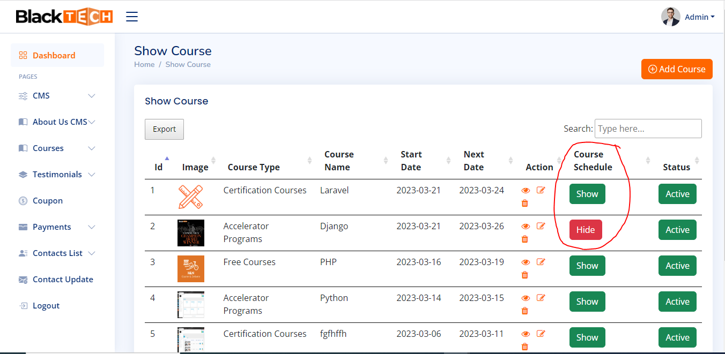

You can edit Upcoming cohort of a particular course from Admin Panel (Edit Course Page) as shown below snapshot

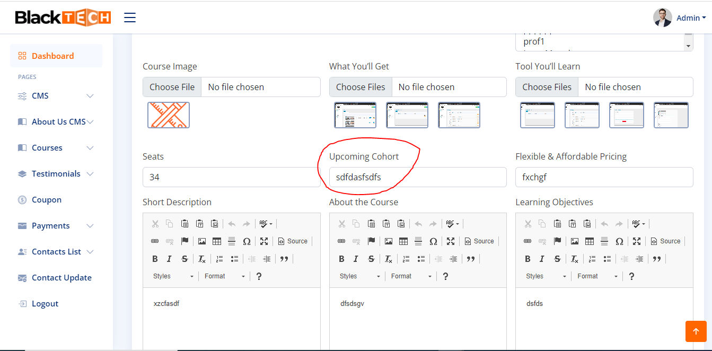

No of seats should be editable. (Already Done)

You can edit No of seats of a particular course from Admin Panel (Edit Course Page) as shown below snapshot

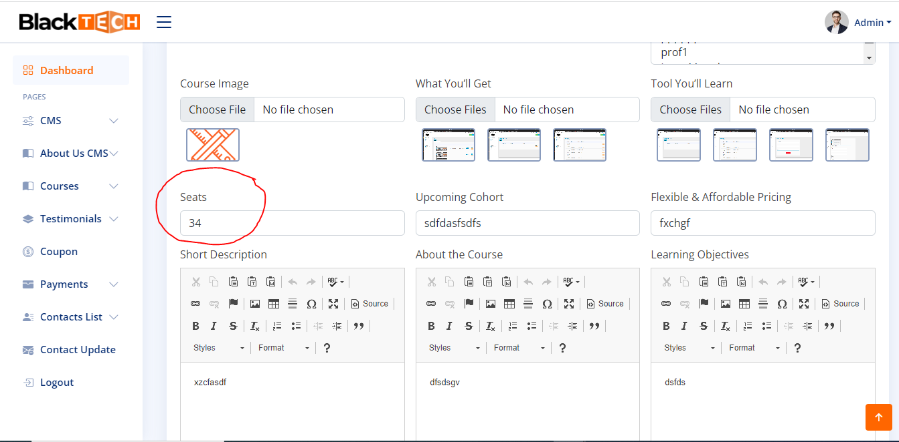

And someone register then less the no of seats (Already Done)

|  |  |  |
| --- | --- | --- |
| Coupon code | * We should be able to set Coupon codes * Coupon code should be reflect different percentage to choose from | **Need to Discuss** |

Need to make it with flat rate and % both. (Done)

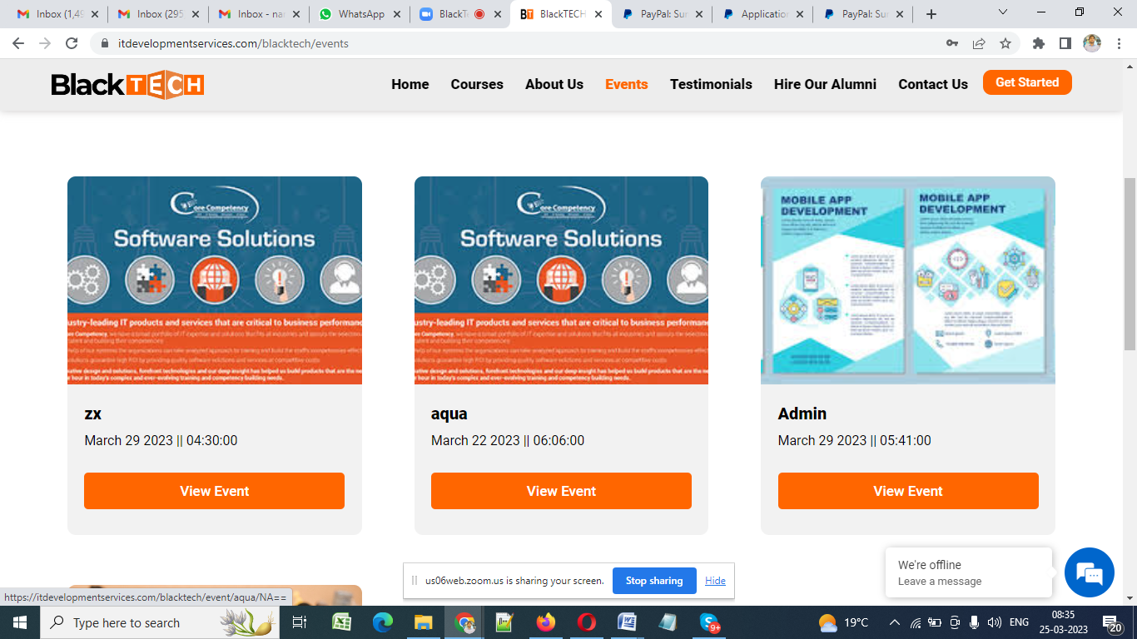

Tell them size of it. (Image Size : 914x500 px)



Tell size of that as well (Image Size : 914x500 px)

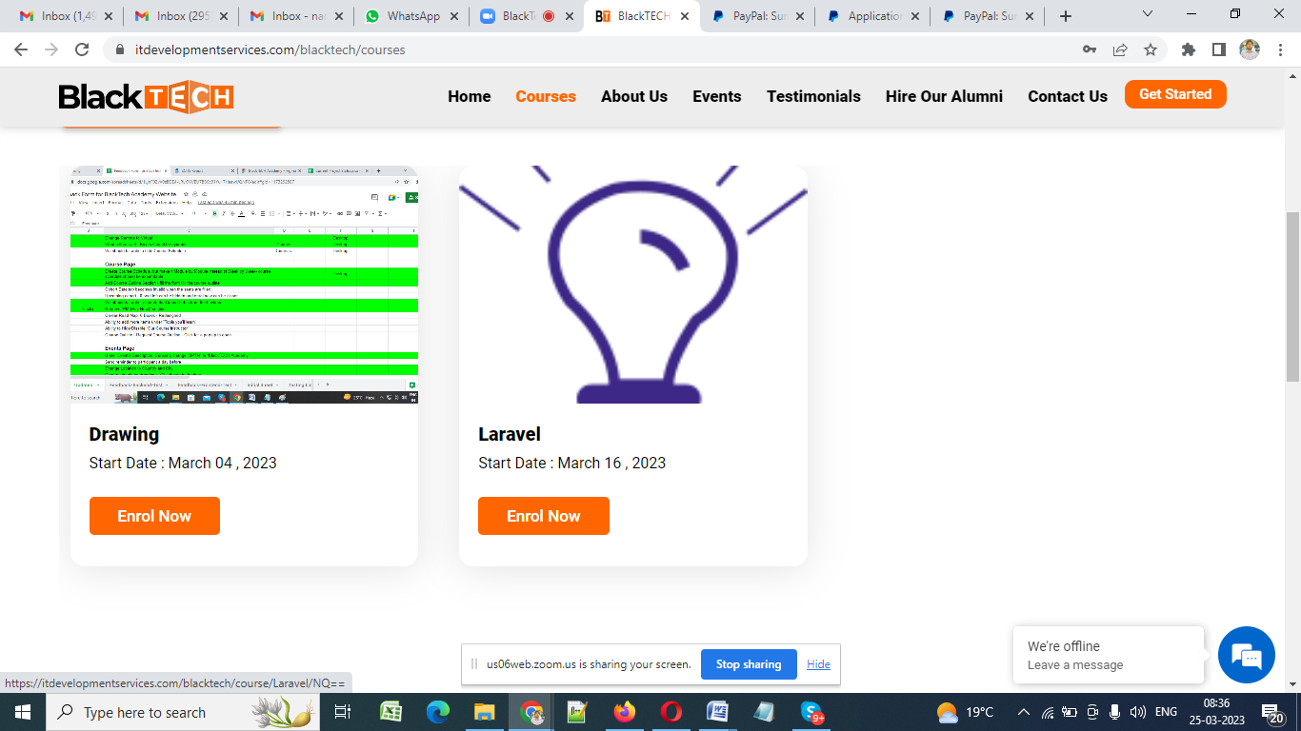

That as well (Image Size : 914x500 px)

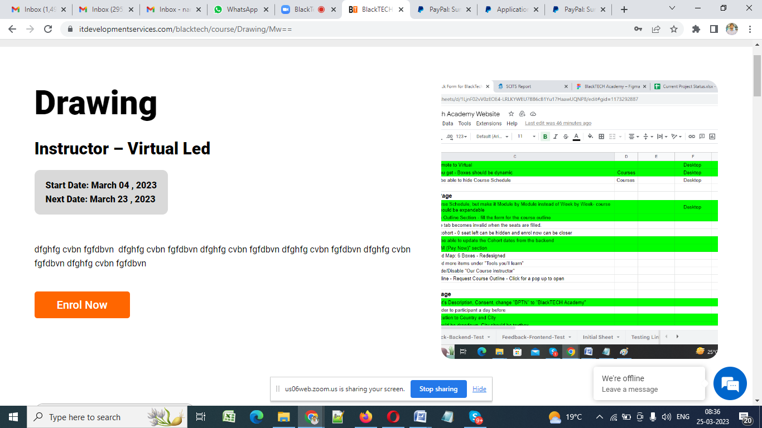

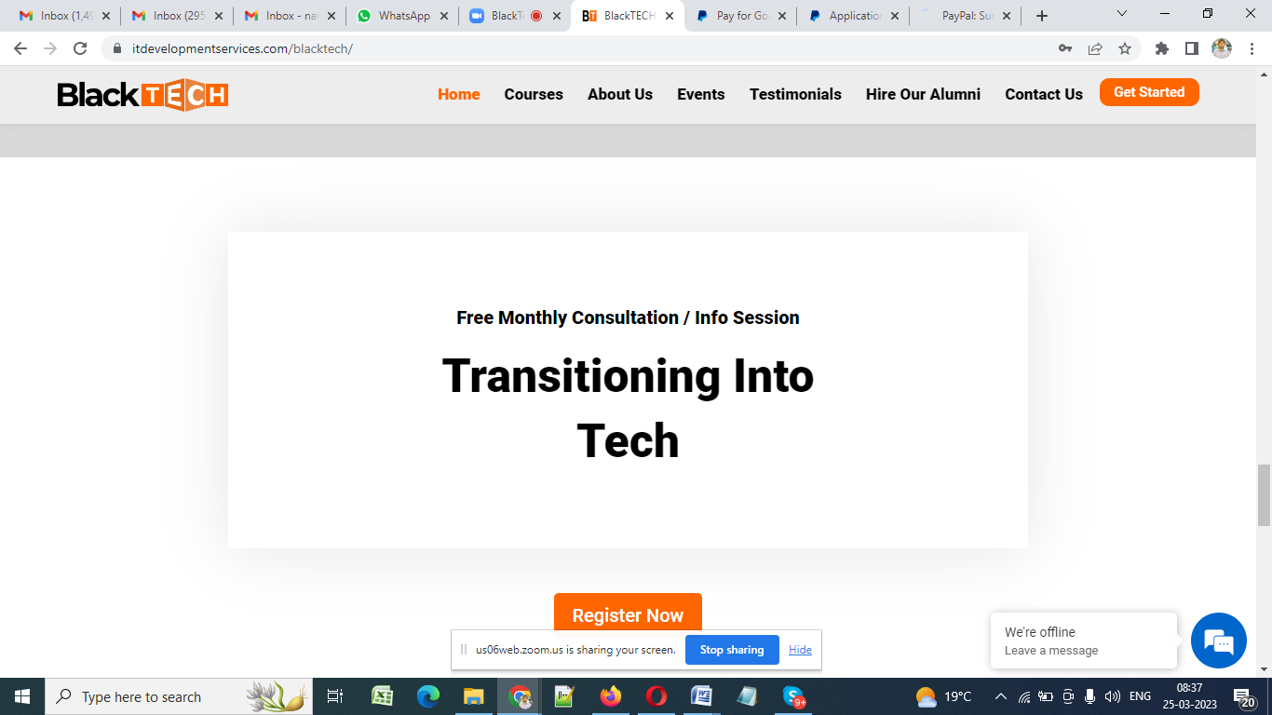

Need big flyer size share image size (Image Size : 914x500 px)



Can we remove equal can keep like this Done

https://itdevelopmentservices.com/blacktech/event/Networking%20Event/

Referral Process need to check, record