**APP edits:**

1. Under “**Work with Us**” both ‘**Internship**” & “**Job**”, please add “Upload Cover Letter” uploading button and remove ‘Personal Statement‘ option:

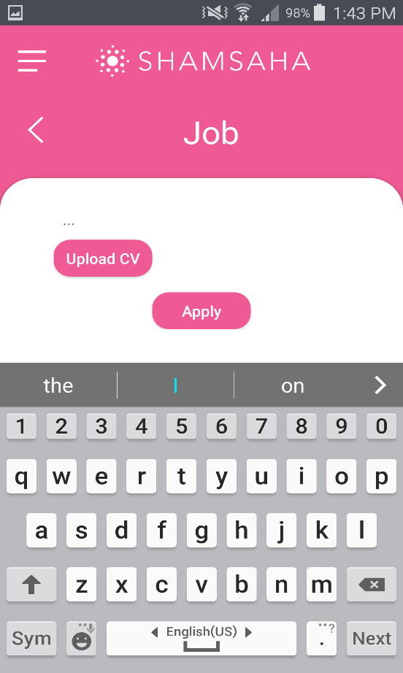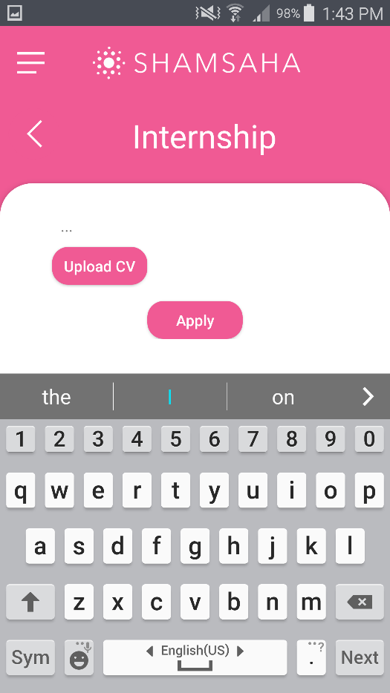

1. **Resources:** No data found under any of the countries except Bahrain. All resources have been sent 2 weeks ago.

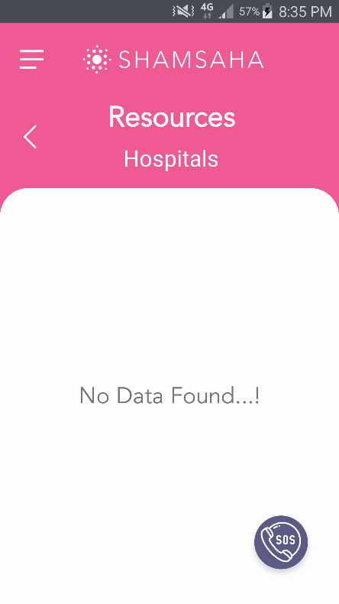

1. Under ‘Corporate Sponsorship’: Please add BHD with the amounts mentioned.

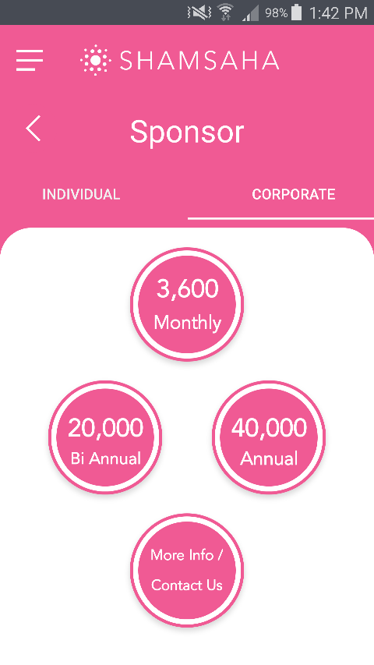

1. **Address:** Please add 3rd Floor after Suite#3082 (I know MJ mentioned to remove it, but because it is a huge building, from experience people find it very difficult to find the location unless we mention thr floor number)

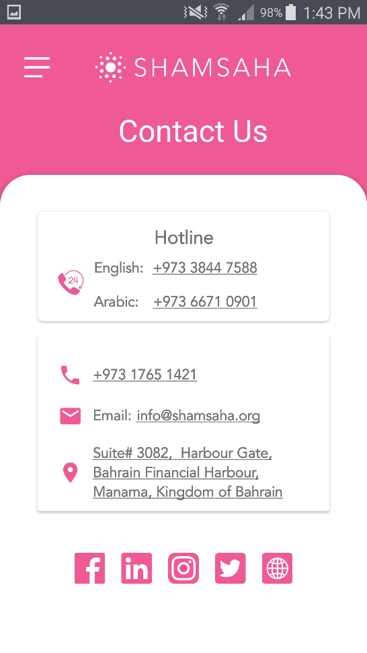

1. **Events:**  I still receive the below error when I go into the Events section ( I have the Samsung Galaxy Note 4)

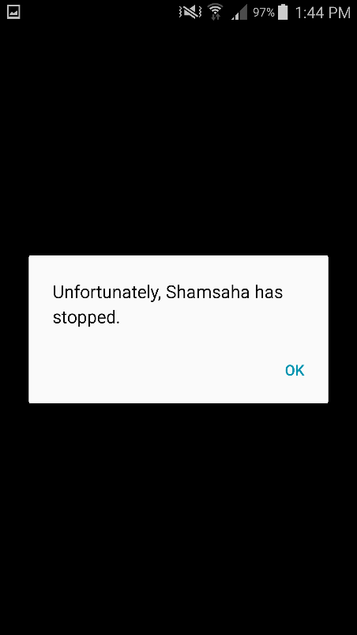

1. Please add **“Remember me”** option next to “Forgot Password” in the Volunteer Login section
2. Also add “Show Password” (the eye) option next to the Password in Volunteer Login section
3. **“Resources”** button is not working in the blow screen:

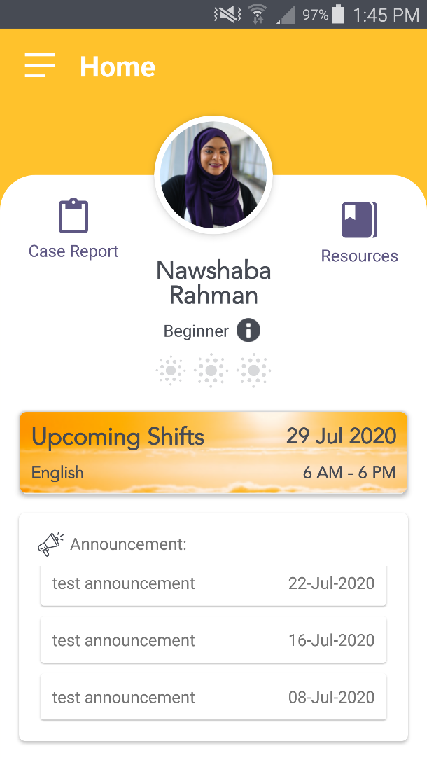

1. **Please add “s” to Advocacy Levels:**

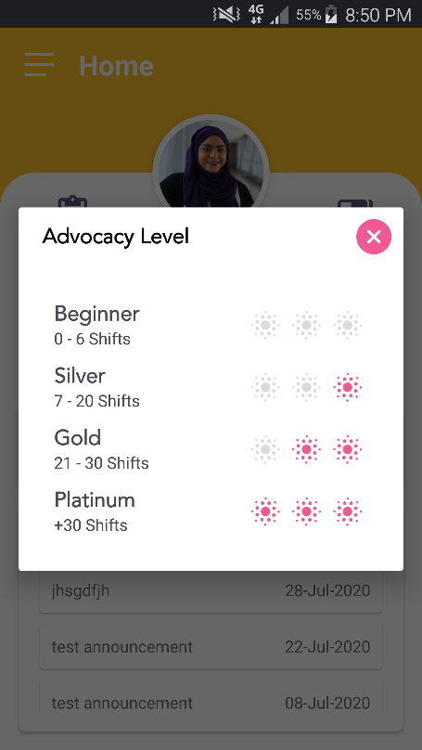

1. “My shifts” with “List Mode” doesn’t appear for me, and “Open Shifts” with “List Mode” doesn’t appear for me either.

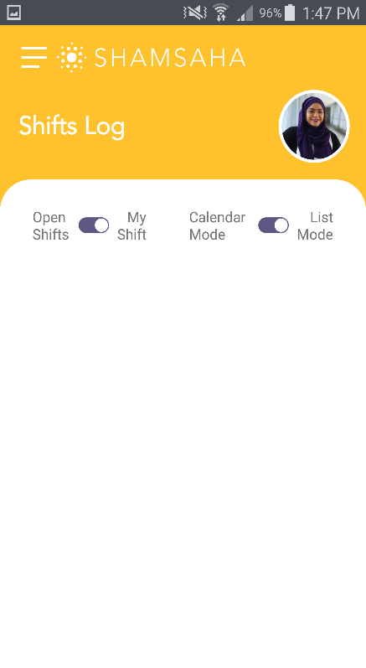

1. My shifts on the Calendar doesn’t appear for me (I have a shift on the 29th July and it doesn’t show):

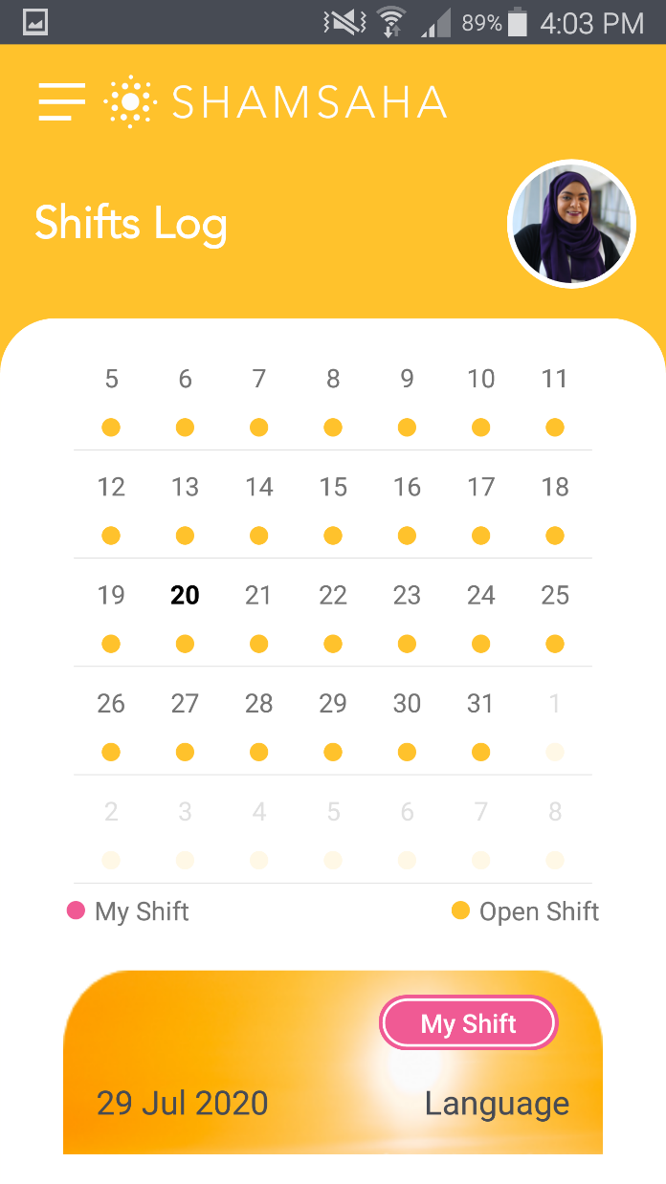

1. Arabic advocate can take English shift, English advocate cannot take Arabic shift (this should reflect from the languages selected from the profile section.
2. Please add “Our Partners” under the Main Menu tab (info has been sent via email)
3. **Question:** Will password be auto assigned to user? How will the password option work for first sign in? Also, how will admin reset password in the back end. Please explain more.