**Bug report of Qapril**

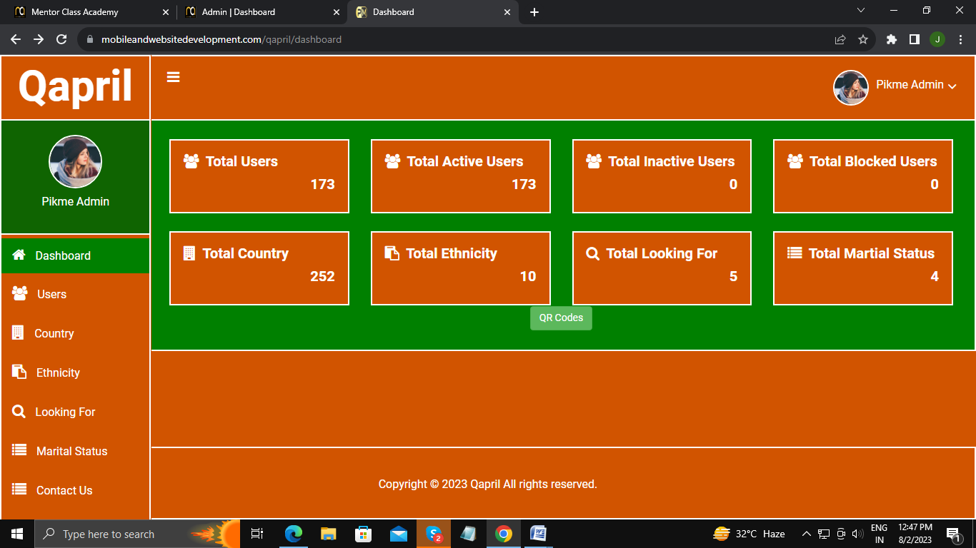

Need to place button of “QR Codes” in proper place

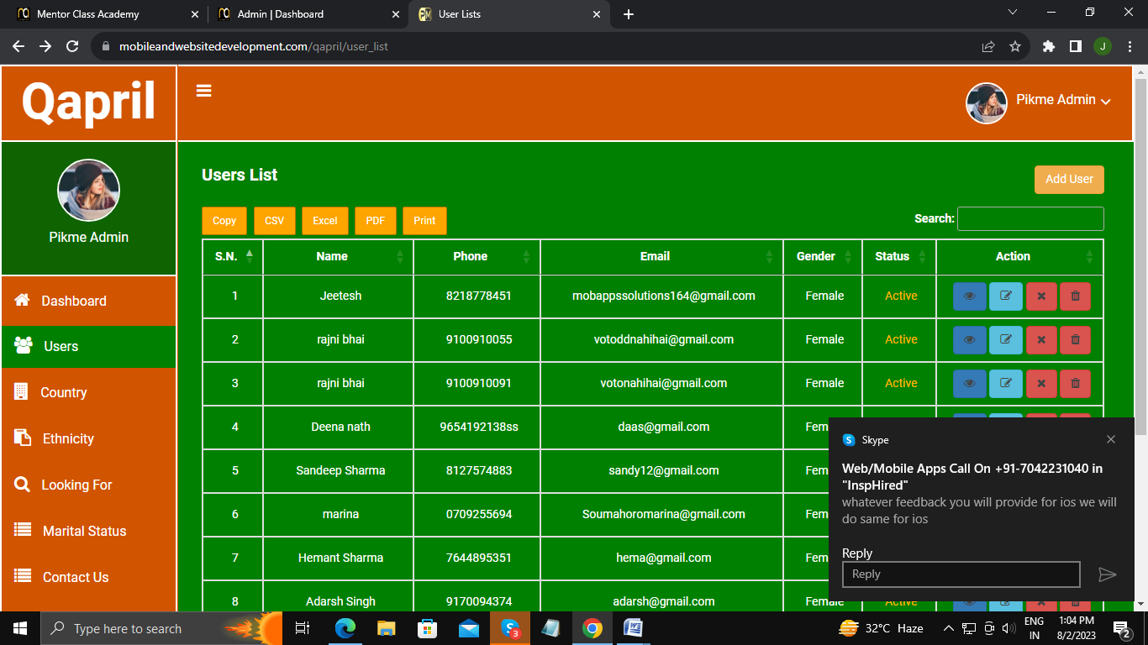

There is no functionality of menu icon. So, either replace or remove it.

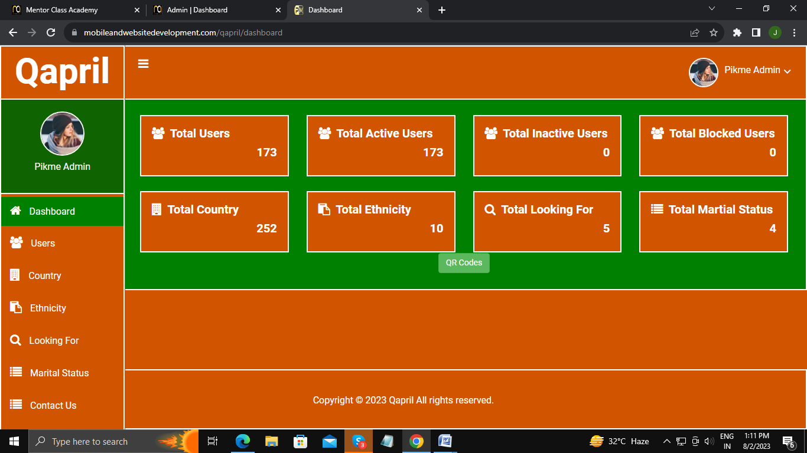

Need to place in centre of screen.

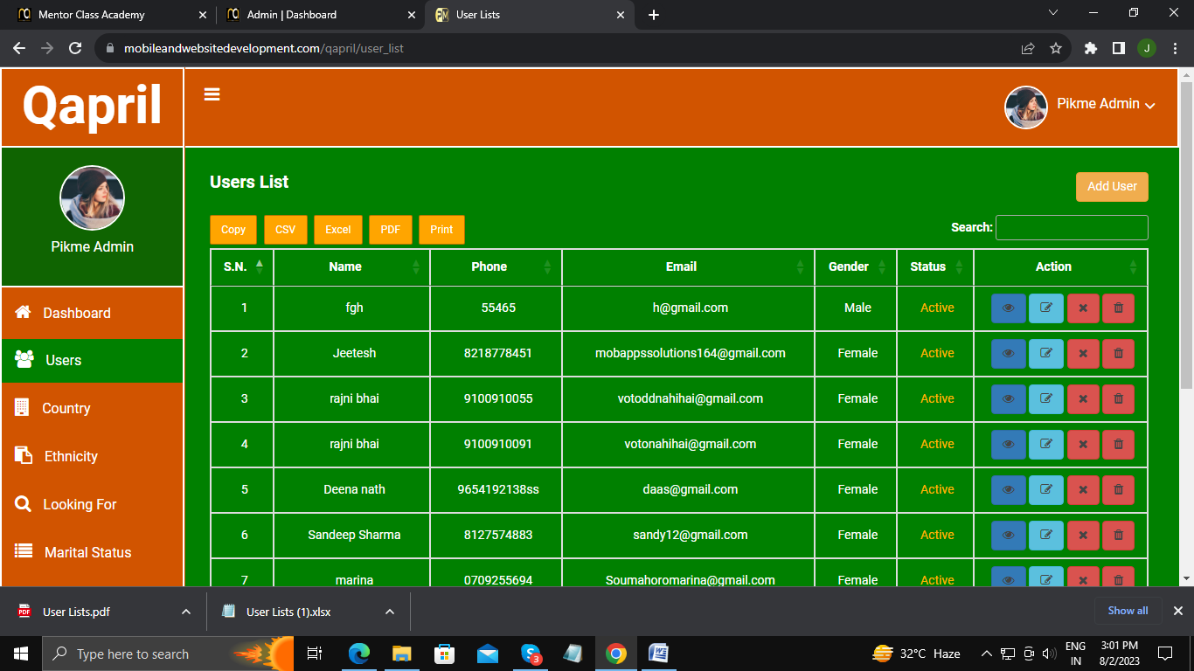

Remove this all except “Excel Sheet” button for downloading the data.

No need to show all person in inactive user list, show only inactive when they are relly inactive.

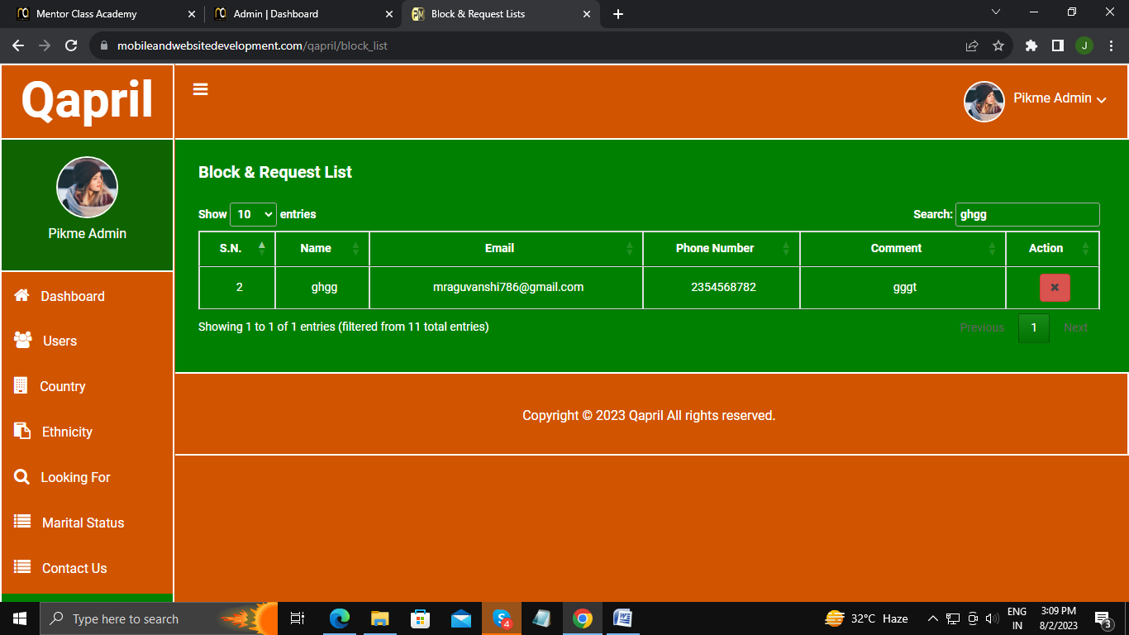

Need to fix cross icon for removing data which are fill in search input field.



Need to place a button to download the data.

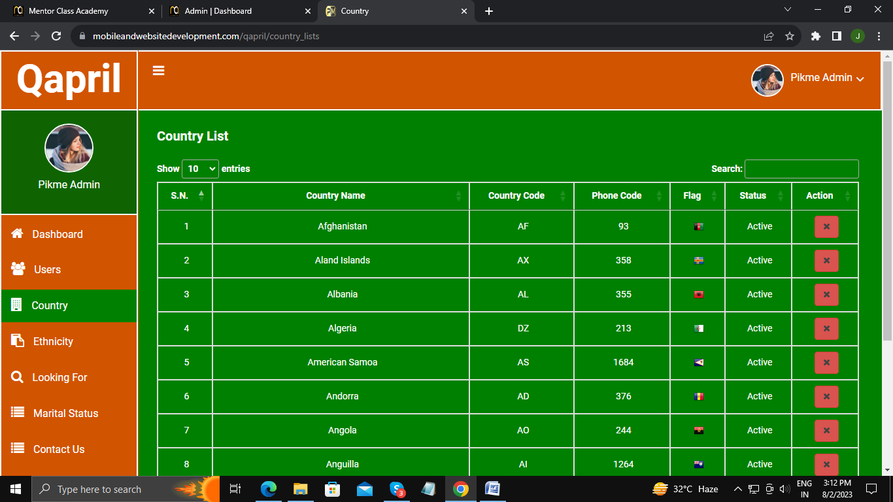

Need to fix cross icon for removing data which are fill in search input field.

Need to add button for download the data.

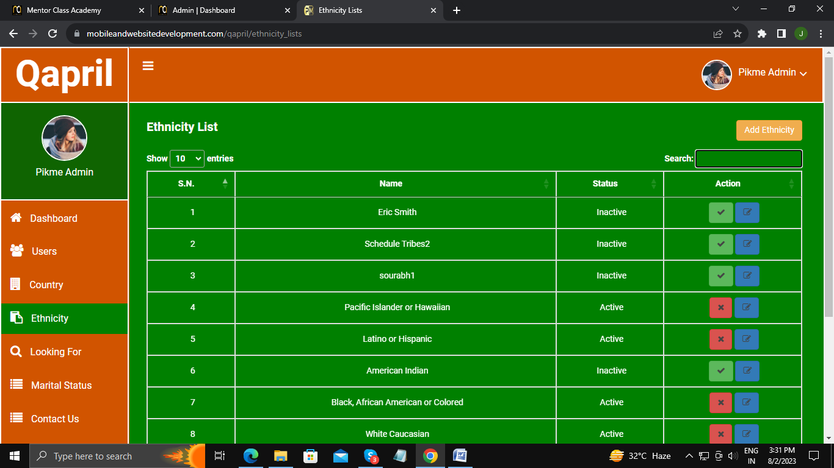

Need to fix cross icon for removing data which are fill in search input field.

Need to add button for download the data.

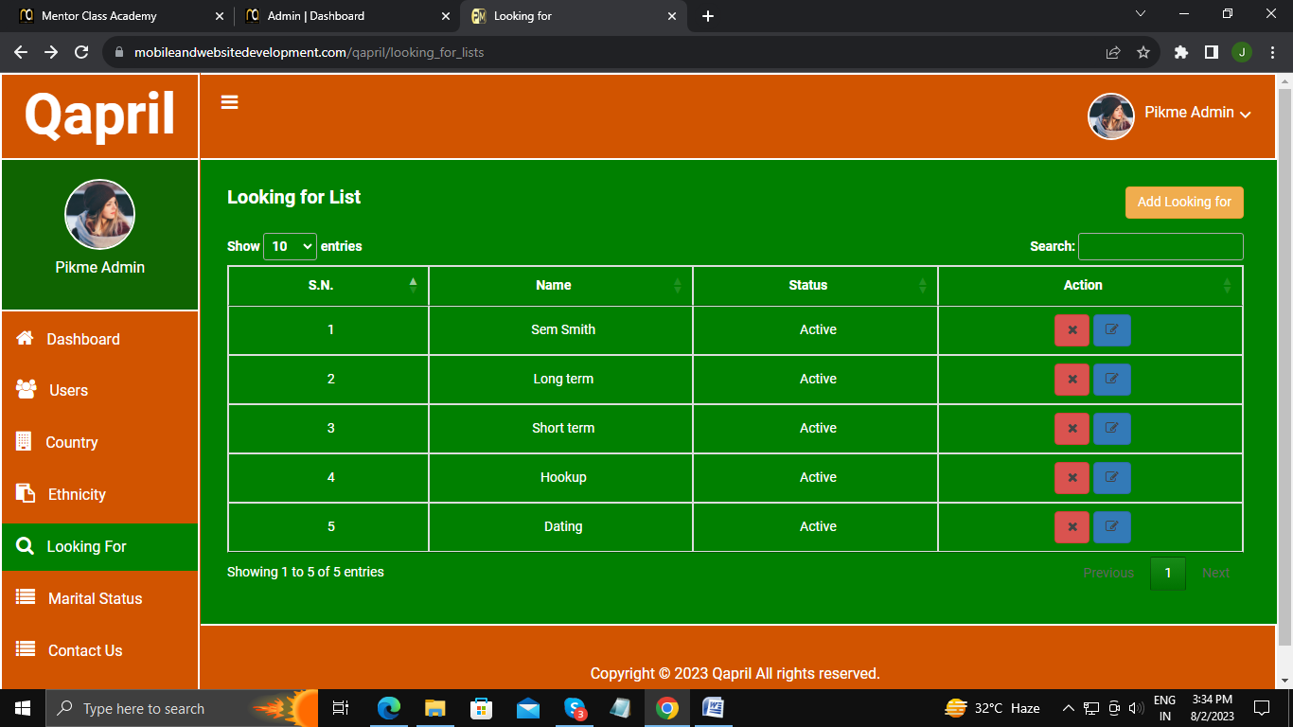

Need to fix cross icon for removing data which are fill in search input field.

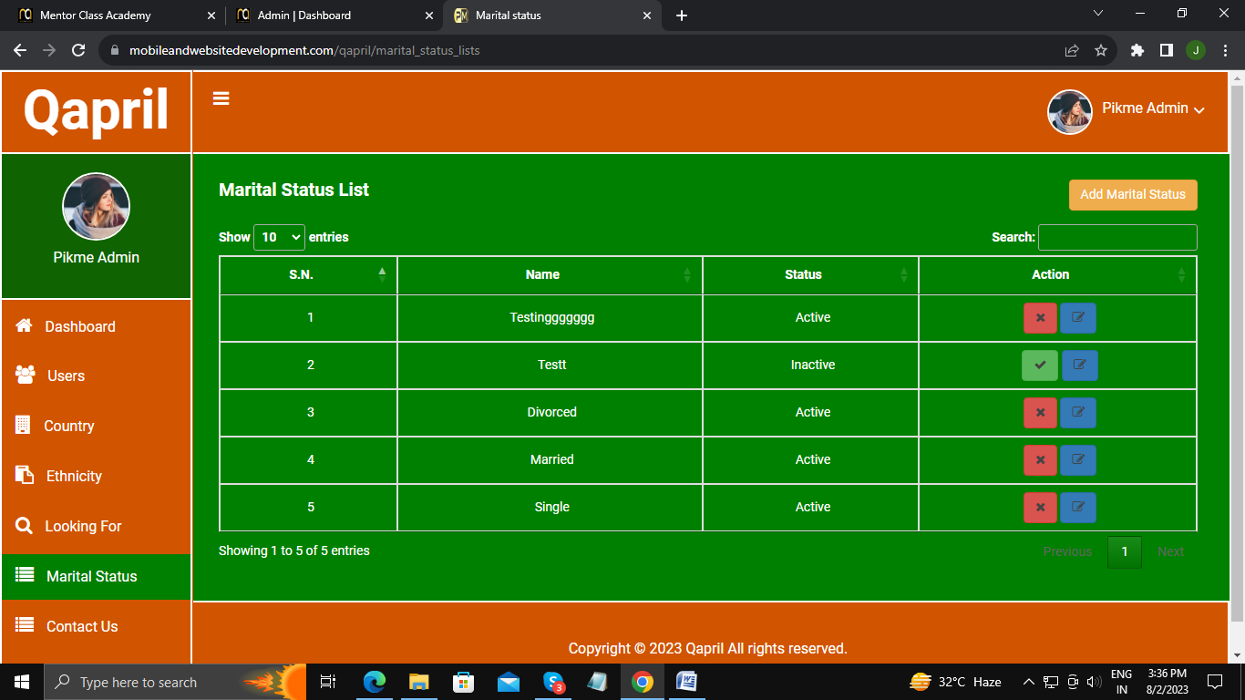

Need to fix cross icon for removing data which are fill in search input field.

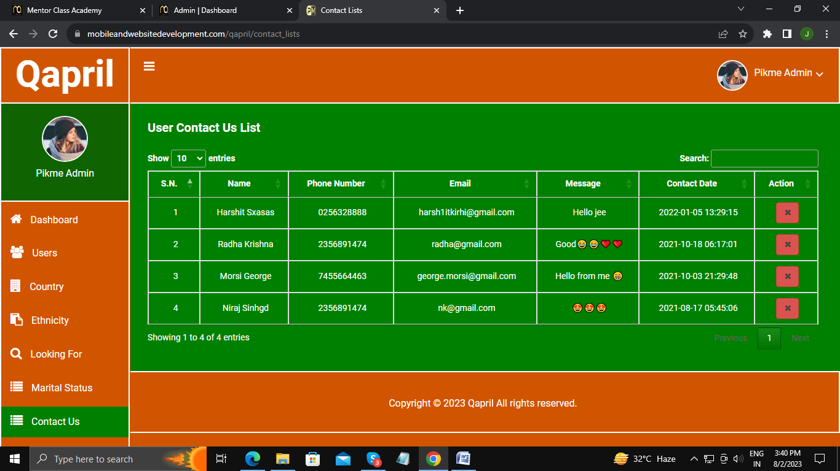

Need to fix cross icon for removing data which are fill in search input field.

Need to add button for download the data.

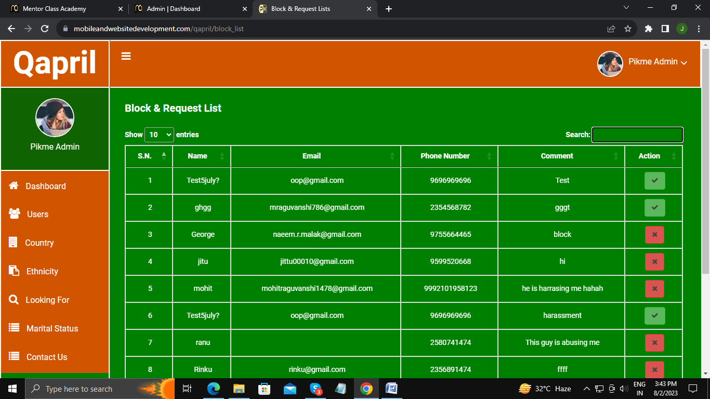

Need to fix cross icon for removing data which are fill in search input field.

Need to add button for download the data.

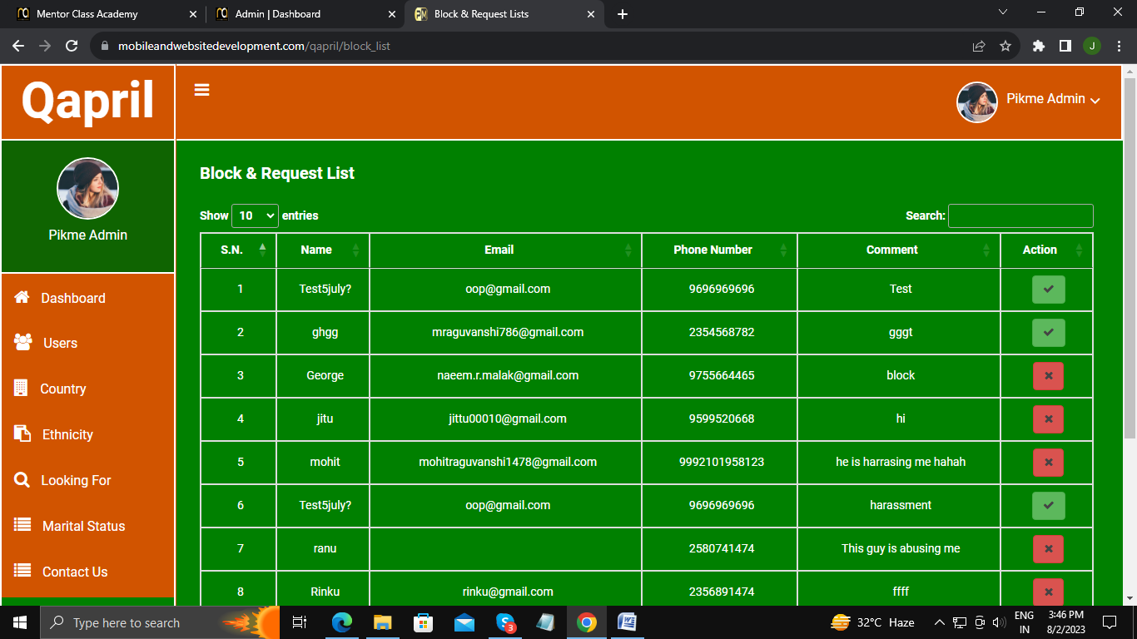 Please mention button in place of this icon

Button for download the data Need to fix cross icon for removing data which are fill in search input field.

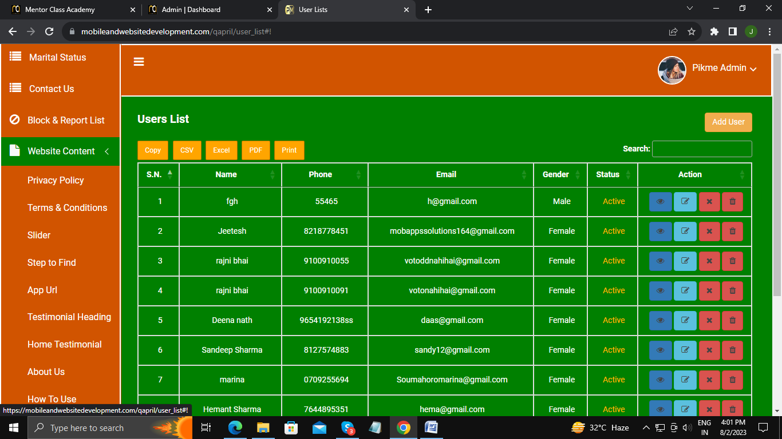

Need to place dropdown menu then show below details.

Slider lists ---(Need to discuss)

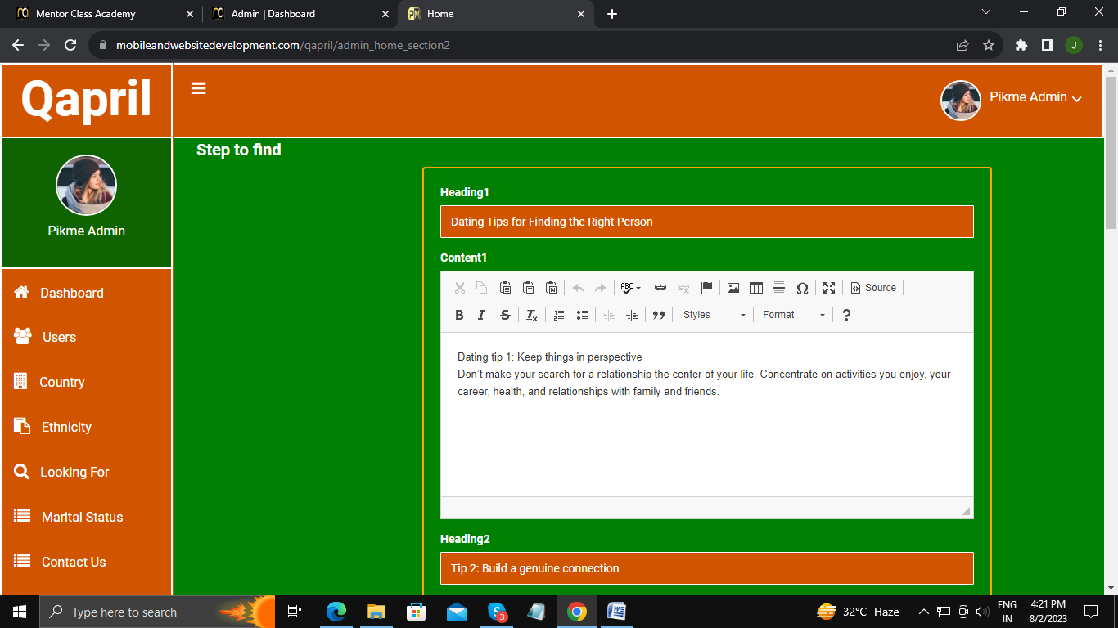

Container shorld be in centre.

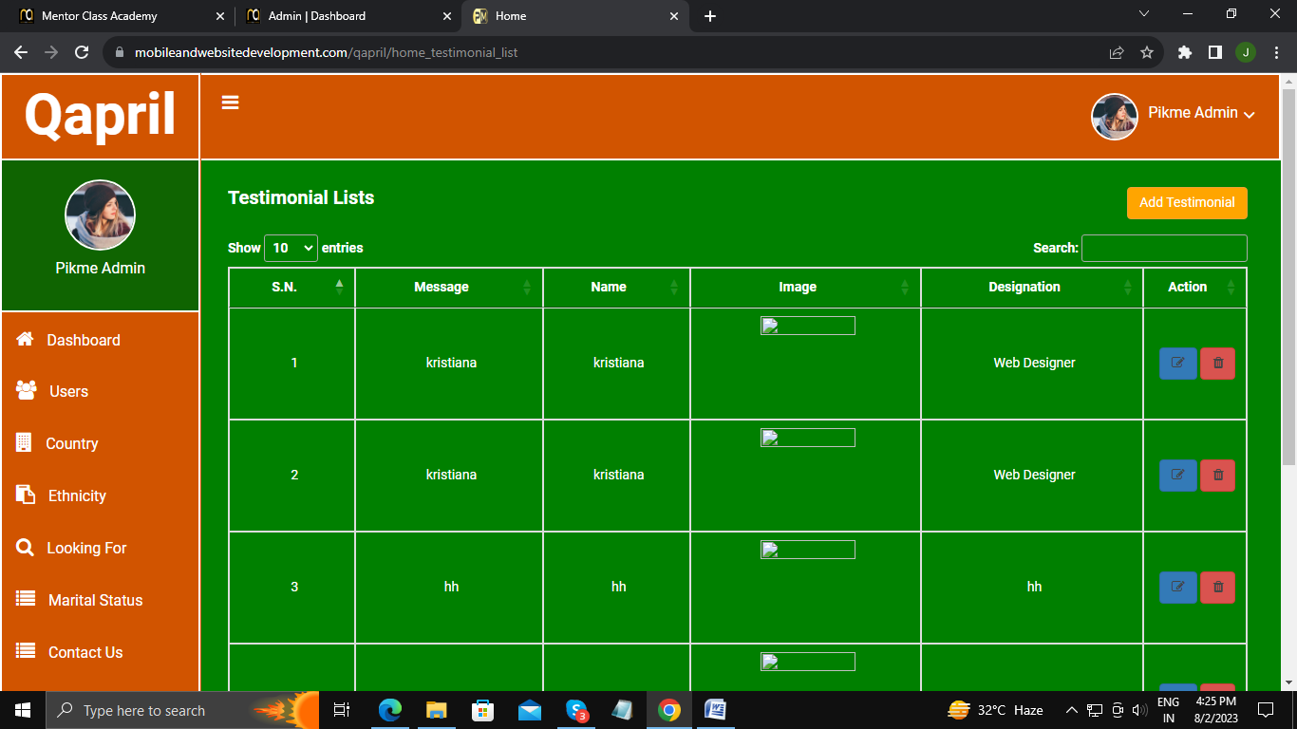

Need to fix cross icon for removing data which are fill in search input field.

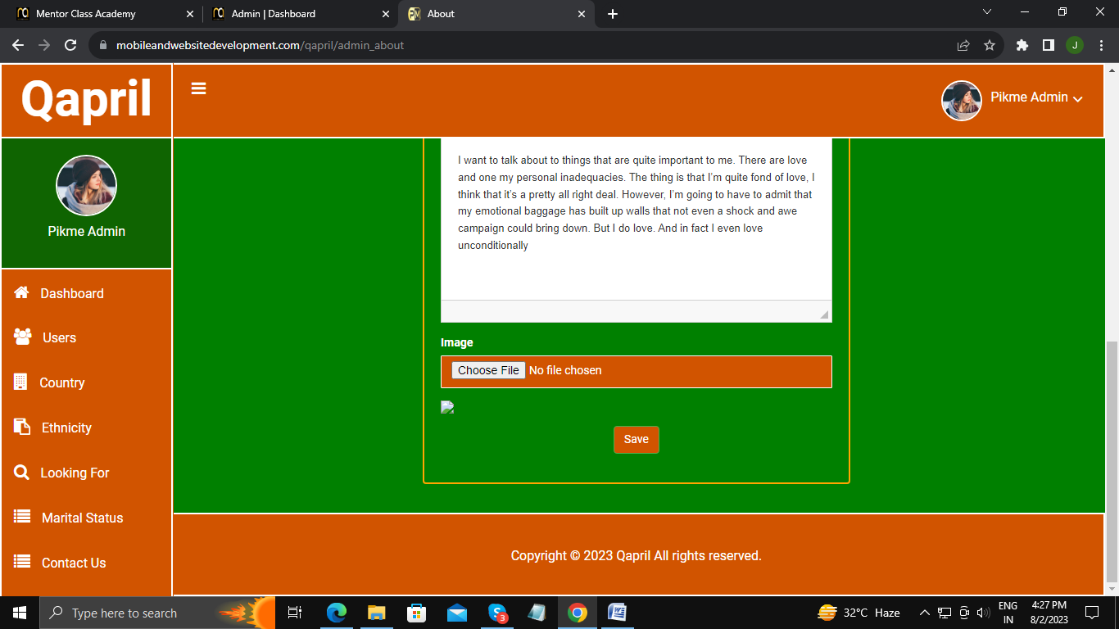

Why not image appear ?

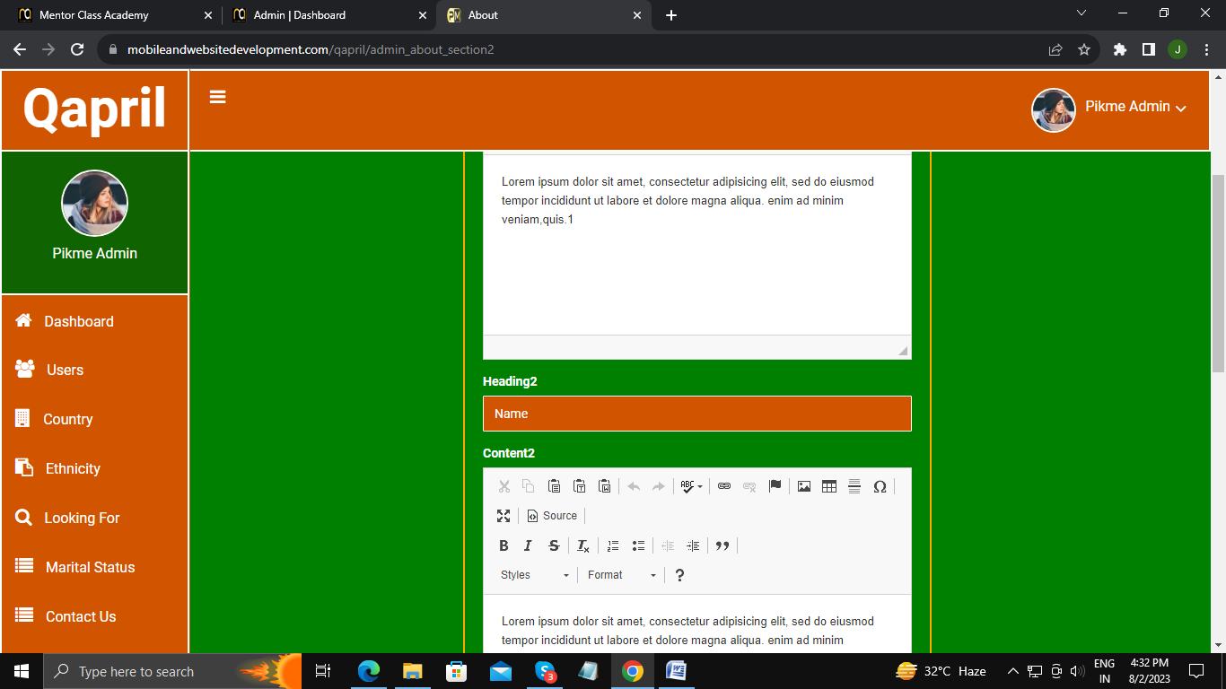

Need to add validation in this, without data it gets submit.

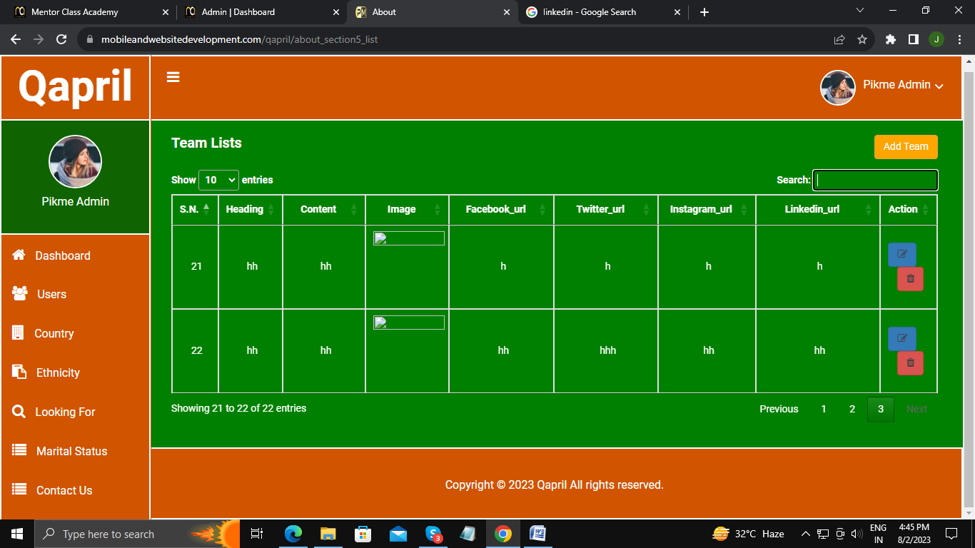

Need to fix cross icon for removing data which are fill in search input field.

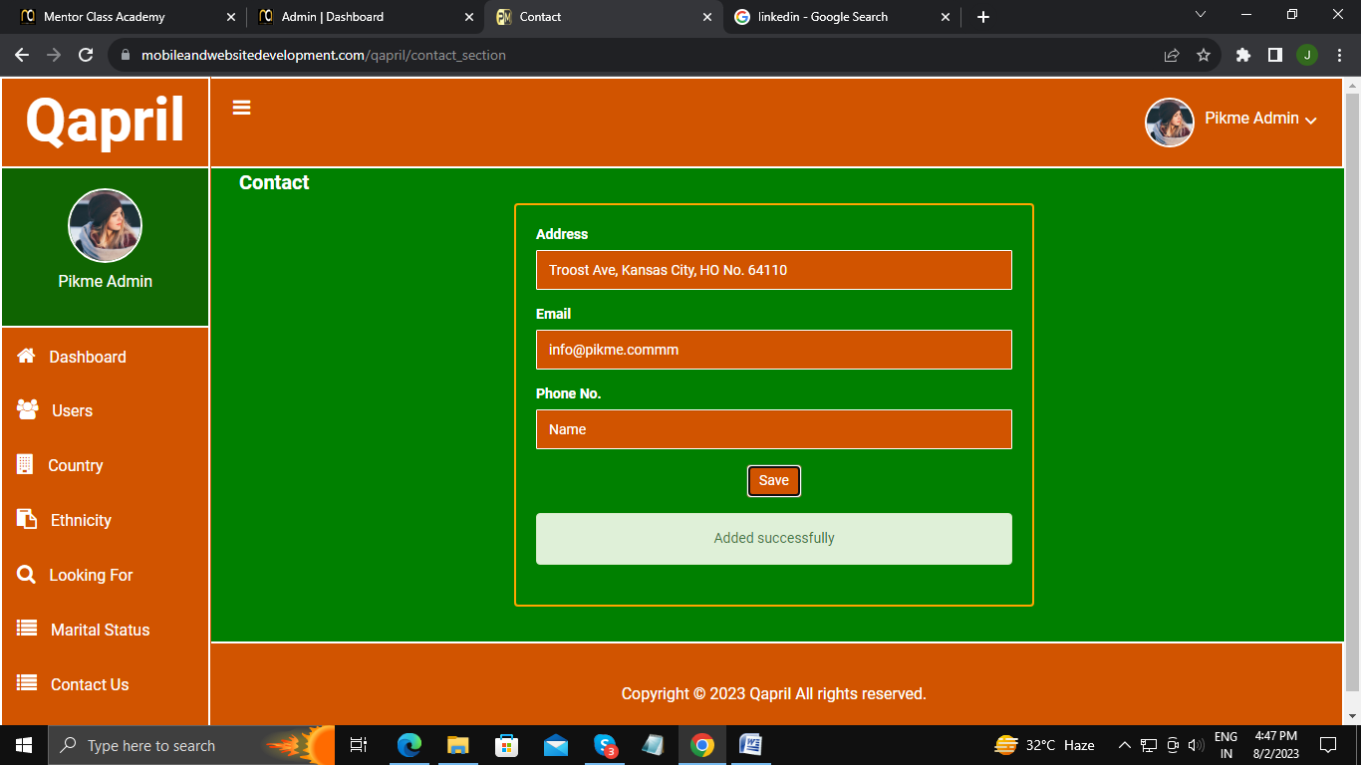

Need to add validation in phone no:. filed.

Need to add validation in email id filed.

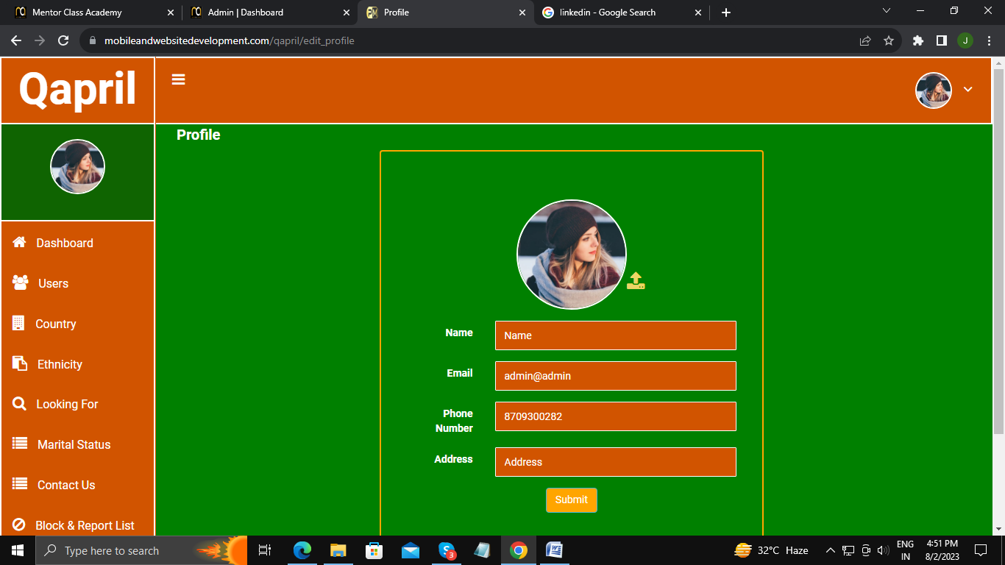

Need to add validation in Name, Email, Phone no:., Address

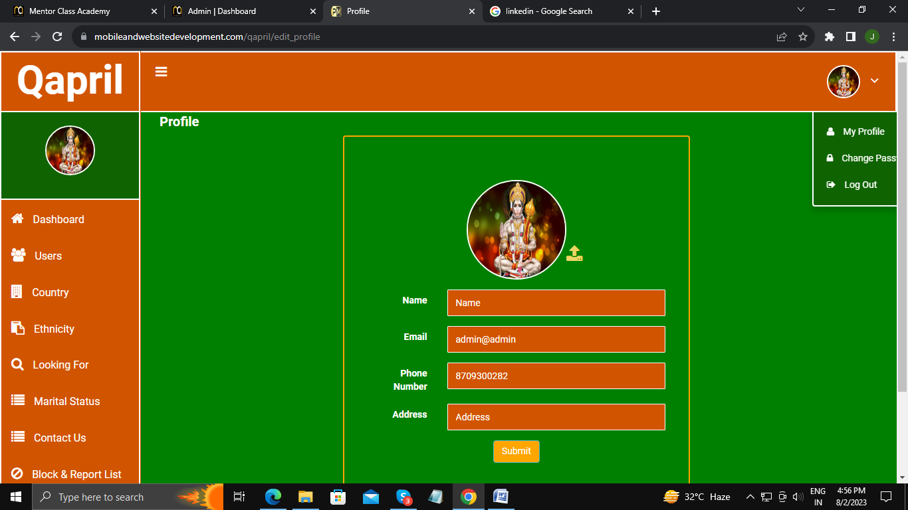

Need to edit deisgn of profile menu.