**DAILY ONLINE ACTIVITIES SUMMARY**

|  |  |  |  |  |  |  |  |
| --- | --- | --- | --- | --- | --- | --- | --- |
| **Date:** | **29/05/20** | | | | **Name:** | **Deena Muthappa** | |
| **Sem & Sec** | **8th sem, A sec** | | | | **USN:** | **4AL16CS028** | |
| **Online Test Summary** | | | | | | | |
| **Subject** | | **BDA** | | | | | |
| **Max. Marks** | | **30** | | **Score** | | **23** | |
| **Certification Course Summary** | | | | | | | |
| **Course** | **Jquery for absolute beginners** | | | | | | |
| **Certificate Provider** | | | **Udemy** | **Duration** | | | **2hrs** |
| **Coding Challenges** | | | | | | | |
| **Problem Statement: Program to generate first N Armstrong numbers** | | | | | | | |
| **Status: Completed** | | | | | | | |
| **Uploaded the report in Github** | | | | **Yes** | | | |
| **If yes Repository name** | | | | **deenamuthappa/Coding-Challenges** | | | |
| **Uploaded the report in slack** | | | | **Yes** | | | |

Online Test Details:

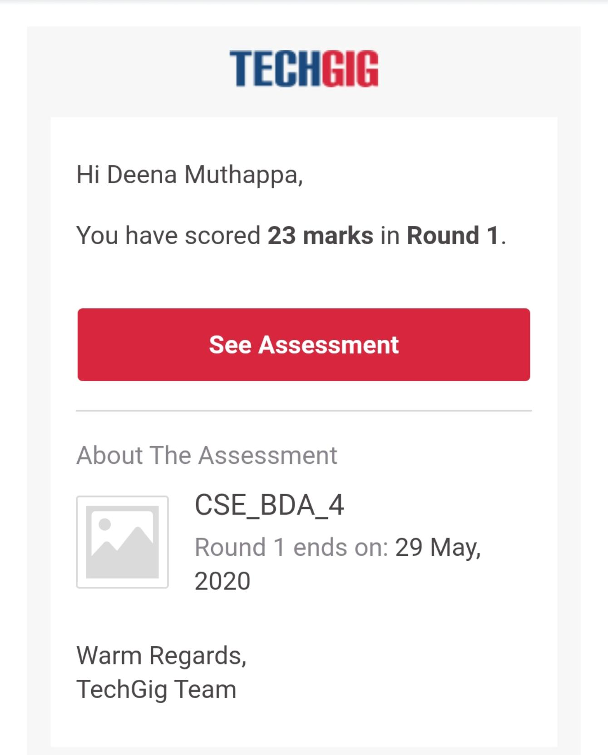

The test was on the subject Big Data Analytics.

Certification Course Details:

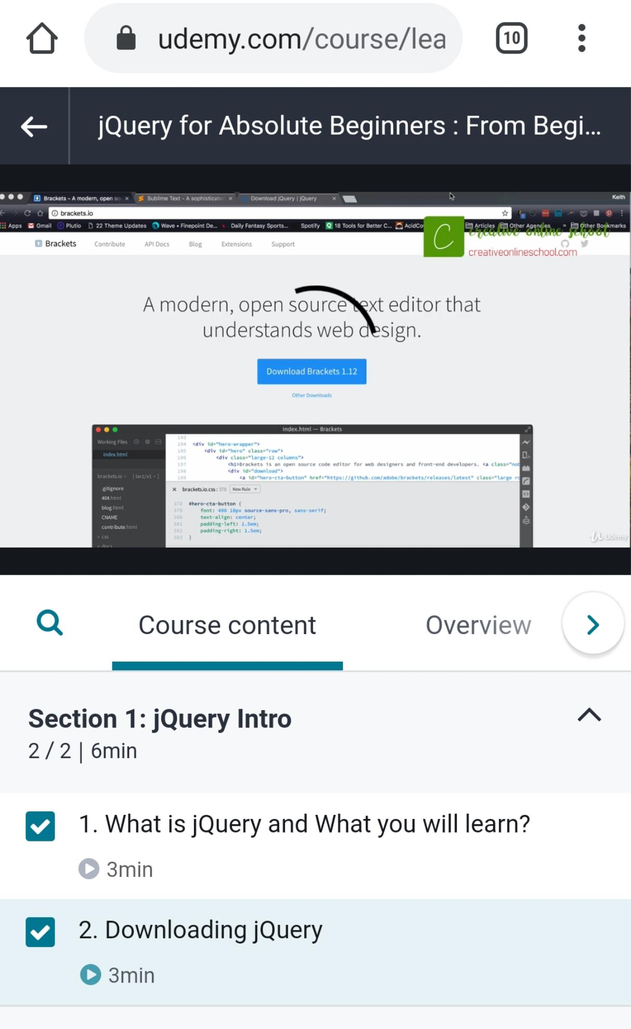

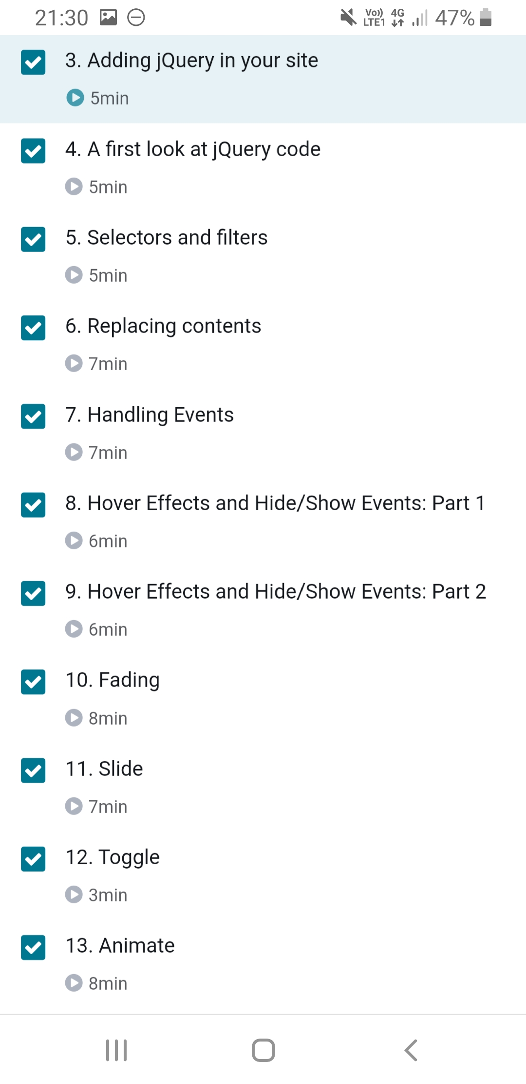

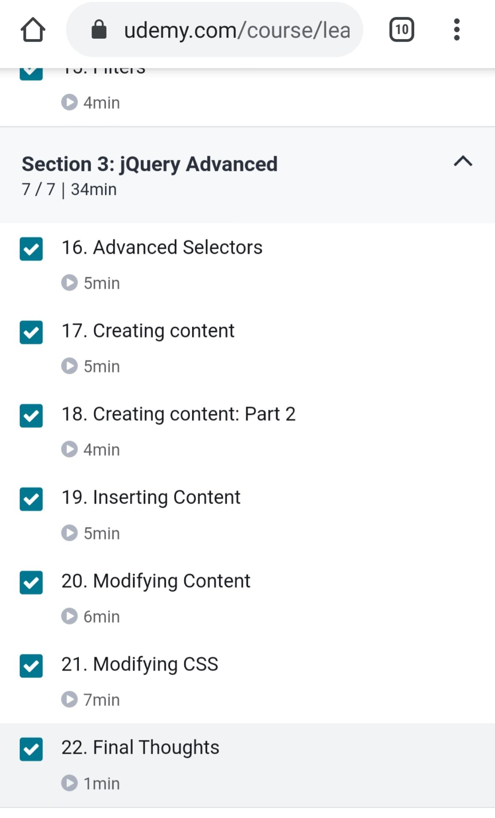

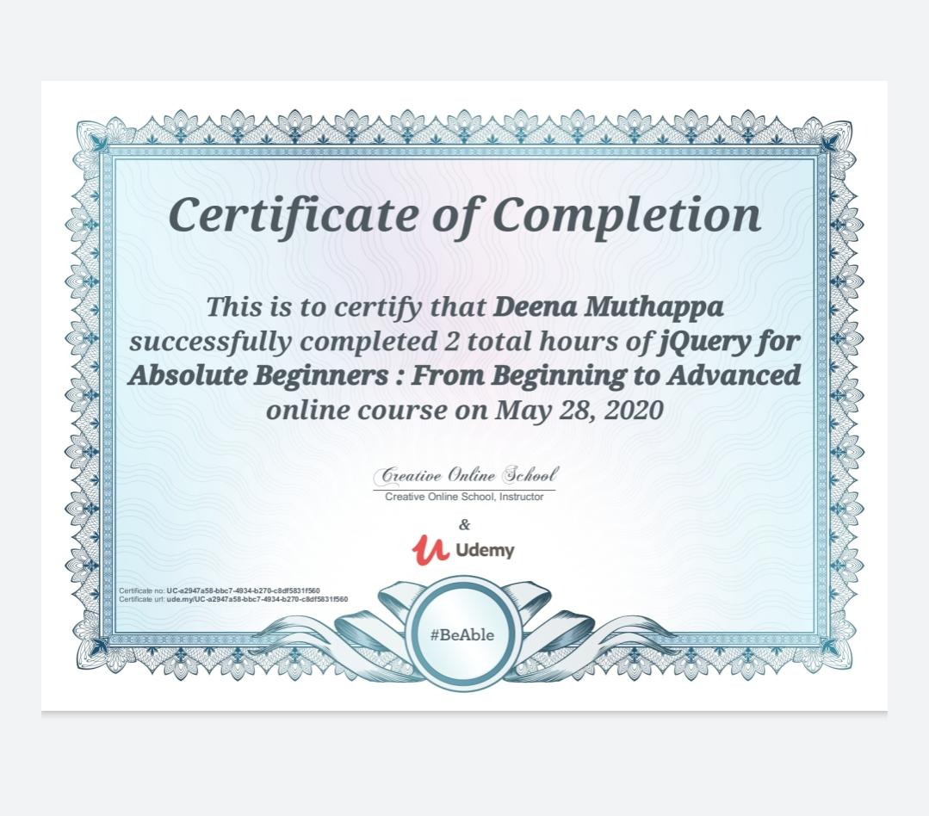

Coding Challenges Details:

#include<stdio.h>  
int main()  
{  
int n,r,sum=0,temp;  
printf("enter the number=");  
scanf("%d",&n);  
temp=n;  
while(n>0)  
{  
r=n%10;  
sum=sum+(rrr);  
n=n/10;  
}  
if(temp==sum)  
printf("armstrong number ");  
else  
printf("not armstrong number");  
return 0;  
}

Output:

enter the number=153  
armstrong number

enter the number= 371   
armstrong number

enter the number=5  
not armstrong number