**DAILY ONLINE ACTIVITIES SUMMARY**

|  |  |  |  |  |  |  |  |
| --- | --- | --- | --- | --- | --- | --- | --- |
| **Date:** | **01/07/20** | | | | **Name:** | **Deena Muthappa** | |
| **Sem & Sec** | **8th sem, A sec** | | | | **USN:** | **4AL16CS028** | |
| **Online Test Summary** | | | | | | | |
| **Subject** | | **Not conducted** | | | | | |
| **Max. Marks** | |  | | **Score** | |  | |
| **Certification Course Summary** | | | | | | | |
| **Course** | **Modern Java Programming Course** | | | | | | |
| **Certificate Provider** | | | **Udemy** | **Duration** | | | **9hrs** |
| **Coding Challenges** | | | | | | | |
| **Problem Statement: Python program to swap elements at given position using swap function** | | | | | | | |
| **Status: Completed** | | | | | | | |
| **Uploaded the report in Github** | | | | **Yes** | | | |
| **If yes Repository name** | | | | **deenamuthaappa/Coding-Challenges** | | | |
| **Uploaded the report in slack** | | | | **Yes** | | | |

Online Test Details: Not conducted

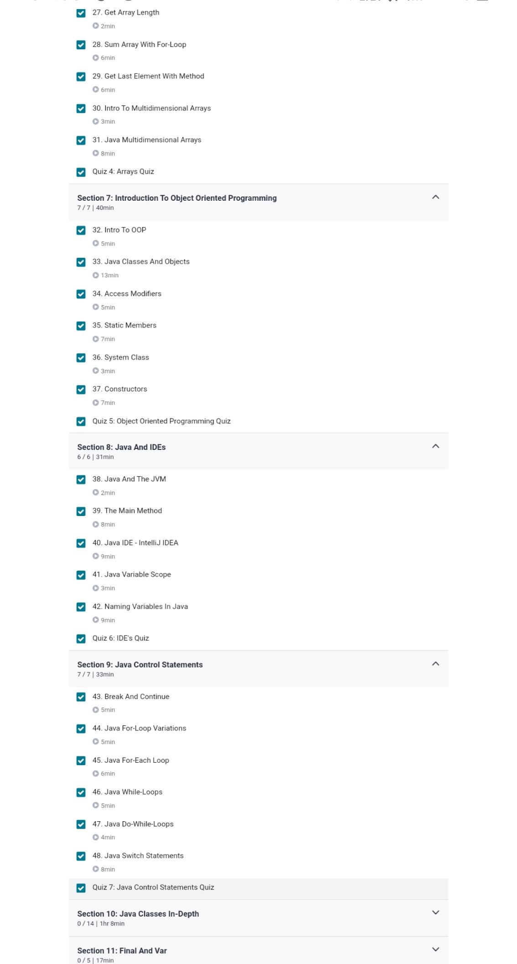Certification Course Details:

Coding Challenges Details:

//python program to swap elements at given position using swap function

def swapPositions(list, pos1, pos2):

list[pos1], list[pos2] = list[pos2], list[pos1]

return list

# Driver function

List = [23, 65, 19, 90]

pos1, pos2 = 1, 3

print(swapPositions(List, pos1-1, pos2-1))