**DAILY ONLINE ACTIVITIES SUMMARY**

|  |  |  |  |  |  |  |  |
| --- | --- | --- | --- | --- | --- | --- | --- |
| **Date:** | **02/07/20** | | | | **Name:** | **Deena Muthappa** | |
| **Sem & Sec** | **8th sem, A sec** | | | | **USN:** | **4AL16CS028** | |
| **Online Test Summary** | | | | | | | |
| **Subject** | | **SMS** | | | | | |
| **Max. Marks** | | **30** | | **Score** | | **Not displayed** | |
| **Certification Course Summary** | | | | | | | |
| **Course** | **Modern Java programming course** | | | | | | |
| **Certificate Provider** | | | **Udemy** | **Duration** | | | **9hrs** |
| **Coding Challenges** | | | | | | | |
| **Problem Statement:**Python code to demonstrate length of list using len() and length_hint. | | | | | | | |
| **Status: Completed** | | | | | | | |
| **Uploaded the report in Github** | | | | **Yes** | | | |
| **If yes Repository name** | | | | **deenamuthaappa/Coding-Challenges** | | | |
| **Uploaded the report in slack** | | | | **Yes** | | | |

Online Test Details:

The test was on the subject System Modelling and simulation

Certification Course Details:

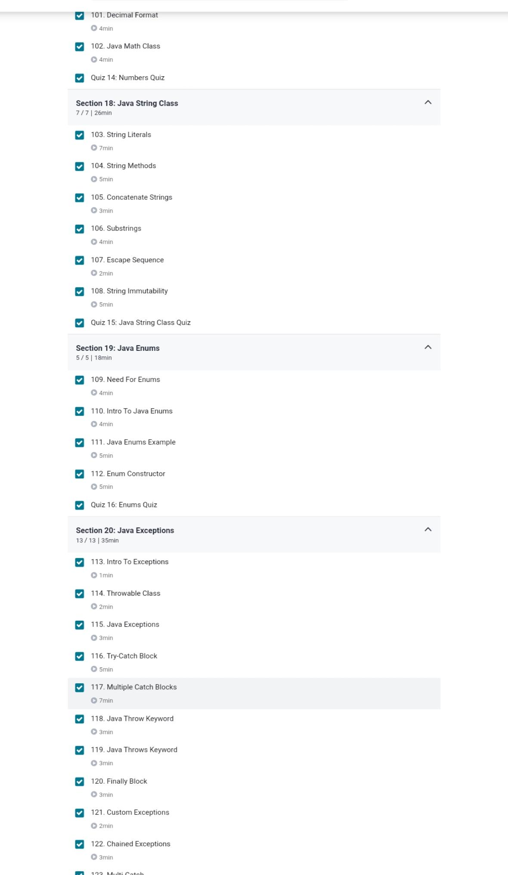

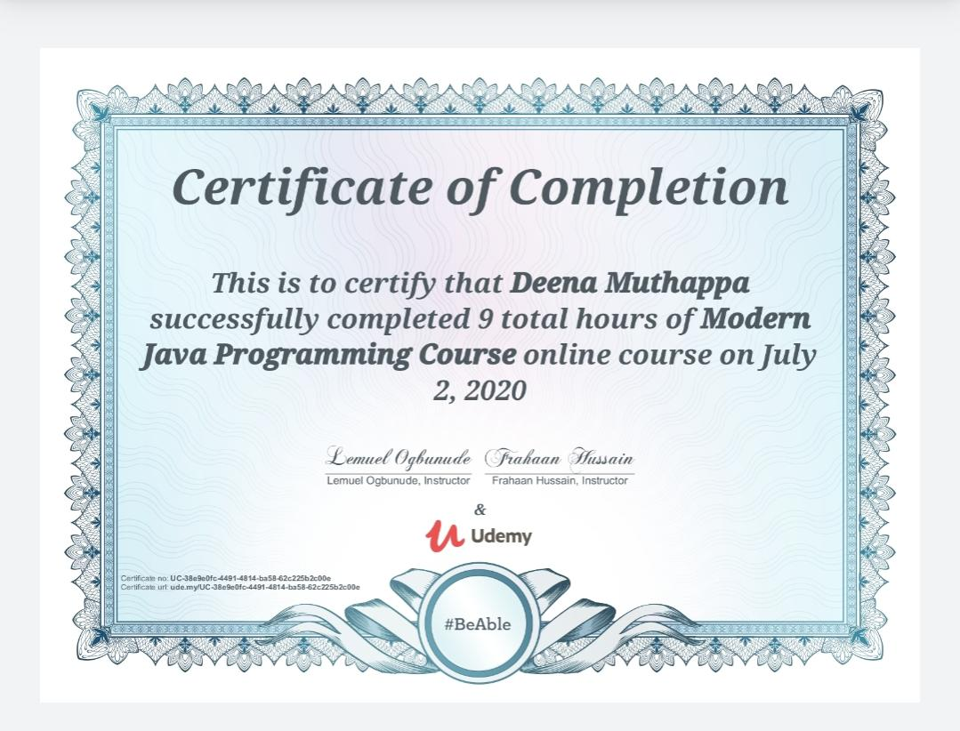

Coding Challenges Details:

# Python code to demonstrate length of list using len() and length_hint.

from operator import length_hint

# Initializing list

test_list = [ 1, 4, 5, 7, 8 ]

# Printing test_list

print ("The list is : " + str(test_list))

# Finding length of list

# using len()

list_len = len(test_list)

# Finding length of list

# using length_hint()

list_len_hint = length_hint(test_list)

# Printing length of list

print ("Length of list using len() is : " + str(list_len))

print ("Length of list using length_hint