**DAILY ONLINE ACTIVITIES SUMMARY**

|  |  |  |  |  |  |  |  |
| --- | --- | --- | --- | --- | --- | --- | --- |
| **Date:** | **03/07/20** | | | | **Name:** | **Deena Muthappa** | |
| **Sem & Sec** | **8th sem, A sec** | | | | **USN:** | **4AL16CS028** | |
| **Online Test Summary** | | | | | | | |
| **Subject** | | **Not conducted** | | | | | |
| **Max. Marks** | |  | | **Score** | |  | |
| **Certification Course Summary** | | | | | | | |
| **Course** | **Linux for absolute beginners** | | | | | | |
| **Certificate Provider** | | | **Udemy** | **Duration** | | | **7.5hrs** |
| **Coding Challenges** | | | | | | | |
| **Problem Statement: write a program to find simple interest** | | | | | | | |
| **Status: Completed** | | | | | | | |
| **Uploaded the report in Github** | | | | **Yes** | | | |
| **If yes Repository name** | | | | **deenamuthaappa/Coding-Challenges** | | | |
| **Uploaded the report in slack** | | | | **Yes** | | | |

Online Test Details:

Not conducted

Certification Course Details:

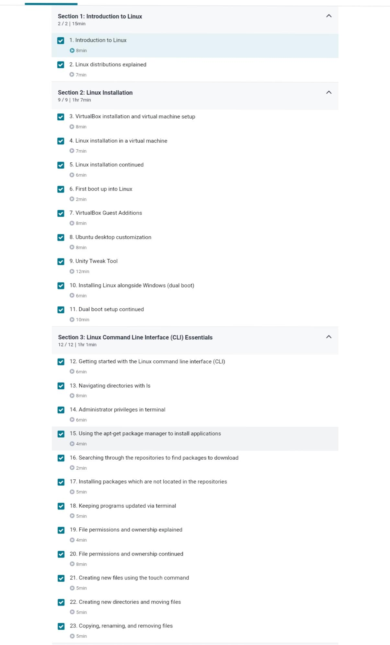

Coding Challenges Details:

//Write a program to find Simple interest

#include<iostream>

#include <stdio.h>

using namespace std;

int main() {

//principle amount

float p = 5;

//time

float r = 4;

//rate in years

float t = 5;

// Simple interest

float SI = 0;

SI =(p * t * r) / 100;

printf("Simple Interest = %f ",SI);

return 0;

}