**DAILY ONLINE ACTIVITIES SUMMARY**

|  |  |  |  |  |  |  |  |
| --- | --- | --- | --- | --- | --- | --- | --- |
| **Date:** | **04/07/20** | | | | **Name:** | **Deena Muthappa** | |
| **Sem & Sec** | **8th sem, A sec** | | | | **USN:** | **4AL16CS028** | |
| **Online Test Summary** | | | | | | | |
| **Subject** | | **Not conducted** | | | | | |
| **Max. Marks** | |  | | **Score** | |  | |
| **Certification Course Summary** | | | | | | | |
| **Course** | **Linux for absolute beginners** | | | | | | |
| **Certificate Provider** | | | **Udemy** | **Duration** | | | **7.5hrs** |
| **Coding Challenges** | | | | | | | |
| **Problem Statement: write a c program for superperfect numbers** | | | | | | | |
| **Status: Completed** | | | | | | | |
| **Uploaded the report in Github** | | | | **Yes** | | | |
| **If yes Repository name** | | | | **deenamuthaappa/Coding-Challenges** | | | |
| **Uploaded the report in slack** | | | | **Yes** | | | |

Online Test Details:

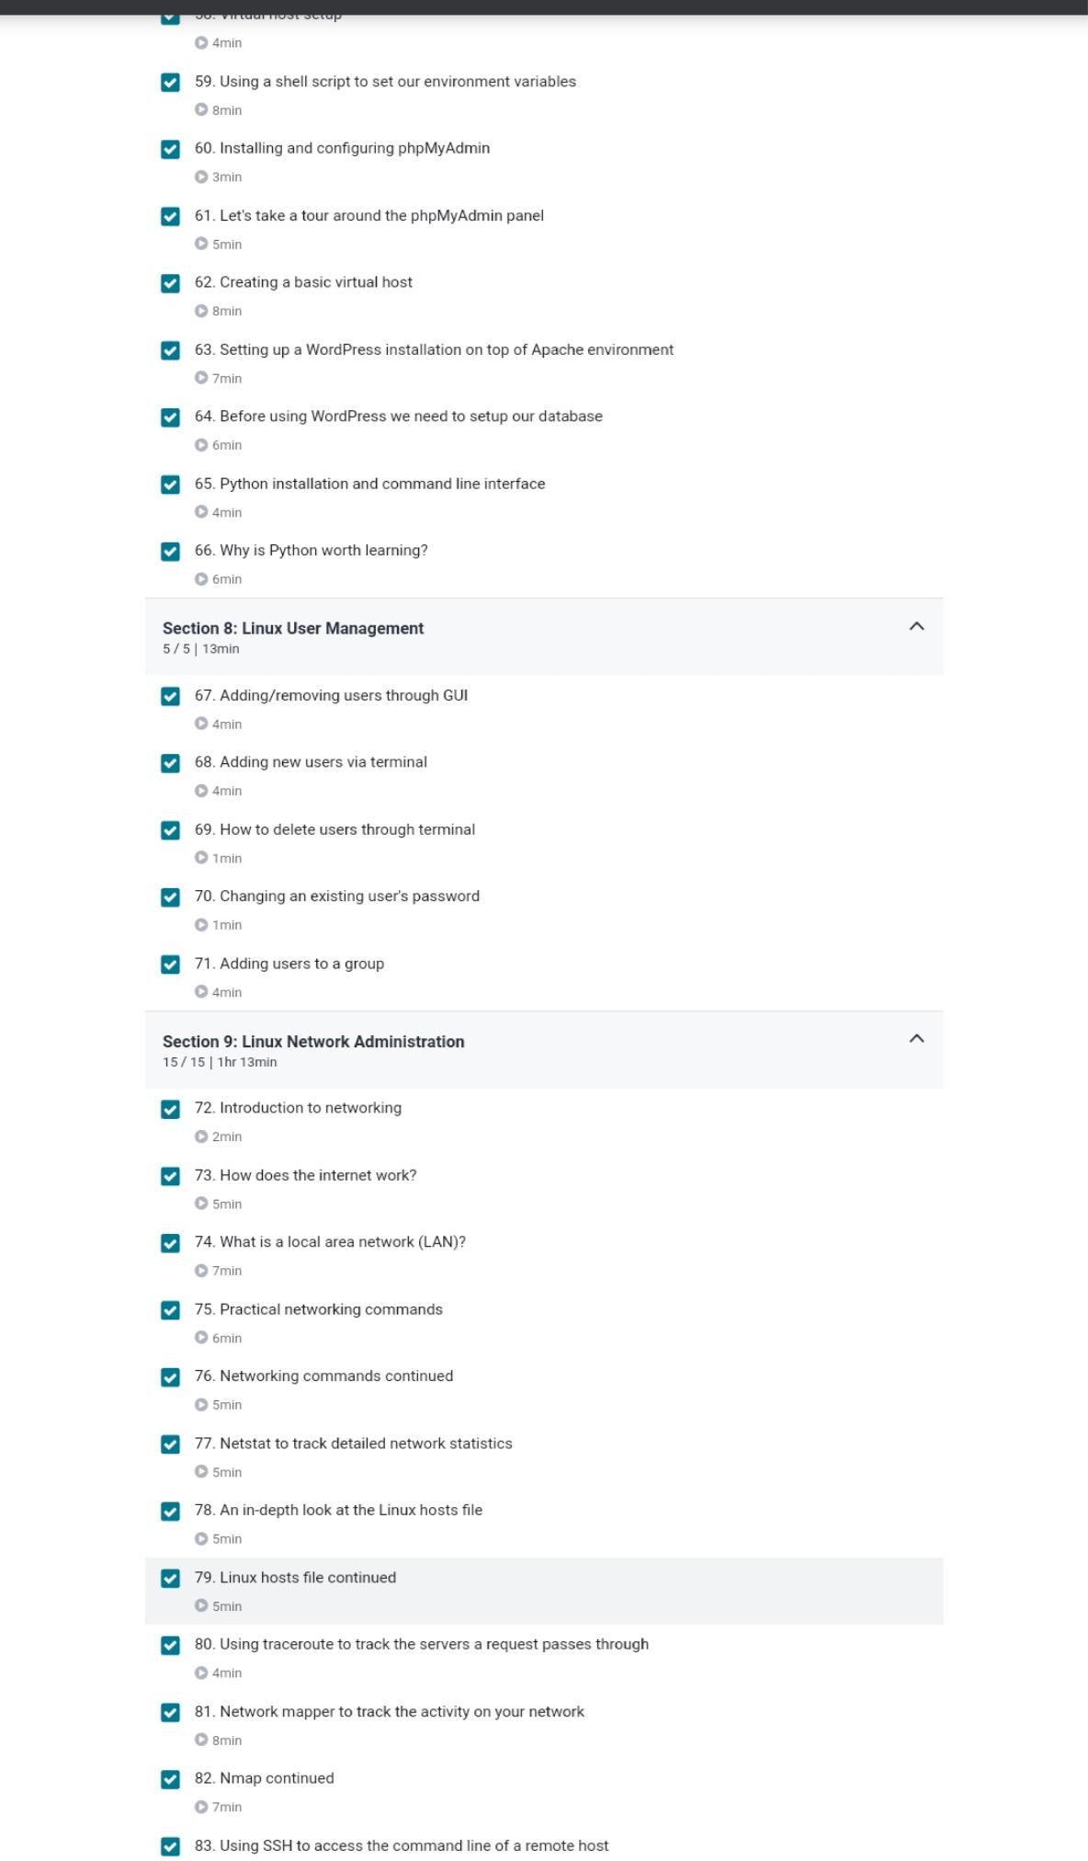Certification Course Details:

Coding Challenges Details:

//Write a c program for super perfect numbers

#include<stdio.h>

//function to find the sum of divisors of num

int divisorsum(int n){

int sum = 0; // intialising the sum

for (int i=1; i*i <= n; ++i){

if (n%i == 0) { // find the sum of divisors

if (i == (n/i))

sum += i;

else

sum += (i + n/i);

}

}

return sum;

}

int main() {

int n = 16;

int n1 = divisorsum(n);

if(2*n == divisorsum(n1)){

printf("The number %d is a superperfect number", n);

} else{

printf("The number %d is not a superperfect number", n);

}

return 0;

}