**DAILY ONLINE ACTIVITIES SUMMARY**

|  |  |  |  |  |  |  |  |
| --- | --- | --- | --- | --- | --- | --- | --- |
| **Date:** | **05/07/20** | | | | **Name:** | **Deena Muthappa** | |
| **Sem & Sec** | **8th sem, A sec** | | | | **USN:** | **4AL16CS028** | |
| **Online Test Summary** | | | | | | | |
| **Subject** | | **Not conducted** | | | | | |
| **Max. Marks** | |  | | **Score** | |  | |
| **Certification Course Summary** | | | | | | | |
| **Course** | **Complete python3 programming** | | | | | | |
| **Certificate Provider** | | | **Udemy** | **Duration** | | | **7.5hrs** |
| **Coding Challenges** | | | | | | | |
| **Problem Statement: Floyd triangle in python** | | | | | | | |
| **Status: Completed** | | | | | | | |
| **Uploaded the report in Github** | | | | **Yes** | | | |
| **If yes Repository name** | | | | **deenamuthaappa/Coding-Challenges** | | | |
| **Uploaded the report in slack** | | | | **Yes** | | | |

Online Test Details:

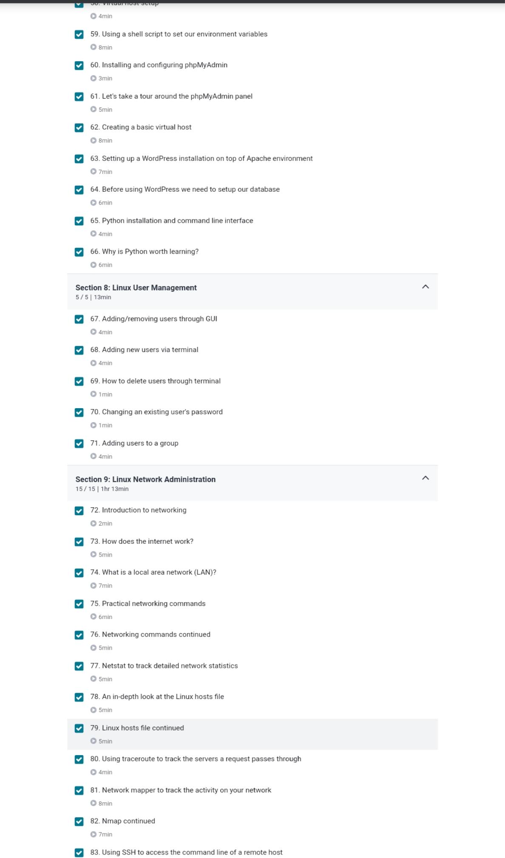Certification Course Details:



Coding Challenges Details:

rows = int(input("Please Enter the total Number of Rows : "))

number = 1

print("Floyd's Triangle")

for i in range(1, rows + 1):

for j in range(1, i + 1):

print(number, end = ' ')

number = number + 1

print()