**DAILY ONLINE ACTIVITIES SUMMARY**

|  |  |  |  |  |  |  |  |
| --- | --- | --- | --- | --- | --- | --- | --- |
| **Date:** | **06/07/20** | | | | **Name:** | **Deena Muthappa** | |
| **Sem & Sec** | **8th sem, A sec** | | | | **USN:** | **4AL16CS028** | |
| **Online Test Summary** | | | | | | | |
| **Subject** | | **Not conducted** | | | | | |
| **Max. Marks** | |  | | **Score** | |  | |
| **Certification Course Summary** | | | | | | | |
| **Course** | **Programming Network Application in Java** | | | | | | |
| **Certificate Provider** | | | **Udemy** | **Duration** | | | **2hrs** |
| **Coding Challenges** | | | | | | | |
| **Problem Statement: java program to convert CharArrayToString** | | | | | | | |
| **Status: Completed** | | | | | | | |
| **Uploaded the report in Github** | | | | **Yes** | | | |
| **If yes Repository name** | | | | **deenamuthaappa/Coding-Challenges** | | | |
| **Uploaded the report in slack** | | | | **Yes** | | | |

Online Test Details:

Certification Course Details:

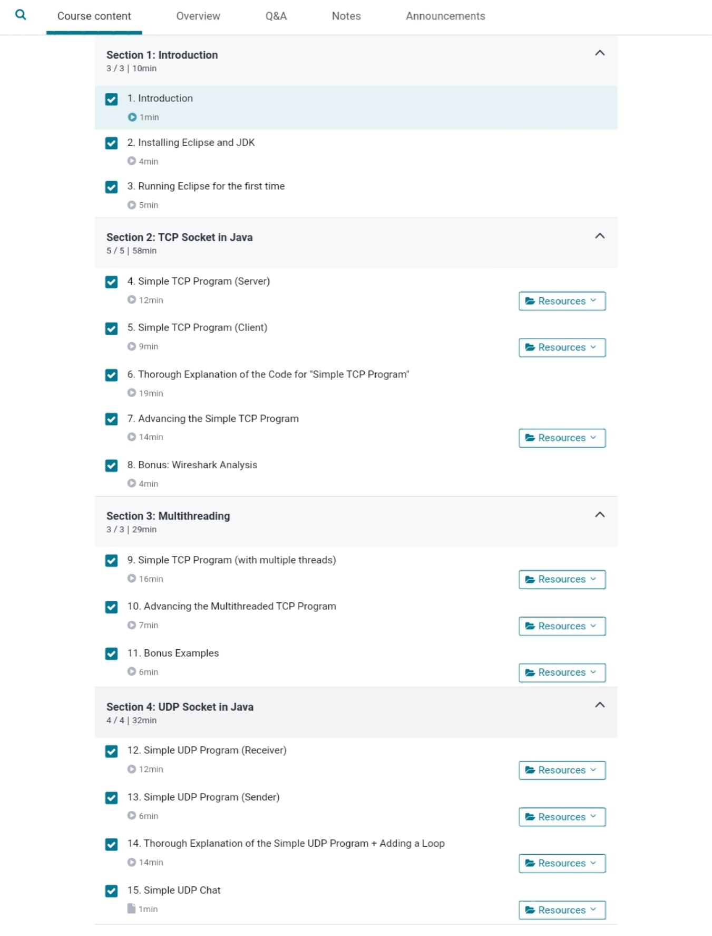

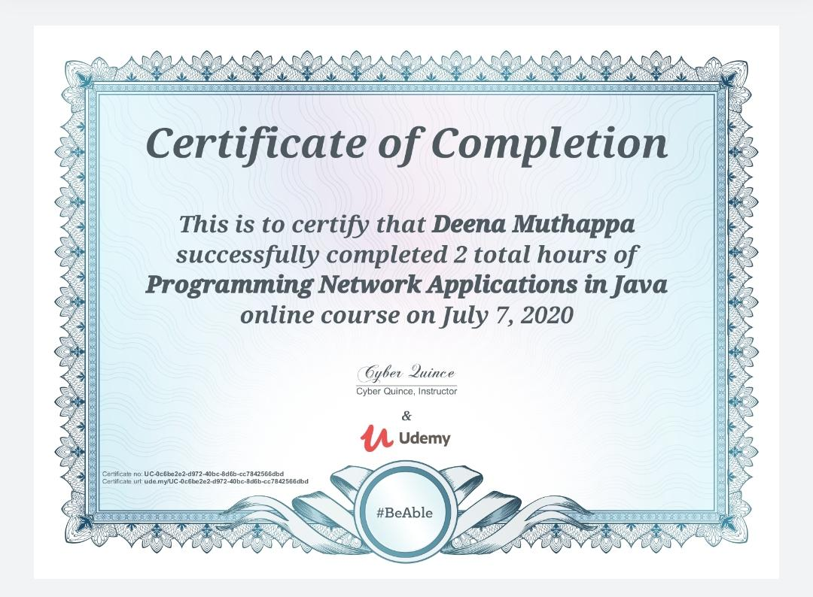

Coding Challenges Details:

class CharArrayToString

{

public static void main(String args[])

{

// Method 1: Using String object

char[] ch = {'g', 'o', 'o', 'd', ' ', 'm', 'o', 'r', 'n', 'i', 'n', 'g'};

String str = new String(ch);

System.out.println(str);

// Method 2: Using valueOf method

String str2 = String.valueOf(ch);

System.out.println(str2);

}

}