**DAILY ONLINE ACTIVITIES SUMMARY**

|  |  |  |  |  |  |  |  |
| --- | --- | --- | --- | --- | --- | --- | --- |
| **Date:** | **07/07/20** | | | | **Name:** | **Deena Muthappa** | |
| **Sem & Sec** | **8th sem, A sec** | | | | **USN:** | **4AL16CS028** | |
| **Online Test Summary** | | | | | | | |
| **Subject** | | **Not conducted** | | | | | |
| **Max. Marks** | |  | | **Score** | |  | |
| **Certification Course Summary** | | | | | | | |
| **Course** | **Ip Addressing** | | | | | | |
| **Certificate Provider** | | | **Udemy** | **Duration** | | | **150 mins** |
| **Coding Challenges** | | | | | | | |
| **Problem Statement: Write a C program to count number of Hnadshakes** | | | | | | | |
| **Status: Completed** | | | | | | | |
| **Uploaded the report in Github** | | | | **Yes** | | | |
| **If yes Repository name** | | | | **deenamuthaappa/Coding-Challenges** | | | |
| **Uploaded the report in slack** | | | | **Yes** | | | |

Online Test Details:

Certification Course Details:

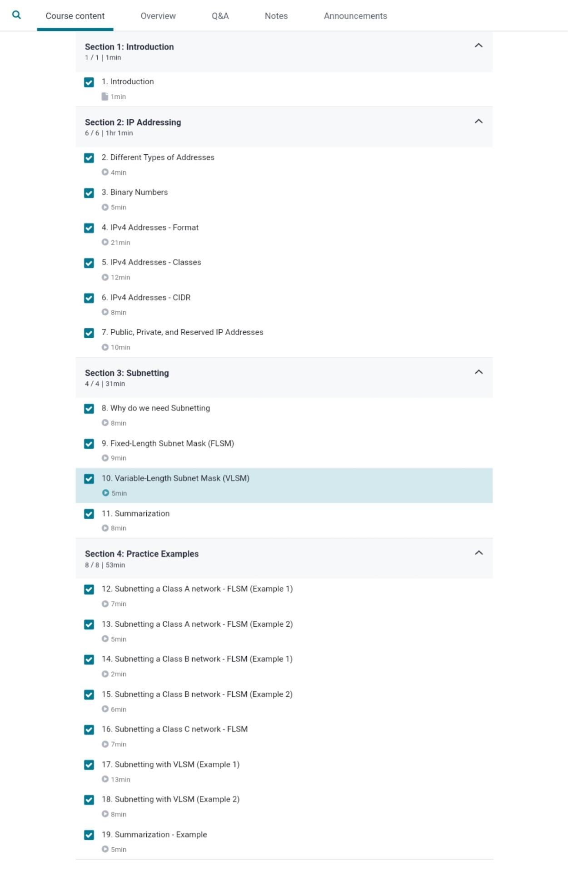

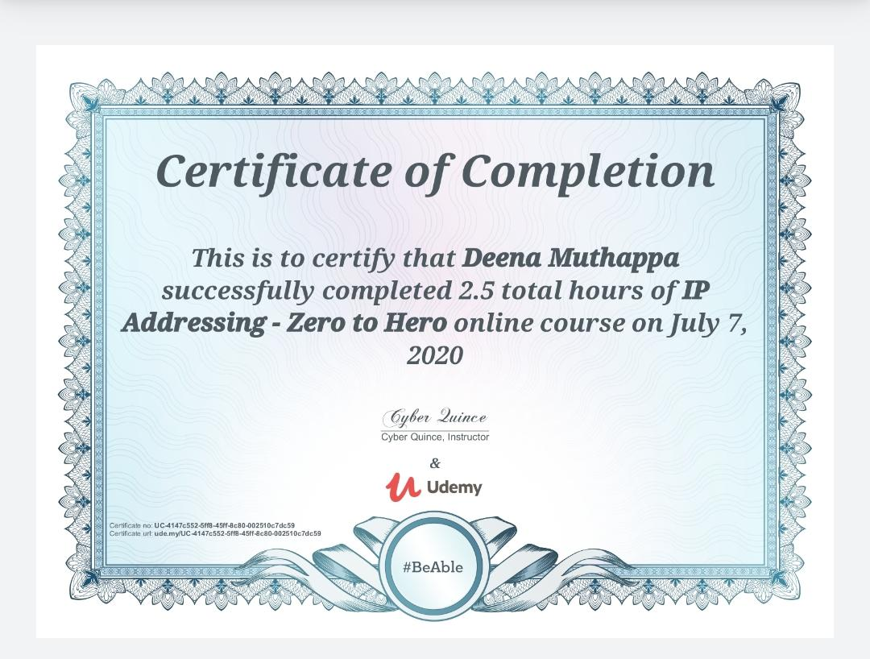

Coding Challenges Details:

//write a c program to count number of handshakes

#include<stdio.h>

int main()

{

int num;

printf("Enter the number of people: ");

scanf("%d",&num);

int total = num * (num-1) / 2;

printf("Total %d handshakes \n",total);

return;

}