**DAILY ONLINE ACTIVITIES SUMMARY**

|  |  |  |  |  |  |  |  |
| --- | --- | --- | --- | --- | --- | --- | --- |
| **Date:** | **08/07/20** | | | | **Name:** | **Deena Muthappa** | |
| **Sem & Sec** | **8th sem, A sec** | | | | **USN:** | **4AL16CS028** | |
| **Online Test Summary** | | | | | | | |
| **Subject** | | **Not conducted** | | | | | |
| **Max. Marks** | |  | | **Score** | |  | |
| **Certification Course Summary** | | | | | | | |
| **Course** | **Java servelets Training** | | | | | | |
| **Certificate Provider** | | | **Udemy** | **Duration** | | | **12.5hrs** |
| **Coding Challenges** | | | | | | | |
| **Problem Statement: program to find HDfS of two numbers** | | | | | | | |
| **Status: Completed** | | | | | | | |
| **Uploaded the report in Github** | | | | **Yes** | | | |
| **If yes Repository name** | | | | **deenamuthaappa/Coding-Challenges** | | | |
| **Uploaded the report in slack** | | | | **Yes** | | | |

Online Test Details:

Certification Course Details:

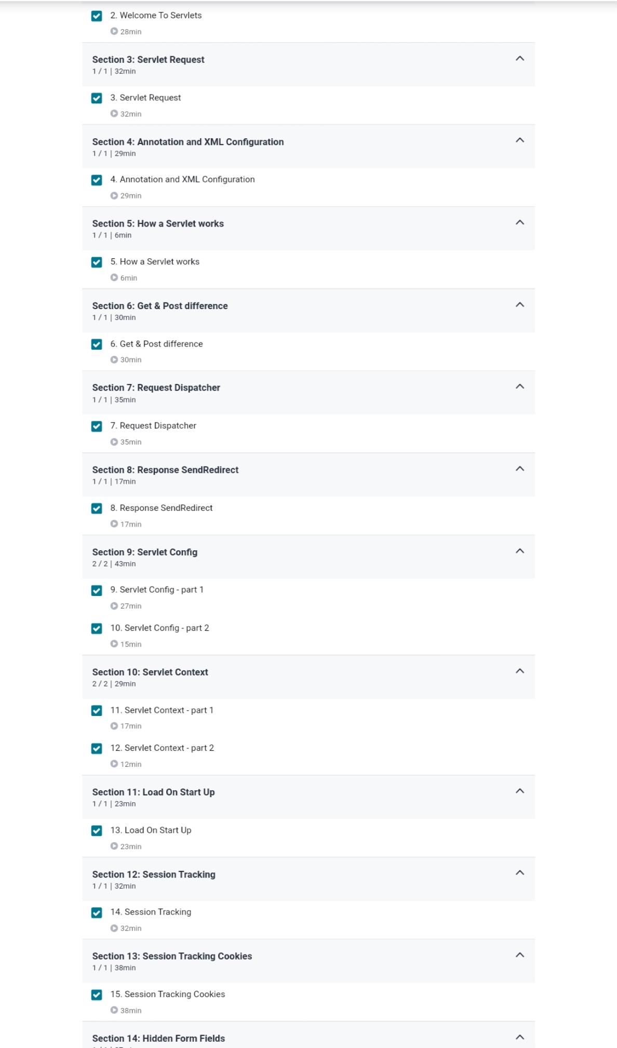

Coding Challenges Details:

//program to find HDFS of two numbers

defcompute_hcf(x,y):

ifx>y:

smaller=y

else:

smaller=x

foriinrange(1,smaller+1):

if((x%i==0)and(y%i==0)):

hcf=i

returnhcf

num1=54

num2=24

print("TheH.C.F.is",compute_hcf(num1,num2))