**DAILY ONLINE ACTIVITIES SUMMARY**

|  |  |  |  |  |  |  |  |
| --- | --- | --- | --- | --- | --- | --- | --- |
| **Date:** | **09/07/20** | | | | **Name:** | **Deena Muthappa** | |
| **Sem & Sec** | **8th sem, A sec** | | | | **USN:** | **4AL16CS028** | |
| **Online Test Summary** | | | | | | | |
| **Subject** | | **Not conducted** | | | | | |
| **Max. Marks** | |  | | **Score** | |  | |
| **Certification Course Summary** | | | | | | | |
| **Course** | **Java servelets training** | | | | | | |
| **Certificate Provider** | | | **Udemy** | **Duration** | | | **12.5hrs** |
| **Coding Challenges** | | | | | | | |
| **Problem Statement: python program to find XOR of all Array elements** | | | | | | | |
| **Status: Completed** | | | | | | | |
| **Uploaded the report in Github** | | | | **Yes** | | | |
| **If yes Repository name** | | | | **deenamuthaappa/Coding-Challenges** | | | |
| **Uploaded the report in slack** | | | | **Yes** | | | |

Online Test Details:

Certification Course Details:

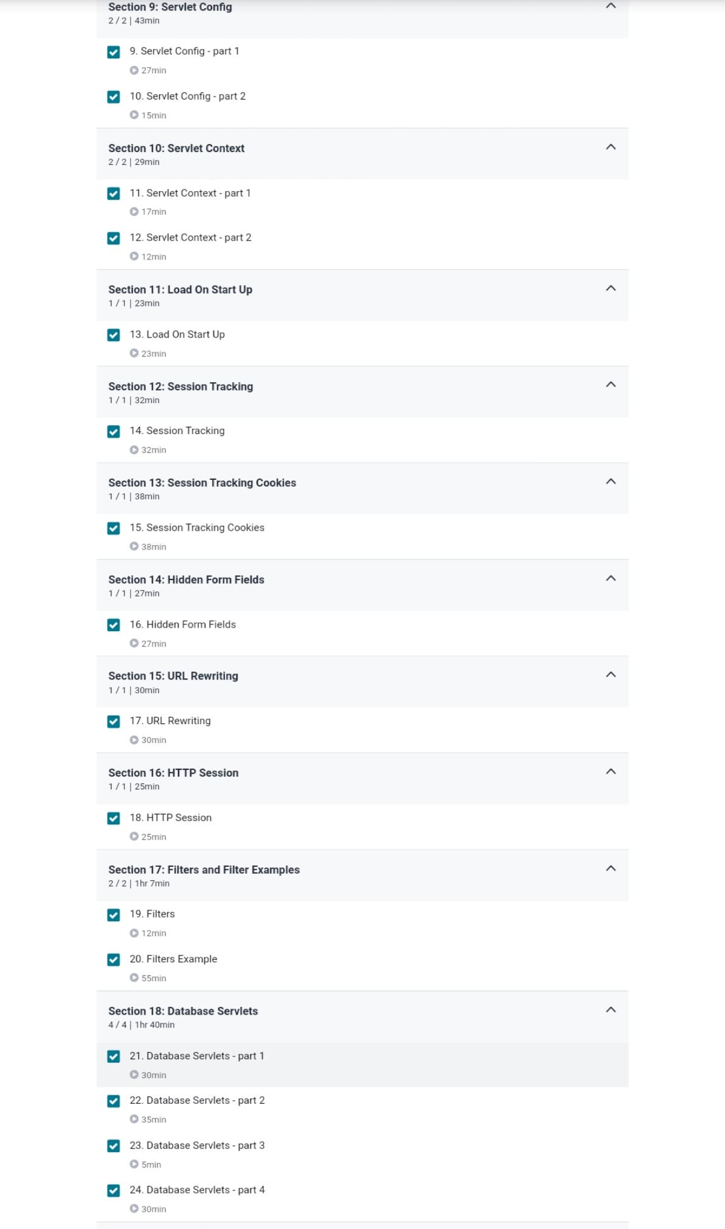

Coding Challenges Details:

#python program to find XOR of all elements in array function

defxorOfArray(arr,n):

xor_arr=0

foriinrange(n):

xor_arr=xor_arr^arr[i]

returnxor_arr

if__name__=='__main__':

arr=[3,9,12,13,15]

n=len(arr)

print(xorOfArray(arr,n))