**DAILY ONLINE ACTIVITIES SUMMARY**

|  |  |  |  |  |  |  |  |
| --- | --- | --- | --- | --- | --- | --- | --- |
| **Date:** | **10/06/20** | | | | **Name:** | **Deena Muthappa** | |
| **Sem & Sec** | **8th sem, A sec** | | | | **USN:** | **4AL16CS028** | |
| **Online Test Summary** | | | | | | | |
| **Subject** | | **Not conducted** | | | | | |
| **Max. Marks** | |  | | **Score** | |  | |
| **Certification Course Summary** | | | | | | | |
| **Course** | **The complete front end web development course** | | | | | | |
| **Certificate Provider** | | | **Udemy** | **Duration** | | | **15hrs** |
| **Coding Challenges** | | | | | | | |
| **Problem Statement: Write a C program to print the sum of boundary elements of a matrix** | | | | | | | |
| **Status: Completed** | | | | | | | |
| **Uploaded the report in Github** | | | | **Yes** | | | |
| **If yes Repository name** | | | | **deenamuthaappa/Coding-Challenges** | | | |
| **Uploaded the report in slack** | | | | **Yes** | | | |

Online Test Details:

Not conductex

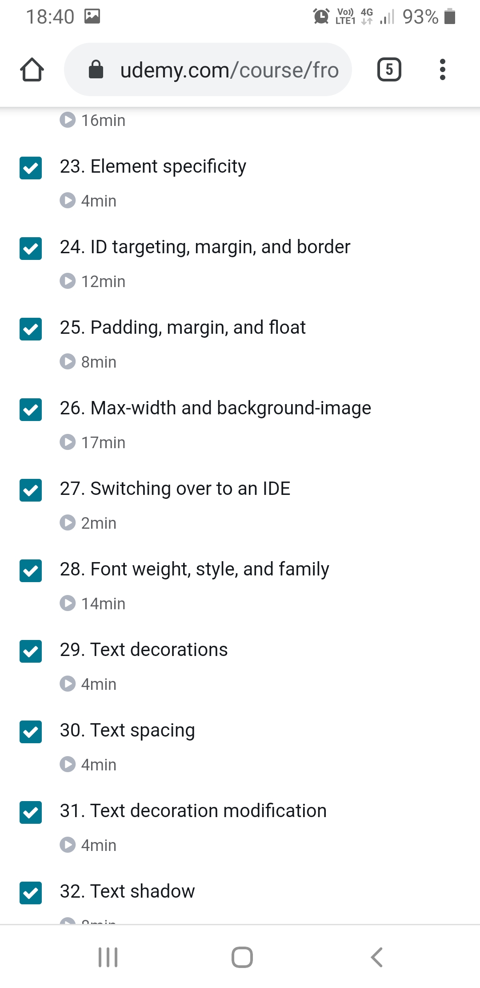Certification Course Details:

Coding Challenges Details:

//Write a C Program to print the sum of boundary elements of a matrix

#include <stdio.h>

#define MAX 100

void printBoundary(int a[][MAX], int m, int n)

{

for (int i = 0; i < m; i++) {

for (int j = 0; j < n; j++) {

if (i == 0 || j == 0 || i == n - 1 || j == n - 1)

printf("%d",a[i][j]);

else

printf(" ");

printf(" ");

}

printf("\n");

}

}

// Driver code

int main()

{

int a[4][MAX] = { { 1, 2, 3, 4 }, { 5, 6, 7, 8 }, { 1, 2, 3, 4 }, { 5, 6, 7, 8 } };

printBoundary(a, 4, 4);

return 0;

}