**DAILY ONLINE ACTIVITIES SUMMARY**

|  |  |  |  |  |  |  |  |
| --- | --- | --- | --- | --- | --- | --- | --- |
| **Date:** | **10/07/20** | | | | **Name:** | **Deena Muthappa** | |
| **Sem & Sec** | **8th sem, A sec** | | | | **USN:** | **4AL16CS028** | |
| **Online Test Summary** | | | | | | | |
| **Subject** | | **Not Conducted** | | | | | |
| **Max. Marks** | |  | | **Score** | |  | |
| **Certification Course Summary** | | | | | | | |
| **Course** | **Java Servelets Training** | | | | | | |
| **Certificate Provider** | | | **Udemy** | **Duration** | | | **12.5hrs** |
| **Coding Challenges** | | | | | | | |
| **Problem Statement: C program to find non repeating character in a string** | | | | | | | |
| **Status: Completed** | | | | | | | |
| **Uploaded the report in Github** | | | | **Yes** | | | |
| **If yes Repository name** | | | | **deenamuthaappa/Coding-Challenges** | | | |
| **Uploaded the report in slack** | | | | **Yes** | | | |

Online Test Details:

Certification Course Details:

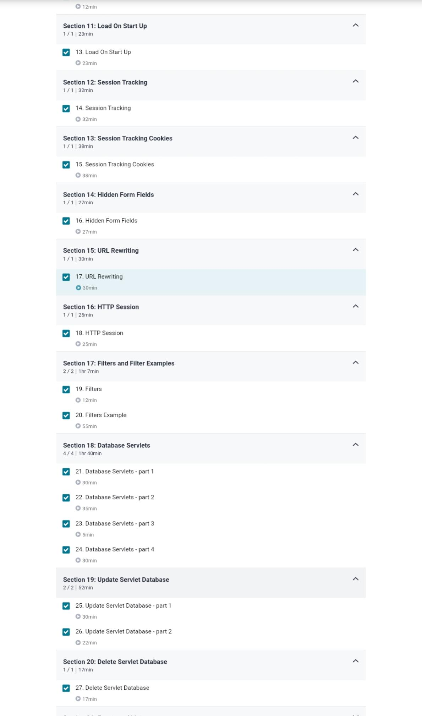

Coding Challenges Details:

//C program to find non repeating character in a string

#include<stdlib.h>

#include<stdio.h>

#define NO_OF_CHARS 256

int *get_char_count (char *str)

{

int *count = (int *)calloc(sizeof(int), NO_OF_CHARS);

int i;

for (i = 0; *(str+i); i++)

count[*(str+i)]++;

return count;

}

int first_non_repeating_character(char *str)

{

int *count = get_char_count(str);

int index = -1, i;

for (i = 0; *(str+i); i++)

{

if (count[*(str+i)] == 1)

{

index = i;

break;

}

}

free(count);