**DAILY ONLINE ACTIVITIES SUMMARY**

|  |  |  |  |  |  |  |  |
| --- | --- | --- | --- | --- | --- | --- | --- |
| **Date:** | **11/06/20** | | | | **Name:** | **Deena Muthappa** | |
| **Sem & Sec** | **8th sem, A sec** | | | | **USN:** | **4AL16CS028** | |
| **Online Test Summary** | | | | | | | |
| **Subject** | | **SMS** | | | | | |
| **Max. Marks** | | **60** | | **Score** | | **60** | |
| **Certification Course Summary** | | | | | | | |
| **Course** | **The complete front end web development course** | | | | | | |
| **Certificate Provider** | | | **Udemy** | **Duration** | | | **15hrs** |
| **Coding Challenges** | | | | | | | |
| **Program Statememt :C** program that contains a function to generate and return random numbers. | | | | | | | |
| **Status: Completed** | | | | | | | |
| **Uploaded the report in Github** | | | | **Yes** | | | |
| **If yes Repository name** | | | | **deenamuthaappa/Coding-Challenges** | | | |
| **Uploaded the report in slack** | | | | **Yes** | | | |

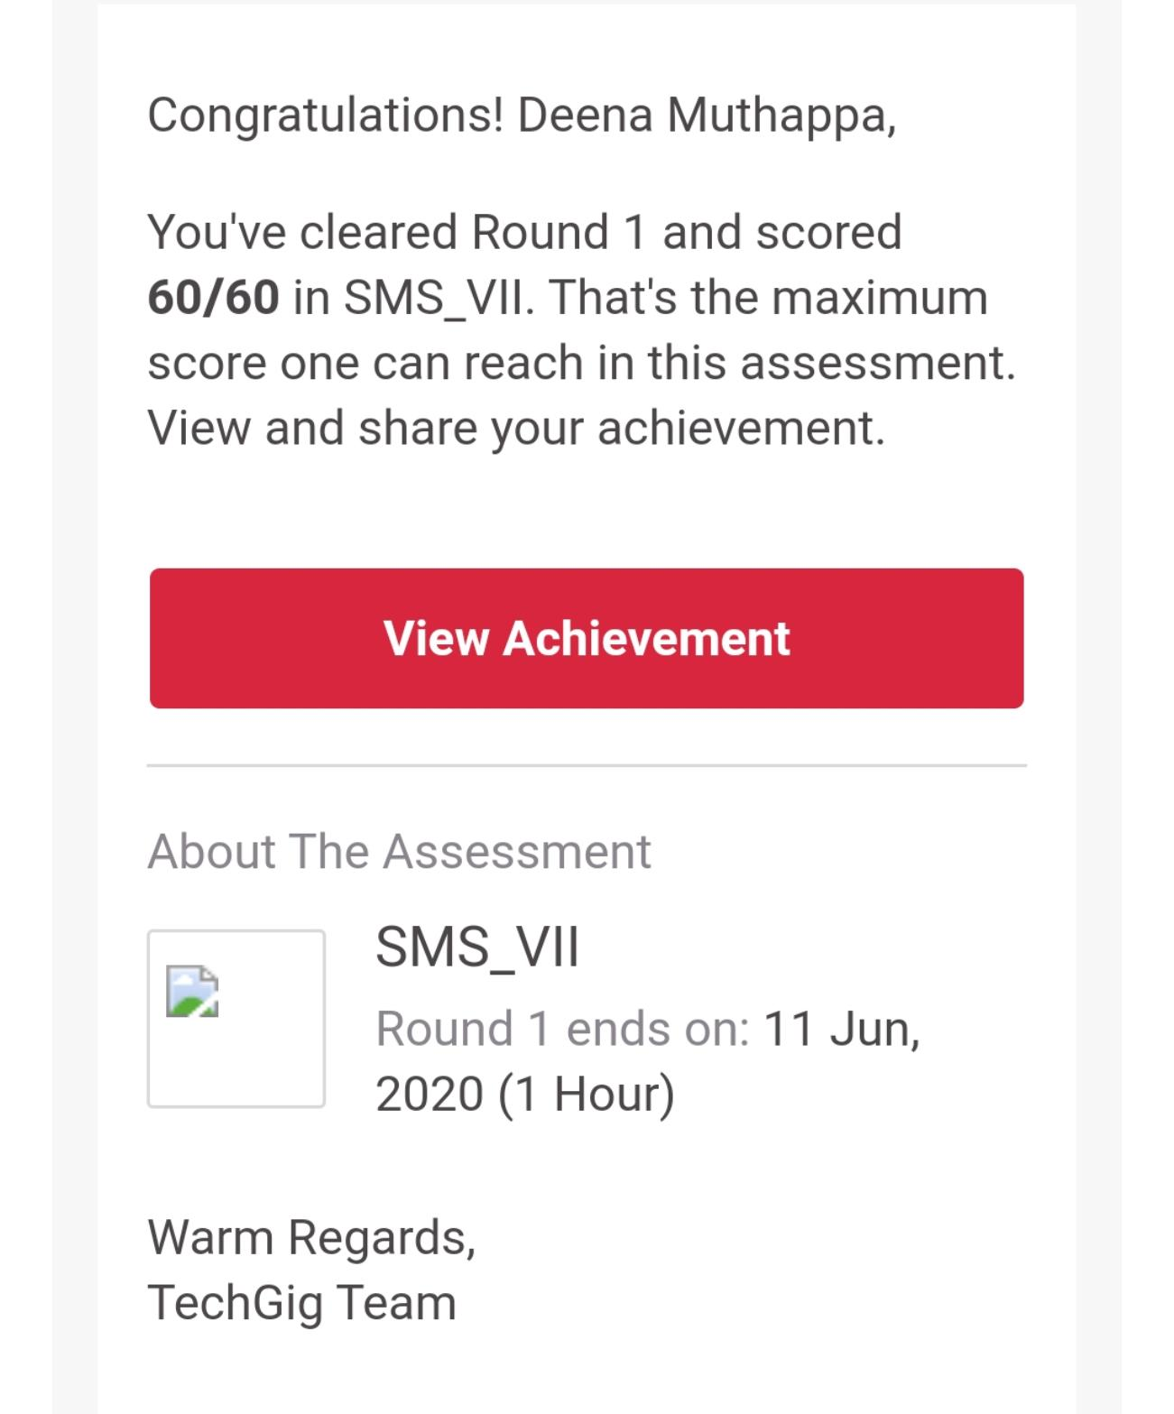Online Test Details:

The test was on the subject System Modelling and Simulation

Certification Course Details:

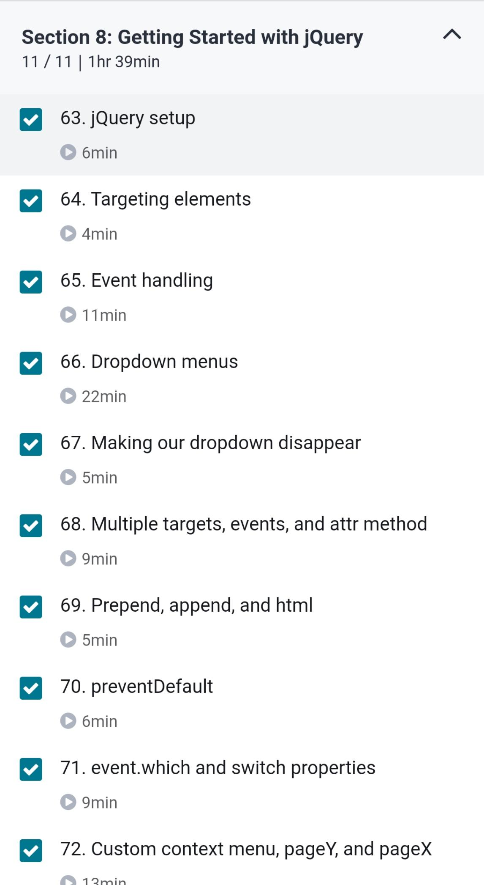

Coding Challenges Details:

**C program with function to generate and return random numbers.**

**#include <stdio.h>**

**#include <time.h>**

**int * getRandom( ) {**

**static int r[10];**

**int i;**

**srand( (unsigned)time( NULL ) );**

**for ( i = 0; i < 10; ++i) {**

**r[i] = rand();**

**printf("%d\n", r[i] );**

**}**

**return r;**

**}**

**int main () {**

**int *p;**

**int i;**

**p = getRandom();**

**for ( i = 0; i < 10; i++ ) {**

**printf("*(p + [%d]) : %d\n", i, *(p + i) );**

**}**

**return 0;**

**}**