**DAILY ONLINE ACTIVITIES SUMMARY**

|  |  |  |  |  |  |  |  |
| --- | --- | --- | --- | --- | --- | --- | --- |
| **Date:** | **11/07/20** | | | | **Name:** | **Deena Muthappa** | |
| **Sem & Sec** | **8th sem, A sec** | | | | **USN:** | **4AL16CS028** | |
| **Online Test Summary** | | | | | | | |
| **Subject** | | **Not conducted** | | | | | |
| **Max. Marks** | |  | | **Score** | |  | |
| **Certification Course Summary** | | | | | | | |
| **Course** | **Java Servlets Training** | | | | | | |
| **Certificate Provider** | | | **Udemy** | **Duration** | | | **12.5hrs** |
| **Coding Challenges** | | | | | | | |
| **Problem Statement: Sum of natural numbers using Recursion** | | | | | | | |
| **Status: Completed** | | | | | | | |
| **Uploaded the report in Github** | | | | **Yes** | | | |
| **If yes Repository name** | | | | **deenamuthaappa/Coding-Challenges** | | | |
| **Uploaded the report in slack** | | | | **Yes** | | | |

Online Test Details:

Certification Course Details:

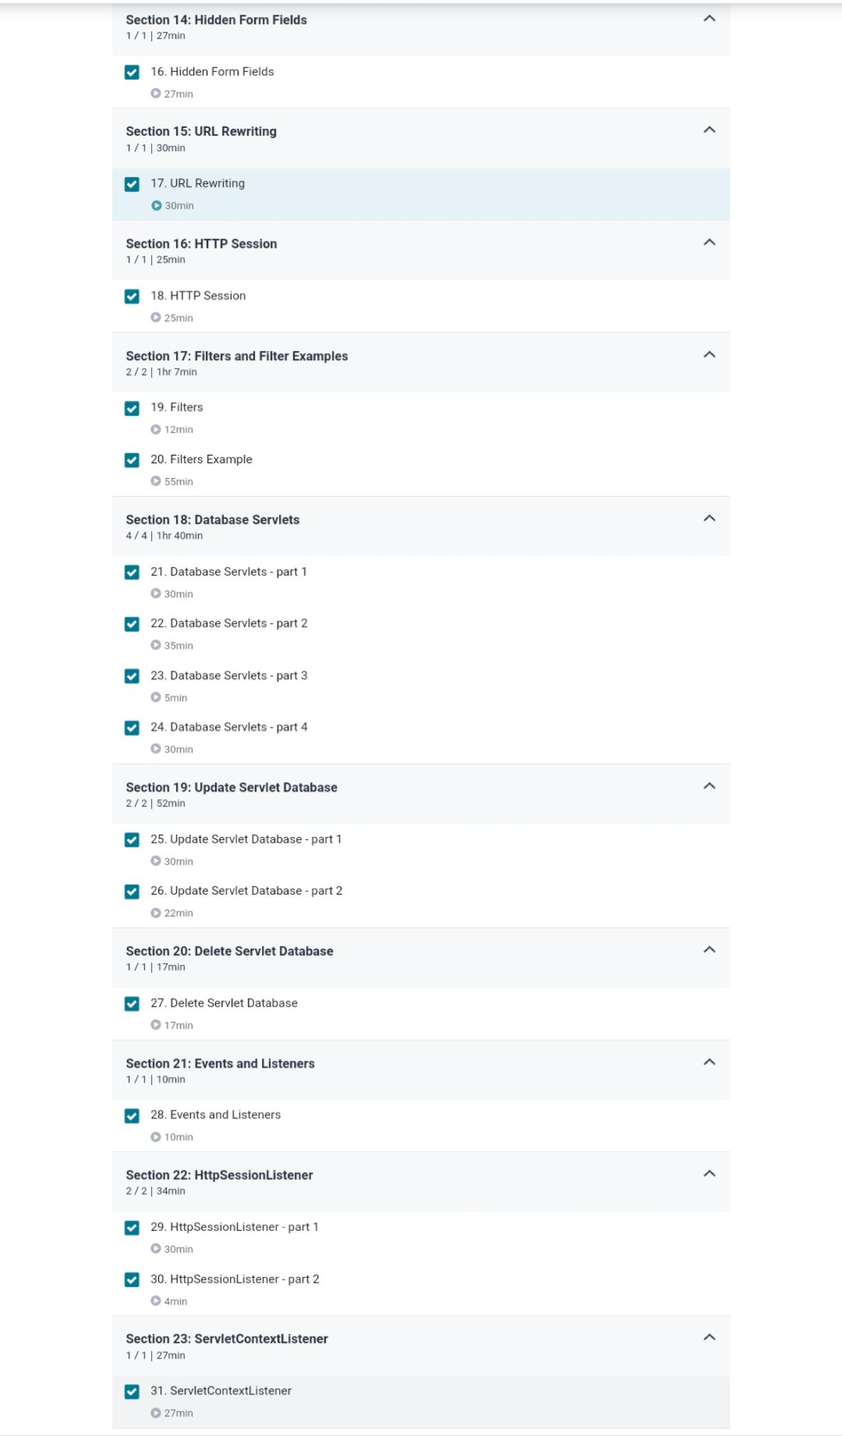

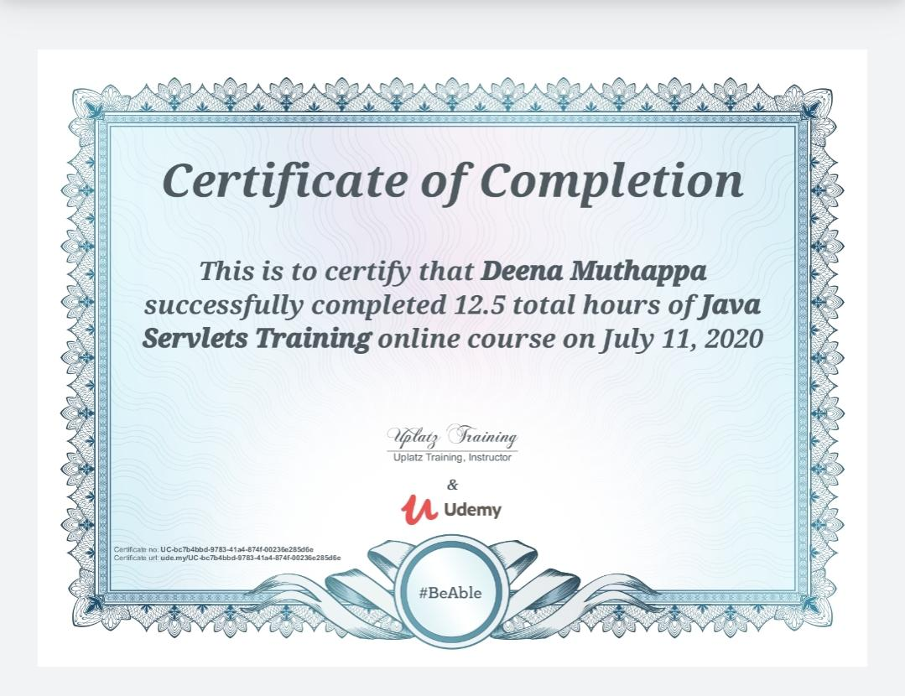

Coding Challenges Details:

//Sum of Natural Numbers Using Recursion

#include <stdio.h>

int addNumbers(int n);

int main() {

int num;

printf("Enter a positive integer: ");

scanf("%d", &num);

printf("Sum = %d", addNumbers(num));

return 0;

}

int addNumbers(int n) {

if (n != 0)

return n + addNumbers(n - 1);

else

return n;

}