**DAILY ONLINE ACTIVITIES SUMMARY**

|  |  |  |  |  |  |  |  |
| --- | --- | --- | --- | --- | --- | --- | --- |
| **Date:** | **12/06/20** | | | | **Name:** | **Deena Muthappa** | |
| **Sem & Sec** | **8th sem, A sec** | | | | **USN:** | **4AL16CS028** | |
| **Online Test Summary** | | | | | | | |
| **Subject** | | **BDA** | | | | | |
| **Max. Marks** | | **30** | | **Score** | | **24** | |
| **Certification Course Summary** | | | | | | | |
| **Course** | **The complete front end web development course** | | | | | | |
| **Certificate Provider** | | | **Udemy** | **Duration** | | | **15hrs** |
| **Coding Challenges** | | | | | | | |
| **Problem Statement :C program to Reverse a String using recursion.** | | | | | | | |
| **Status: Completed** | | | | | | | |
| **Uploaded the report in Github** | | | | **Yes** | | | |
| **If yes Repository name** | | | | **deenamuthaappa/Coding-Challenges** | | | |
| **Uploaded the report in slack** | | | | **Yes** | | | |

Online Test Details:

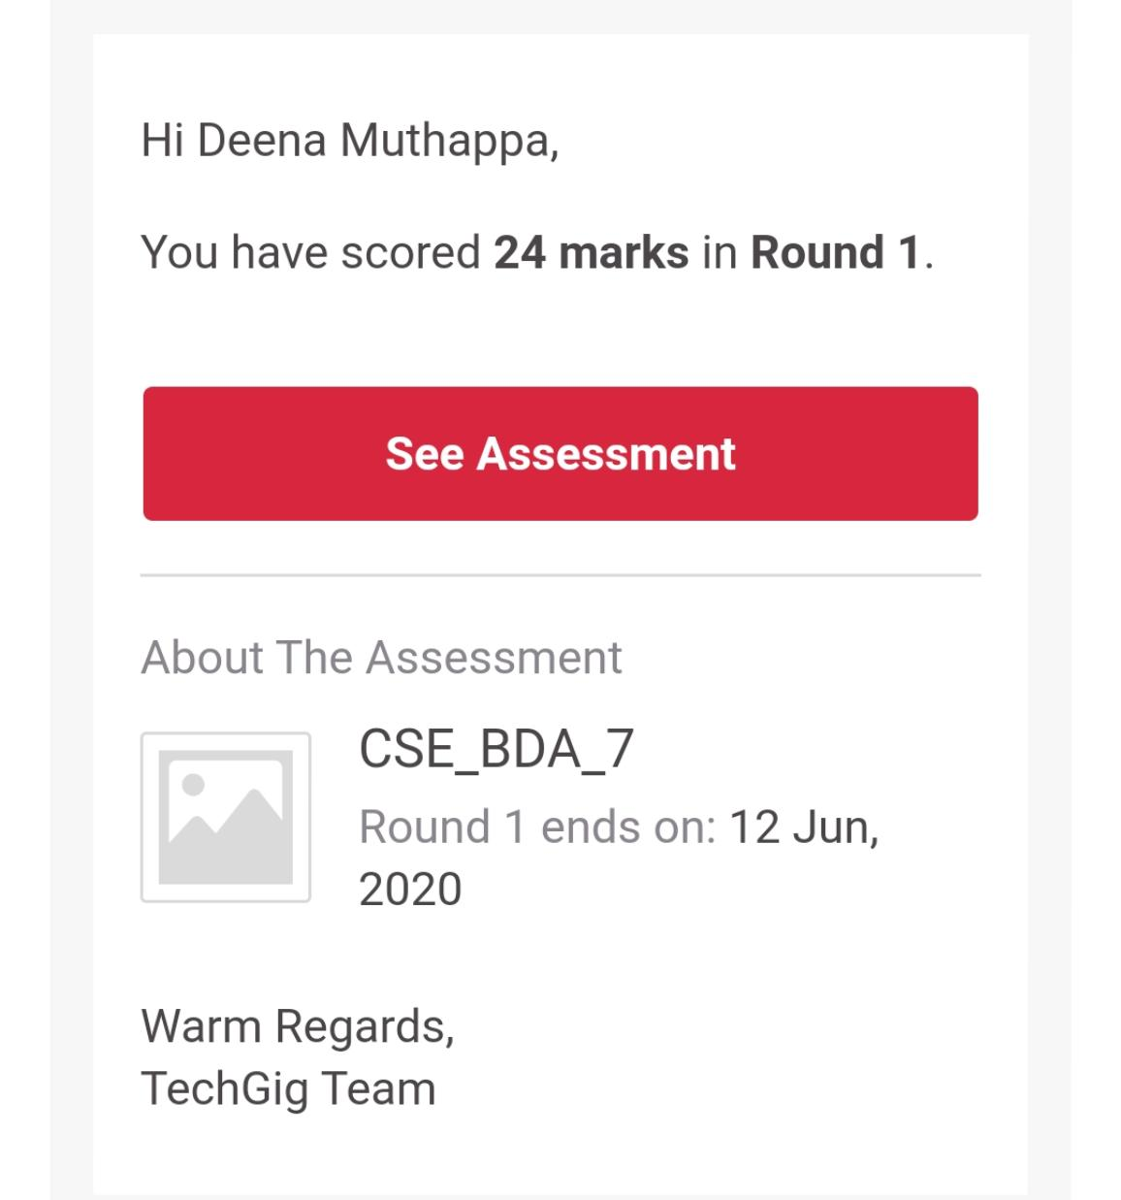

The test was on the subject Big Data Analytics

Certification Course Details:

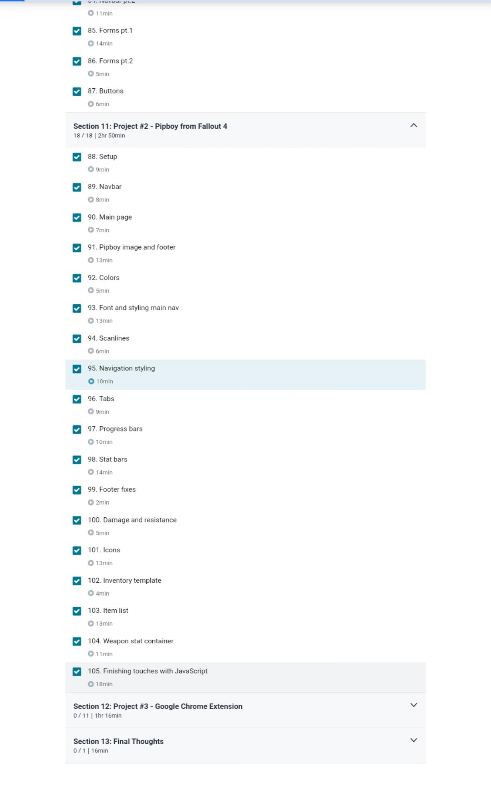

Coding Challenges Details:

//C program to Reverse a String using recursion

#include <stdio.h>

#include <string.h>

void reverse_string(char*, int, int);

int main()

{

char string_array[150];

printf("Enter any string:");

scanf("%s", &string_array);

reverse_string(string_array, 0, strlen(string_array)-1);

printf("\nReversed String is: %s",string_array);

return 0;

}

void reverse_string(char *x, int start, int end)

{

char ch;

if (start >= end)

return;

ch = *(x+start);

*(x+start) = *(x+end);

*(x+end) = ch;

reverse_string(x, ++start, --end);

}