**DAILY ONLINE ACTIVITIES SUMMARY**

|  |  |  |  |  |  |  |  |
| --- | --- | --- | --- | --- | --- | --- | --- |
| **Date:** | **12/07/20** | | | | **Name:** | **Deena Muthappa** | |
| **Sem & Sec** | **8th sem, A sec** | | | | **USN:** | **4AL16CS028** | |
| **Online Test Summary** | | | | | | | |
| **Subject** | | **Not conducted** | | | | | |
| **Max. Marks** | |  | | **Score** | |  | |
| **Certification Course Summary** | | | | | | | |
| **Course** | **HTML, javascript and Bootstrap Certification** | | | | | | |
| **Certificate Provider** | | | **Udemy** | **Duration** | | | **6hrs** |
| **Coding Challenges** | | | | | | | |
| **Problem Statement:Python Program for Reversal algorithm for array rotation** | | | | | | | |
| **Status: Completed** | | | | | | | |
| **Uploaded the report in Github** | | | | **Yes** | | | |
| **If yes Repository name** | | | | **deenamuthaappa/Coding-Challenges** | | | |
| **Uploaded the report in slack** | | | | **Yes** | | | |

Online Test Details:

Certification Course Details:

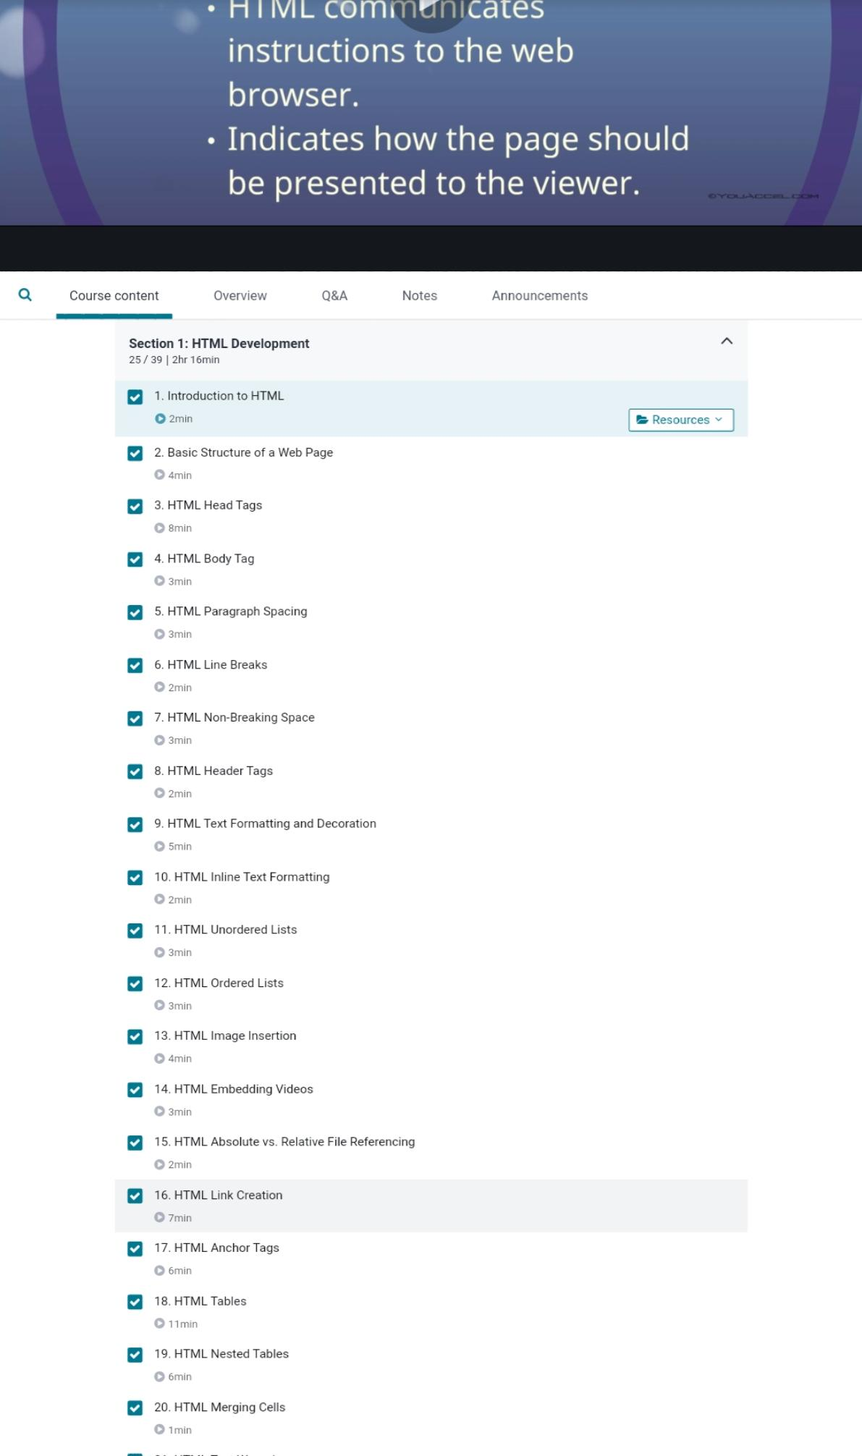

Coding Challenges Details:

#Python Program for Reversal algorithm for array rotation

def rverseArray(arr, start, end):

    while (start < end):

        temp = arr[start]

        arr[start] = arr[end]

        arr[end] = temp

        start += 1

        end = end-1

# Function to left rotate arr[] of size n by d

def leftRotate(arr, d):

    n = len(arr)

    rverseArray(arr, 0, d-1)

    rverseArray(arr, d, n-1)

    rverseArray(arr, 0, n-1)

# Function to print an array

def printArray(arr):

    for i in range(0, len(arr)):

        print (arr[i])

# Driver function to test above functions

arr = [1, 2, 3, 4, 5, 6, 7]

leftRotate(arr, 2) # Rotate array by 2

printArray(arr)