**DAILY ONLINE ACTIVITIES SUMMARY**

|  |  |  |  |  |  |  |  |
| --- | --- | --- | --- | --- | --- | --- | --- |
| **Date:** | **13/07/20** | | | | **Name:** | **Deena Muthappa** | |
| **Sem & Sec** | **8th sem, A sec** | | | | **USN:** | **4AL16CS028** | |
| **Online Test Summary** | | | | | | | |
| **Subject** | | **Not conducted** | | | | | |
| **Max. Marks** | |  | | **Score** | |  | |
| **Certification Course Summary** | | | | | | | |
| **Course** | **HTML, javascript and Bootstrap Certification** | | | | | | |
| **Certificate Provider** | | | **Udemy** | **Duration** | | | **6hrs** |
| **Coding Challenges** | | | | | | | |
| **Problem Statement: Program to print plus star pattern series** | | | | | | | |
| **Status: Completed** | | | | | | | |
| **Uploaded the report in Github** | | | | **Yes** | | | |
| **If yes Repository name** | | | | **deenamuthaappa/Coding-Challenges** | | | |
| **Uploaded the report in slack** | | | | **Yes** | | | |

Online Test Details:

Certification Course Details:

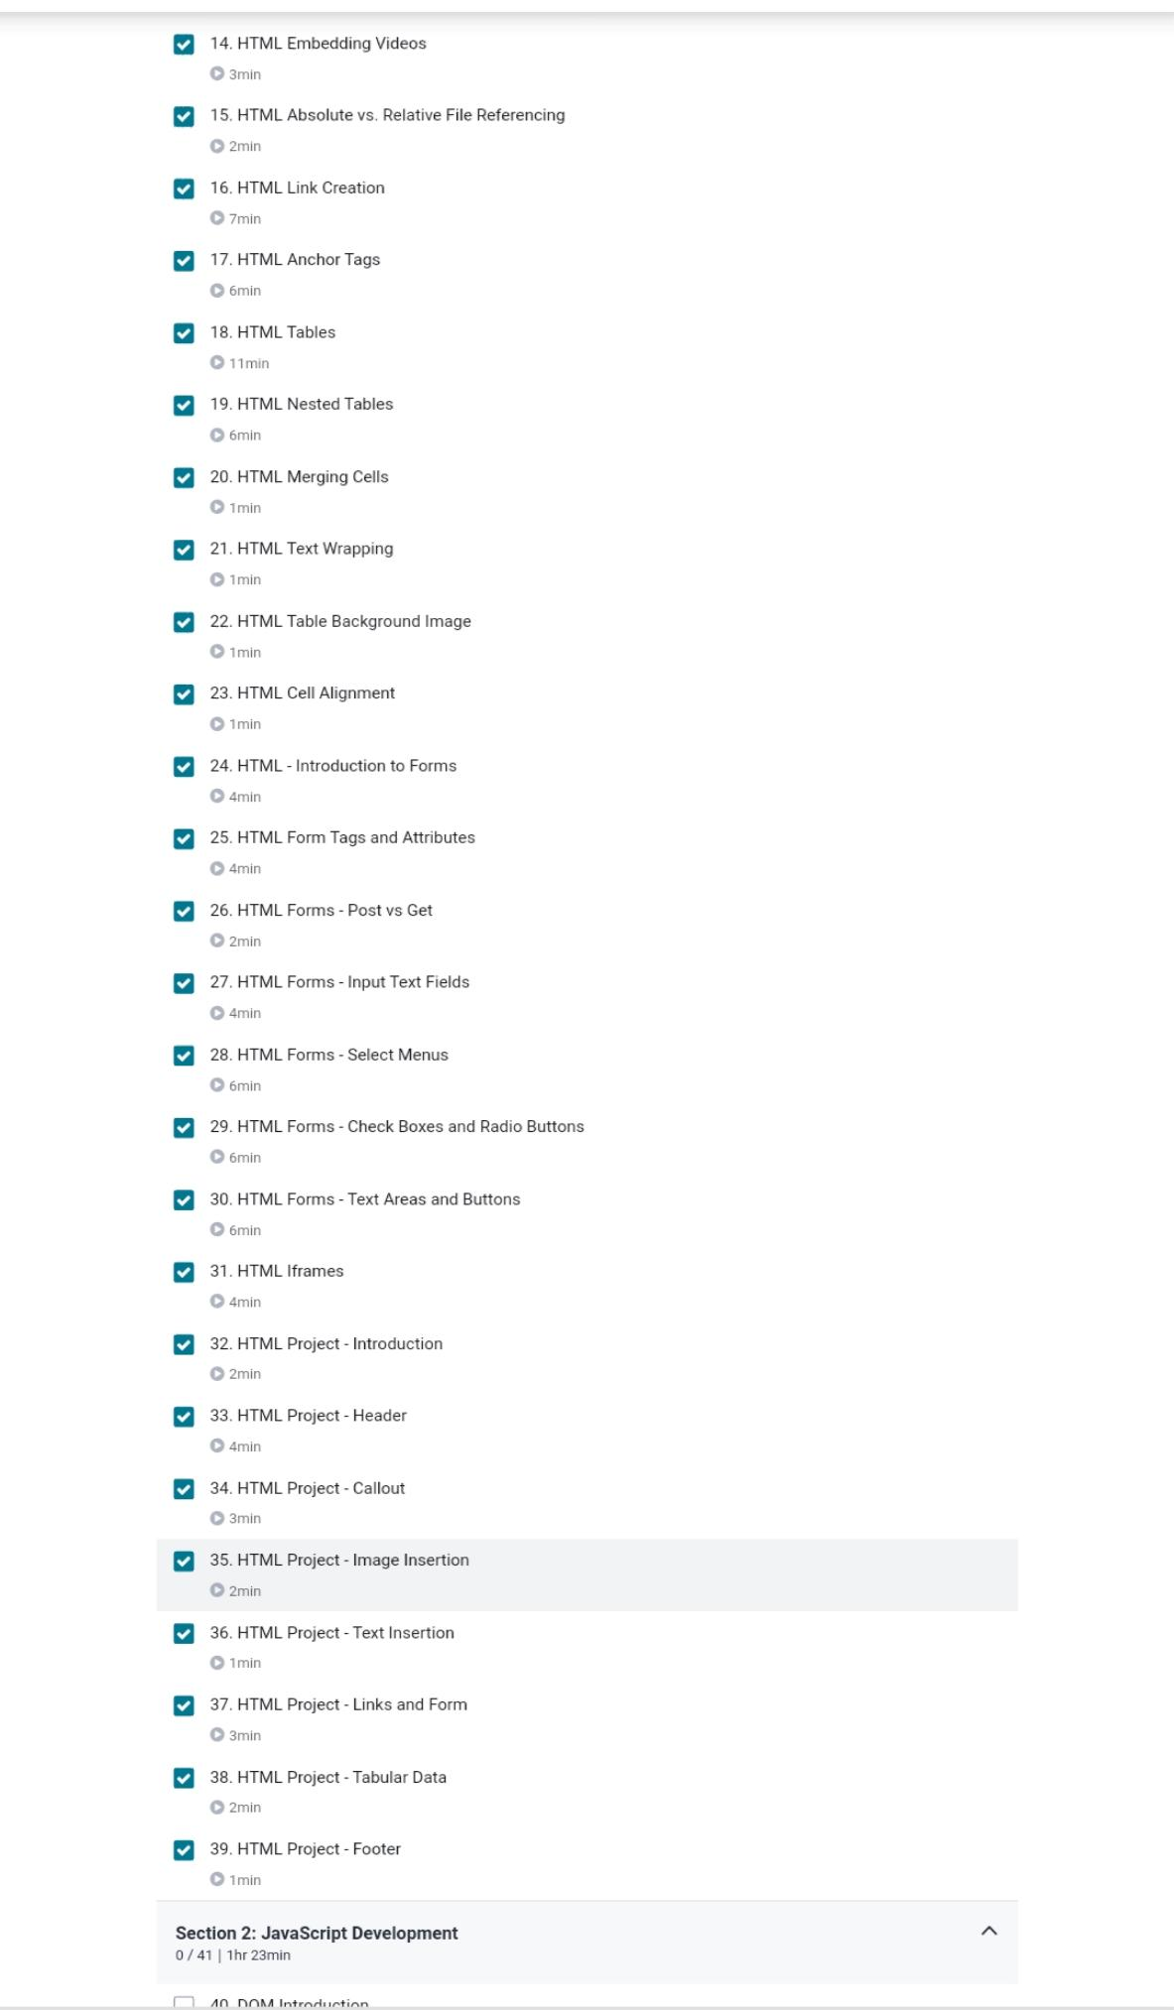

Coding Challenges Details:

//Program to print plus star pattern series

#include <stdio.h>

int main()

{

int i, j, N;

printf("Enter N: ");

scanf("%d", &N);

// Run an outer loop from 1 to N*2-1

for(i=1; i<=(N * 2 - 1); i++)

{

// For the center horizontal plus

if(i == N)

{

for(j=1; j<=(N * 2 - 1); j++)

{

printf("+");

}

}

else

{

// For spaces before single plus sign

for(j=1; j<=N-1; j++)

{

printf(" ");

}

printf("+");

}

printf("\n");

}

return 0;

}