**DAILY ONLINE ACTIVITIES SUMMARY**

|  |  |  |  |  |  |  |  |
| --- | --- | --- | --- | --- | --- | --- | --- |
| **Date:** | **14/06/20** | | | | **Name:** | **Deena Muthappa** | |
| **Sem & Sec** | **8th sem, A sec** | | | | **USN:** | **4AL16CS028** | |
| **Online Test Summary** | | | | | | | |
| **Subject** | | **Not conducted** | | | | | |
| **Max. Marks** | |  | | **Score** | |  | |
| **Certification Course Summary** | | | | | | | |
| **Course** | **Complete SQL bootcamp with MYSQL,PHP,PYTHON** | | | | | | |
| **Certificate Provider** | | | **Udemy** | **Duration** | | | **150 mins** |
| **Coding Challenges** | | | | | | | |
| **Problem Statement: Write a C program to implement the binary reversal** | | | | | | | |
| **Status: Completed** | | | | | | | |
| **Uploaded the report in Github** | | | | **Yes** | | | |
| **If yes Repository name** | | | | **deenamuthaappa/Coding-Challenges** | | | |
| **Uploaded the report in slack** | | | | **Yes** | | | |

Online Test Details:

Not conducted

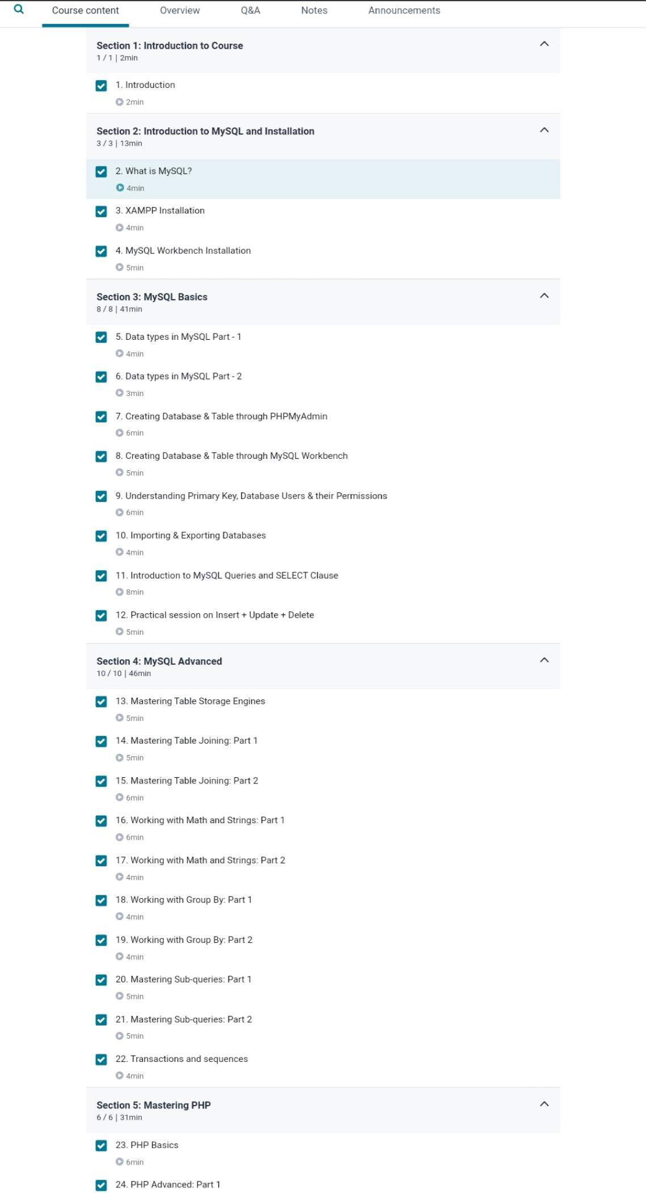Certification Course Details:

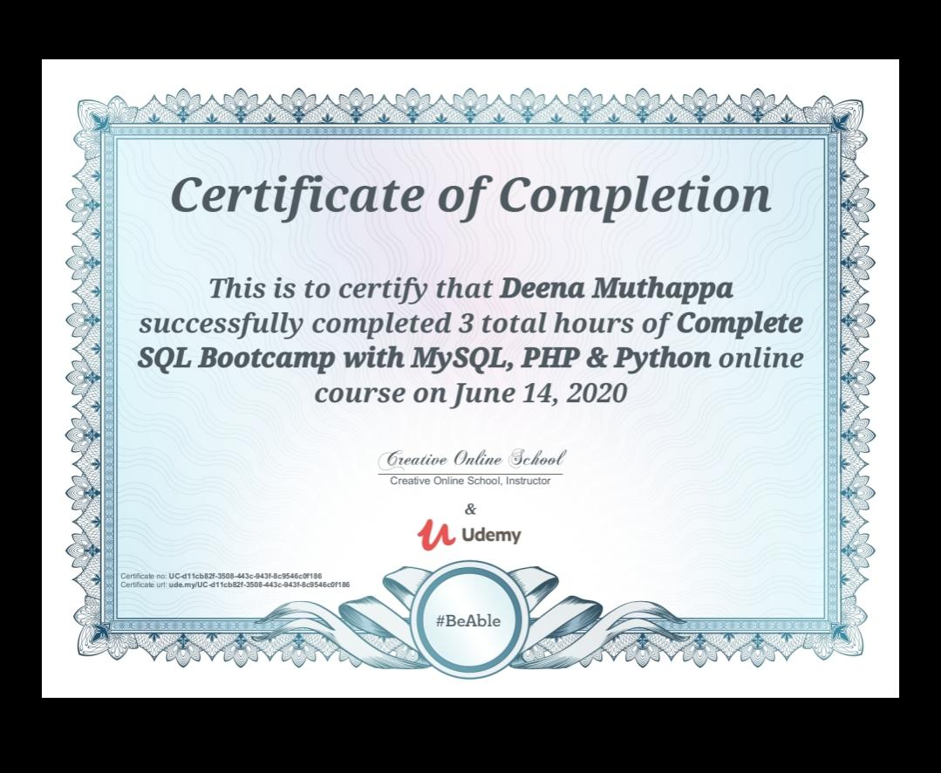

Coding Challenges Details:

//Write a C Program to implement the Binary Reversal

#include <stdio.h>

unsigned int reverseBits(unsigned int n)

{

unsigned int rev = 0;

while (n > 0)

{

rev <<= 1;

if (n & 1 == 1)

rev ^= 1;

n >>= 1;

}

return rev;

}

int main()

{

unsigned int n = 213;

printf("%d",reverseBits(n));

return 0;

}