**DAILY ONLINE ACTIVITIES SUMMARY**

|  |  |  |  |  |  |  |  |
| --- | --- | --- | --- | --- | --- | --- | --- |
| **Date:** | **14/07/20** | | | | **Name:** | **Deena Muthappa** | |
| **Sem & Sec** | **8th sem, A sec** | | | | **USN:** | **4AL16CS028** | |
| **Online Test Summary** | | | | | | | |
| **Subject** | | **Not conducted** | | | | | |
| **Max. Marks** | |  | | **Score** | |  | |
| **Certification Course Summary** | | | | | | | |
| **Course** | **HTML, javascript and Bootstrap Certification** | | | | | | |
| **Certificate Provider** | | | **Udemy** | **Duration** | | | **6hrs** |
| **Coding Challenges** | | | | | | | |
| **Problem Statement :Function to check if string follows order of characters defined by a** | | | | | | | |
| **Status: Completed** | | | | | | | |
| **Uploaded the report in Github** | | | | **Yes** | | | |
| **If yes Repository name** | | | | **deenamuthaappa/Coding-Challenges** | | | |
| **Uploaded the report in slack** | | | | **Yes** | | | |

Online Test Details:

Certification Course Details:

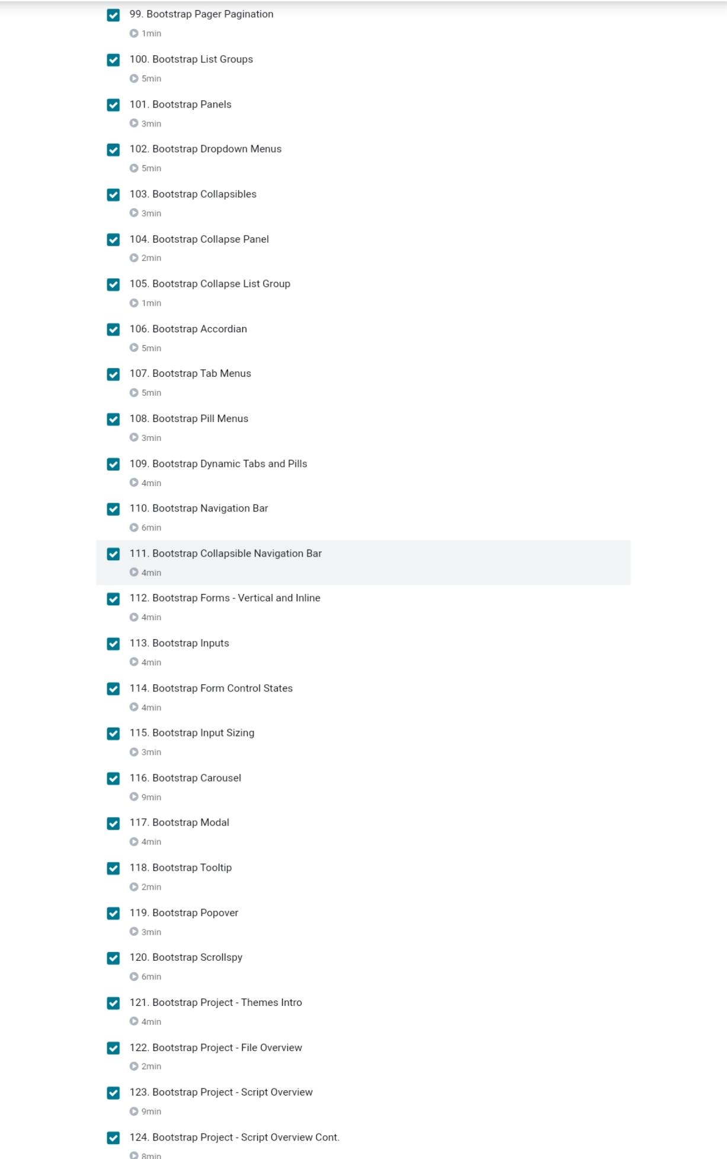



Coding Challenges Details:

from collections import OrderedDict

def checkOrder(input, pattern):

# create empty OrderedDict

# output will be like {'a': None,'b': None, 'c': None}

dict = OrderedDict.fromkeys(input)

# traverse generated OrderedDict parallel with

# pattern string to check if order of characters

# are same or not

ptrlen = 0

for key,value in dict.iteritems():

if (key == pattern[ptrlen]):

ptrlen = ptrlen + 1

# check if we have traverse complete

# pattern string

if (ptrlen == (len(pattern))):

return 'true'

# if we come out from for loop that means

# order was mismatched

return 'false'

# Driver program

if __name__ == "__main__":

input = 'engineers rock'

pattern = 'egr'

print checkOrder(input,pattern)