**DAILY ONLINE ACTIVITIES SUMMARY**

|  |  |  |  |  |  |  |  |
| --- | --- | --- | --- | --- | --- | --- | --- |
| **Date:** | **15/07/20** | | | | **Name:** | **Deena Muthappa** | |
| **Sem & Sec** | **8th sem, A sec** | | | | **USN:** | **4AL16CS028** | |
| **Online Test Summary** | | | | | | | |
| **Subject** | | **Not conducted** | | | | | |
| **Max. Marks** | |  | | **Score** | |  | |
| **Certification Course Summary** | | | | | | | |
| **Course** | **React native and redux course using hooks** | | | | | | |
| **Certificate Provider** | | | **Udemy** | **Duration** | | | **14.2hrs** |
| **Coding Challenges** | | | | | | | |
| **Problem Statement:Write a C program to find all triplets with given sum** | | | | | | | |
| **Status: Completed** | | | | | | | |
| **Uploaded the report in Github** | | | | **Yes** | | | |
| **If yes Repository name** | | | | **deenamuthaappa/Coding-Challenges** | | | |
| **Uploaded the report in slack** | | | | **Yes** | | | |

Online Test Details:

Certification Course Details:

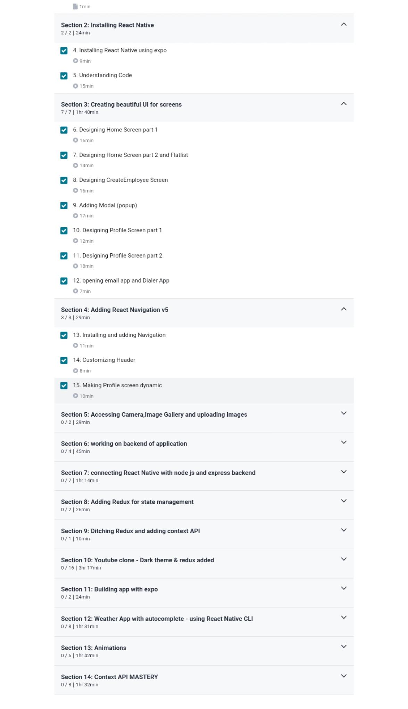

Coding Challenges

Write a C program to find all triplets with given sum

#include<stdio.h>

void find_all_triplets(int arr[], int n, int sum)

{

for (int i = 0; i < n - 2; i++)

{

for (int j = i + 1; j < n - 1; j++)

{

for (int k = j + 1; k < n; k++)

{

if (arr[i] + arr[j] + arr[k] == sum)

{

printf("%d,%d,%d\n",arr[i],arr[j],arr[k]);

}}}}}

int main()

{

int n, sum;

printf("\nEnter the number of elements : ");

scanf("%d",&n);

int arr[n];

printf("\nInput the array elements : ");

for(int i = 0; i < n; i++)

{

scanf("%d",&arr[i]);

}

printf("\nEnter the sum value : ");

scanf("%d",&sum);

printf("\nThe triplets are \n ");

find_all_triplets(arr, n, sum);

return 0;

}