**DAILY ONLINE ACTIVITIES SUMMARY**

|  |  |  |  |  |  |  |  |
| --- | --- | --- | --- | --- | --- | --- | --- |
| **Date:** | **16/06/20** | | | | **Name:** | **Deena Muthappa** | |
| **Sem & Sec** | **8th sem, A sec** | | | | **USN:** | **4AL16CS028** | |
| **Online Test Summary** | | | | | | | |
| **Subject** | | **BDA** | | | | | |
| **Max. Marks** | | **30** | | **Score** | | **22** | |
| **Certification Course Summary** | | | | | | | |
| **Course** | **Angular Material :Ultimate masterclass with angular 9** | | | | | | |
| **Certificate Provider** | | | **Udemy** | **Duration** | | | **12hrs** |
| **Coding Challenges** | | | | | | | |
| **Problem Statement: C program fro triply linked list** | | | | | | | |
| **Status: Completed** | | | | | | | |
| **Uploaded the report in Github** | | | | **Yes** | | | |
| **If yes Repository name** | | | | **deenamuthaappa/Coding-Challenges** | | | |
| **Uploaded the report in slack** | | | | **Yes** | | | |

Online Test Details:



The test was on the subject Big Data Analytics

Certification Course Details:

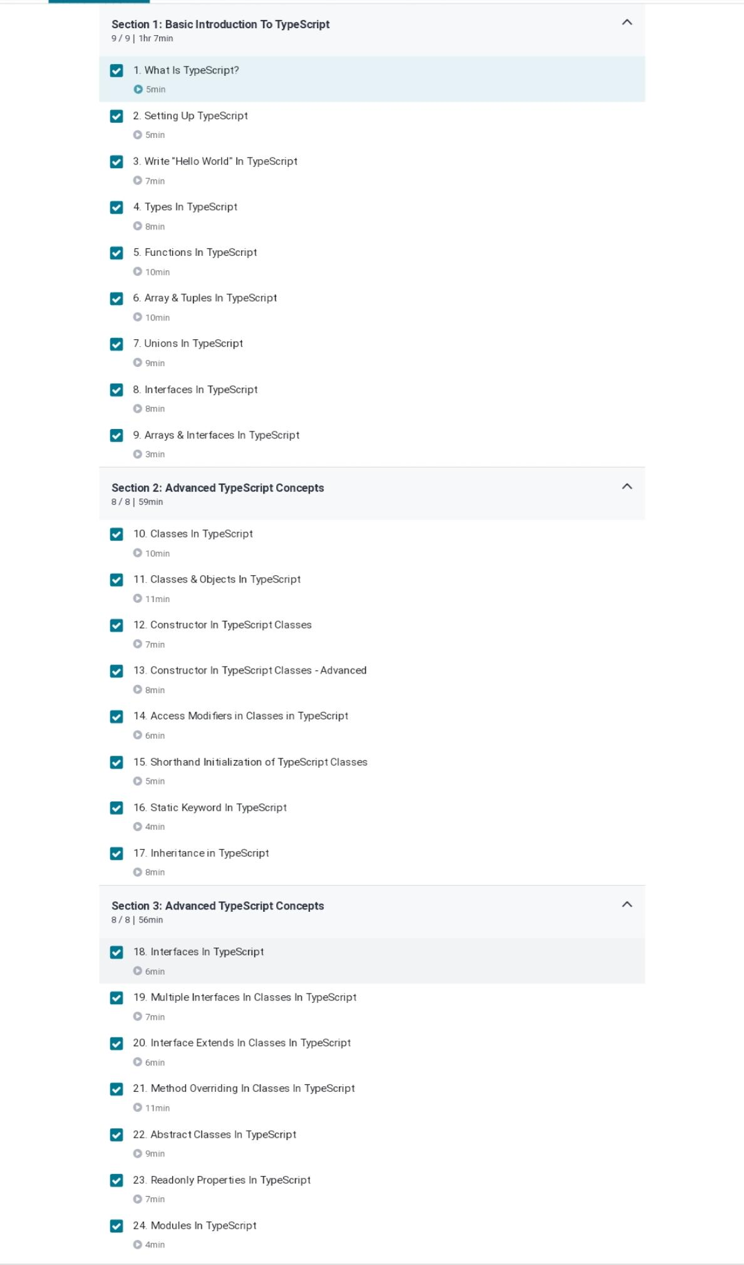

Coding Challenges Details:

|  |
| --- |
| /* |
|  | * C++ Program to Implement Triply Linked List |
|  | */ |
|  | #include<stdio.h> |
|  | #include<conio.h> |
|  | #include<iostream> |
|  | using namespace std; |
|  | int c = 0; |
|  | struct node |
|  | { |
|  | node *next, *prev, *top; |
|  | int data; |
|  | }*head = NULL, *tail = NULL, *p = NULL, *r = NULL, *np = NULL, *q = NULL; |
|  | void create(int x) |
|  | { |
|  | np = new node; |
|  | np->data = x; |
|  | np->next = NULL; |
|  | np->prev = NULL; |
|  | np->top = NULL; |
|  | if (c == 0) |
|  | { |
|  | tail = np; |
|  | head = np; |
|  | p = head; |
|  | p->next = NULL; |
|  | p->prev = NULL; |
|  | p->top = NULL; |
|  | c++; |
|  | } |
|  | else |
|  | { |
|  | p = head; |
|  | r = p; |
|  | if (np->data < p->data) |
|  | { |
|  | np->next = p; |
|  | p->prev = np; |
|  | np->prev = NULL; |
|  | head = np; |
|  | p = head; |
|  | do |
|  | { |
|  | p = p->next; |
|  | } |
|  | while (p->next != NULL); |
|  | tail = p; |
|  | } |
|  | else if (np->data > p->data) |
|  | { |
|  | while (p != NULL && np->data > p->data) |
|  | { |
|  | r = p; |
|  | p = p->next; |
|  | if (p == NULL) |
|  | { |
|  | r->next = np; |
|  | np->prev = r; |
|  | np->next = NULL; |
|  | tail = np; |
|  | break; |
|  | } |
|  | else if (np->data <= p->data) |
|  | { |
|  | if (np->data < p->data) |
|  | { |
|  | r->next = np; |
|  | np->prev = r; |
|  | np->next = p; |
|  | p->prev = np; |
|  | if (p->next != NULL) |
|  | { |
|  | do |
|  | { |
|  | p = p->next; |
|  | } |
|  | while (p->next !=NULL); |
|  | } |
|  | tail = p; |
|  | break; |
|  | } |
|  | else if (p->data == np->data) |
|  | { |
|  | q = p; |
|  | while (q->top != NULL) |
|  | { |
|  | q = q->top; |
|  | } |
|  | q->top = np; |
|  | np->top = NULL; |
|  | break; |
|  | } |
|  | } |
|  | } |
|  | } |
|  | } |
|  | } |
|  | void traverse_tail() |
|  | { |
|  | node *t = tail; |
|  | //cout<<"\n\nlinear display of nodes currently present in linked list....\n\n"; |
|  | while (t != NULL) |
|  | { |
|  | cout<<t->data<<"\t"; |
|  | q = t; |
|  | while (q->top != NULL) |
|  | { |
|  | q = q->top; |
|  | cout<<"top->"<<q->data<<"\t"; |
|  | } |
|  | t = t->prev; |
|  | } |
|  | cout<<endl; |
|  | } |
|  | void traverse_head() |
|  | { |
|  | node *t = head; |
|  | while (t != NULL) |
|  | { |
|  | cout<<t->data<<"\t"; |
|  | q = t; |
|  | while (q->top != NULL) |
|  | { |
|  | q = q->top; |
|  | cout<<"top->"<<q->data<<"\t"; |
|  | } |
|  | t = t->next; |
|  | } |
|  | cout<<endl; |
|  | } |
|  | int main() |
|  | { |
|  | int i = 0, n, x, ch; |
|  | cout<<"enter the no of nodes\n"; |
|  | cin>>n; |
|  | while (i < n) |
|  | { |
|  | cout<<"\nenter value of node\n"; |
|  | cin>>x; |
|  | create(x); |
|  | i++; |
|  | } |
|  | cout<<"\nTraversing Doubly Linked List head first\n"; |
|  | traverse_head(); |
|  | cout<<"\nTraversing Doubly Linked List tail first\n"; |
|  | traverse_tail(); |
|  | getch(); |
|  | } |