**DAILY ONLINE ACTIVITIES SUMMARY**

|  |  |  |  |  |  |  |  |
| --- | --- | --- | --- | --- | --- | --- | --- |
| **Date:** | **17/07/20** | | | | **Name:** | **Deena Muthappa** | |
| **Sem & Sec** | **8th sem, A sec** | | | | **USN:** | **4AL16CS028** | |
| **Online Test Summary** | | | | | | | |
| **Subject** | | **Not conducted** | | | | | |
| **Max. Marks** | |  | | **Score** | |  | |
| **Certification Course Summary** | | | | | | | |
| **Course** | **React native and redux course using hooks** | | | | | | |
| **Certificate Provider** | | | **Udemy** | **Duration** | | | **14.2hrs** |
| **Coding Challenges** | | | | | | | |
| **Problem Statement: Write a C program to check elements in string can be equal**  **or not.** | | | | | | | |
| **Status: Completed** | | | | | | | |
| **Uploaded the report in Github** | | | | **Yes** | | | |
| **If yes Repository name** | | | | **deenamuthaappa/Coding-Challenges** | | | |
| **Uploaded the report in slack** | | | | **Yes** | | | |

Online Test Details:

Certification Course Details:

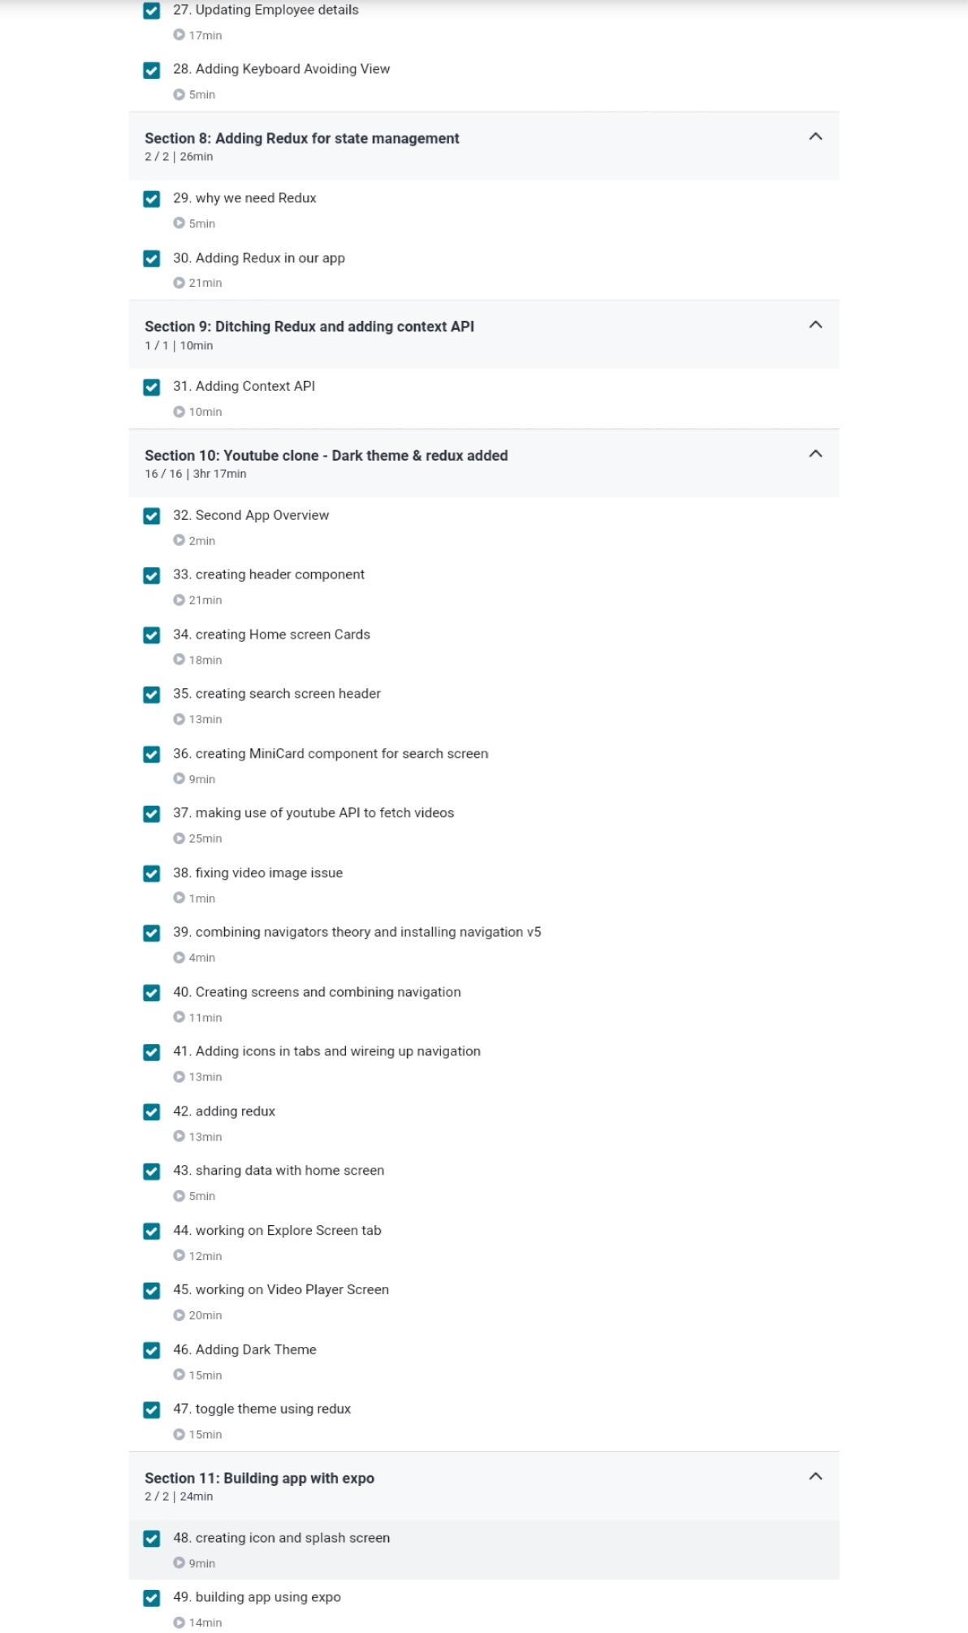

Coding Challenges

Program 1:

#include <stdio.h>

int make_equal(int a[], int n)

{

int flag = 1;

for (int i = 0; i < n; i++)

{

while (a[i] % 2 == 0)

a[i] /= 2;

while (a[i] % 3 == 0)

a[i] /= 3;

}

for (int i = 1; i < n; i++)

{

if (a[i] != a[0])

{

flag = 0 ;

}

return flag;

}

}

int main()

{

int n, i;

scanf("%d", &n);

int a[n];

for(i=0; i<n; i++)

scanf("%d", &a[i]);

if (make_equal(a, n) == 1)

printf("Yes\n");

else

printf("No\n");

return 0;

}