**DAILY ONLINE ACTIVITIES SUMMARY**

|  |  |  |  |  |  |  |  |
| --- | --- | --- | --- | --- | --- | --- | --- |
| **Date:** | **17/07/20** | | | | **Name:** | **Deena Muthappa** | |
| **Sem & Sec** | **8th sem, A sec** | | | | **USN:** | **4AL16CS028** | |
| **Online Test Summary** | | | | | | | |
| **Subject** | | **Not conducted** | | | | | |
| **Max. Marks** | |  | | **Score** | |  | |
| **Certification Course Summary** | | | | | | | |
| **Course** | **React native and redux course using hooks** | | | | | | |
| **Certificate Provider** | | | **Udemy** | **Duration** | | | **14.2hrs** |
| **Coding Challenges** | | | | | | | |
| **Problem Statement: Write a C program to find highest occurring character in a**  **string.** | | | | | | | |
| **Status: Completed** | | | | | | | |
| **Uploaded the report in Github** | | | | **Yes** | | | |
| **If yes Repository name** | | | | **deenamuthaappa/Coding-Challenges** | | | |
| **Uploaded the report in slack** | | | | **Yes** | | | |

Online Test Details:

Certification Course Details:

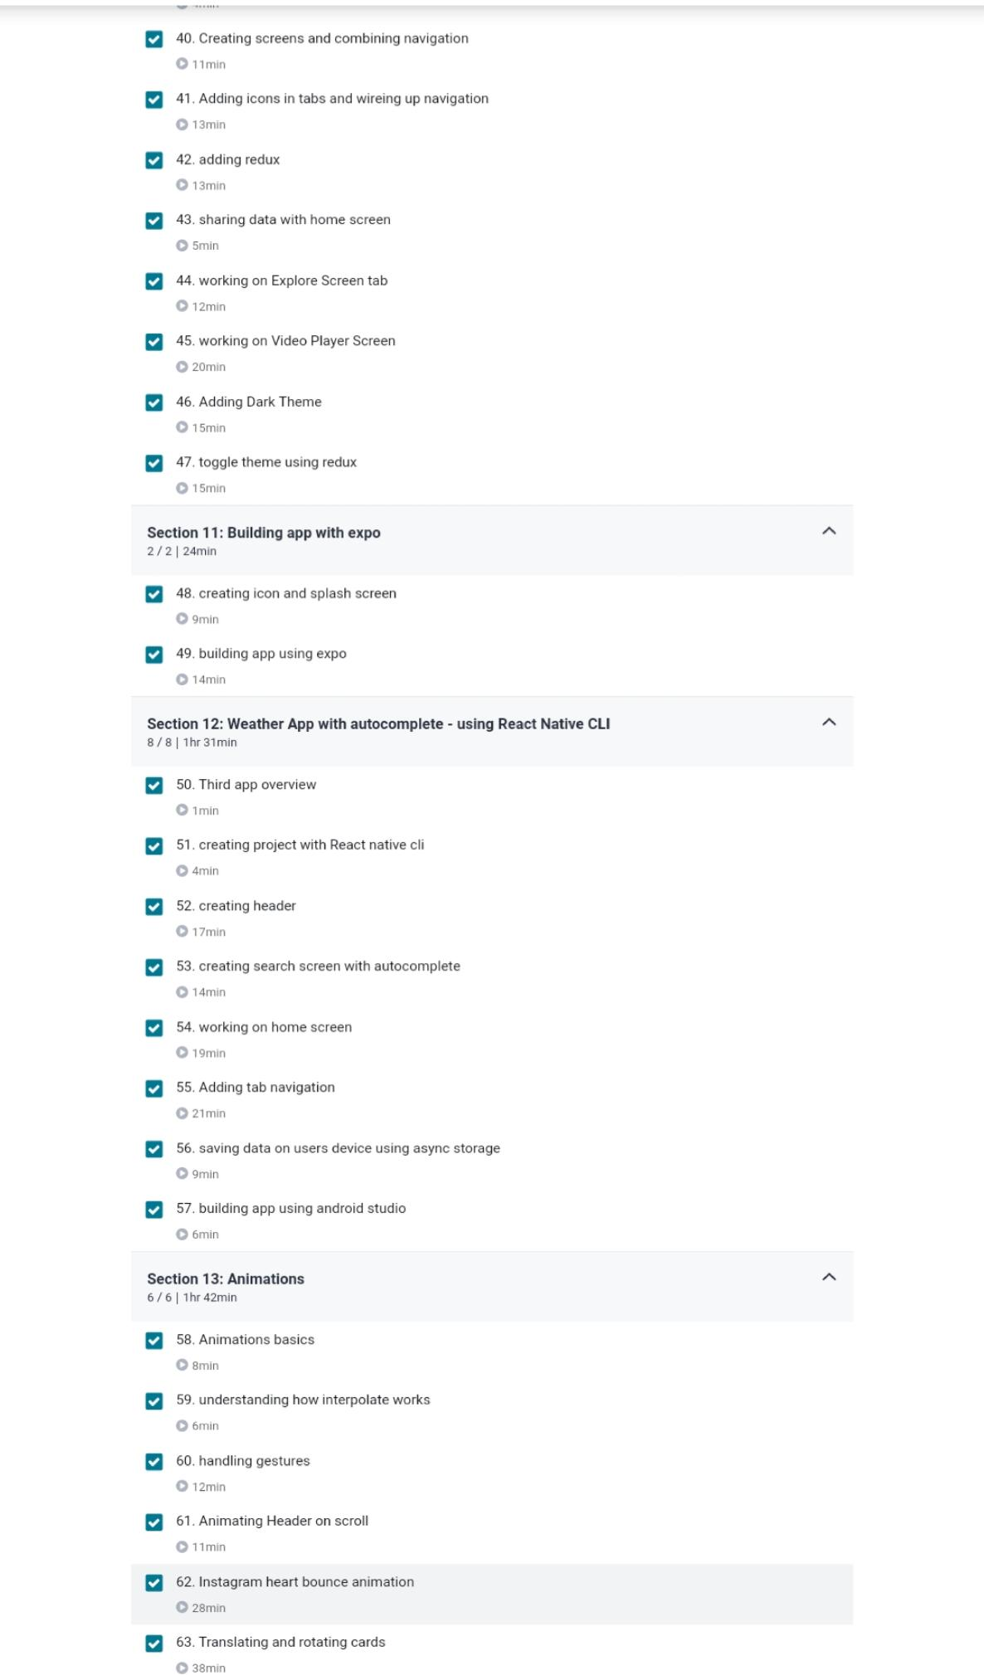

Coding Challenges

//Write a C program to find highest occurring character in a

string

#include<stdio.h>

#include<string.h>

#define ASCII_SIZE 256

char getMaxOccuringChar(char* str)

{

// Create array to keep the count of individual

// characters and initialize the array as 0

int count[ASCII_SIZE] = {0};

// Construct character count array from the input

// string.

int len = strlen(str);

int max = 0; // Initialize max count

char result; // Initialize result

// Traversing through the string and maintaining

// the count of each character

for (int i = 0; i < len; i++) {

count[str[i]]++;

if (max < count[str[i]]) {

max = count[str[i]];

result = str[i];

}

}

return result;

}

// Driver program to test the above function

int main()

{

char str[] = "sample string";

printf("Enter the string: ");

gets(str);

printf("Max occurring character is %c\n", getMaxOccuringChar(str));

}