**DAILY ONLINE ACTIVITIES SUMMARY**

|  |  |  |  |  |  |  |  |
| --- | --- | --- | --- | --- | --- | --- | --- |
| **Date:** | **19/07/20** | | | | **Name:** | **Deena Muthappa** | |
| **Sem & Sec** | **8th sem, A sec** | | | | **USN:** | **4AL16CS028** | |
| **Online Test Summary** | | | | | | | |
| **Subject** | | **Not conducted** | | | | | |
| **Max. Marks** | |  | | **Score** | |  | |
| **Certification Course Summary** | | | | | | | |
| **Course** | **React native and redux course using hooks** | | | | | | |
| **Certificate Provider** | | | **Udemy** | **Duration** | | | **14.2hrs** |
| **Coding Challenges** | | | | | | | |
| **Problem Statement: Write a C program to remove character except alphabets.** | | | | | | | |
| **Status: Completed** | | | | | | | |
| **Uploaded the report in Github** | | | | **Yes** | | | |
| **If yes Repository name** | | | | **deenamuthaappa/Coding-Challenges** | | | |
| **Uploaded the report in slack** | | | | **Yes** | | | |

Online Test Details:

Certification Course Details:

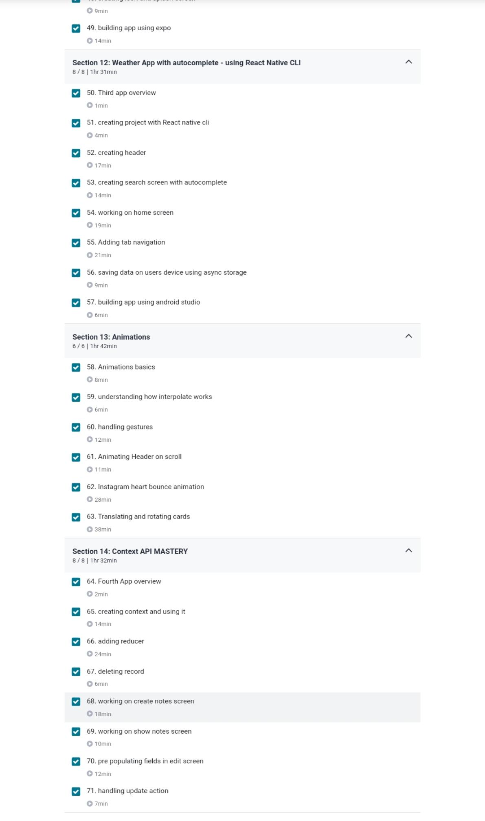



Coding Challenges

#include <stdio.h>

int main() {

char line[150];

printf("Enter a string: ");

fgets(line, sizeof(line), stdin);

for (int i = 0, j; line[i] != '\0'; ++i) {

while (!(line[i] >= 'a' && line[i] <= 'z') && !(line[i] >= 'A' && line[i] <= 'Z') && !

(line[i] == '\0')) {

for (j = i; line[j] != '\0'; ++j) {

line[j] = line[j + 1];

}

line[j] = '\0';

}

}

printf("Output String: ");

puts(line);

printf("\n");

return 0;

}