**DAILY ONLINE ACTIVITIES SUMMARY**

|  |  |  |  |  |  |  |  |
| --- | --- | --- | --- | --- | --- | --- | --- |
| **Date:** | **20/07/20** | | | | **Name:** | **Deena Muthappa** | |
| **Sem & Sec** | **8th sem, A sec** | | | | **USN:** | **4AL16CS028** | |
| **Online Test Summary** | | | | | | | |
| **Subject** | | **Not conducted** | | | | | |
| **Max. Marks** | |  | | **Score** | |  | |
| **Certification Course Summary** | | | | | | | |
| **Course** | **Practical database course for beginners** | | | | | | |
| **Certificate Provider** | | | **Udemy** | **Duration** | | | **3hrs** |
| **Coding Challenges** | | | | | | | |
| **Problem Statement: Write a C program to remove character except alphabets.** | | | | | | | |
| **Status: Completed** | | | | | | | |
| **Uploaded the report in Github** | | | | **Yes** | | | |
| **If yes Repository name** | | | | **deenamuthaappa/Coding-Challenges** | | | |
| **Uploaded the report in slack** | | | | **Yes** | | | |

Online Test Details:

Certification Course Details:

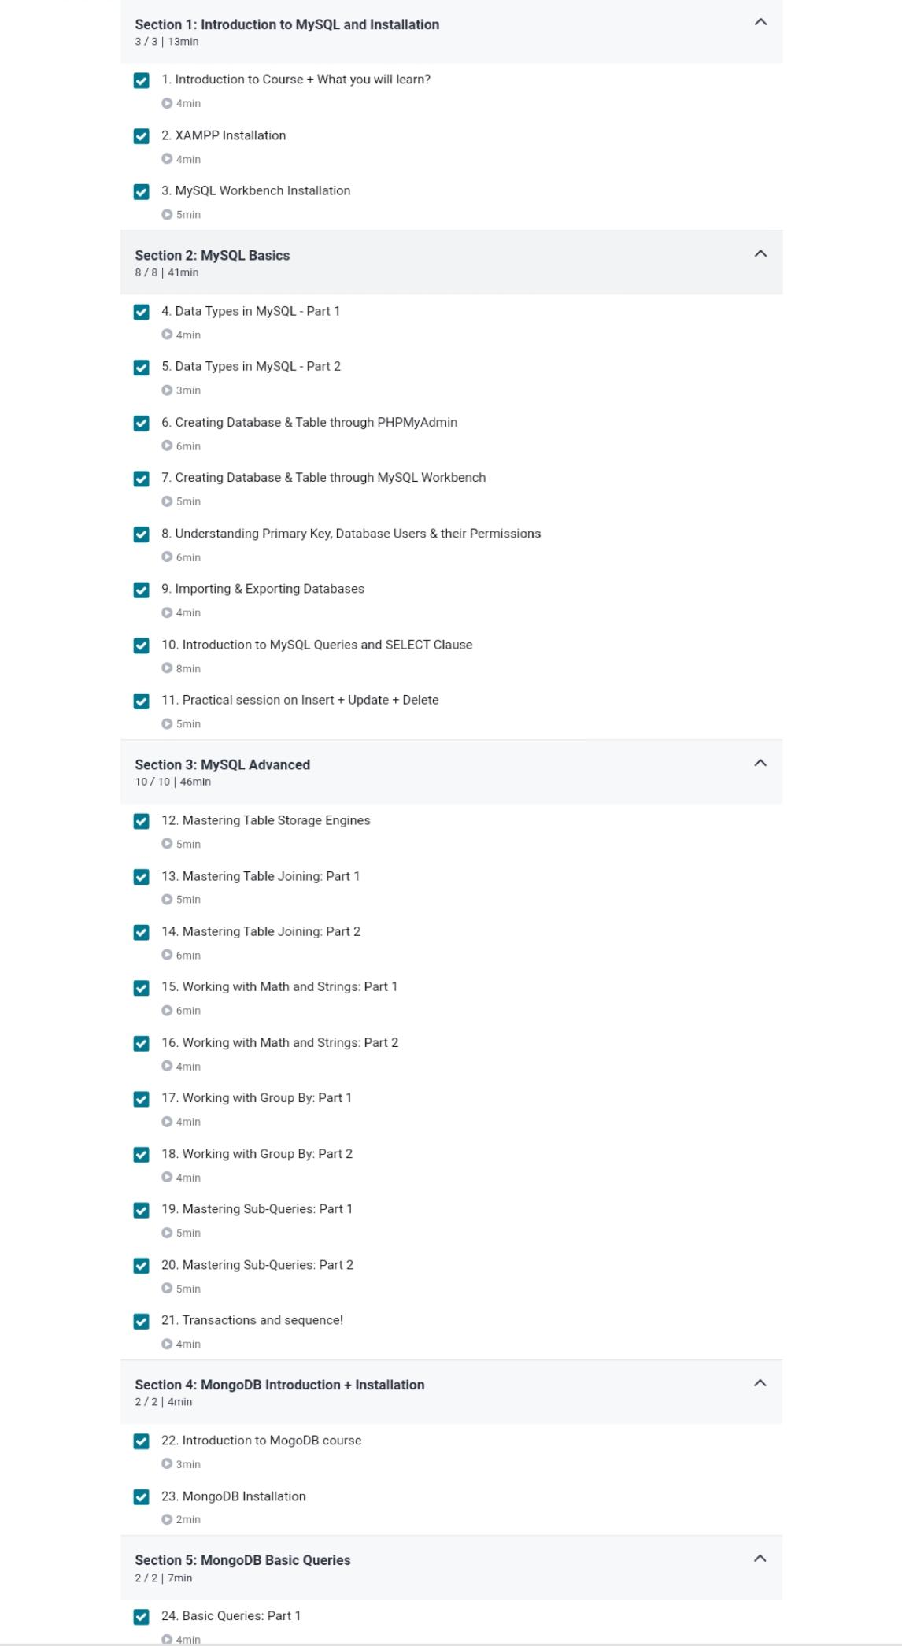



Coding Challenges

//Write a C program to remove character except alphabets.

#include <stdio.h>

#include <string.h>

void convert(char *num)

{

int len = strlen(num); // find no of digit

/* no number */

if (len == 0) {

fprintf(stderr, "empty string\n");

return;

}

char *single_digits[] = { "zero", "one", "two", "three", "four","five","six", "seven",

"eight", "nine"};

char *two_digits[] = {"", "ten", "eleven", "twelve", "thirteen",

"fourteen","fifteen", "sixteen","seventeen", "eighteen", "nineteen"};

char *tens_multiple[] = {"", "", "twenty", "thirty", "forty", "fifty",

"sixty", "seventy", "eighty", "ninety"};

char *tens_power[] = {"hundred", "thousand"};

/* single number*/

if (len == 1) {

printf("%s\n", single_digits[*num - '0']);

return;

}

while (*num != '\0') {

if (len >= 3) {

if (*num -'0' != 0) {

printf("%s ", single_digits[*num - '0']);

printf("%s ", tens_power[len-3]); // here len can be 3 or 4

}

--len;

}

/* Code path for last 2 digits */

else {

if (*num == '1') {

int sum = *num - '0' + *(num + 1)- '0';

printf("%s\n", two_digits[sum]);

return;

}

else if (*num == '2' && *(num + 1) == '0') {

printf("twenty\n");

return;

}

/* number range 21 to 99 */

else {

int i = *num - '0';

printf("%s \n", i? tens_multiple[i]: "");

++num;

if (*num != '0')

printf("%s \n", single_digits[*num - '0']);

}

}

++num;

}

int main(void)

{

char a[10];

printf("\nEnter the number : ");

scanf("%s",a);

printf("\nThe number in word is ");

convert(a);

printf("\n");

return 0;

}