**DAILY ONLINE ACTIVITIES SUMMARY**

|  |  |  |  |  |  |  |  |
| --- | --- | --- | --- | --- | --- | --- | --- |
| **Date:** | **21/07/20** | | | | **Name:** | **Deena Muthappa** | |
| **Sem & Sec** | **8th sem, A sec** | | | | **USN:** | **4AL16CS028** | |
| **Online Test Summary** | | | | | | | |
| **Subject** | | **Not conducted** | | | | | |
| **Max. Marks** | |  | | **Score** | |  | |
| **Certification Course Summary** | | | | | | | |
| **Course** | **Learn C++ programming from scratch** | | | | | | |
| **Certificate Provider** | | | **Udemy** | **Duration** | | | **1hrs** |
| **Coding Challenges** | | | | | | | |
| **Problem Statement:Write a C program to count number of vowels in a given string** | | | | | | | |
| **Status: Completed** | | | | | | | |
| **Uploaded the report in Github** | | | | **Yes** | | | |
| **If yes Repository name** | | | | **deenamuthaappa/Coding-Challenges** | | | |
| **Uploaded the report in slack** | | | | **Yes** | | | |

Online Test Details:

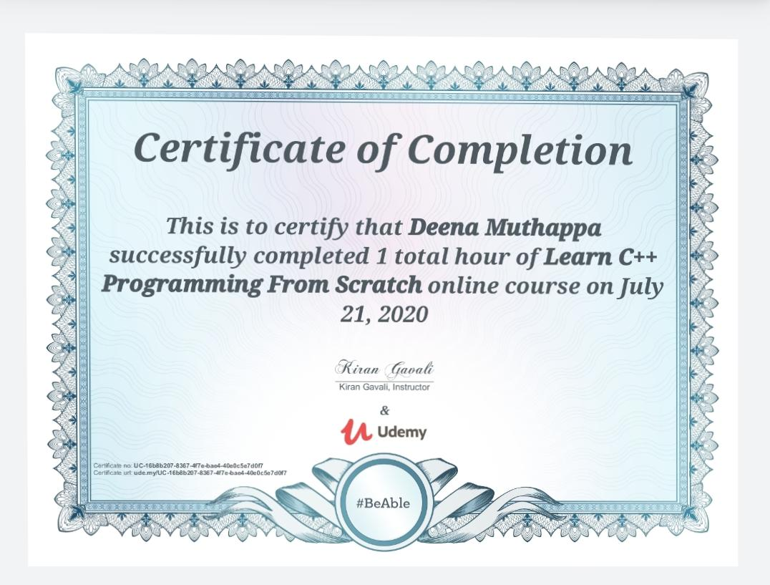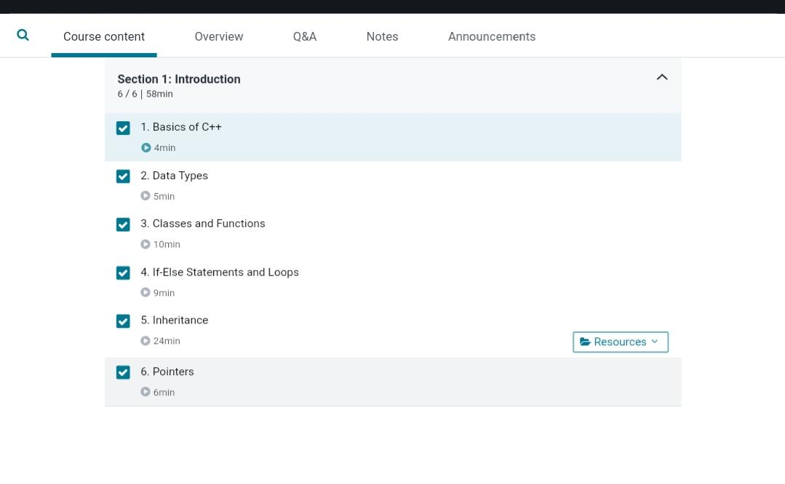Certification Course Details:

Coding Challenges

//Write a C program to count number of vowels in given string

#include<stdio.h>

int main()

{

char str[100];

char *ptr;

int cntV,cntC;

printf("Enter a string: ");

gets(str);

ptr=str;

cntV=cntC=0;

while(*ptr!='\0')

{

if(*ptr=='A' ||*ptr=='E' ||*ptr=='I' ||*ptr=='O' ||*ptr=='U' ||*ptr=='a' ||*ptr=='e' ||

*ptr=='i' ||*ptr=='o' ||*ptr=='u')

cntV++;

else

cntC++;

ptr++;

}

printf("Total number of vowels : %d\nTotal number of consonants : %d\

n",cntV,cntC);

return 0;

}