**DAILY ONLINE ACTIVITIES SUMMARY**

|  |  |  |  |  |  |  |  |
| --- | --- | --- | --- | --- | --- | --- | --- |
| **Date:** | **22/07/20** | | | | **Name:** | **Deena Muthappa** | |
| **Sem & Sec** | **8th sem, A sec** | | | | **USN:** | **4AL16CS028** | |
| **Online Test Summary** | | | | | | | |
| **Subject** | | **Not conducted** | | | | | |
| **Max. Marks** | |  | | **Score** | |  | |
| **Certification Course Summary** | | | | | | | |
| **Course** | **Microsoft SQL server for beginners to expert** | | | | | | |
| **Certificate Provider** | | | **Udemy** | **Duration** | | | **2.5hrs** |
| **Coding Challenges** | | | | | | | |
| **Problem Statement: Write a C program to convert binary number to decimal.** | | | | | | | |
| **Status: Completed** | | | | | | | |
| **Uploaded the report in Github** | | | | **Yes** | | | |
| **If yes Repository name** | | | | **deenamuthaappa/Coding-Challenges** | | | |
| **Uploaded the report in slack** | | | | **Yes** | | | |

Online Test Details:

Certification Course Details:

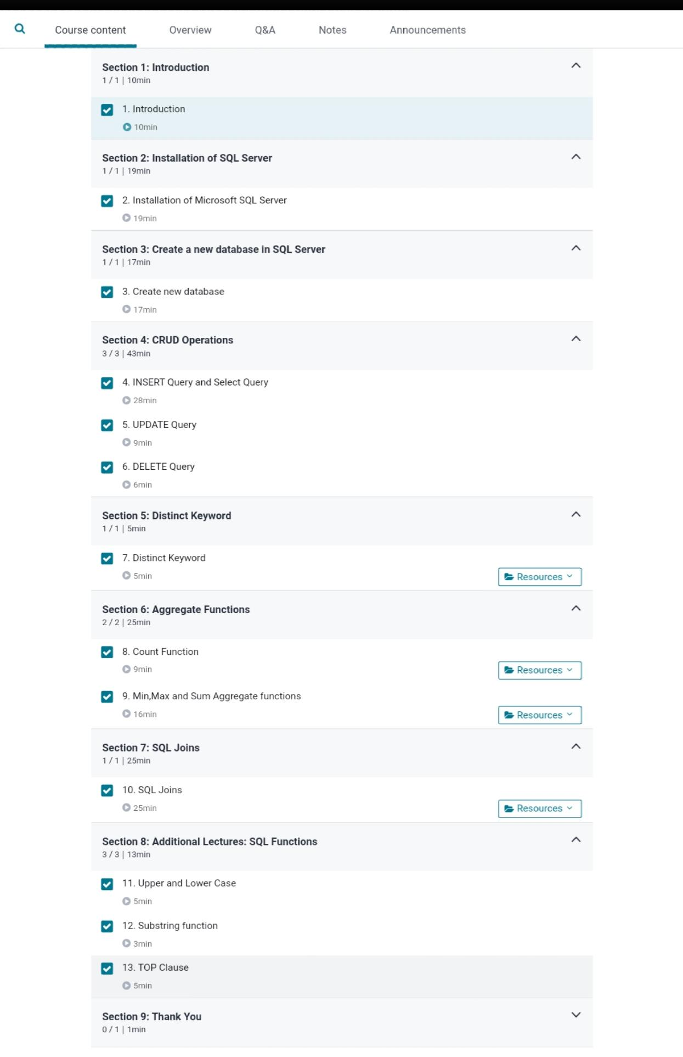

Coding Challenges

#include <stdio.h>

void main()

{

int num, binary_val, decimal_val = 0, base = 1, rem;

printf("Enter a binary number(1s and 0s) \n");

scanf("%d", &num); /* maximum five digits */

binary_val = num;

while (num > 0)

{

rem = num % 10;

decimal_val = decimal_val + rem * base;

num = num / 10 ;

base = base * 2;

}

printf("The Binary number is = %d \n", binary_val);

printf("Its decimal equivalent is = %d \n", decimal_val);

}