**DAILY ONLINE ACTIVITIES SUMMARY**

|  |  |  |  |  |  |  |  |
| --- | --- | --- | --- | --- | --- | --- | --- |
| **Date:** | **23/06/20** | | | | **Name:** | **Deena Muthappa** | |
| **Sem & Sec** | **8th sem, A sec** | | | | **USN:** | **4AL16CS028** | |
| **Online Test Summary** | | | | | | | |
| **Subject** | | **Not conducted** | | | | | |
| **Max. Marks** | |  | | **Score** | |  | |
| **Certification Course Summary** | | | | | | | |
| **Course** | **C programming for beginners- Master the C fundamentals** | | | | | | |
| **Certificate Provider** | | | **Udemy** | **Duration** | | | **11.5hrs** |
| **Coding Challenges** | | | | | | | |
| **Problem Statement: write a c++ program to sort stack using temporary stack** | | | | | | | |
| **Status: Completed** | | | | | | | |
| **Uploaded the report in Github** | | | | **Yes** | | | |
| **If yes Repository name** | | | | **deenamuthaappa/Coding-Challenges** | | | |
| **Uploaded the report in slack** | | | | **Yes** | | | |

Online Test Details:

Not conducted

Certification Course Details:

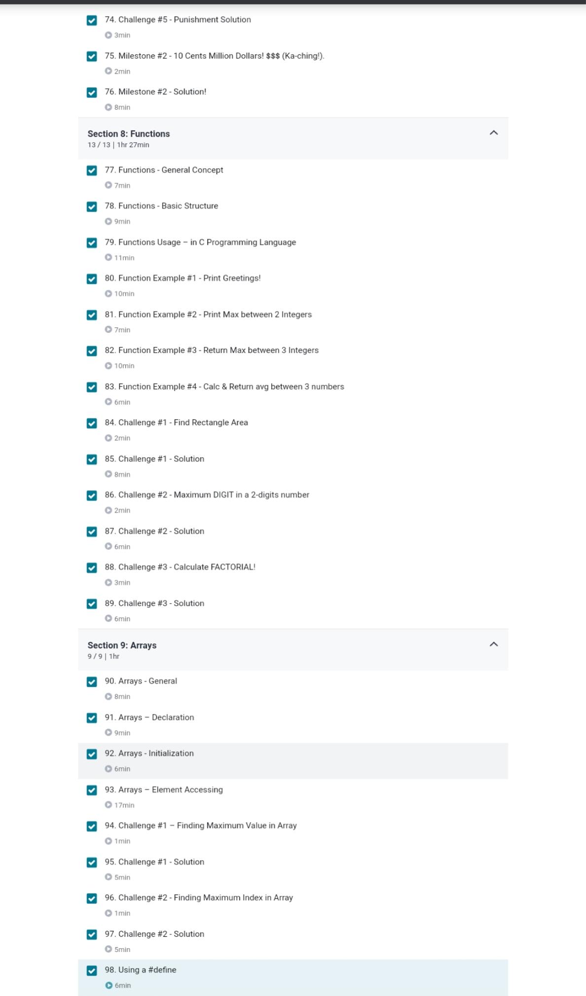

Coding Challenges Details:

**PROGRAM 1 .**

**//Sort a stack using a temporary stack**

**#include <bits/stdc++.h>**

**using namespace std;**

**stack<int> sortStack(stack<int> &input)**

**{**

**stack<int> tmpStack;**

**while (!input.empty())**

**{**

**// pop out the first element**

**int tmp = input.top();**

**input.pop();**

**while (!tmpStack.empty() && tmpStack.top() > tmp)**

**{**

**input.push(tmpStack.top());**

**tmpStack.pop();**

**}**

**tmpStack.push(tmp);**

**}**

**return tmpStack;**

**}**

**int main()**

**{**

**stack<int> input;**

**input.push(34);**

**input.push(3);**

**input.push(31);**

**input.push(98);**

**input.push(92);**

**input.push(23);**

**stack<int> tmpStack = sortStack(input);**

**cout << "Sorted numbers are:\n";**

**while (!tmpStack.empty())**

**{**

**cout << tmpStack.top()<< " ";**

**tmpStack.pop();**

**}**

**}**