**DAILY ONLINE ACTIVITIES SUMMARY**

|  |  |  |  |  |  |  |  |
| --- | --- | --- | --- | --- | --- | --- | --- |
| **Date:** | **23/07/20** | | | | **Name:** | **Deena Muthappa** | |
| **Sem & Sec** | **8th sem, A sec** | | | | **USN:** | **4AL16CS028** | |
| **Online Test Summary** | | | | | | | |
| **Subject** | | **Not conducted** | | | | | |
| **Max. Marks** | |  | | **Score** | |  | |
| **Certification Course Summary** | | | | | | | |
| **Course** | **Microsoft SQL server from beginners to expert** | | | | | | |
| **Certificate Provider** | | | **Udemy** | **Duration** | | | **2.5hrs** |
| **Coding Challenges** | | | | | | | |
| **Problem Statement: Write a C program to convert decimal number to binary.** | | | | | | | |
| **Status: Completed** | | | | | | | |
| **Uploaded the report in Github** | | | | **Yes** | | | |
| **If yes Repository name** | | | | **deenamuthaappa/Coding-Challenges** | | | |
| **Uploaded the report in slack** | | | | **Yes** | | | |

Online Test Details:

Certification Course Details:

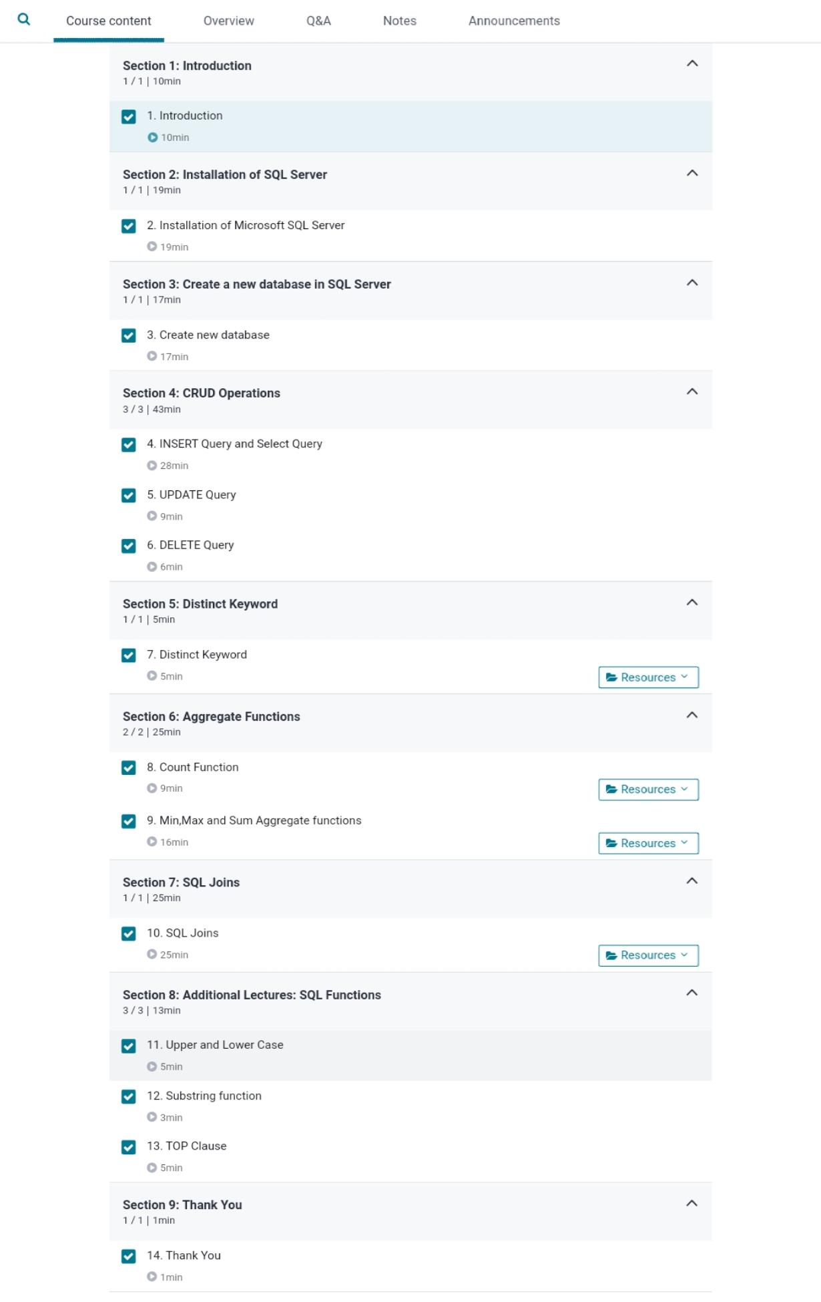

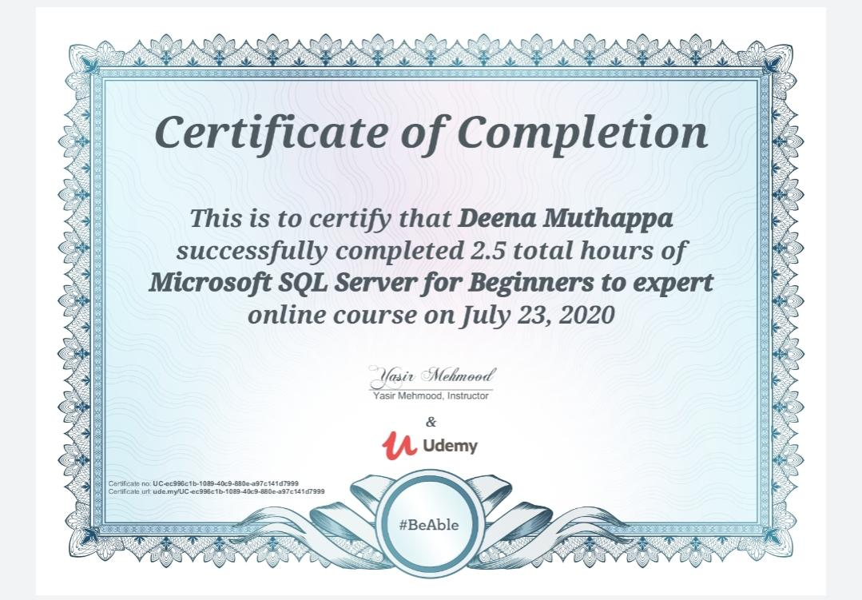

Coding Challenges

#include <stdio.h>

long int decimal_to_binary(int n)

{

long int binary = 0;

int remainder, i, flag = 1;

for(i = 1; n != 0; i = i * 10)

{

remainder = n % 2;

n /= 2;

binary += remainder * i;

}

return binary;

}

int main()

{

int n;

printf("Enter a decimal number: ");

scanf("%d", &n);

printf("Equivalent binary number: %d\n", decimal_to_binary(n));

return 0;

}