**DAILY ONLINE ACTIVITIES SUMMARY**

|  |  |  |  |  |  |  |  |
| --- | --- | --- | --- | --- | --- | --- | --- |
| **Date:** | **24/06/20** | | | | **Name:** | **Deena Muthappa** | |
| **Sem & Sec** | **8th sem, A sec** | | | | **USN:** | **4AL16CS028** | |
| **Online Test Summary** | | | | | | | |
| **Subject** | | **Not conducted** | | | | | |
| **Max. Marks** | |  | | **Score** | |  | |
| **Certification Course Summary** | | | | | | | |
| **Course** | **C programming for beginners- Master the C fundamentals** | | | | | | |
| **Certificate Provider** | | | **Udemy** | **Duration** | | | **11.5hrs** |
| **Coding Challenges** | | | | | | | |
| **Problem Statement: Java program to sort a numeric array and a string** | | | | | | | |
| **Status: Completed** | | | | | | | |
| **Uploaded the report in Github** | | | | **Yes** | | | |
| **If yes Repository name** | | | | **deenamuthaappa/Coding-Challenges** | | | |
| **Uploaded the report in slack** | | | | **Yes** | | | |

Online Test Details:

Certification Course Details:

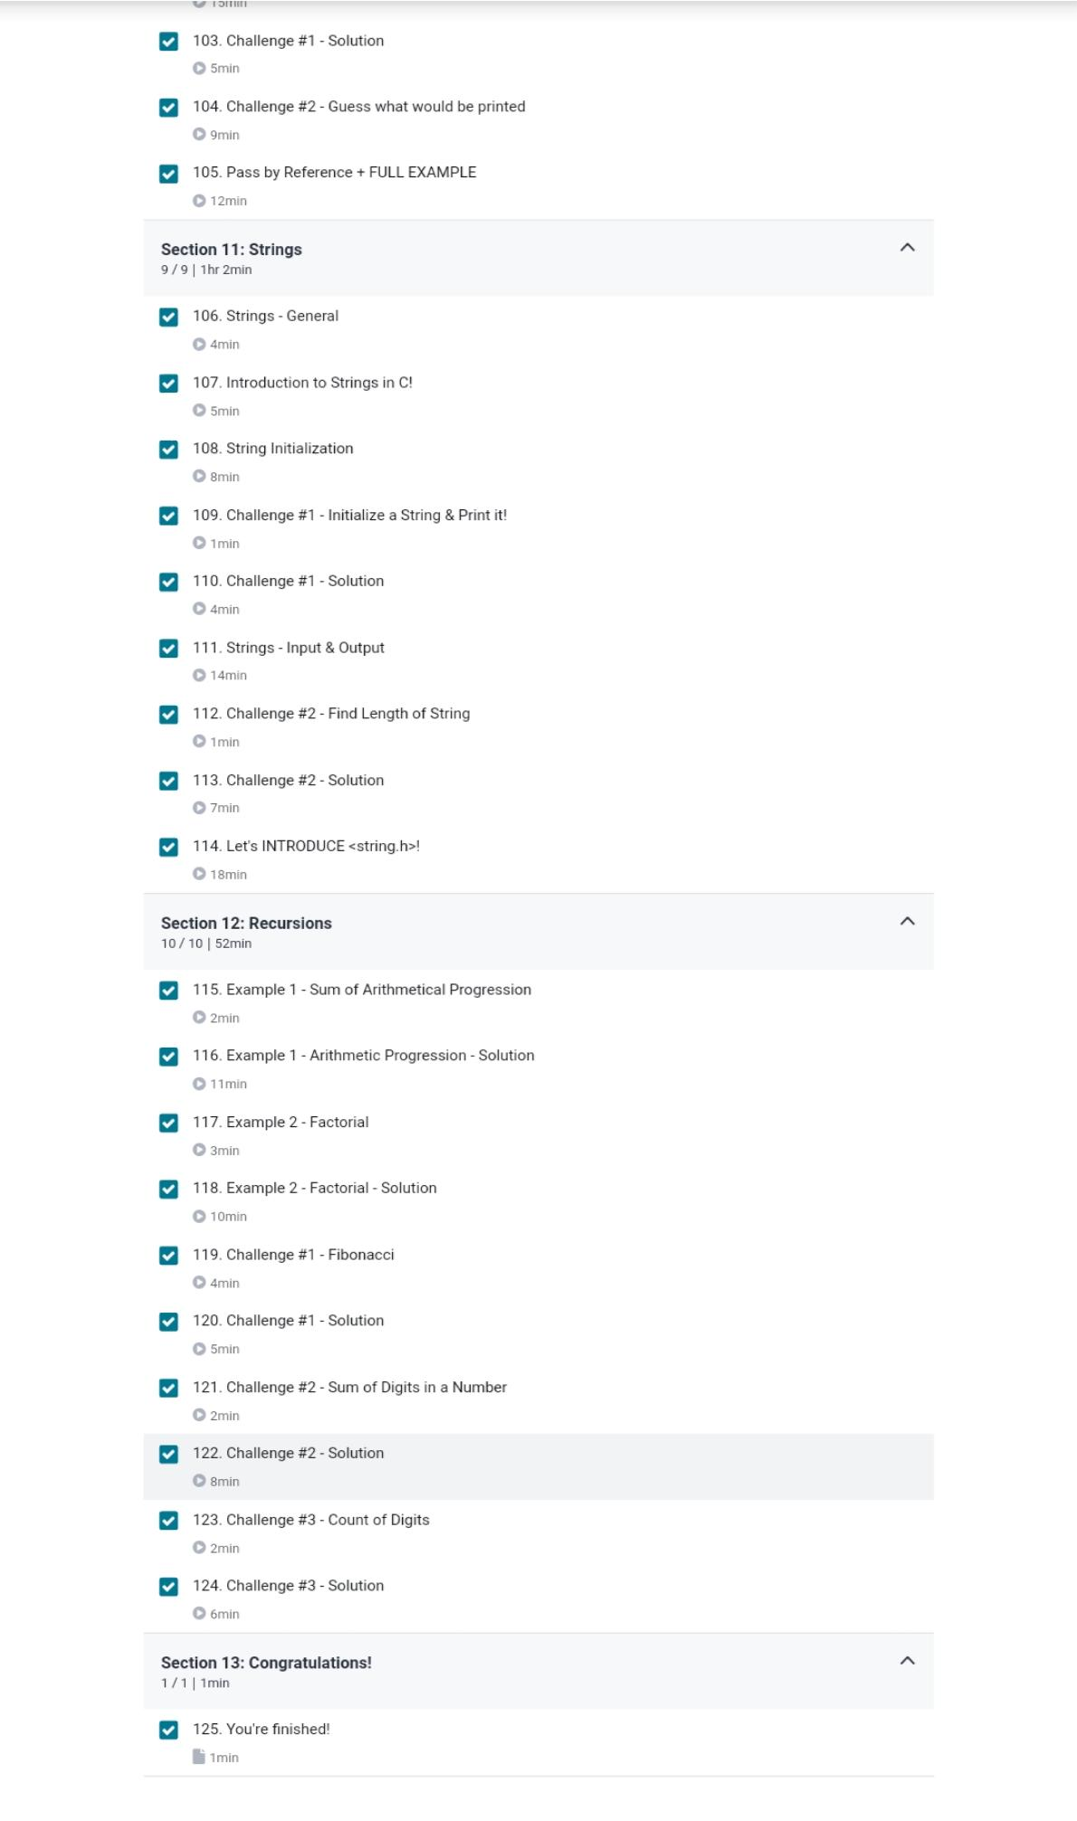

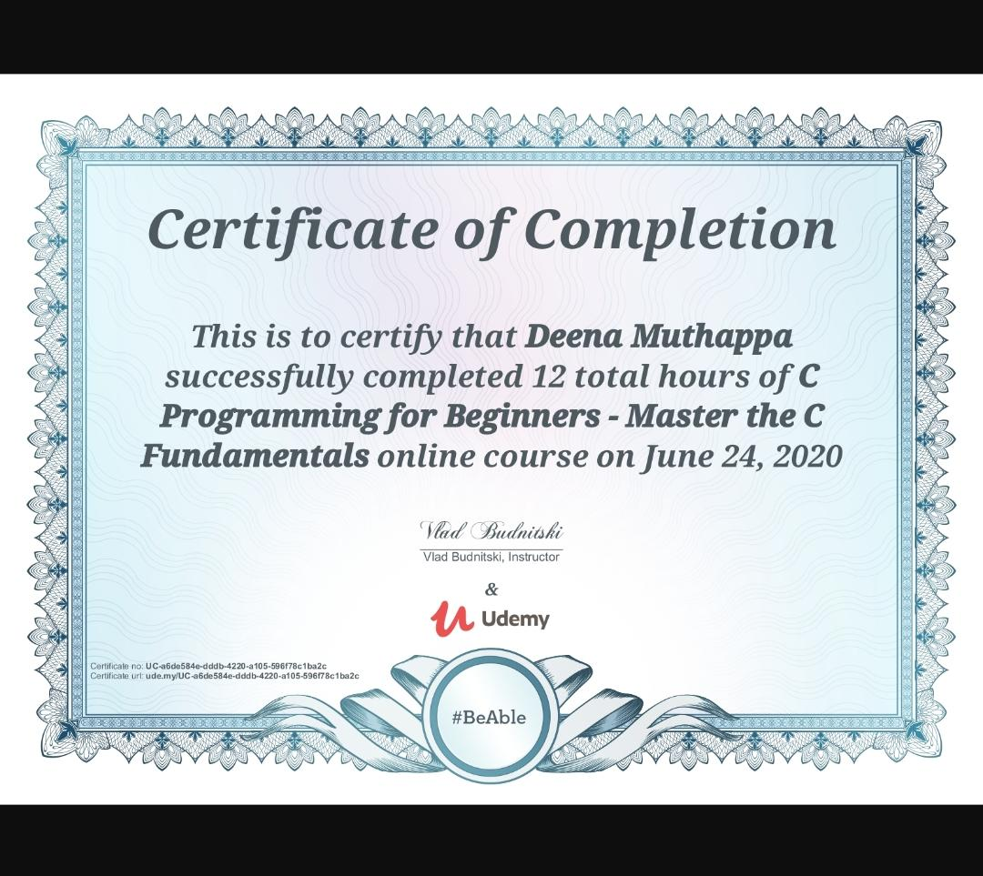

Coding Challenges Details:

Write a Java program to sort a numeric array and a string array.

import java.util.Arrays;

public class Exercise1 {

public static void main(String[] args){

int[] my_array1 = {

1789, 2035, 1899, 1456, 2013,

1458, 2458, 1254, 1472, 2365,

1456, 2165, 1457, 2456};

String[] my_array2 = {

"Java",

"Python",

"PHP",

"C#",

"C Programming",

"C++"

};

System.out.println("Original numeric array : "+Arrays.toString(my_array1));

Arrays.sort(my_array1);

System.out.println("Sorted numeric array : "+Arrays.toString(my_array1));

System.out.println("Original string array : "+Arrays.toString(my_array2));

Arrays.sort(my_array2);

System.out.println("Sorted string array : "+Arrays.toString(my_array2));

}

}