**DAILY ONLINE ACTIVITIES SUMMARY**

|  |  |  |  |  |  |  |  |
| --- | --- | --- | --- | --- | --- | --- | --- |
| **Date:** | **15/07/20** | | | | **Name:** | **Deena Muthappa** | |
| **Sem & Sec** | **8th sem, A sec** | | | | **USN:** | **4AL16CS028** | |
| **Online Test Summary** | | | | | | | |
| **Subject** | | **Not conducted** | | | | | |
| **Max. Marks** | |  | | **Score** | |  | |
| **Certification Course Summary** | | | | | | | |
| **Course** | **NodeJs React Rest Summer 2020** | | | | | | |
| **Certificate Provider** | | | **Udemy** | **Duration** | | | **26hrs** |
| **Coding Challenges** | | | | | | | |
| **Problem Statement: Write a C program to check weather given number can be**  **expressed in sum of two prime numbers.** | | | | | | | |
| **Status: Completed** | | | | | | | |
| **Uploaded the report in Github** | | | | **Yes** | | | |
| **If yes Repository name** | | | | **deenamuthaappa/Coding-Challenges** | | | |
| **Uploaded the report in slack** | | | | **Yes** | | | |

Online Test Details:

Certification Course Details:

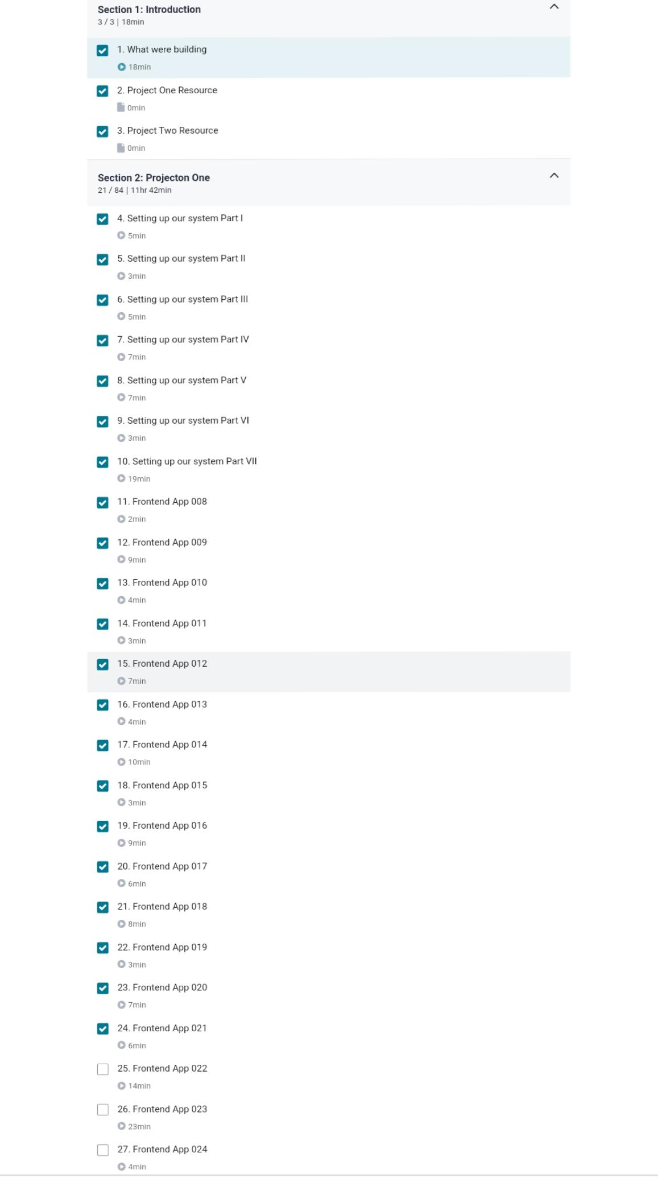

Coding Challenges

#include <stdio.h>

int sum_of_two_primes(int n);

int main()

{

int n, i;

printf("Enter the number: ");

scanf("%d", &n);

int flag = 0;

for(i = 2; i <= n/2; ++i)

{

if (sum_of_two_primes(i) == 1)

{

if (sum_of_two_primes(n-i) == 1)

{

printf("\n%d can be expressed as the sum of %d and %d\n\n", n, i, n - i);

flag = 1;

}

}

}

if (flag == 0)

printf("%d cannot be expressed as the sum of two prime numbers\n", n);

return 0;

}

int sum_of_two_primes(int n)

{

int i, isPrime = 1;

for(i = 2; i <= n/2; ++i)

{

if(n % i == 0)

{

isPrime = 0;

break;

}

}

return isPrime;

}