**DAILY ONLINE ACTIVITIES SUMMARY**

|  |  |  |  |  |  |  |  |
| --- | --- | --- | --- | --- | --- | --- | --- |
| **Date:** | **25/06/20** | | | | **Name:** | **Deena Muthappa** | |
| **Sem & Sec** | **8th sem, A sec** | | | | **USN:** | **4AL16CS028** | |
| **Online Test Summary** | | | | | | | |
| **Subject** | | **SMS** | | | | | |
| **Max. Marks** | | **30** | | **Score** | | **Not displayed** | |
| **Certification Course Summary** | | | | | | | |
| **Course** | **The complete HTML5 course:From beginning to expert** | | | | | | |
| **Certificate Provider** | | | **Udemy** | **Duration** | | | **3hrs** |
| **Problem Statement: C program to find sum of array elements using dynamic memory location** | | | | | | | |
| **Status: Completed** | | | | | | | |
| **Uploaded the report in Github** | | | | **Yes** | | | |
| **If yes Repository name** | | | | **deenamuthaappa/Coding-Challenges** | | | |
| **Uploaded the report in slack** | | | | **Yes** | | | |

Online Test Details:

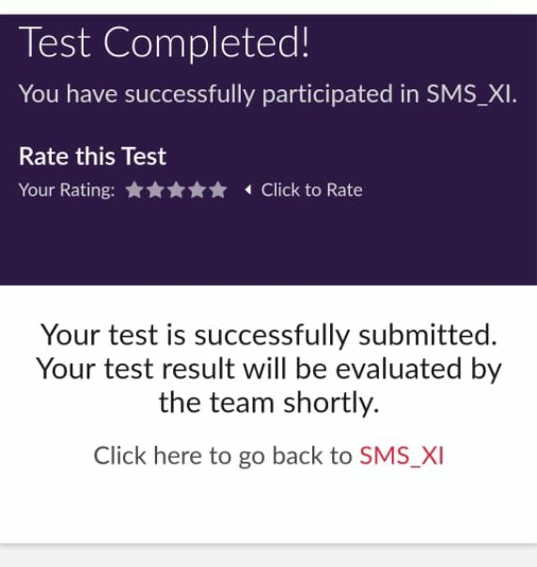

The test was on the subject System Modelling and Simulation

Certification Course Details:

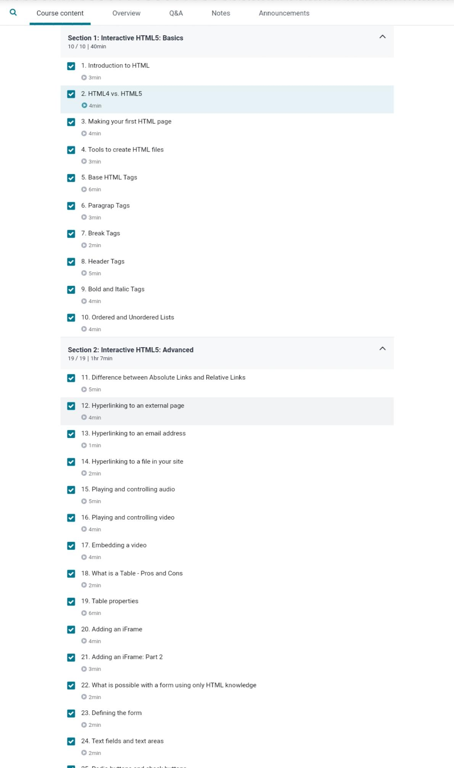

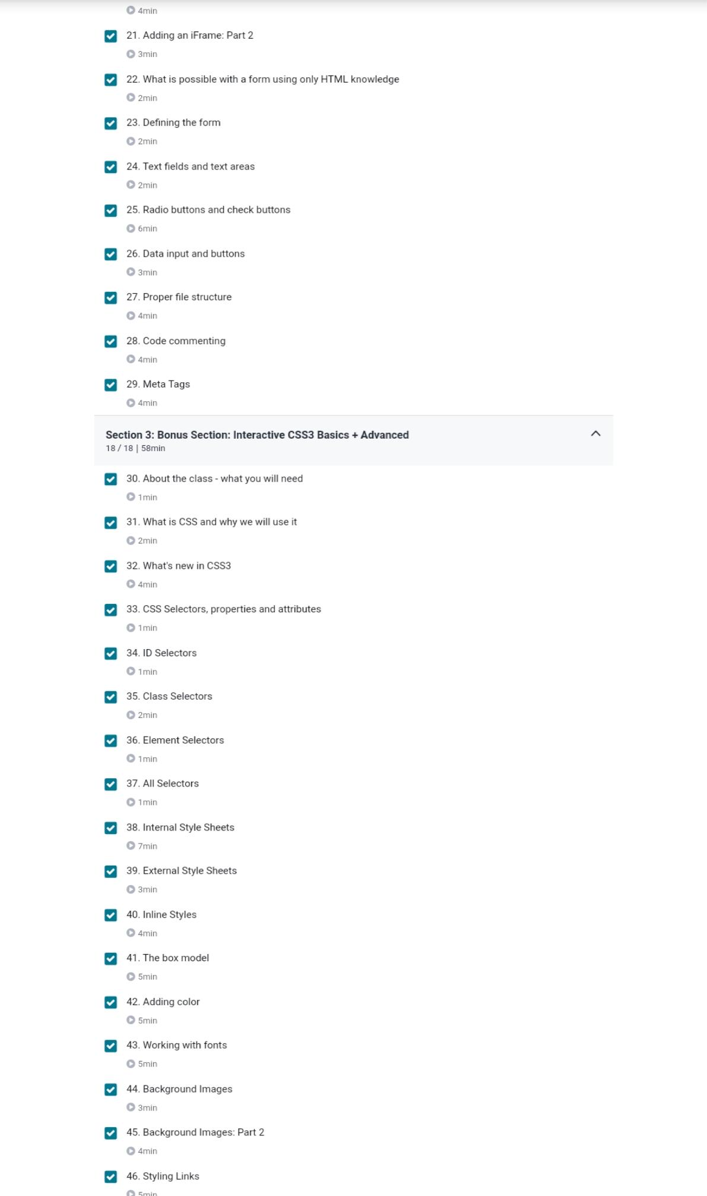



Coding Challenges Details:

#include<stdio.h>

#include<stdlib.h>

**int** main()

{

**int** *ptr; //declaration of integer pointer

**int** limit; //to store array limit

**int** i; //loop counter

**int** sum; //to store sum of all elements

printf("Enter limit of the array: ");

scanf("%d",&limit);

//declare memory dynamically

ptr=(**int**\*)malloc(limit\***sizeof**(**int**));

//read array elements

**for**(i=0;i<limit;i++)

{

printf("Enter element %02d: ",i+1);

scanf("%d",(ptr+i));

}

//print array elements

printf("\nEntered array elements are:\n");

**for**(i=0;i<limit;i++)

{

printf("%d\n",*(ptr+i));

}

//calculate sum of all elements

sum=0; //assign 0 to replace garbage value

**for**(i=0;i<limit;i++)

{

sum+=*(ptr+i);

}

printf("Sum of array elements is: %d\n",sum);

//free memory

free(ptr); //hey, don't forget to free dynamically allocated memory.

**return** 0;

}